ANTENNA QY21506XL2D8
Good stacking characteristics at big vertical and horizontal distances
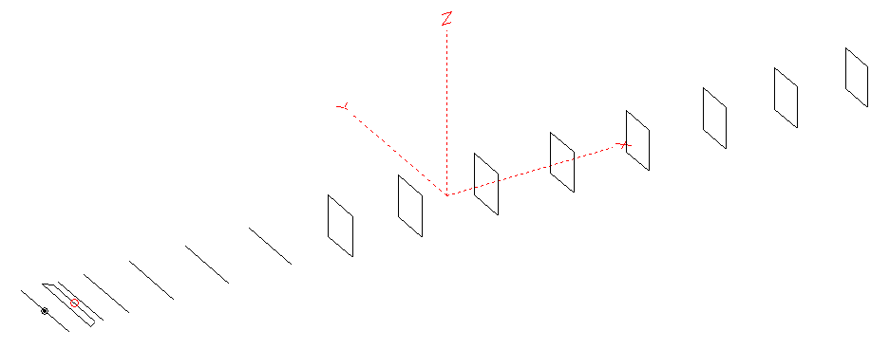

PERFORMANCES: (No loss condition)
TYPE | ELE | L (mm) | G (dBi) | F/B (dB) | F/Sh (dBi) | F/Sv (dBi) | Hor (◦) | Ver (◦) | Temp (◦K) | G/T (dB) | ΔF * (kHz)
QY21506XL2D8 | 15 | 9765 | 17.01 | 26.99 | 20.96 | 18.07 | 28.2 | 29.2 | 217.5 | -6.37 | 3000
* ΔF given for SWR=1,5

PERFORMANCES: (Loss included)
Element material | G (dBi) | Temp (◦K) | G/T (dB)
Aluminum rods | 16.92 | 219.5 | -6.49

DIMENSIONS:
 | Ref | De1 | De2 | D1 | D2 | D3 | D4 | D5 | DQ1 | DQ2 | DQ3 | DQ4 | DQ5 | DQ6 | DQ7 | DQ8
Pos | 0 | 250 | 350 | 428 | 735 | 1279 | 1954 | 2715 | 3555 | 4395 | 5305 | 6222 | 7126 | 8055 | 8915 | 9765
Length | 1016 | 1016 | 886 | 944 | 952 | 928 | 898 | 896 | 518 | 502 | 490 | 482 | 476 | 472 | 466 | 458
REMARKS : All elements made of Al rods Ǿ6mm
The height of the rectangles 500mm
All dimensions given in milimetres
Building hints: No boom correction included.
COMPARISON
Antenna | Boomlength (mm) | Material | Gain (dBi) | TA (◦K) | G/T (dB) | Bandwidth  (MHz)
QY21506XL2D8 | 9765 | No loss | 17.01 | 217.5 | -6.37 | 141.200- 146.450
QY21506XL2D8 | 9765 | Aluminum | 16.92 | 219.5 | -6.49 | 141.200- 146.450
G0KSC  14ELJJB | 9757 | No loss | 16.83 | 213.7 | -6.47 | 142.850- 145.320
G0KSC  14ELJJB | 9757 | Aluminum | 16.74 | 215.5 | -6.59 | 142.850- 145.320
EF0215-6 | 10060 | No loss | 17.23 | 226.3 | -6.32 | 143.700 – 144.450
EF0215-6 | 10060 | Aluminum | 17.04 | 229.6 | -6.57 | 143.700 – 144.450

DIAGRAMS (no loss included)
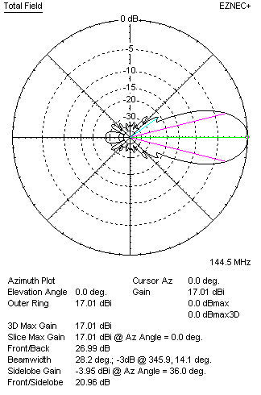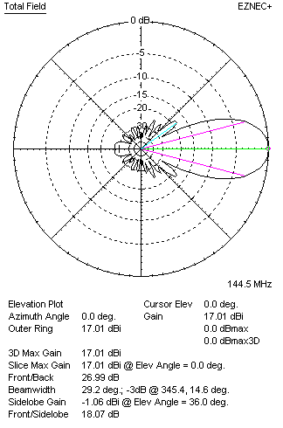
DIAGRAMS (loss included)
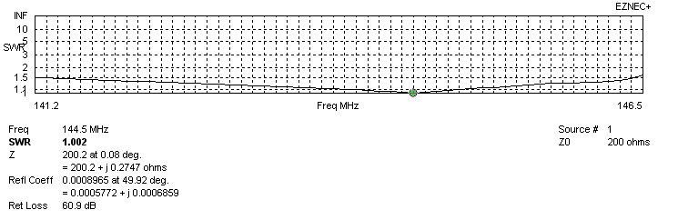
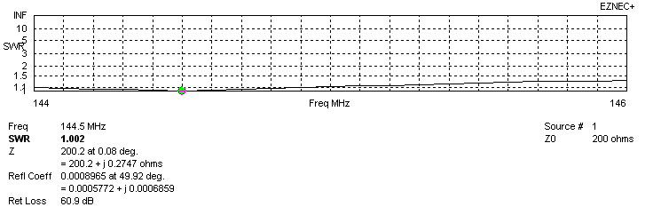
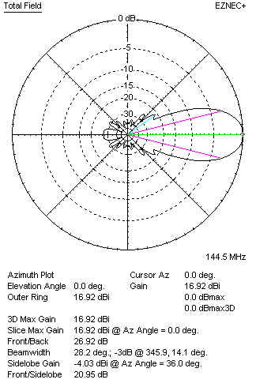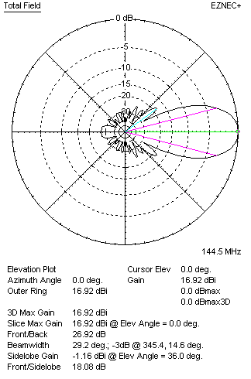
STACKING

QY21506XL2D8 STACKING TABLE
(including loss for aluminum – AGT = -0.10 dB)
VERTICAL  DISTANCE (cm) | G  (dB) | TA  (°K) | G/T  (dB) | HORIZONTAL  DISTANCE (cm) | G  (dB) | TA  (°K) | G/T  (dB)
100 | 17.12 | 237.4 | -6.63 | 100
110 | 17.49 | 228.6 | -6.10 | 110
120 | 17.73 | 224.2 | -5.78 | 120 | 16.92 | 254.8 | -7.14
130 | 17.91 | 221.9 | -5.55 | 130 | 17.46 | 243.2 | -6.40
140 | 18.04 | 220.2 | -5.39 | 140 | 17.77 | 235.4 | -5.95
150 | 18.16 | 218.2 | -5.23 | 150 | 17.98 | 230.8 | -5.65
160 | 18.26 | 216.7 | -5.10 | 160 | 18.13 | 228.1 | -5.45
170 | 18.35 | 216.0 | -5.00 | 170 | 18.25 | 226.5 | -5.30
180 | 18.44 | 215.9 | -4.90 | 180 | 18.35 | 225.5 | -5.18
190 | 18.52 | 216.0 | -4.82 | 190 | 18.44 | 224.9 | -5.08
200 | 18.60 | 216.2 | -4.75 | 200 | 18.52 | 224.4 | -4.99
210 | 18.67 | 216.7 | -4.69 | 210 | 18.60 | 224.1 | -4.90
220 | 18.74 | 217.5 | -4.64 | 220 | 18.67 | 223.8 | -4.83
230 | 18.80 | 218.5 | -4.60 | 230 | 18.74 | 223.5 | -4.75
240 | 18.87 | 219.7 | -4.55 | 240 | 18.81 | 223.2 | -4.68
250 | 18.92 | 221.0 | -4.52 | 250 | 18.87 | 222.8 | -4.61
260 | 18.98 | 222.1 | -4.49 | 260 | 18.94 | 222.3 | -4.53
270 | 19.04 | 223.0 | -4.44 | 270 | 19.00 | 221.8 | -4.46
280 | 19.09 | 223.5 | -4.40 | 280 | 19.06 | 221.1 | -4.39
290 | 19.15 | 223.5 | -4.34 | 290 | 19.12 | 220.5 | -4.31
300 | 19.22 | 223.1 | -4.27 | 300 | 19.19 | 219.8 | -4.23
310 | 19.28 | 222.5 | -4.19 | 310 | 19.25 | 219.2 | -4.16
320 | 19.34 | 221.8 | -4.12 | 320 | 19.31 | 218.6 | -4.09
330 | 19.41 | 221.0 | -4.03 | 330 | 19.37 | 218.1 | -4.02
340 | 19.47 | 220.3 | -3.96 | 340 | 19.43 | 217.6 | -3.95
350 | 19.53 | 219.7 | -3.89 | 350 | 19.49 | 217.3 | -3.88
360 | 19.58 | 219.3 | -3.83 | 360 | 19.55 | 217.1 | -3.82
370 | 19.68 | 218.8 | -3.72 | 370 | 19.60 | 216.9 | -3.76
380 | 19.72 | 218.6 | -3.68 | 380 | 19.65 | 216.9 | -3.71
390 | 19.76 | 218.4 | -3.63 | 390 | 19.69 | 216.9 | -3.67
400 | 19.80 | 218.3 | -3.59 | 400 | 19.73 | 217.0 | -3.63
410 | 19.83 | 218.1 | -3.56 | 410 | 19.77 | 217.1 | -3.60
420 | 19.86 | 218.0 | -3.52 | 420 | 19.80 | 217.3 | -3.57
430 | 19.88 | 217.7 | -3.50 | 430 | 19.83 | 217.4 | -3.54
440 | 19.91 | 217.5 | -3.46 | 440 | 19.86 | 217.5 | -3.51
450 | 19.93 | 217.1 | -3.44 | 450 | 19.88 | 217.7 | -3.50
460 | 19.94 | 216.8 | -3.42 | 460 | 19.90 | 217.8 | -3.48
470 | 19.96 | 216.4 | -3.39 | 470 | 19.92 | 217.9 | -3.46
480 | 19.97 | 216.1 | -3.38 | 480 | 19.93 | 217.9 | -3.45
490 | 19.98 | 215.7 | -3.36 | 490 | 19.94 | 218.0 | -3.44
500 | 19.99 | 215.4 | -3.34 | 500 | 19.95 | 218.1 | -3.44
510 | 20.00 | 215.3 | -3.33 | 510 | 19.96 | 218.2 | -3.43
520 | 20.00 | 215.2 | -3.33 | 520 | 19.97 | 218.3 | -3.42
Remark: brown colour letters show not consistent data!

TWO ANTENNAS VERTICALLY STACKED AT 520CM
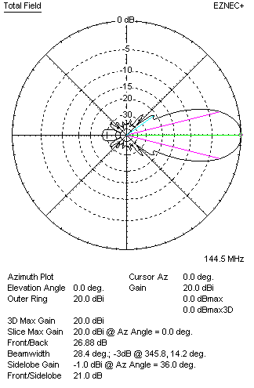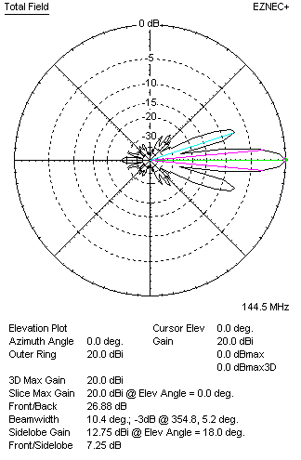

Performances
TYPE | Condition | G  (dBi) | F/B  (dB) | F/Sh  (dBi) | F/Sv (dBi) | Hor  (◦) | Ver  (◦) | Temp (◦K) | G/T (dB) | B (MHz)  for SWR=1.5
2xQY21506XL2D8 | No loss | 20.10 | 26.97 | 21.01 | 7.24 | 28.4 | 10.4 | 213.2 | -3.19 | 141.200- 146.450
2xQY21506XL2D8 | Aluminum | 20.00 | 26.88 | 21.00 | 7.25 | 28.4 | 10.4 | 215.3 | -3.33 | 141.200- 146.450

FOUR ANTENNAS VERTICALLY STACKED AT 520+520+520 CM
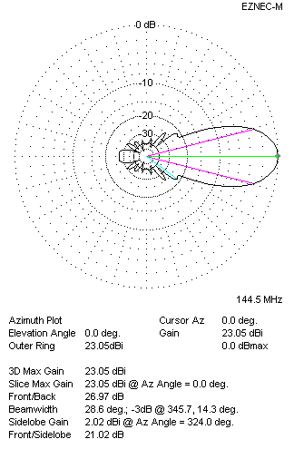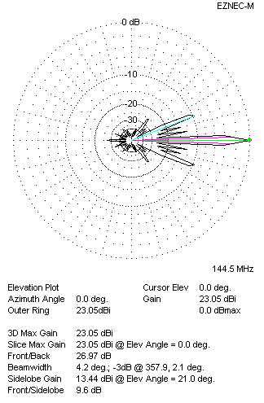
Performances
TYPE | Condition | G  (dBi) | F/B  (dB) | F/Sh  (dBi) | F/Sv (dBi) | Hor  (◦) | Ver  (◦) | Temp (◦K) | G/T (dB) | B (MHz)  for SWR=1.5
4xQY21506XL2D8 | No losss | 23.14 | 27.06 | 21.03 | 9.58 | 28.6 | 4.2 | 211.8 | -0.12 | 141.200- 146.450
4xQY21506XL2D8 | Aluminum | 23.05 | 26.97 | 21.02 | 9.60 | 28.6 | 4.2 | 213.9 | -0.25 | 141.200- 146.450

FOUR ANTENNAS IN H- STACK, H=520 CM, V=500 CM
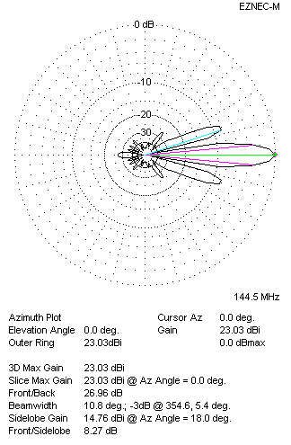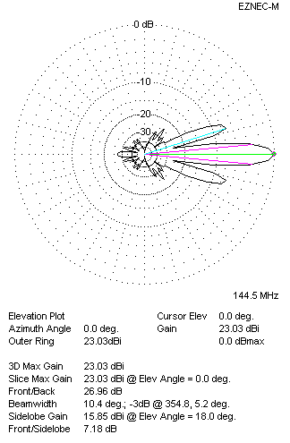
Performances
TYPE | Condition | G  (dBi) | F/B  (dB) | F/Sh  (dBi) | F/Sv (dBi) | Hor  (◦) | Ver  (◦) | Temp (◦K) | G/T (dB) | B (MHz)  for SWR=1.5
4xQY21506XL2D8 | No losss | 23.12 | 27.05 | 8.25 | 7.16 | 10.8 | 10.4 | 212.9 | -0.16 | 141.200- 146.450
4xQY21506XL2D8 | Aluminum | 23.03 | 26.96 | 8.27 | 7.18 | 10.8 | 10.4 | 214.9 | -0.29 | 141.200- 146.450

XPOL VERSION

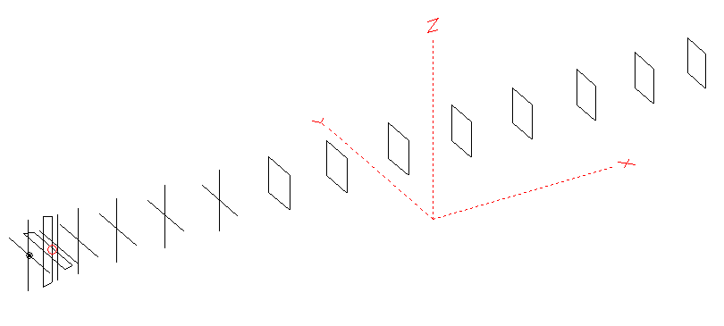
Horizontal components: Same as above
Vertical components: Same as above, except:
- All vertical yagi elements positioned 20 mm backward regarding horizontals.
- All crossed elements must cross each other in their centerlines

HORIZONTAL PERFORMANCES
Everything as the above data

VERTICAL PERFORMANCES with no corrections
Loss included condition (for Aluminum)
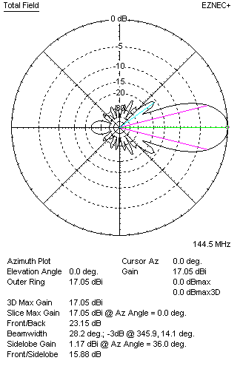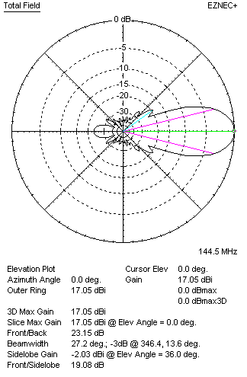
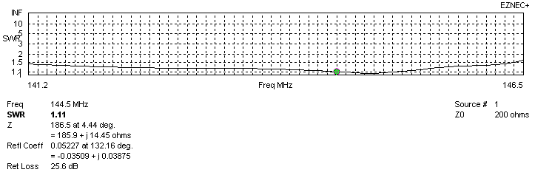
VERTICAL PERFORMANCES after corrections, loss included condition
If you want to get better SWR diagram for vertical antenna you can do the following:
- Change length of DE2 from 886 to 890 mm
- Change length of D2 from 952 to 950 mm
- Change length of D3 from 928 to 922 mm
- Change length of D4 from 914 to 912 mm

In this case the SWR diagram will be like this:
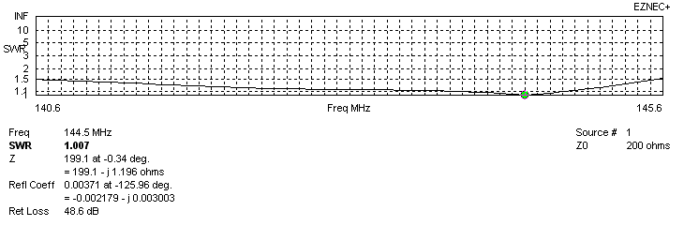
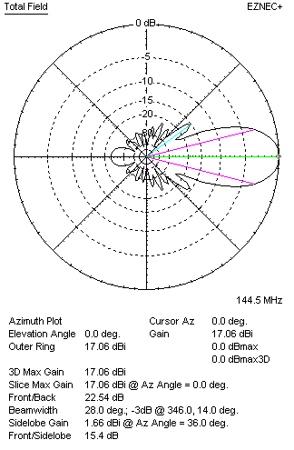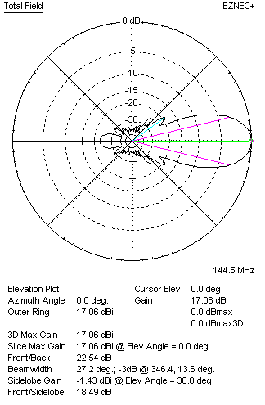

PERFORMANCES
 | TYPE | Condition | G  (dBi) | F/B  (dB) | F/Sh  (dBi) | F/Sv (dBi) | Hor  (◦) | Ver  (◦) | Temp (◦K) | G/T (dB) | B (MHz)  for SWR=1.5
 | Horizontal  part | No losss | 17.01 | 26.99 | 20.96 | 18.07 | 28.2 | 29.2 | 217.5 | -6.37 | 141.200- 146.450
 | Horizontal  part | Aluminum | 16.92 | 26.92 | 20.95 | 18.08 | 28.2 | 29.2 | 219.5 | -6.49 | 141.200- 146.450
 | Vertical  part | No losss | 17.15 | 22.52 | 15.36 | 18.49 | 28.0 | 27.2 | 223.4 | -6.34 | 140.600 – 145.550
 | Vertical  part | Aluminum | 17.06 | 22.54 | 15.40 | 18.49 | 28.0 | 27.2 | 225.1 | -6.46 | 140.600 – 145.550

