ANTENNA Y21408X3D7
Good stacking characteristics at big vertical and horizontal distances
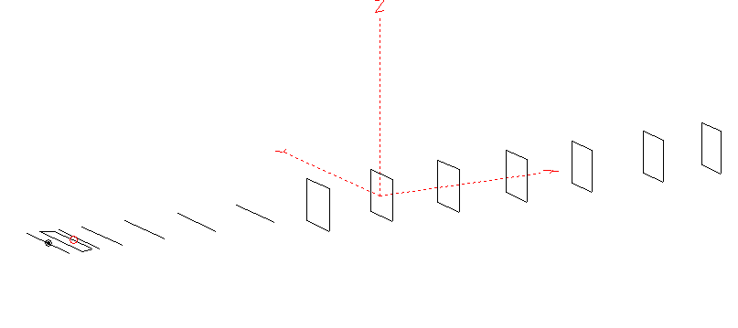
PERFORMANCES: (No loss condition)
TYPE | ELE | L (mm) | G (dBi) | F/B (dB) | F/Sh (dBi) | F/Sv (dBi) | Hor (◦) | Ver (◦) | Temp (◦K) | G/T (dB) | ΔF * (kHz)
QY21408XL3D7 | 14 | 8655 | 16.61 | 28.32 | 19.68 | 17.45 | 29.2 | 30.4 | 218.5 | -6.78 | 4700
* ΔF given for SWR=1.5

PERFORMANCES: (Loss included)
Element material | G (dBi) | Temp (◦K) | G/T (dB)
Aluminum rods | 16.53 | 220.1 | -6.90

DIMENSIONS:
 | Ref | De1 | De2 | D1 | D2 | D3 | D4 | D5 | DQ1 | DQ2 | DQ3 | DQ4 | DQ5 | DQ6 | DQ7 | REMARKS : All elements made of Al rods Ǿ8mm  The height of the rectangles 500mm  All dimensions given in milimetres
Pos | 0 | 160 | 330 | 405 | 702 | 1258 | 1939 | 2705 | 3525 | 4355 | 5223 | 6108 | 6965 | 7895 | 8655
Length | 1012 | 1012 | 884 | 948 | 950 | 924 | 904 | 886 | 524 | 506 | 496 | 486 | 476 | 470 | 456
Building hints: No boom correction included

COMPARISON
Antenna | Boomlength (mm) | Material | Gain (dBi) | TA (◦K) | G/T (dB) | Bandwidth  (MHz)
QY21408XL3D7 | 8655 | No loss | 16.61 | 218.5 | -6.78 | 141.600 - 146.300
QY21408XL3D7 | 8655 | Aluminum | 16.53 | 220.1 | -6.90 | 141.600 - 146.300
G0KSC  14ELJJD | 8817 | No loss | 16.55 | 220.7 | -6.89 | 142.500 – 145.300
G0KSC  14ELJJD | 8817 | Aluminum | 16.40 | 223.2 | -7.09 | 142.500 – 145.300
EF0214-5 | 9100 | No loss | 16.81 | 220.7 | -6.63 | 143.720 - 144.620
EF0214-5 | 9100 | Aluminum | 16.67 | 235.4 | -6.82 | 143.720 - 144.620

.

DIAGRAMS (no loss included)
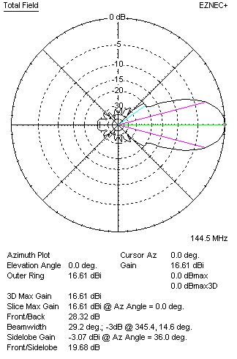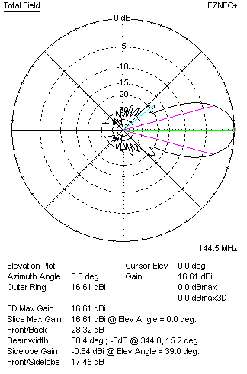
DIAGRAMS (loss included)
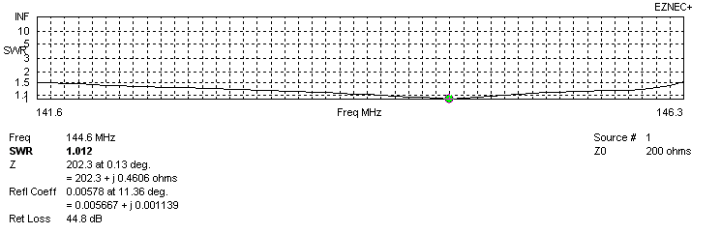
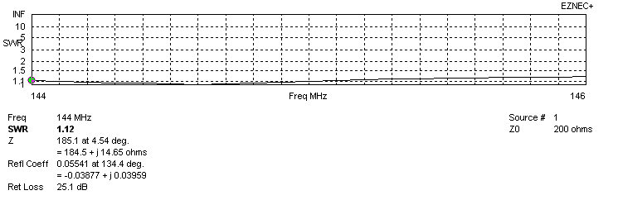
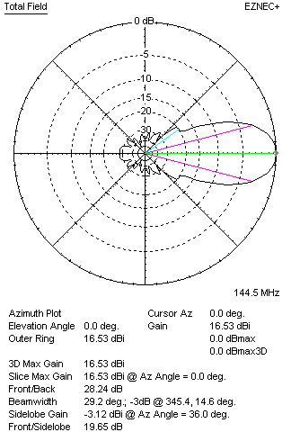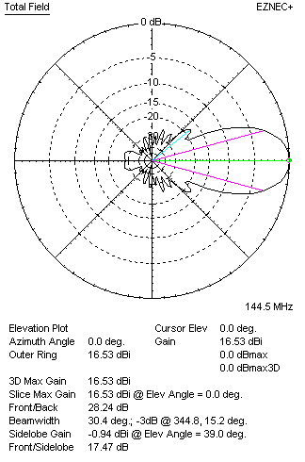
STACKING

QY21408XL3D7 – STACKING TABLE
(including loss for aluminum – AGT = -0.09 dB)
VERTICAL  DISTANCE (cm) | G  (dB) | TA  (°K) | G/T  (dB) | HORIZONTAL  DISTANCE (cm) | G  (dB) | TA  (°K) | G/T  (dB)
100 | 16.64 | 232.2 | -7.02 | 100
110 | 16.98 | 225.7 | -6.56 | 110
120 | 17.23 | 221.9 | -6.23 | 120 | 16.58 | 239.1 | -7.21
130 | 17.42 | 219.5 | -5.99 | 130 | 17.04 | 233.5 | -6.64
140 | 17.58 | 217.7 | -5.80 | 140 | 17.33 | 229.8 | -6.28
150 | 17.72 | 215.9 | -5.62 | 150 | 17.54 | 227.4 | -6.03
160 | 17.84 | 214.6 | -5.48 | 160 | 17.70 | 226.0 | -5.84
170 | 17.95 | 213.9 | -5.35 | 170 | 17.83 | 225.1 | -5.69
180 | 18.05 | 213.8 | -5.25 | 180 | 17.95 | 224.6 | -5.56
190 | 18.14 | 214.0 | -5.16 | 190 | 18.05 | 224.3 | -5.46
200 | 18.23 | 214.6 | -5.09 | 200 | 18.14 | 224.0 | -5.36
210 | 18.31 | 215.5 | -5.02 | 210 | 18.23 | 223.9 | -5.27
220 | 18.39 | 216.7 | -4.97 | 220 | 18.31 | 223.7 | -5.19
230 | 18.46 | 218.2 | -4.93 | 230 | 18.39 | 223.4 | -5.10
240 | 18.53 | 219.7 | -4.89 | 240 | 18.47 | 223.1 | -5.01
250 | 18.60 | 221.1 | -4.85 | 250 | 18.54 | 222.6 | -4.94
260 | 18.66 | 222.3 | -4.81 | 260 | 18.62 | 222.1 | 4.85
270 | 18.73 | 223.0 | -4.75 | 270 | 18.69 | 221.5 | -4.76
280 | 18.80 | 223.2 | -4.69 | 280 | 18.76 | 220.8 | -4.68
290 | 18.87 | 223.0 | -4.61 | 290 | 18.83 | 220.2 | -4.60
300 | 18.94 | 222.6 | -4.53 | 300 | 18.90 | 219.5 | -4.52
310 | 19.01 | 221.9 | -4.45 | 310 | 18.96 | 219.0 | -4.44
320 | 19.07 | 221.2 | -4.38 | 320 | 19.03 | 218.4 | -4.36
330 | 19.14 | 220.6 | -4.30 | 330 | 19.09 | 218.0 | -4.30
340 | 19.20 | 220.2 | -4.23 | 340 | 19.15 | 217.7 | -4.23
350 | 19.25 | 219.9 | -4.17 | 350 | 19.20 | 217.5 | -4.17
360 | 19.30 | 219.8 | -4.12 | 360 | 19.26 | 217.4 | -4.11
370 | 19.35 | 219.7 | -4.07 | 370 | 19.30 | 217.3 | -4.07
380 | 19.39 | 219.6 | -4.03 | 380 | 19.34 | 217.4 | -4.03
390 | 19.42 | 219.6 | -4.00 | 390 | 19.38 | 217.5 | -3.99
400 | 19.46 | 219.6 | -3.96 | 400 | 19.41 | 217.7 | -3.97
410 | 19.48 | 219.6 | -3.94 | 410 | 19.44 | 217.9 | -3.94
420 | 19.51 | 219.5 | -3.90 | 420 | 19.47 | 218.1 | -3.92
430 | 19.53 | 219.4 | -3.88 | 430 | 19.49 | 218.3 | -3.90
440 | 19.54 | 219.1 | -3.87 | 440 | 19.51 | 218.5 | -3.88
450 | 19.56 | 218.8 | -3.84 | 450 | 19.52 | 218.7 | -3.88
460 | 19.57 | 218.4 | -3.82 | 460 | 19.54 | 218.8 | -3.86
470 | 19.58 | 217.9 | -3.80 | 470 | 19.55 | 219.0 | -3.85
480 | 19.59 | 217.4 | -3.78 | 480 | 19.56 | 219.1 | -3.85
490 | 19.59 | 216.9 | -3.77 | 490 | 19.57 | 219.2 | -3.84
500 | 19.60 | 216.4 | -3.75 | 500 | 19.57 | 219.3 | -3.84
Remark: brown colour letters show not consistent data!

TWO ANTENNAS VERTICALLY STACKED AT 500CM
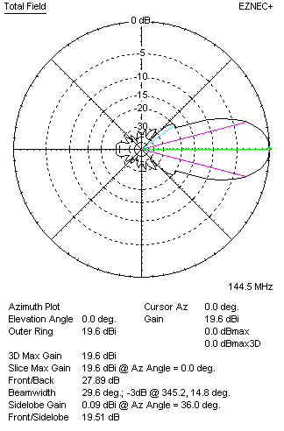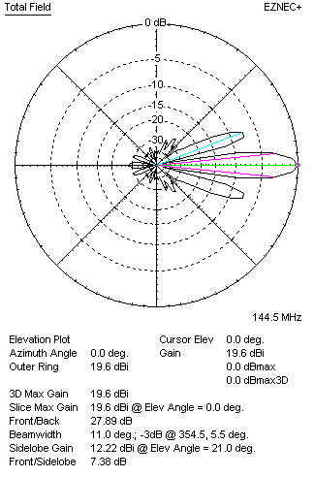

Performances
TYPE | Condition | G  (dBi) | F/B  (dB) | F/Sh  (dBi) | F/Sv (dBi) | Hor  (◦) | Ver  (◦) | Temp (◦K) | G/T (dB) | B (MHz)  for SWR=1.5
2xQY21308XL3D7 | No losss | 19.69 | 27.97 | 19.53 | 7.37 | 29.6 | 11.0 | 214.7 | -3.63 | 141.600 - 146.300
2xQY21308XL3D7 | Aluminum | 19.60 | 27.89 | 19.51 | 7.38 | 29.6 | 11.0 | 216.4 | -3.75 | 141.600 - 146.300

FOUR ANTENNAS VERTICALLY STACKED AT 500+500+500 CM
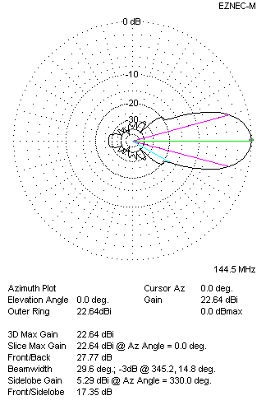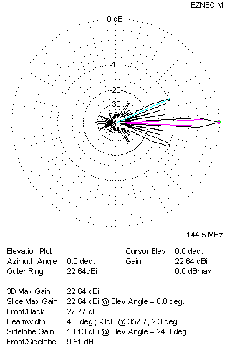
Performances
TYPE | Condition | G  (dBi) | F/B  (dB) | F/Sh  (dBi) | F/Sv (dBi) | Hor  (◦) | Ver  (◦) | Temp (◦K) | G/T (dB) | B (MHz)  for SWR=1.5
4xQY21308XL3D7 | No losss | 22.73 | 2785 | 22.39 | 9.49 | 29.6 | 4.6 | 212.6 | -0.55 | 141.600 - 146.300
4xQY21308XL3D7 | Aluminum | 22.64 | 27.77 | 22.42 | 9.51 | 29.6 | 4.6 | 214.7 | -0.63 | 141.600 - 146.300

FOUR ANTENNAS IN H- STACK, H=500 CM, V=490 CM
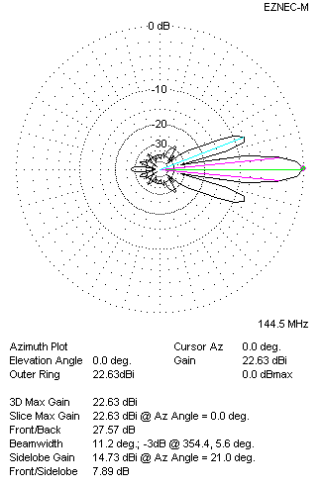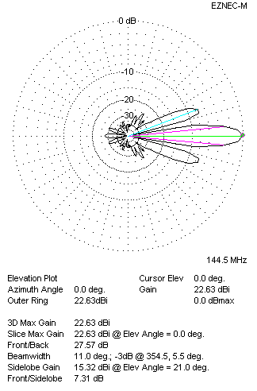
Performances
TYPE | Condition | G  (dBi) | F/B  (dB) | F/Sh  (dBi) | F/Sv (dBi) | Hor  (◦) | Ver  (◦) | Temp (◦K) | G/T (dB) | B (MHz)  for SWR=1.5
4xQY21308XL3D7 | No losss | 22.71 | 27.64 | 7.88 | 7.29 | 11.2 | 11.0 | 214.7 | -0.63 | 141.600 - 146.300
4xQY21308XL3D7 | Aluminum | 22.63 | 27.57 | 7.89 | 7.31 | 11.2 | 11.0 | 217.0 | -0.73 | 141.600 - 146.300

XPOL VERSION

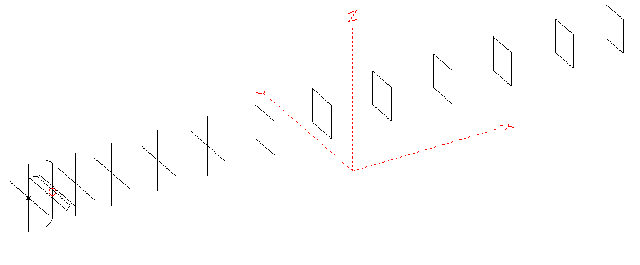
Horizontal components: Same as above
Vertical components: Same as above, except:
- All vertical yagi elements positioned 20 mm backward regarding horizontals.
- All crossed elements must cross each other in their centerlines

HORIZONTAL PERFORMANCES
Everything as the above data

VERTICAL PERFORMANCES with no corrections
Loss included condition (for Aluminum)
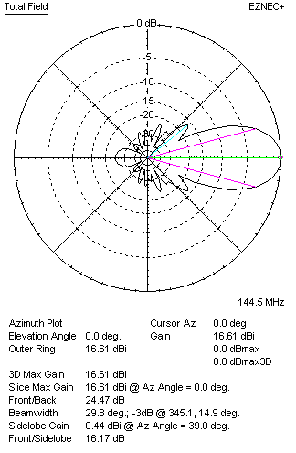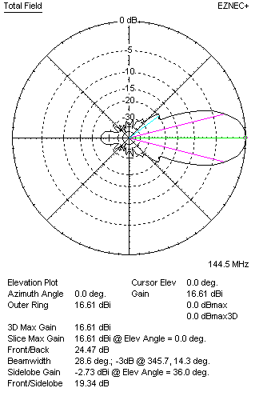
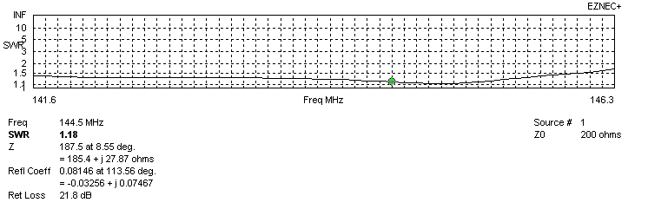
VERTICAL PERFORMANCES after corrections, loss included condition
If you want to get better SWR diagram for vertical antenna you can do the following:
- Change length of DE2 from 884 to 874 mm
- Change length of D1 from 950 to 948 mm
- Change length of D3 from 924 to 916 mm
- Change length of D4 from 904 to 900 mm
- Change length of D5 from 886 to 880 mm
- Change position of D2 for +5 mm.

In this case the SWR diagram will be like this:
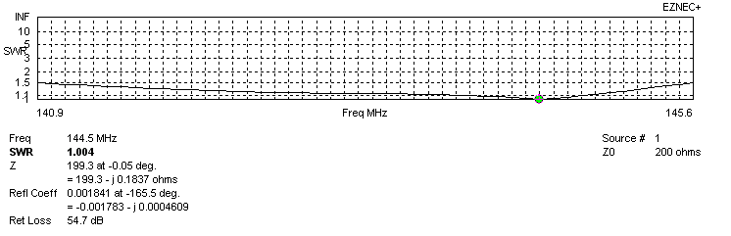
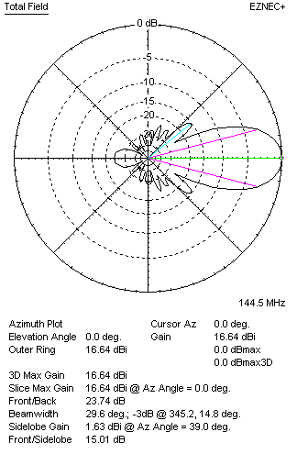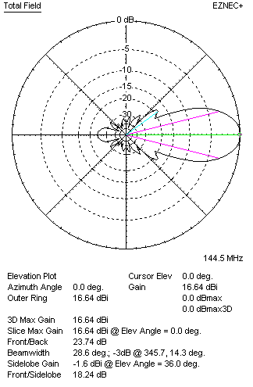

PERFORMANCES
 | TYPE | Condition | G  (dBi) | F/B  (dB) | F/Sh  (dBi) | F/Sv (dBi) | Hor  (◦) | Ver  (◦) | Temp (◦K) | G/T (dB) | B (MHz)  for SWR=1.5
 | Horizontal  part | No losss | 16.61 | 28.32 | 19.68 | 17.45 | 29.2 | 30.4 | 218.5 | -6.78 | 141.600 - 146.300
 | Horizontal  part | Aluminum | 16.53 | 28.24 | 19.56 | 17.47 | 29.2 | 30.4 | 220.1 | -6.90 | 141.600 - 146.300
 | Vertical  part | No losss | 16.72 | 23.74 | 15.01 | 18.27 | 29.6 | 28.6 | 221.5 | -6.73 | 140.900 – 145.600
 | Vertical  part | Aluminum | 16.64 | 23.74 | 15.01 | 18.24 | 29.6 | 28.6 | 222.9 | -6.84 | 140.900 – 145.600

