ANTENNA Y21406X3D7
Good stacking characteristics at big vertical and horizontal distances
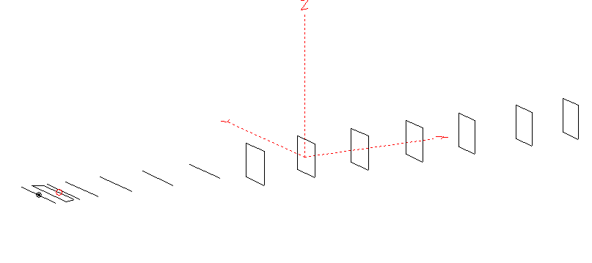
PERFORMANCES: (No loss condition)
TYPE | ELE | L (mm) | G (dBi) | F/B (dB) | F/Sh (dBi) | F/Sv (dBi) | Hor (◦) | Ver (◦) | Temp (◦K) | G/T (dB) | ΔF * (kHz)
QY21406XL3D7 | 14 | 8585 | 16.52 | 33.99 | 20.46 | 17.73 | 29.8 | 31.0 | 218.4 | -6.87 | 4500
* ΔF given for SWR=1.5

PERFORMANCES: (Loss included)
Element material | G (dBi) | Temp (◦K) | G/T (dB)
Aluminum rods | 16.43 | 220.2 | -7.00

DIMENSIONS:
 | Ref | De1 | De2 | D1 | D2 | D3 | D4 | D5 | DQ1 | DQ2 | DQ3 | DQ4 | DQ5 | DQ6 | DQ7 | REMARKS : All elements made of Al rods Ǿ6mm  The height of the rectangles 500mm  All dimensions given in milimetres
Pos | 0 | 250 | 350 | 421 | 731 | 1279 | 1954 | 2725 | 3545 | 4365 | 5275 | 6112 | 7046 | 7895 | 8585
Length | 1016 | 1016 | 864 | 942 | 952 | 930 | 910 | 894 | 518 | 502 | 490 | 482 | 476 | 472 | 466
Building hints: No boom correction included

COMPARISON
Antenna | Boomlength (mm) | Material | Gain (dBi) | TA (◦K) | G/T (dB) | Bandwidth  (MHz)
QY21406XL3D7 | 8585 | No loss | 16.52 | 218.4 | -6.87 | 142.100 - 146.600
QY21406XL3D7 | 8585 | Aluminum | 16.43 | 220.2 | -7.00 | 142.100 - 146.600
G0KSC  14ELJJD | 8817 | No loss | 16.55 | 220.7 | -6.89 | 142.500 – 145.300
G0KSC  14ELJJD | 8817 | Aluminum | 16.40 | 223.2 | -7.09 | 142.500 – 145.300
EF0214-5 | 9100 | No loss | 16.81 | 220.7 | -6.63 | 143.720 - 144.620
EF0214-5 | 9100 | Aluminum | 16.67 | 235.4 | -6.82 | 143.720 - 144.620

.

DIAGRAMS (no loss included)
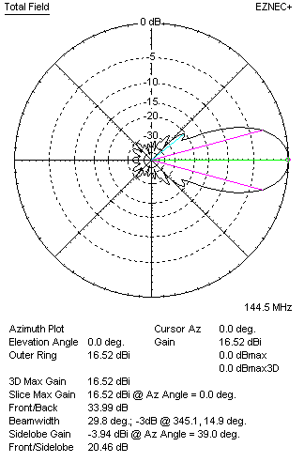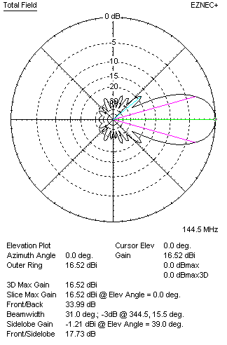
DIAGRAMS (loss included)
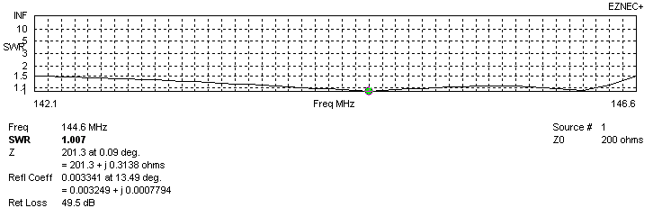
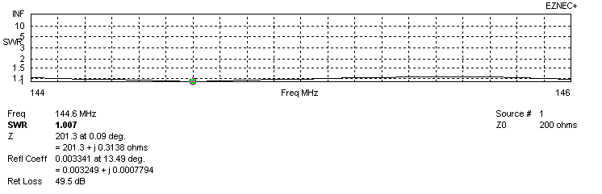
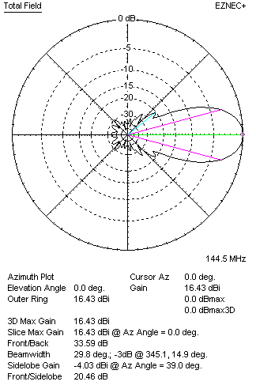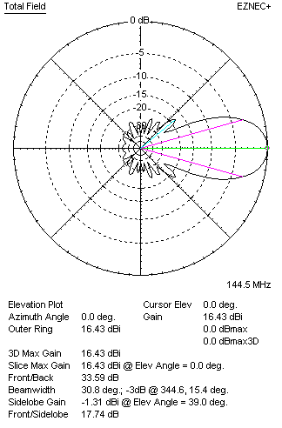
STACKING

QY21406XL3D7 – STACKING TABLE
(including loss for aluminum – AGT = -0.09 dB)
VERTICAL  DISTANCE (cm) | G  (dB) | TA  (°K) | G/T  (dB) | HORIZONTAL  DISTANCE (cm) | G  (dB) | TA  (°K) | G/T  (dB)
100 | 16.94 | 227.3 | -6.63 | 100
110 | 17.19 | 222.2 | -6.28 | 110
120 | 17.37 | 219.8 | -6.05 | 120
130 | 17.51 | 219.3 | -5.90 | 130
140 | 17.63 | 219.5 | -5.78 | 140
150 | 17.73 | 218.9 | -5.67 | 150
160 | 17.83 | 217.6 | -5.55 | 160
170 | 17.93 | 216.8 | -5.43 | 170
180 | 18.01 | 216.7 | -5.35 | 180
190 | 18.10 | 217.1 | -5.27 | 190
200 | 18.17 | 217.8 | -5.21 | 200 | 18.10 | 225.7 | -5.44
210 | 18.25 | 218.7 | -5.15 | 210 | 18.17 | 225.5 | -5.35
220 | 18.31 | 219.8 | -5.11 | 220 | 18.25 | 225.2 | -5.27
230 | 18.38 | 221.1 | -5.07 | 230 | 18.32 | 224.8 | -5.19
240 | 18.44 | 222.4 | -5.03 | 240 | 18.39 | 224.3 | -5.12
250 | 18.50 | 223.6 | -4.99 | 250 | 18.46 | 223.8 | -5.04
260 | 18.57 | 224.3 | -4.94 | 260 | 18.52 | 223.0 | 4.96
270 | 18.63 | 224.6 | -4.88 | 270 | 18.59 | 221.9 | -4.88
280 | 18.70 | 224.4 | -4.81 | 280 | 18.66 | 221.3 | -4.79
290 | 18.77 | 223.7 | -4.73 | 290 | 18.73 | 220.5 | -4.71
300 | 18.84 | 222.7 | -4.64 | 300 | 18.79 | 219.7 | -4.63
310 | 18.91 | 221.7 | -4.55 | 310 | 18.86 | 219.0 | -4.55
320 | 18.98 | 220.7 | -4.46 | 320 | 18.92 | 218.3 | -4.47
330 | 19.04 | 219.9 | -4.38 | 330 | 18.97 | 217.8 | -4.41
340 | 19.10 | 219.3 | -4.31 | 340 | 19.02 | 217.2 | -4.35
350 | 19.16 | 219.0 | -4.25 | 350 | 19.09 | 216.8 | -4.27
360 | 19.21 | 219.0 | -4.19 | 360 | 19.15 | 216.8 | -4.21
370 | 19.25 | 219.0 | -4.16 | 370 | 19.20 | 216.8 | -4.15
380 | 19.29 | 219.1 | -4.12 | 380 | 19.25 | 216.8 | -4.11
390 | 19.33 | 219.1 | -4.08 | 390 | 19.28 | 216.9 | -4.08
400 | 19.36 | 219.0 | -4.05 | 400 | 19.32 | 217.1 | -4.05
410 | 19.39 | 219.0 | -4.01 | 410 | 19.35 | 217.3 | -4.02
420 | 19.41 | 219.0 | -3.99 | 420 | 19.38 | 217.5 | -4.00
430 | 19.44 | 218.9 | -3.96 | 430 | 19.40 | 218.0 | -3.99
440 | 19.45 | 218.7 | -3.95 | 440 | 19.42 | 218.1 | -3.97
450 | 19.47 | 218.5 | -3.92 | 450 | 19.43 | 218.4 | -3.96
460 | 19.48 | 218.2 | -3.91 | 460 | 19.45 | 218.6 | -3.95
470 | 19.49 | 217.9 | -3.89 | 470 | 19.46 | 218.9 | -3.94
480 | 19.50 | 217.5 | -3.87 | 480 | 19.47 | 219.1 | -3.93
490 | 19.51 | 217.0 | -3.85 | 490 | 19.48 | 219.4 | -3.92
500 | 19.52 | 216.6 | -3.84 | 500 | 19.48 | 219.6 | -3.93
Remark: brown colour letters show not consistent data!

TWO ANTENNAS VERTICALLY STACKED AT 500CM
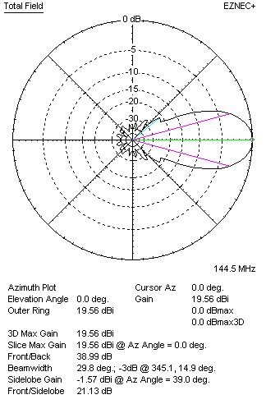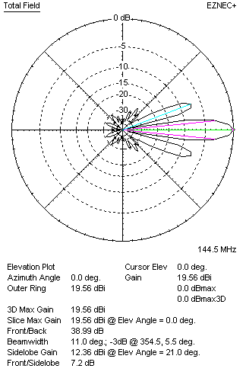

Performances
TYPE | Condition | G  (dBi) | F/B  (dB) | F/Sh  (dBi) | F/Sv (dBi) | Hor  (◦) | Ver  (◦) | Temp (◦K) | G/T (dB) | B (MHz)  for SWR=1.5
2xQY21406XL3D7 | No losss | 19.61 | 33.80 | 20.39 | 7.08 | 30.2 | 11.0 | 214.7 | -3.71 | 142.100 - 146.600
2xQY21406XL3D7 | Aluminum | 19.52 | 33.44 | 20.40 | 7.10 | 30.0 | 11.0 | 216.6 | -3.84 | 142.100 - 146.600

FOUR ANTENNAS VERTICALLY STACKED AT 500+500+500 CM
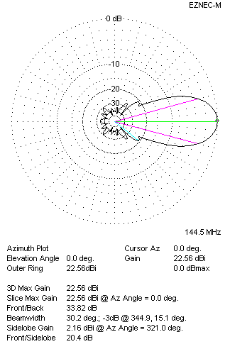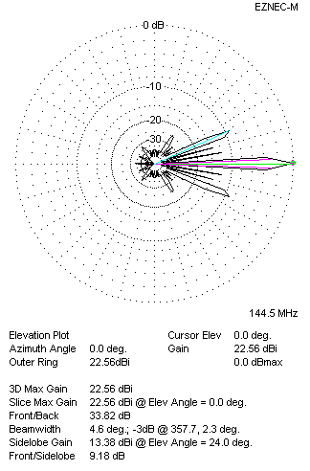
Performances
TYPE | Condition | G  (dBi) | F/B  (dB) | F/Sh  (dBi) | F/Sv (dBi) | Hor  (◦) | Ver  (◦) | Temp (◦K) | G/T (dB) | B (MHz)  for SWR=1.5
4xQY21406XL3D7 | No losss | 22.65 | 34.18 | 20.39 | 9.25 | 30.2 | 4.6 | 213.6 | -0.65 | 142.100 - 146.600
4xQY21406XL3D7 | Aluminum | 22.56 | 33.82 | 20.40 | 9.18 | 30.2 | 4.6 | 215.5 | -0.77 | 142.100 - 146.600

FOUR ANTENNAS IN H- STACK, H=500 CM, V=490 CM
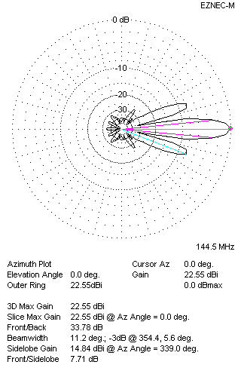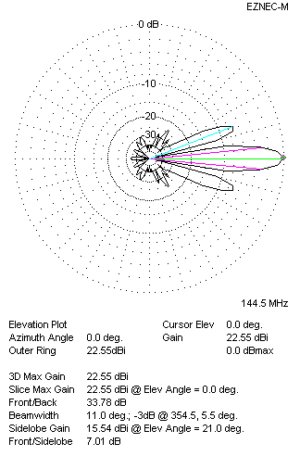
Performances
TYPE | Condition | G  (dBi) | F/B  (dB) | F/Sh  (dBi) | F/Sv (dBi) | Hor  (◦) | Ver  (◦) | Temp (◦K) | G/T (dB) | B (MHz)  for SWR=1.5
4xQY21406XL3D7 | No losss | 22.64 | 34.14 | 7.69 | 6.99 | 11.2 | 11.0 | 215.6 | -0.70 | 142.100 - 146.600
4xQY21406XL3D7 | Aluminum | 22.55 | 33.78 | 7.71 | 7.01 | 11.2 | 11.0 | 217.4 | -0.82 | 142.100 - 146.600

XPOL VERSION

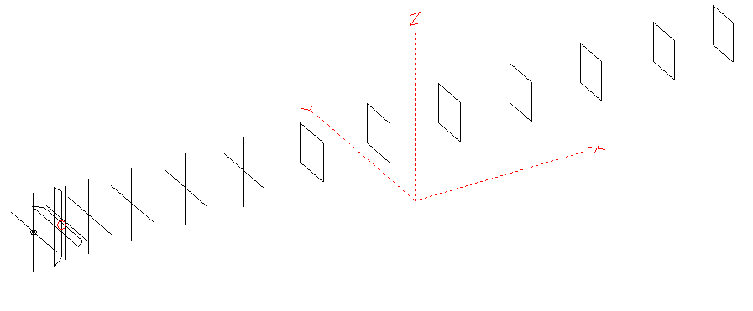
Horizontal components: Same as above
Vertical components: Same as above, except:
- All vertical yagi elements positioned 20 mm backward regarding horizontals.
- All crossed elements must cross each other in their centerlines

HORIZONTAL PERFORMANCES
Everything as the above data

VERTICAL PERFORMANCES with no corrections
Loss included condition (for Aluminum)
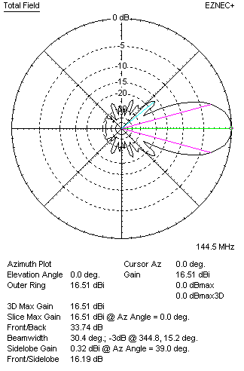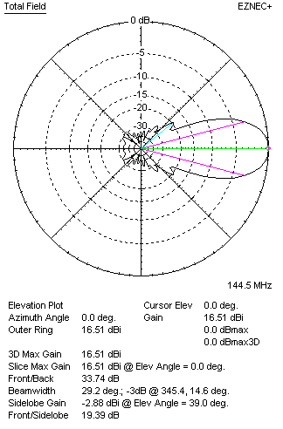
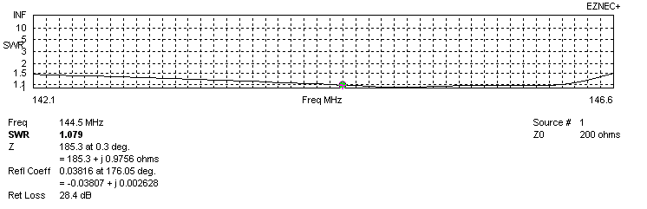
VERTICAL PERFORMANCES after corrections, loss included condition
If you want to get better SWR diagram for vertical antenna you can do the following:
- Change length of DE2 from 864 to 870 mm
- Change length of D3 from 930 to 928 mm
- Change length of D4 from 910 to 908 mm

In this case the SWR diagram will be like this:
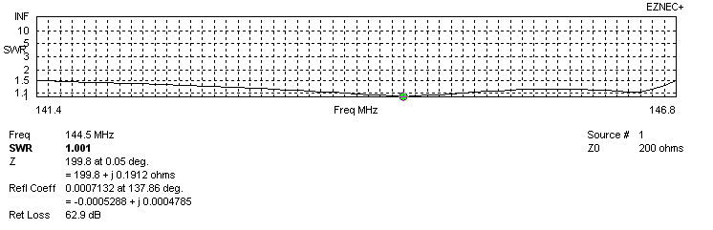
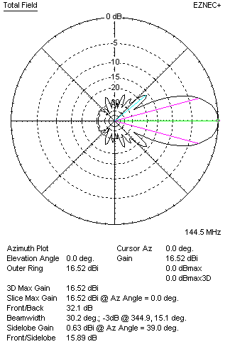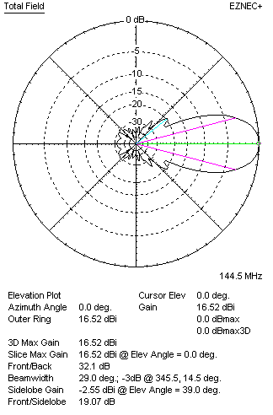

PERFORMANCES
 | TYPE | Condition | G  (dBi) | F/B  (dB) | F/Sh  (dBi) | F/Sv (dBi) | Hor  (◦) | Ver  (◦) | Temp (◦K) | G/T (dB) | B (MHz)  for SWR=1.5
 | Horizontal  part | No losss | 16.52 | 33.99 | 20.46 | 17.73 | 29.8 | 31.0 | 218.4 | -6.87 | 142.100 - 146.600
 | Horizontal  part | Aluminum | 16.43 | 33.59 | 20.46 | 17.74 | 29.8 | 30.8 | 220.2 | -7.00 | 142.100 - 146.600
 | Vertical  part | No losss | 16.61 | 32.37 | 15.88 | 19.06 | 30.4 | 29.2 | 220.9 | -6.83 | 141.400 – 146.800
 | Vertical  part | Aluminum | 16.52 | 32.10 | 15.89 | 19.07 | 30.0 | 29.0 | 222.6 | -6.96 | 141.400 – 146.800

