ANTENNA Y21405XL2D7
Good stacking characteristics at big vertical and horizontal distances
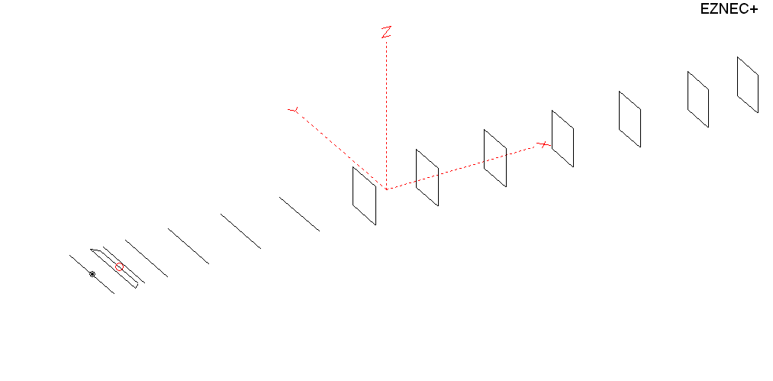
PERFORMANCES: (No loss condition)
TYPE | ELE | L (mm) | G (dBi) | F/B (dB) | F/Sh (dBi) | F/Sv (dBi) | Hor (◦) | Ver (◦) | Temp (◦K) | G/T (dB) | ΔF * (kHz)
QY21405XL2D7 | 14 | 8765 | 16.60 | 38.02 | 21.21 | 18.26 | 29.6 | 30.8 | 215.1 | -6.73 | 3550
* ΔF given for SWR=1.5

PERFORMANCES: (Loss included)
Element material | G (dBi) | Temp (◦K) | G/T (dB)
Aluminum rods | 16.48 | 217.5 | -6.89

DIMENSIONS:
 | Ref | De1 | De2 | D1 | D2 | D3 | D4 | D5 | DQ1 | DQ2 | DQ3 | DQ4 | DQ5 | DQ6 | DQ7 | REMARKS :  All elements made of Al rods Ǿ5mm  The height of the rectangle is 500mm  All dimensions given in milimetres
Pos | 0 | 270 | 370 | 421 | 707 | 1252 | 1933 | 2685 | 3535 | 4385 | 5283 | 6188 | 7085 | 8016 | 8765
Length | 1018 | 1018 | 850 | 942 | 960 | 936 | 920 | 900 | 522 | 498 | 492 | 486 | 476 | 470 | 456
Building hints: No boom correction included.

COMPARISON
Antenna | Boomlength (mm) | Material | Gain (dBi) | TA (◦K) | G/T (dB) | Bandwidth  (MHz)
QY21406XL2D7 | 8765 | No loss | 16.60 | 215.1 | -6.73 | 142.700- 146.250
QY21406XL2D7 | 8765 | Aluminum | 16.48 | 217.5 | -6.89 | 142.700- 146.250
G0KSC 14ELJJD | 8817 | No loss | 16.55 | 220.7 | -6.89 | 142.350- 145.270
G0KSC 14ELJJD | 8817 | Aluminum | 16.48 | 222.1 | -6.98 | 142.350- 145.270
EF0214-5 | 9100 | No loss | 16.81 | 220.7 | -6.63 | 143.720-144.620
EF0214-5 | 9100 | Aluminum | 16.67 | 223.3 | -6.82 | 143.720-144.620

DIAGRAMS (no loss included)
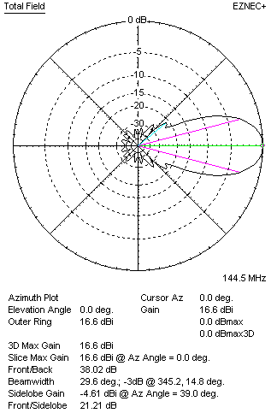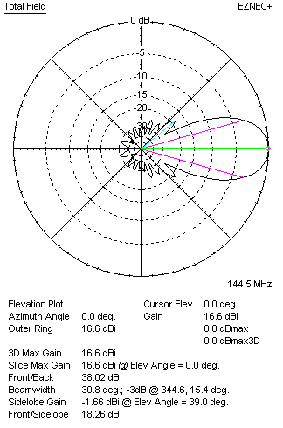
DIAGRAMS (loss included)
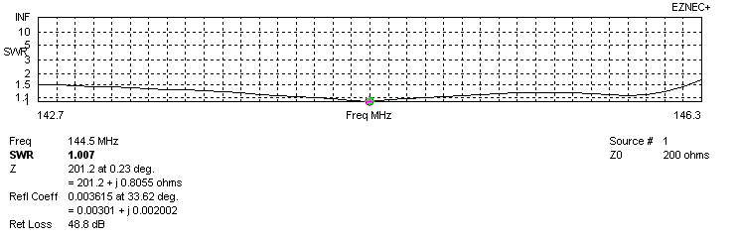
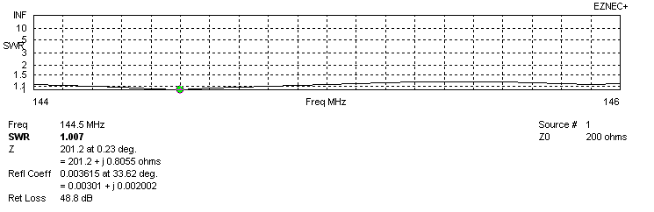
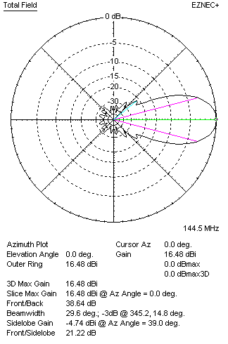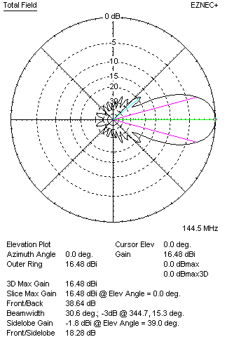
STACKING

QY21405XL2D7 – STACKING TABLE
(including loss for aluminum – AGT = -0.13 dB)
VERTICAL  DISTANCE (cm) | G  (dB) | TA  (°K) | G/T  (dB) | HORIZONTAL  DISTANCE (cm) | G  (dB) | TA  (°K) | G/T  (dB)
100 | 16.86 | 235.6 | -6.86 | 100
110 | 17.17 | 227.9 | -6.41 | 110
120 | 17.39 | 223.7 | -6.11 | 120 | 16.58 | 245.1 | -7.31
130 | 17.55 | 221.3 | -5.90 | 130 | 17.11 | 237.6 | -6.65
140 | 17.68 | 219.2 | -5.73 | 140 | 17.41 | 232.0 | -6.24
150 | 17.79 | 217.0 | -5.57 | 150 | 17.61 | 228.3 | -5.98
160 | 17.90 | 215.2 | -5.43 | 160 | 17.76 | 226.0 | -5.78
170 | 17.99 | 214.3 | -5.32 | 170 | 17.88 | 224.6 | -5.63
180 | 18.08 | 214.0 | -5.22 | 180 | 17.98 | 223.7 | -5.52
190 | 18.16 | 213.9 | -5.14 | 190 | 18.07 | 223.1 | -5.41
200 | 18.24 | 214.1 | -5.07 | 200 | 18.15 | 222.6 | -5.33
210 | 18.31 | 214.8 | -5.01 | 210 | 18.23 | 222.3 | -5.24
220 | 18.38 | 215.7 | -4.96 | 220 | 18.30 | 221.9 | -5.16
230 | 18.44 | 217.0 | -4.92 | 230 | 18.37 | 221.5 | -5.08
240 | 18.51 | 218.3 | -4.88 | 240 | 18.44 | 221.1 | -5.01
250 | 18.57 | 219.6 | -4.85 | 250 | 18.51 | 220.6 | -4.93
260 | 18.63 | 220.6 | -4.81 | 260 | 18.58 | 219.9 | -4.84
270 | 18.69 | 221.1 | -4.76 | 270 | 18.64 | 219.3 | -4.77
280 | 18.75 | 221.2 | -4.70 | 280 | 18.71 | 218.6 | -4.69
290 | 18.81 | 220.9 | -4.63 | 290 | 18.78 | 217.8 | -4.60
300 | 18.88 | 220.3 | -4.55 | 300 | 18.84 | 217.1 | -4.53
310 | 18.95 | 219.5 | -4.46 | 310 | 18.91 | 216.5 | -4.45
320 | 19.01 | 218.7 | -4.39 | 320 | 18.97 | 216.0 | -4.37
330 | 19.08 | 217.9 | -4.30 | 330 | 19.03 | 215.5 | -4.30
340 | 19.14 | 217.3 | -4.23 | 340 | 19.09 | 215.2 | -4.24
350 | 19.19 | 216.9 | -4.17 | 350 | 19.15 | 214.9 | -4.17
360 | 19.25 | 216.7 | -4.11 | 360 | 19.20 | 214.8 | -4.12
370 | 19.29 | 216.6 | -4.07 | 370 | 19.24 | 214.7 | -4.08
380 | 19.33 | 216.5 | -4.02 | 380 | 19.29 | 214.8 | -4.03
390 | 19.37 | 216.6 | -3.99 | 390 | 19.33 | 214.9 | -3.99
400 | 19.40 | 216.6 | -3.96 | 400 | 19.36 | 215.1 | -3.97
410 | 19.43 | 216.6 | -3.93 | 410 | 19.39 | 215.3 | -3.94
420 | 19.45 | 216.6 | -3.91 | 420 | 19.42 | 215.5 | -3.91
430 | 19.47 | 216.4 | -3.88 | 430 | 19.44 | 215.7 | -3.90
440 | 19.49 | 216.2 | -3.86 | 440 | 19.46 | 215.9 | -3.88
450 | 19.51 | 216.0 | -3.83 | 450 | 19.48 | 216.1 | -3.87
460 | 19.52 | 215.7 | -3.83 | 460 | 19.49 | 216.3 | -3.86
470 | 19.53 | 215.3 | -3.80 |  | 19.49 | 216.3 | -3.86
480 | 19.54 | 215.0 | -3.78 |  | 19.51 | 216.6 | -3.85
480 | 19.55 | 214.6 | -3.77 |  | 19.52 | 216.7 | -3.84
500 | 19.56 | 214.4 | -3.75 |  | 19.53 | 216.8 | -3.83
 |  |  |  |  | 19.53 | 217.0 | -3.83
Remark: brown colour letters show not consistent data!

TWO ANTENNAS VERTICALLY STACKED AT 500CM
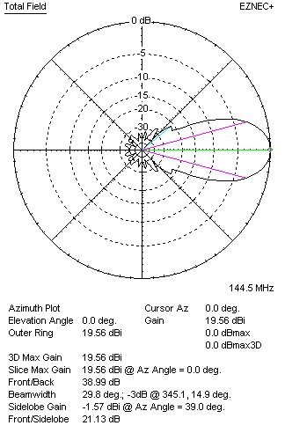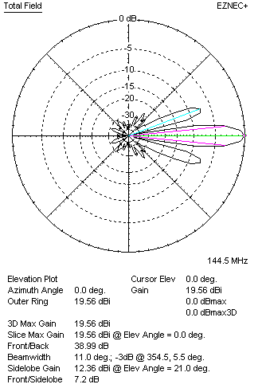

Performances
TYPE | Condition | G  (dBi) | F/B  (dB) | F/Sh  (dBi) | F/Sv (dBi) | Hor  (◦) | Ver  (◦) | Temp (◦K) | G/T (dB) | B (MHz)  for SWR=1.5
2xQY21305XL2D7 | No losss | 19.68 | 38.34 | 21.11 | 7.17 | 29.8 | 11.6 | 211.9 | -3.58 | 142.700- 146.250
2xQY21305XL2D7 | Aluminum | 19.56 | 38.99 | 21.13 | 7.20 | 29.8 | 11.0 | 214.4 | -3.75 | 142.700- 146.250

FOUR ANTENNAS VERTICALLY STACKED AT 500+500+500 CM
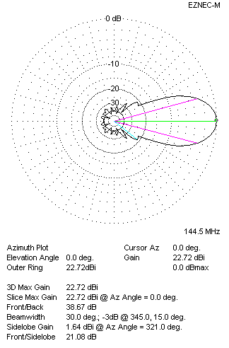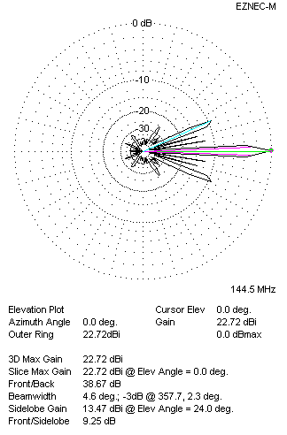
Performances
TYPE | Condition | G  (dBi) | F/B  (dB) | F/Sh  (dBi) | F/Sv (dBi) | Hor  (◦) | Ver  (◦) | Temp (◦K) | G/T (dB) | B (MHz)  for SWR=1.5
4xQY21305XL2D7 | No losss | 22.72 | 38.67 | 21.08 | 9.25 | 30.0 | 4.6 | 210.4 | -0.51 | 142.700- 146.250
4xQY21305XL2D7 | Aluminum | 22.60 | 39.38 | 21.10 | 9.29 | 30.0 | 4.6 | 213.0 | -0.68 | 142.700- 146.250

FOUR ANTENNAS IN H- STACK, H=500 CM, V=500 CM
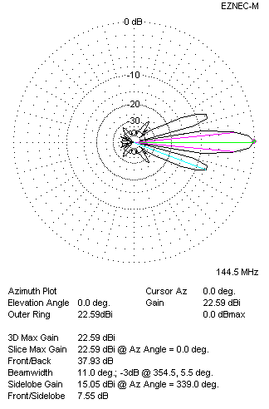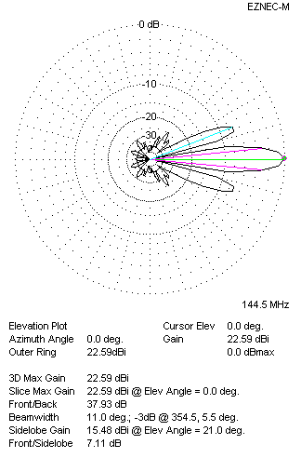
Performances
TYPE | Condition | G  (dBi) | F/B  (dB) | F/Sh  (dBi) | F/Sv (dBi) | Hor  (◦) | Ver  (◦) | Temp (◦K) | G/T (dB) | B (MHz)  for SWR=1.5
4xQY21305XL2D7 | No losss | 22.71 | 37.40 | 7.52 | 7.08 | 11.0 | 11.0 | 212.4 | -0.56 | 142.700- 146.250
4xQY21305XL2D7 | Aluminum | 22.59 | 37.93 | 7.55 | 7.11 | 11.0 | 11.0 | 214.8 | -0.73 | 142.700- 146.250

XPOL VERSION

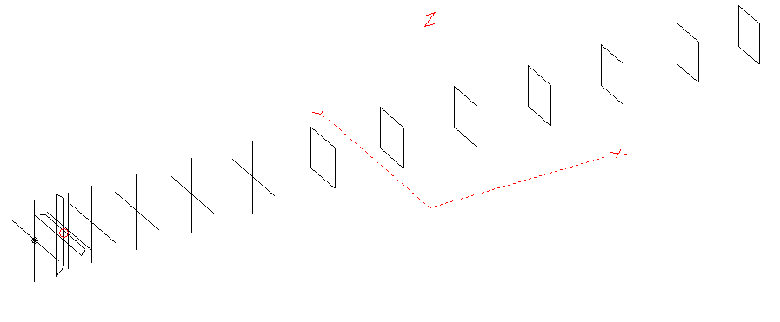
Horizontal components: Same as above
Vertical components: Same as above, except:
- All vertical yagi elements positioned 20 mm backward regarding horizontals.
- All crossed elements must cross each other in their centerlines

HORIZONTAL PERFORMANCES
Everything as the above data

VERTICAL PERFORMANCES with no corrections
Loss included condition (for Aluminum)
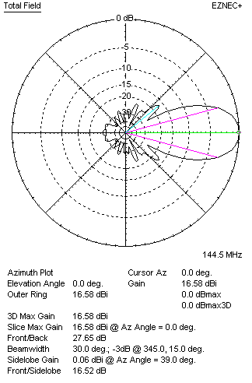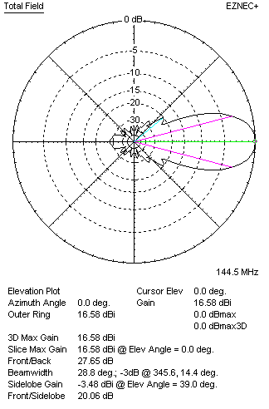
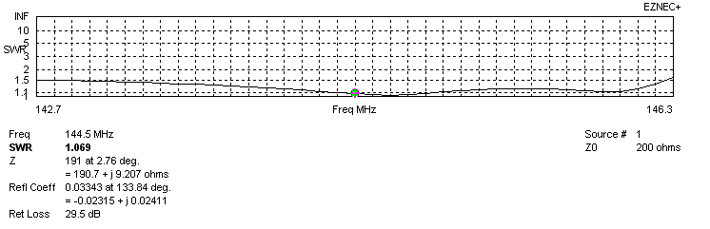
VERTICAL PERFORMANCES after corrections, loss included condition
If you want to get better SWR diagram for vertical antenna you can do the following:
- Change length of DE2 from 850 to 896 mm
- Change length of D2 from 960 to 958 mm
- Change length of D3 from 936 to 934 mm
- Change position of D1 for -2 mm.

In this case the SWR diagram will be like this:
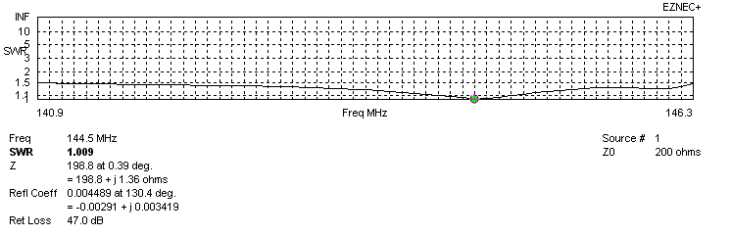
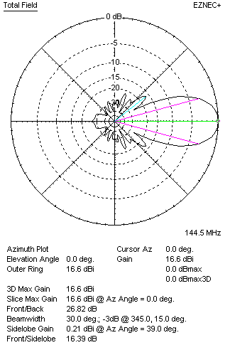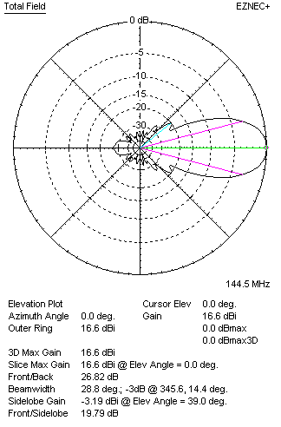

PERFORMANCES
 | TYPE | Condition | G  (dBi) | F/B  (dB) | F/Sh  (dBi) | F/Sv (dBi) | Hor  (◦) | Ver  (◦) | Temp (◦K) | G/T (dB) | B (MHz)  for SWR=1.5
 | Horizontal  part | No losss | 16.60 | 38.02 | 21.21 | 18.26 | 29.6 | 30.8 | 215.1 | -6.73 | 142.700- 146.250
 | Horizontal  part | Aluminum | 16.48 | 38.64 | 21.22 | 18.28 | 29.6 | 30.6 | 217.5 | -6.89 | 142.700- 146.250
 | Vertical  part | No losss | 16.72 | 26.65 | 16.37 | 19.77 | 30.0 | 28.8 | 218.1 | -6.67 | 140.900 – 146.300
 | Vertical  part | Aluminum | 16.60 | 26.82 | 16.39 | 19.79 | 30.0 | 28.8 | 220.3 | -6.83 | 140.900 – 146.300

