ANTENNA QY21310XL4D6
Good stacking characteristics at big vertical and horizontal distances
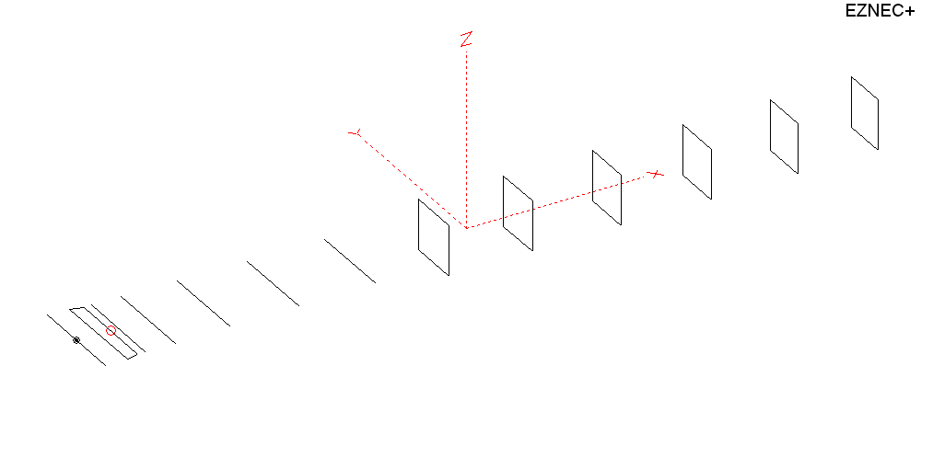
PERFORMANCES: (No loss condition)
TYPE | ELE | L (mm) | G (dBi) | F/B (dB) | F/Sh (dBi) | F/Sv (dBi) | Hor (◦) | Ver (◦) | Temp (◦K) | G/T (dB) | ΔF * (kHz)
QY21310XL4D6 | 13 | 7775 | 16.28 | 39.07 | 19.17 | 17.59 | 30.2 | 31.2 | 220.8 | -7.16 | 3000
* ΔF given for SWR=1,5

PERFORMANCES: (Loss included)
Element material | G (dBi) | Temp (◦K) | G/T (dB)
Aluminum rods | 16.20 | 222.2 | -7.27

DIMENSIONS:
 | Ref | De1 | De2 | D1 | D2 | D3 | D4 | D5 | DQ1 | DQ2 | DQ3 | DQ4 | DQ5 | DQ6 | REMARKS :  - All elements made of Al rods Ǿ10 mm  - The height of the rectangle is 500 mm  - All dimensions given in milimetres
Pos | 0 | 215 | 335 | 415 | 709 | 1258 | 1939 | 2705 | 3525 | 4358 | 5239 | 6138 | 6999 | 7775
Length | 1010 | 990 | 910 | 940 | 946 | 918 | 898 | 878 | 524 | 502 | 498 | 486 | 478 | 466
Building hints: No boom correction included.

COMPARISON
Antenna | Boomlength (mm) | Material | Gain (dBi) | TA (◦K) | G/T (dB) | Bandwidth  (MHz)
QY21310XL4D6 | 7775 | No loss | 16.28 | 220.8 | -7.16 | 143.250- 146.250
QY21310XL4D6 | 7775 | Aluminum | 16.20 | 222.2 | -7.27 | 143.250- 146.250
G0KSC  13ELKKB | 7855 | No loss | 16.13 | 219.4 | -7.28 | 142.650-145.370
G0KSC  13ELKKB | 7855 | Aluminum | 16.03 | 221.1 | -7.42 | 142.650-145.370
EF0213-5 | 8150 | No loss | 16.40 | 224.8 | -7.12 | 143.660-144.620
EF0213-5 | 8150 | Aluminum | 16.25 | 227.6 | -7.32 | 143.660-144.620

DIAGRAMS (no loss included)
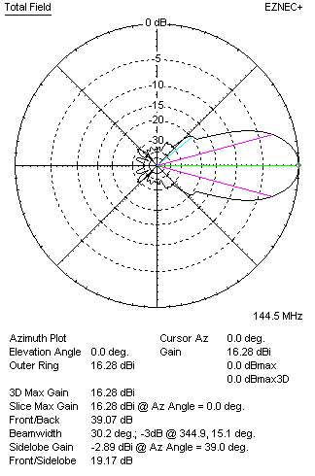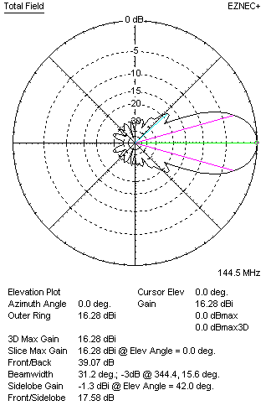
DIAGRAMS (losses included)
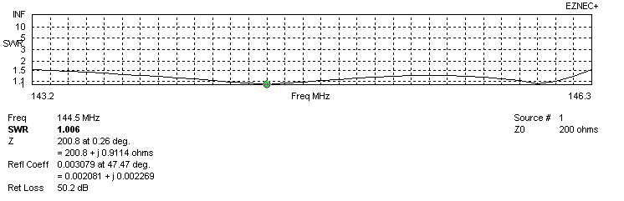
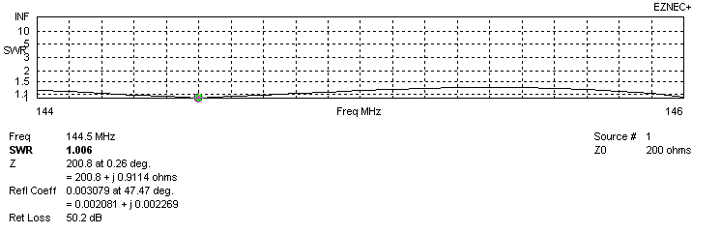
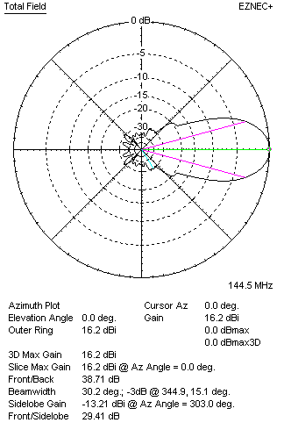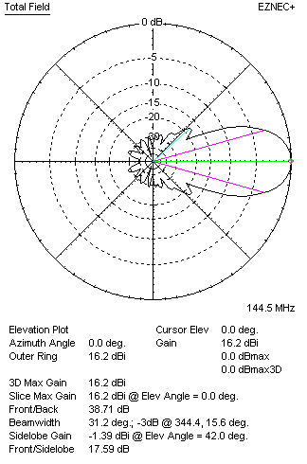
STACKING

QY21310XL4D6
(including loss for aluminum – AGT = -0.08 dB)
VERTICAL  DISTANCE (cm) | G  (dB) | TA  (°K) | G/T  (dB) | HORIZONTAL  DISTANCE (cm) | G  (dB) | TA  (°K) | G/T  (dB)
100 | 16.37 | 240.5 | -7.44 | 100
110 | 16.70 | 231.9 | -6.95 | 110
120 | 16.94 | 226.8 | -6.62 | 120 | 16.20 | 249.6 | -7.77
130 | 17.13 | 223.6 | -6.37 | 130 | 16.71 | 241.8 | -7.12
140 | 17.29 | 220.9 | -6.15 | 140 | 17.01 | 238.3 | -6.74
150 | 17.44 | 218.0 | -5.94 | 150 | 17.22 | 234.0 | -6.47
160 | 17.57 | 215.6 | -5.77 | 160 | 17.39 | 231.6 | -6.26
170 | 17.68 | 214.5 | -5.63 | 170 | 17.53 | 230.0 | -6.09
180 | 17.79 | 214.4 | -5.52 | 180 | 17.66 | 228.7 | -5.93
190 | 17.88 | 215.0 | -5.44 | 190 | 17.77 | 227.8 | -5.80
200 | 17.97 | 216.1 | -5.38 | 200 | 17.87 | 227.0 | -5.69
210 | 18.05 | 217.7 | -5.33 | 210 | 17.96 | 226.4 | -5.59
220 | 18.12 | 219.6 | -5.30 | 220 | 18.05 | 225.8 | -5.49
230 | 18.19 | 221.6 | -5.27 | 230 | 18.13 | 225.2 | -5.40
240 | 18.26 | 223.5 | -5.23 | 240 | 18.21 | 224.6 | -5.30
250 | 18.33 | 224.9 | -5.19 | 250 | 18.28 | 224.0 | -5.22
260 | 18.40 | 225.8 | -5.14 | 260 | 18.36 | 223.4 | -5.13
270 | 18.47 | 226.0 | -5.07 | 270 | 18.43 | 222.6 | -5.05
280 | 18.54 | 225.7 | -4.99 | 280 | 18.50 | 222.0 | -4.96
290 | 18.62 | 225.0 | -4.90 | 290 | 18.57 | 221.3 | -4.88
300 | 18.69 | 224.2 | -4.82 | 300 | 18.64 | 220.6 | -4.80
310 | 18.76 | 223.3 | -4.73 | 310 | 18.71 | 220.1 | -4.72
320 | 18.83 | 222.5 | -4.64 | 320 | 18.77 | 219.6 | -4.65
330 | 18.89 | 221.9 | -4.57 | 330 | 18.83 | 219.3 | -4.58
340 | 18.95 | 221.5 | 4.50 | 340 | 18.89 | 219.0 | -4.51
350 | 19.00 | 221.3 | -4.45 | 350 | 18.94 | 218.9 | -4.46
360 | 19.05 | 221.2 | -4.40 | 360 | 18.99 | 218.9 | -4.41
370 | 19.09 | 221.2 | -4.36 | 370 | 19.03 | 218.9 | -4.37
380 | 19.12 | 221.2 | -4.33 | 380 | 19.07 | 219.1 | -4.34
390 | 19.16 | 221.2 | -4.29 | 390 | 19.10 | 219.3 | -4.31
400 | 19.18 | 221.1 | -4.27 | 400 | 19.13 | 219.6 | -4.29
410 | 19.21 | 221.0 | -4.23 | 410 | 19.15 | 219.9 | -4.27
420 | 19.22 | 220.9 | -4.22 | 420 | 19.17 | 220.2 | -4.26
430 | 19.24 | 220.8 | -4.20 | 430 | 19.19 | 220.5 | -4.24
440 | 19.25 | 220.6 | -4.19 | 440 | 19.20 | 220.8 | -4.24
450 | 19.26 | 220.4 | -4.17 | 450 | 19.22 | 221.0 | -4.22
460 | 19.27 | 220.2 | 4.16 | 460 | 19.23 | 221.3 | -4.22
470 | 19.27 | 220.0 | -4.15 | 470 | 19.24 | 221.5 | -4.21
480 | 19.27 | 219.7 | -4.15 | 480 | 19.24 | 221.7 | -4.22
Remark: brown colour letters show not consistent data!

TWO ANTENNAS VERTICALLY STACKED AT 480CM
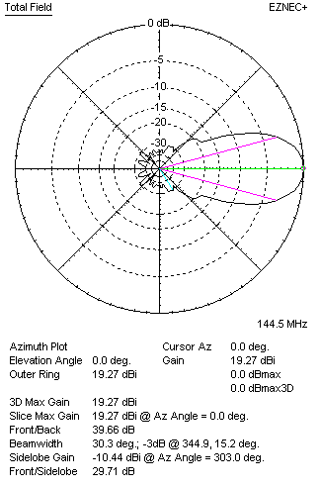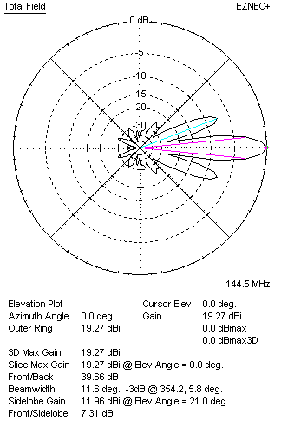

Performances
TYPE | Condition | G  (dBi) | F/B  (dB) | F/Sh  (dBi) | F/Sv (dBi) | Hor  (◦) | Ver  (◦) | Temp (◦K) | G/T (dB) | B (MHz)  for SWR=1.5
2xQY21310XL4D6 | No losss | 19.35 | 40.12 | 20.24 | 7.30 | 30.4 | 11.6 | 218.3 | -4.04 | 143.250- 146.250
2xQY21310XL4D6 | Aluminum | 19.27 | 39.66 | 20.26 | 7.31 | 30.3 | 11.6 | 219.7 | -4.15 | 143.250- 146.250

FOUR ANTENNAS VERTICALLY STACKED AT 480+480+480 CM
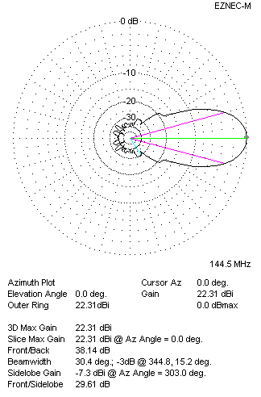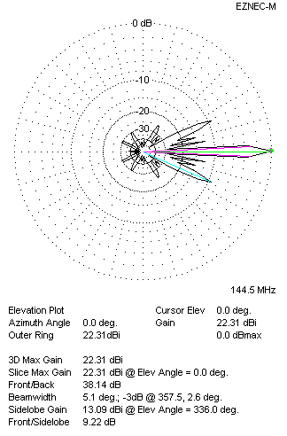
Performances
TYPE | Condition | G  (dBi) | F/B  (dB) | F/Sh  (dBi) | F/Sv (dBi) | Hor  (◦) | Ver  (◦) | Temp (◦K) | G/T (dB) | B (MHz)  for SWR=1.5
4xQY21310XL4D6 | No losss | 22.39 | 38.50 | 20.24 | 9.2 | 30.4 | 5.1 | 216.3 | -0.96 | 143.250- 146.250
4xQY21310XL4D6 | Aluminum | 22.31 | 38.14 | 20.25 | 9.22 | 30.4 | 5.1 | 217.6 | -1.07 | 143.250- 146.250

FOUR ANTENNAS IN H- STACK, H=440 CM, V=480 CM
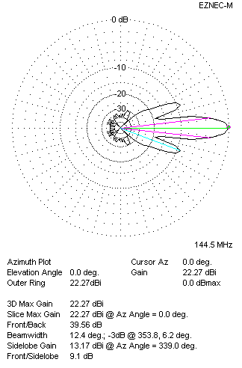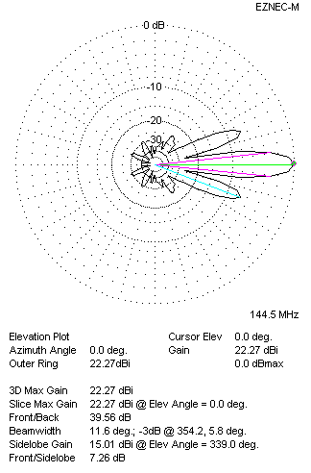
Performances
TYPE | Condition | G  (dBi) | F/B  (dB) | F/Sh  (dBi) | F/Sv (dBi) | Hor  (◦) | Ver  (◦) | Temp (◦K) | G/T (dB) | B (MHz)  for SWR=1.5
4xQY21310XL4D6 | No losss | 22.35 | 40.08 | 9.09 | 7.25 | 12.4 | 11.6 | 218.6 | -1.05 | 143.250- 146.250
4xQY21310XL4D6 | Aluminum | 22.27 | 39.56 | 9.10 | 7.26 | 12.4 | 11.6 | 220.0 | -1.15 | 143.250- 146.250

XPOL VERSION

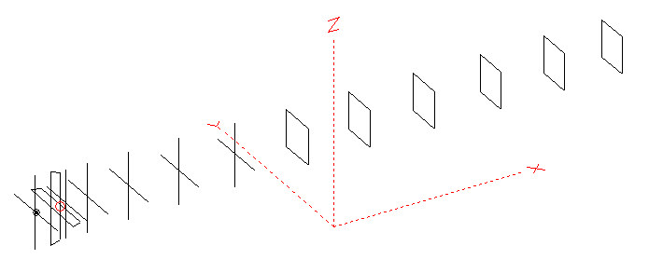
Horizontal components: Same as above
Vertical components: Same as above, except:
- All vertical yagi elements positioned 20 mm backward regarding horizontals.
- All crossed elements must cross each other in their centerlines

HORIZONTAL PERFORMANCES
Everything as the above data

VERTICAL PERFORMANCES with no corrections
Loss included condition (for Aluminum)
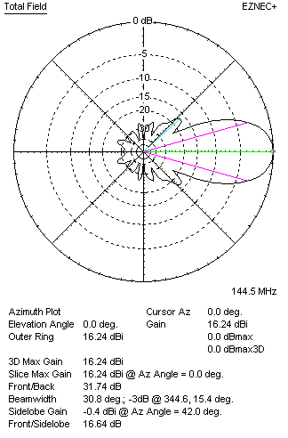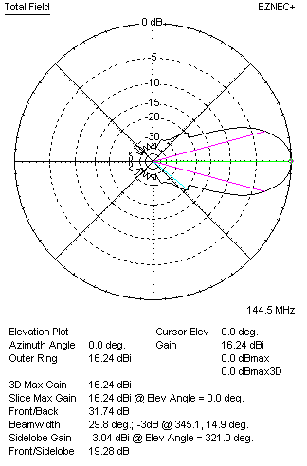
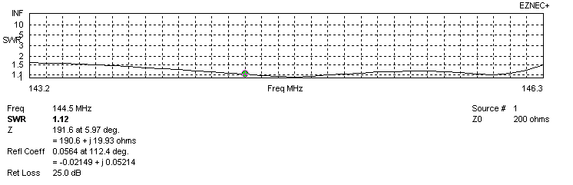
VERTICAL PERFORMANCES after corrections, loss included condition
If you want to get better SWR diagram for vertical antenna you can do the following:
- Change length of DE1 from 990 to 1010 mm
- Change length of DE2 from 910 to 850 mm
- Change length of D3 from 918 to 920 mm
- Change length of D3 from 898 to 896 mm
- Change position od D1 for +3 mm.
- Change position od D2 for +10 mm.

In this case the SWR diagram will be like this:
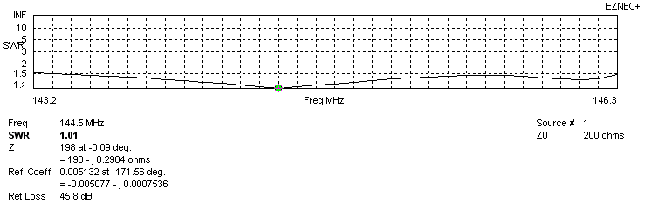
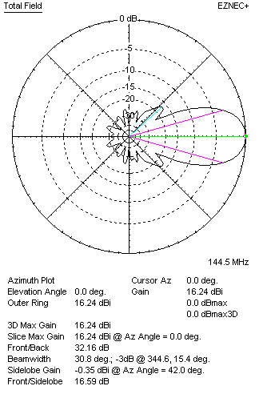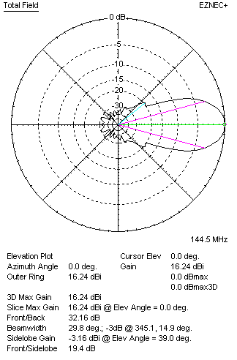

PERFORMANCES: (No loss condition)
 | TYPE | Condition | G  (dBi) | F/B  (dB) | F/Sh  (dBi) | F/Sv (dBi) | Hor  (◦) | Ver  (◦) | Temp (◦K) | G/T (dB) | B (MHz)  for SWR=1.5
 | Horizontal  part | No losss | 16.28 | 39.07 | 19.17 | 17.59 | 30.2 | 31.2 | 220.8 | -7.16 | 143.250- 146.250
 | Horizontal  part | Aluminum | 16.20 | 38.71 | 19.14 | 17.59 | 30.2 | 31.2 | 222.2 | -7.27 | 143.250- 146.250
 | Vertical  part | No losss | 16.32 | 31.90 | 16.57 | 19.41 | 30.8 | 29.8 | 222.4 | -7.15 | 143.300 – 146.300
 | Vertical  part | Aluminum | 16.24 | 32.16 | 16.59 | 19.40 | 30.8 | 29.8 | 223.8 | -7.26 | 143.300 – 146.300

