ANTENNA QY21305XL3D6
Good stacking characteristics at big vertical and horizontal distances
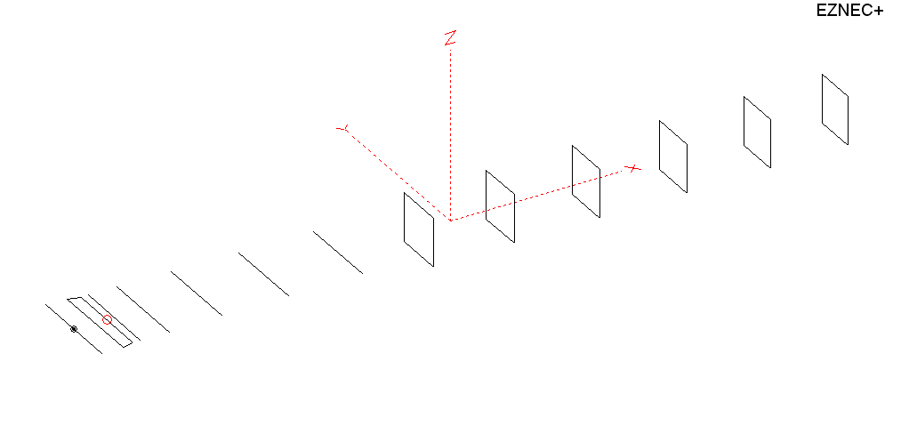
PERFORMANCES: (No loss condition)
TYPE | ELE | L (mm) | G (dBi) | F/B (dB) | F/Sh (dBi) | F/Sv (dBi) | Hor (◦) | Ver (◦) | Temp (◦K) | G/T (dB) | ΔF * (kHz)
QY21305XL3D6 | 13 | 7805 | 16.22 | 34.89 | 20.29 | 18.42 | 30.6 | 32.0 | 217.4 | -7.15 | 3430
* ΔF given for SWR=1.5

PERFORMANCES: (Losses included)
Element material | G (dBi) | Temp (◦K) | G/T (dB)
Aluminum rods | 16.10 | 219.7 | -7.32

DIMENSIONS:
 | Ref | De1 | De2 | D1 | D2 | D3 | D4 | D5 | DQ1 | DQ2 | DQ3 | DQ4 | DQ5 | DQ6 | REMARKS :  - All elements made of Al rods Ǿ5 mm  - The height of the rectangle is 500 mm  - All dimensions given in milimetres
Pos | 0 | 265 | 355 | 421 | 707 | 1252 | 1930 | 2685 | 3525 | 4375 | 5263 | 6168 | 7035 | 7805
Length | 1018 | 1018 | 810 | 944 | 960 | 932 | 920 | 900 | 522 | 498 | 492 | 486 | 476 | 464
Building hints: No boom correction included.

COMPARISON
Antenna | Boomlength (mm) | Material | Gain (dBi) | TA (◦K) | G/T (dB) | Bandwidth  (MHz)
QY21305XL3D6 | 7805 | No loss | 16.22 | 217.4 | -7.15 | 142.900- 146.330
QY21305XL3D6 | 7805 | Aluminum | 16.10 | 219.7 | -7.32 | 142.900- 146.330
G0KSC  13ELKKB | 7855 | No loss | 16.09 | 220.1 | -7.34 | 142.800- 145.400
G0KSC  13ELKKB | 7855 | Aluminum | 15.99 | 221.9 | -7.47 | 142.800- 145.400
EF0213-5 | 8150 | No loss | 16.35 | 221.5 | -7.10 | 143.720-144.620
EF0213-5 | 8150 | Aluminum | 15.99 | 224.0 | -7.28 | 143.720-144.620
EF0213-5M | 7940 | No loss | 16.12 | 223.9 | -7.38 | 140.500-146.000
EF0213-5M | 7940 | Aluminum | 16.00 | 226.2 | -7.54 | 140.500-146.000

DIAGRAMS (no loss included)
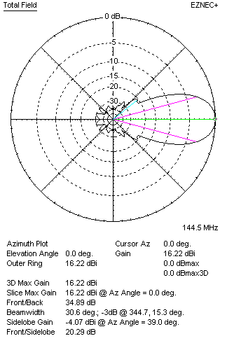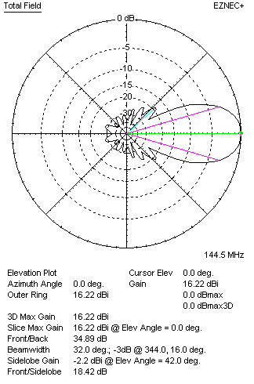
DIAGRAMS (loss included)
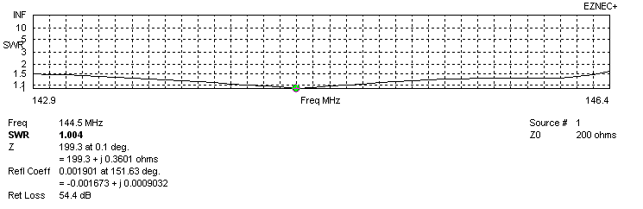
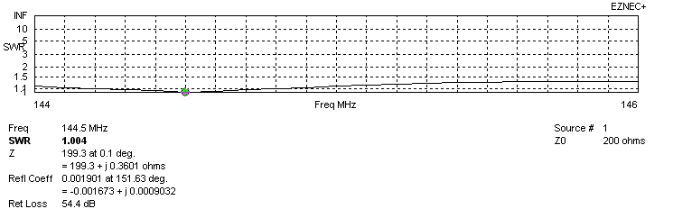
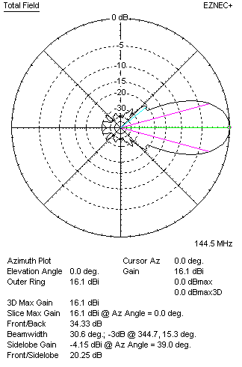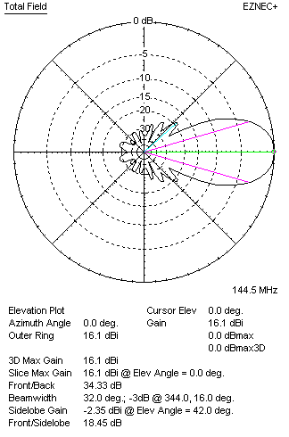

STACKING

QY21305XL4D6 STACKING TABLE
(including loss for aluminum – AGT = -0.12 dB)
VERTICAL  DISTANCE (cm) | G  (dB) | TA  (°K) | G/T  (dB) | HORIZONTAL  DISTANCE (cm) | G  (dB) | TA  (°K) | G/T  (dB)
100 | 16.59 | 234.8 | -7.12 | 100
110 | 16.86 | 227.5 | -6.71 | 110
120 | 17.06 | 223.4 | -6.43 | 120 | 16.31 | 249.3 | -7.66
130 | 17.21 | 221.0 | -6.23 | 130 | 16.78 | 241.0 | -7.04
140 | 17.34 | 218.9 | -6.06 | 140 | 17.06 | 235.2 | -6.65
150 | 17.46 | 217.0 | -5.90 | 150 | 17.26 | 231.4 | -6.38
160 | 17.56 | 215.9 | -5.78 | 160 | 17.41 | 228.9 | -6.19
170 | 17.65 | 215.7 | -5.69 | 170 | 17.53 | 227.2 | -6.03
180 | 17.74 | 215.9 | -5.60 | 180 | 17.64 | 226.1 | -5.90
190 | 17.82 | 216.3 | -5.53 | 190 | 17.73 | 225.2 | -5.80
200 | 17.90 | 216.9 | -5.46 | 200 | 17.82 | 224.5 | -5.69
210 | 17.98 | 217.9 | -5.40 | 210 | 17.90 | 223.9 | -5.60
220 | 18.05 | 219.1 | -5.36 | 220 | 17.98 | 223.3 | -5.51
230 | 18.12 | 220.5 | -5.31 | 230 | 18.05 | 222.7 | -5.43
240 | 18.19 | 221.7 | -5.27 | 240 | 18.13 | 222.1 | -5.33
250 | 18.25 | 222.6 | -5.23 | 250 | 18.20 | 221.4 | -5.25
260 | 18.32 | 223.0 | -5.16 | 260 | 18.27 | 220.7 | -5.17
270 | 18.39 | 222.9 | -5.09 | 270 | 18.34 | 220.0 | -5.08
280 | 18.46 | 222.4 | -5.01 | 280 | 18.41 | 219.4 | -5.00
290 | 18.53 | 221.7 | -4.93 | 290 | 18.48 | 218.7 | -4.92
300 | 18.61 | 220.7 | -4.83 | 300 | 18.55 | 218.2 | -4.84
310 | 18.67 | 219.8 | -4.75 | 310 | 18.61 | 217.7 | -4.77
320 | 18.74 | 219.0 | -4.66 | 320 | 18.68 | 217.3 | -4.69
330 | 18.80 | 218.3 | -4.59 | 330 | 18.74 | 217.0 | -4.62
340 | 18.86 | 217.9 | -4.52 | 340 | 18.79 | 216.8 | -4.57
350 | 18.91 | 217.7 | -4.47 | 350 | 18.84 | 216.8 | -4.52
360 | 18.96 | 217.7 | -4.42 | 360 | 18.89 | 216.8 | -4.47
370 | 19.00 | 217.8 | -4.38 | 370 | 18.93 | 216.9 | -4.43
380 | 19.03 | 218.0 | -4.35 | 380 | 18.97 | 217.1 | -4.40
390 | 19.06 | 218.3 | -4.33 | 390 | 19.01 | 217.4 | -4.36
400 | 19.09 | 218.6 | -4.31 | 400 | 19.03 | 217.7 | -4.35
410 | 19.11 | 218.9 | -4.29 | 410 | 19.06 | 218.0 | -4.32
420 | 19.13 | 219.0 | -4.27 | 420 | 19.08 | 218.3 | -4.31
430 | 19.14 | 219.1 | -4.27 | 430 | 19.10 | 218.6 | -4.30
440 | 19.15 | 219.0 | -4.26 | 440 | 19.11 | 218.8 | -4.29
450 | 19.16 | 218.9 | -4.24 | 450 | 19.12 | 219.1 | -4.29
Remark: brown colour letters show not consistent data!

TWO ANTENNAS VERTICALLY STACKED AT 460CM
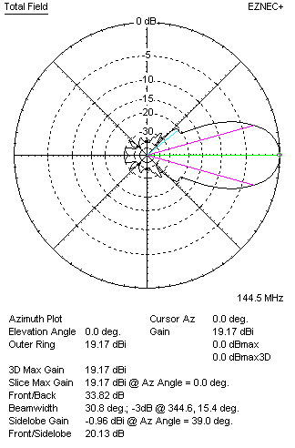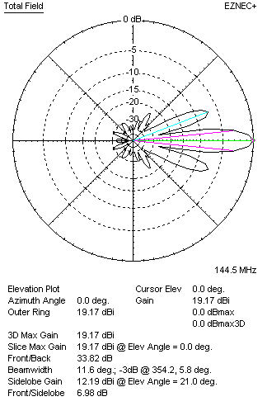

Performances
TYPE | Condition | G  (dBi) | F/B  (dB) | F/Sh  (dBi) | F/Sv (dBi) | Hor  (◦) | Ver  (◦) | Temp (◦K) | G/T (dB) | B (MHz)  for SWR=1.5
2xQY21305XL3D6 | No losss | 19.29 | 34.31 | 20.17 | 6.96 | 31.0 | 11.6 | 216.0 | -4.05 | 142.900- 146.330
2xQY21305XL3D6 | Aluminum | 19.17 | 33.82 | 20.44 | 6.98 | 30.8 | 11.6 | 218.3 | -4.22 | 142.900- 146.330

FOUR ANTENNAS VERTICALLY STACKED AT 440+440+440 CM
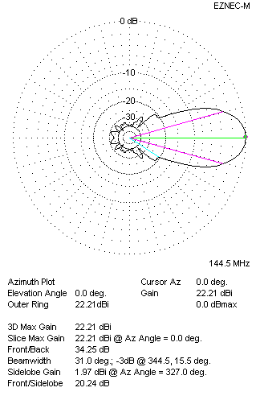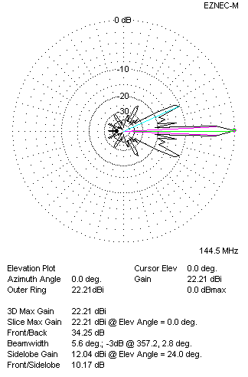
Performances
TYPE | Condition | G  (dBi) | F/B  (dB) | F/Sh  (dBi) | F/Sv (dBi) | Hor  (◦) | Ver  (◦) | Temp (◦K) | G/T (dB) | B (MHz)  for SWR=1.5
4xQY21305XL3D6 | No losss | 22.32 | 34.73 | 20.28 | 10.14 | 31.0 | 5.6 | 216.3 | -1.03 | 142.900- 146.330
4xQY21305XL3D6 | Aluminum | 22.21 | 34.24 | 20.27 | 10.17 | 31.0 | 5.6 | 218.1 | -1.13 | 142.900- 146.330

FOUR ANTENNAS IN H- STACK, H=440 CM, V=440 CM
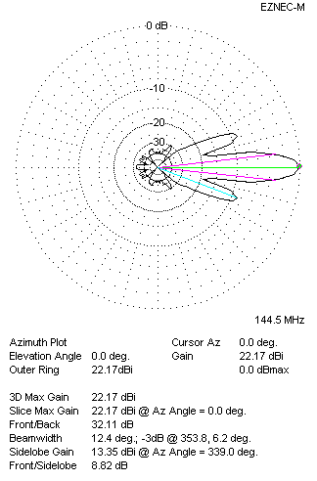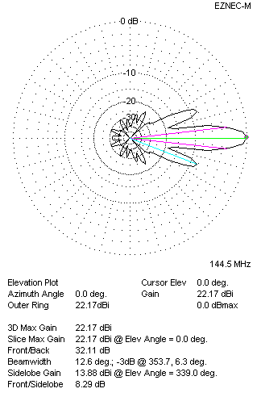
Performances
TYPE | Condition | G  (dBi) | F/B  (dB) | F/Sh  (dBi) | F/Sv (dBi) | Hor  (◦) | Ver  (◦) | Temp (◦K) | G/T (dB) | B (MHz)  for SWR=1.5
4xQY21305XL3D6 | No losss | 22.29 | 32.53 | 8.80 | 8.27 | 12.4 | 12.6 | 217.2 | -1.08 | 142.900- 146.330
4xQY21305XL3D6 | Aluminum | 22.17 | 32.11 | 8.82 | 8.29 | 12.4 | 12.6 | 219.5 | -1.24 | 142.900- 146.330

XPOL VERSION

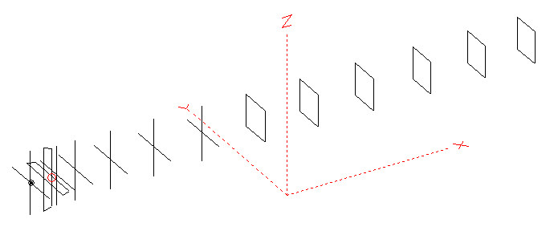
Horizontal components: Same as above
Vertical components: Same as above, except:
- All vertical yagi elements positioned 20 mm backward regarding horizontals.
- All crossed elements must cross each other in their centerlines

HORIZONTAL PERFORMANCES
Everything as the above data

VERTICAL PERFORMANCES with no corrections
Loss included condition (for Aluminum)
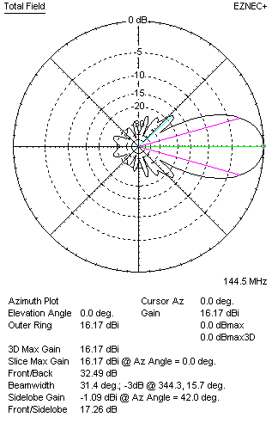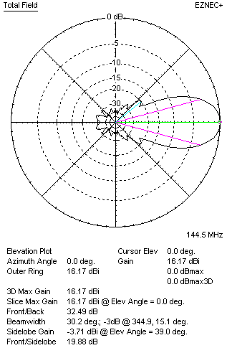
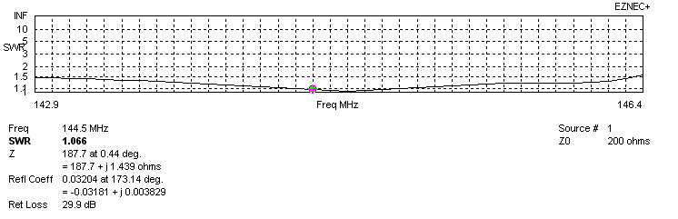
VERTICAL PERFORMANCES after corrections, loss included condition
If you want to get better SWR diagram for vertical antenna you can do the following:
- Change length of DE2 from 810 to 840 mm
- Change position of D1 for -4 mm.

In this case the SWR diagram will be like this:
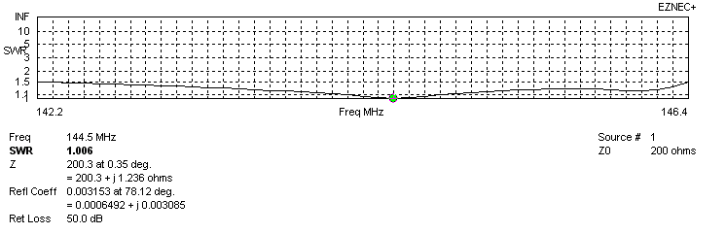
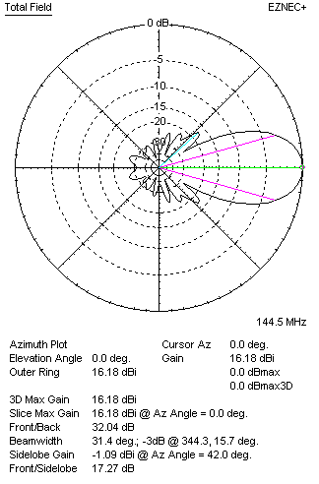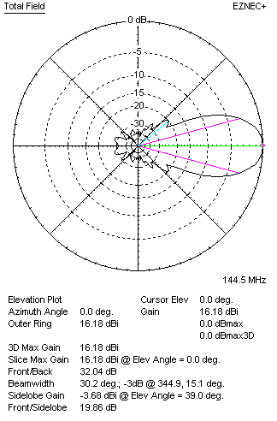

PERFORMANCES
 | TYPE | Condition | G  (dBi) | F/B  (dB) | F/Sh  (dBi) | F/Sv (dBi) | Hor  (◦) | Ver  (◦) | Temp (◦K) | G/T (dB) | B (MHz)  for SWR=1.5
 | Horizontal  part | No losss | 16.22 | 34.89 | 20.29 | 18.42 | 30.6 | 32.0 | 217.4 | -7.15 | 142.900- 146.330
 | Horizontal  part | Aluminum | 16.10 | 34.33 | 20.25 | 18.45 | 30.6 | 32.0 | 219.7 | -7.32 | 142.900- 146.330
 | Vertical  part | No losss | 16.30 | 31.97 | 17.25 | 19.89 | 31.6 | 30.4 | 218.6 | -7.10 | 142.200 – 146.400
 | Vertical  part | Aluminum | 16.18 | 32.04 | 17.27 | 19.86 | 31.4 | 30.2 | 220.9 | -7.26 | 142.200 – 146.400

