ANTENNA QY21210XL4D5
Good stacking characteristics at any vertical and horizontal distances
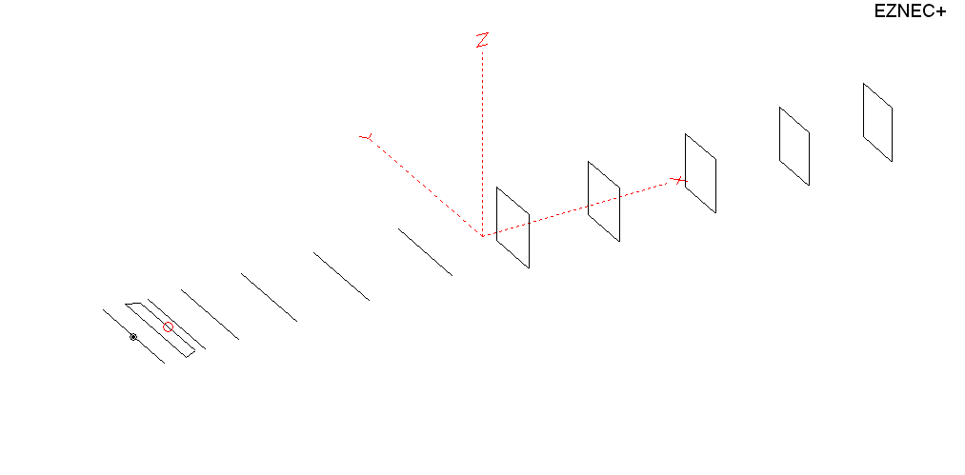
PERFORMANCES: (No loss condition)
TYPE | ELE | L (mm) | G (dBi) | F/B (dB) | F/Sh (dBi) | F/Sv (dBi) | Hor (◦) | Ver (◦) | Temp (◦K) | G/T (dB) | ΔF * (kHz)
QY21120XL4D5 | 12 | 6915 | 15.87 | 31.29 | 27.84 | 18.81 | 31.2 | 32.8 | 222.9 | -7.61 | 2650
* ΔF given for SWR=1,5

PERFORMANCES: (Losses included)
Element material | G (dBi) | Temp (◦K) | G/T (dB)
Aluminum rods | 15.80 | 224.3 | -7.71

DIMENSIONS:
 | Ref | De1 | De2 | D1 | D2 | D3 | D4 | D5 | DQ1 | DQ2 | DQ3 | DQ4 | DQ5 | REMARKS  -All elements made of Al rods Ǿ10 mm  - The height of the rectangle is 500 mm  - All dimensions given in milimetres
Pos | 0 | 200 | 313 | 399 | 709 | 1258 | 1932 | 2715 | 3525 | 4368 | 5269 | 6138 | 6915
Length | 1008 | 988 | 886 | 930 | 944 | 916 | 900 | 876 | 524 | 500 | 492 | 484 | 470
Building hints: No boom correction included.

COMPARISON
Antenna | Boomlength (mm) | Material | Gain (dBi) | TA (◦K) | G/T (dB) | Bandwidth  (MHz)
QY21210XL4D5 | 6915 | No loss | 15.87 | 222.9 | -7.61 | 143.350- 146.000
QY21210XL4D5 | 6915 | Aluminum | 15.80 | 224.3 | -7.71 | 143.350- 146.000
GOKSC  12ELKKA | 6906 | No loss | 15.69 | 222.4 | -7.78 | 142.600- 145.450
GOKSC  12ELKKA | 6906 | Aluminum | 15.61 | 223.8 | -7.89 | 142.600- 145.450
EF0212-5 | 7260 | No loss | 15.91 | 224.0 | -7.59 | 143.300- 144.820
EF0212-5 | 7260 | Aluminum | 15.81 | 226.0 | -7.73 | 143.300- 144.820

DIAGRAMS (no loss included)
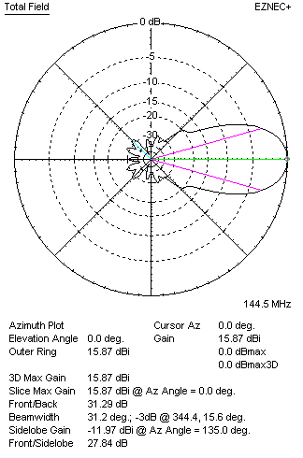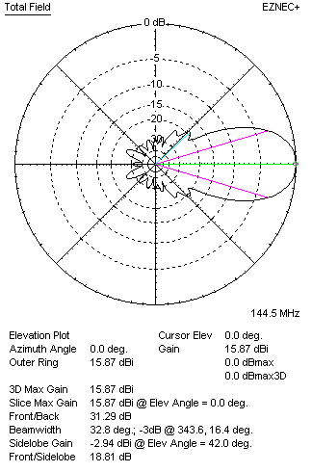
DIAGRAMS (loss included)
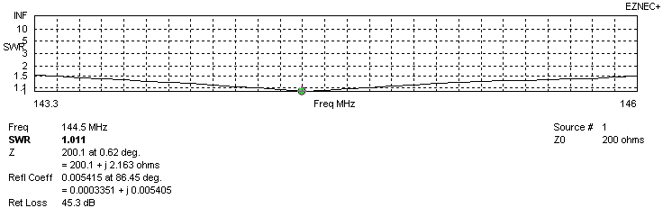
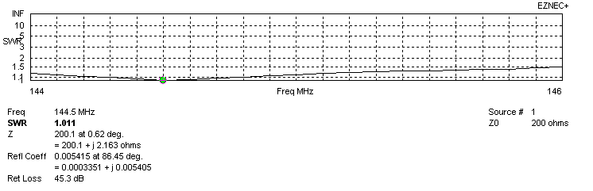
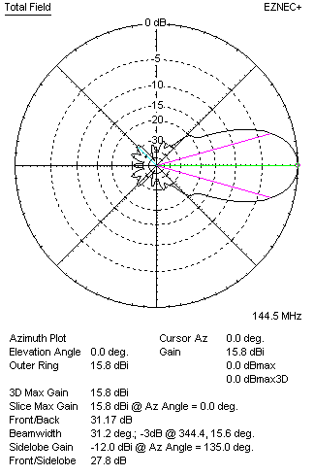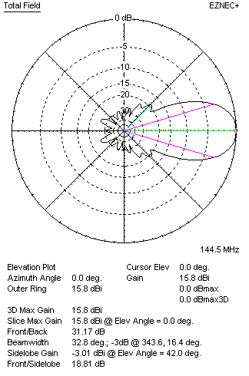

STACKING

QY21210XL4D5 - STACKING TABLE
(including loss for aluminum – AGT = -0.07 dB)
VERTICAL  DISTANCE (cm) | G  (dB) | TA  (°K) | G/T  (dB) | HORIZONTAL  DISTANCE (cm) | G  (dB) | TA  (°K) | G/T  (dB)
100 | 16.22 | 241.0 | -7.60 | 100
110 | 16.49 | 233.1 | -7.18 | 110 | 14.18 | 304.2 | -10.65
120 | 16.68 | 228.9 | -6.92 | 120 | 15.87 | 254.1 | -8.18
130 | 16.84 | 227.1 | -6.72 | 130 | 16.38 | 246.2 | -7.53
140 | 16.98 | 225.8 | -6.56 | 140 | 16.68 | 241.5 | -7.15
150 | 17.12 | 223.6 | -6.37 | 150 | 16.89 | 237.8 | -6.87
160 | 17.24 | 221.40 | -6.21 | 160 | 17.06 | 235.0 | -6.65
170 | 17.36 | 220.2 | -6.07 | 170 | 17.20 | 232.9 | -6.47
180 | 17.46 | 219.9 | -5.96 | 180 | 17.33 | 231.2 | -6.31
190 | 17.56 | 220.1 | -5.87 | 190 | 17.44 | 229.9 | -6.17
200 | 17.65 | 220.9 | -5.79 | 200 | 17.54 | 228.8 | -6.05
210 | 17.73 | 221.9 | -5.73 | 210 | 17.64 | 227.8 | -5.94
220 | 17.81 | 223.2 | -5.68 | 220 | 17.72 | 227.0 | -5.84
230 | 17.89 | 224.3 | -5.62 | 230 | 17.81 | 226.2 | -5.74
240 | 17.96 | 225.2 | -5.56 | 240 | 17.89 | 225.5 | -5.64
250 | 18.04 | 225.5 | -5.49 | 250 | 17.97 | 224.8 | -5.55
260 | 18.12 | 225.4 | -5.41 | 260 | 18.04 | 224.1 | -5.47
270 | 18.19 | 224.9 | -5.33 | 270 | 18.12 | 223.5 | -5.37
280 | 18.27 | 224.3 | -5.24 | 280 | 18.19 | 222.9 | -5.29
290 | 18.34 | 223.5 | -5.15 | 290 | 18.26 | 222.4 | -5.21
300 | 18.41 | 222.8 | -5.07 | 300 | 18.33 | 221.9 | -5.13
310 | 18.48 | 222.3 | -4.99 | 310 | 18.40 | 221.5 | -5.05
320 | 18.54 | 222.0 | -4.92 | 320 | 18.46 | 221.3 | -4.99
330 | 18.60 | 222.0 | -4.86 | 330 | 18.51 | 221.1 | -4.94
340 | 18.64 | 222.2 | -4.83 | 340 | 18.56 | 221.1 | -4.89
350 | 18.69 | 222.6 | -4.78 | 350 | 18.61 | 221.1 | -4.84
360 | 18.72 | 223.1 | -4.76 | 360 | 18.65 | 221.2 | -4.80
370 | 18.76 | 223.5 | -4.73 | 370 | 18.69 | 221.4 | -4.76
380 | 18.78 | 224.0 | -4.72 | 380 | 18.72 | 221.7 | -4.74
390 | 18.81 | 224.3 | -4.70 | 390 | 18.74 | 222.0 | -4.72
400 | 18.82 | 224.6 | -4.69 | 400 | 18.76 | 222.4 | -4.71
410 | 18.84 | 224.9 | -4.68 | 410 | 18.78 | 222.7 | -4.70
420 | 18.85 | 225.2 | -4.68 | 420 | 18.80 | 223.1 | -4.68
430 | 18.85 | 225.3 | -4.68 | 430 | 18.81 | 223.4 | -4.68
440 |  |  |  | 440 | 18.82 | 223.6 | -4.68
450 |  |  |  | 450 | 18.83 | 223.9 | -4.67
Remark: brown colour letters show not consistent data!

TWO ANTENNAS VERTICALLY STACKED AT 410CM
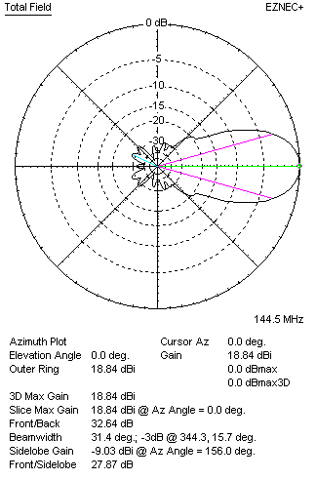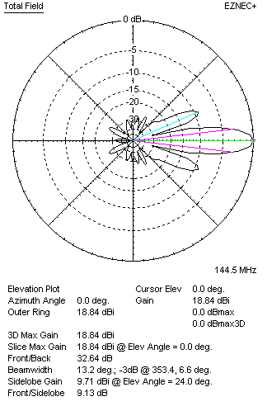

Performances
TYPE | Condition | G  (dBi) | F/B  (dB) | F/Sh  (dBi) | F/Sv (dBi) | Hor  (◦) | Ver  (◦) | Temp (◦K) | G/T (dB) | B (MHz)  for SWR=1.5
2xQY21210XL4D5 | No losss | 18.91 | 32.82 | 20.12 | 9.12 | 31.6 | 13.2 | 223.6 | -4.59 | 143.350- 146.000
2xQY21210XL4D5 | Aluminum | 18.84 | 32.64 | 20.11 | 9.13 | 31.4 | 13.2 | 224.9 | -4.68 | 143.350- 146.000

FOUR ANTENNAS VERTICALLY STACKED AT 410+410+410 CM
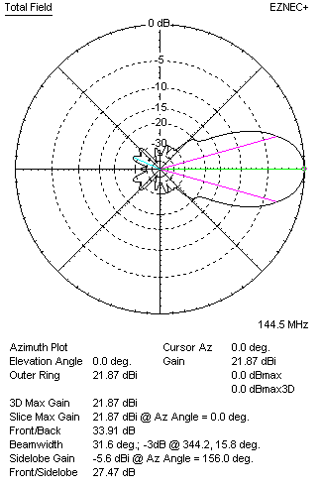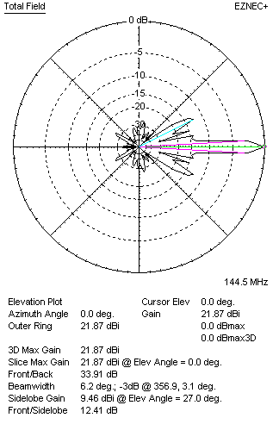
Performances
TYPE | Condition | G  (dBi) | F/B  (dB) | F/Sh  (dBi) | F/Sv (dBi) | Hor  (◦) | Ver  (◦) | Temp (◦K) | G/T (dB) | B (MHz)  for SWR=1.5
4xQY21210XL4D5 | No losss | 21.94 | 34.15 | 20.31 | 12.38 | 31.6 | 6.2 | 227.6 | -1.63 | 143.350- 146.000
4xQY21210XL4D5 | Aluminum | 21.87 | 33.91 | 20.31 | 12.41 | 31.6 | 6.2 | 228.8 | -1.73 | 143.350- 146.000

FOUR ANTENNAS IN H- STACK, H=420 CM, V=410 CM
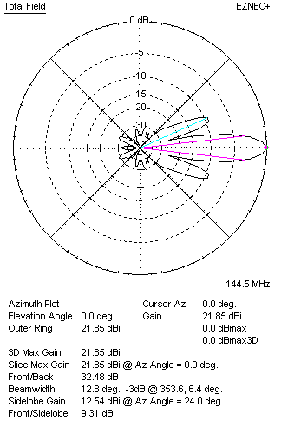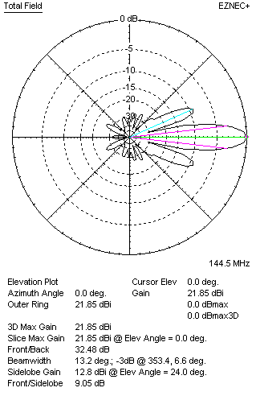
Performances
TYPE | Condition | G  (dBi) | F/B  (dB) | F/Sh  (dBi) | F/Sv (dBi) | Hor  (◦) | Ver  (◦) | Temp (◦K) | G/T (dB) | B (MHz)  for SWR=1.5
4xQY21210XL4D5 | No losss | 21.92 | 32.68 | 9.30 | 9.03 | 12.8 | 13.2 | 223.6 | -1.57 | 143.350- 146.000
4xQY21210XL4D5 | Aluminum | 21.85 | 32.48 | 9.31 | 9.05 | 12.8 | 13.2 | 224.8 | -1.67 | 143.350- 146.000

XPOL VERSION

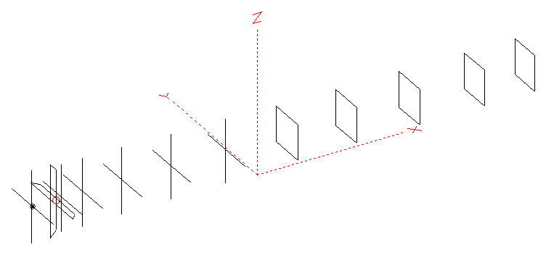
Horizontal components: Same as above
Vertical components: Same as above, except:
- All vertical yagi elements positioned 20 mm backward regarding horizontals.
- All crossed elements must cross each other in their centerlines

HORIZONTAL PERFORMANCES
Everything as the above data

VERTICAL PERFORMANCES with no corrections
Loss included condition (for Aluminum)
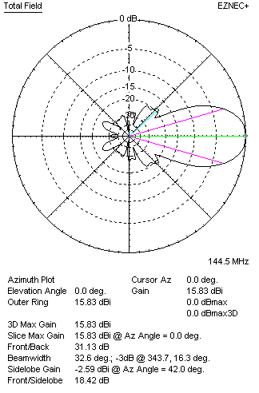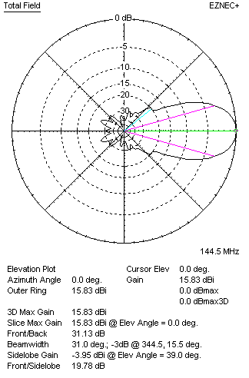
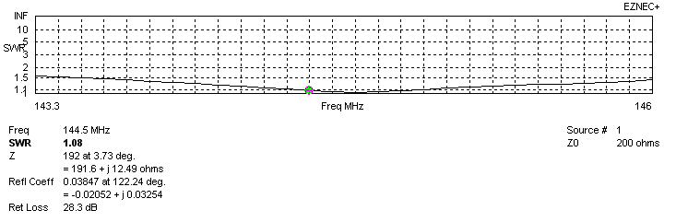
VERTICAL PERFORMANCES after corrections, loss included condition
If you want to get better SWR diagram for vertical antenna you can do the following:
- Change length of DE2 from 886 to 912 mm
- Change length of D1 from 930 to 934 mm
- Change length of D3 from 916 to 914 mm
- Change position od D1 for +2 mm.

In this case the SWR diagram will be like this:
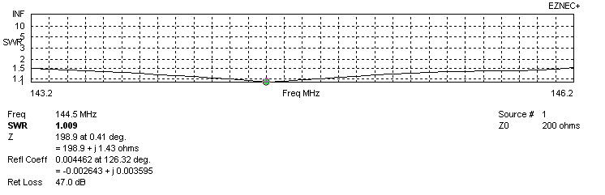
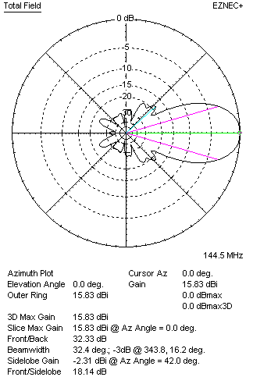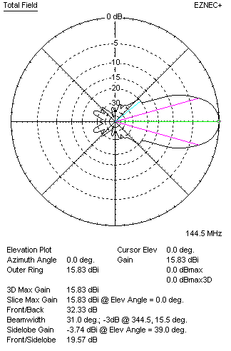

PERFORMANCES
 | TYPE | Condition | G  (dBi) | F/B  (dB) | F/Sh  (dBi) | F/Sv (dBi) | Hor  (◦) | Ver  (◦) | Temp (◦K) | G/T (dB) | B (MHz)  for SWR=1.5
 | Horizontal  part | No losss | 15.87 | 31.29 | 27.84 | 18.81 | 31.2 | 32.8 | 222.9 | -7.61 | 143.210- 146.020
 | Horizontal  part | Aluminum | 15.80 | 31.17 | 27.80 | 18.81 | 31.2 | 32.8 | 224.3 | -7.71 | 143.210- 146.020
 | Vertical  part | No losss | 15.90 | 32.15 | 18.14 | 19.60 | 32.4 | 31.0 | 225.4 | -7.63 | 143.200 – 146.150
 | Vertical  part | Aluminum | 15.83 | 32.33 | 18.14 | 19.57 | 32.4 | 31.0 | 226.7 | -7.72 | 143.200 – 146.150

