ANTENNA QY21206XL4D5
Good stacking characteristics at any vertical and horizontal distances
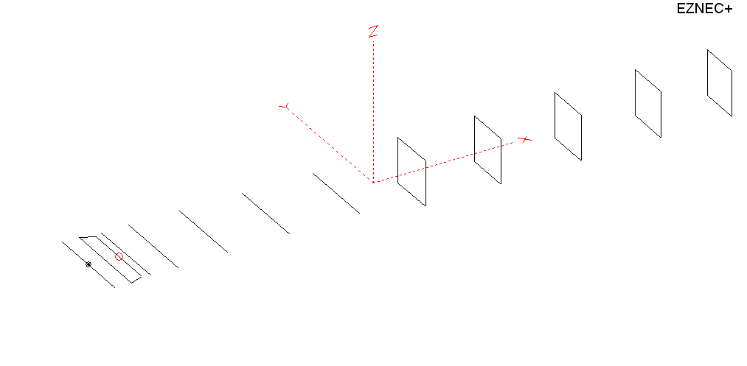
PERFORMANCES: (No loss condition)
TYPE | ELE | L (mm) | G (dBi) | F/B (dB) | F/Sh (dBi) | F/Sv (dBi) | Hor (◦) | Ver (◦) | Temp (◦K) | G/T (dB) | ΔF * (kHz)
QY21206XL4D5 | 12 | 6885 | 15.84 | 30.27 | 28.71 | 18.28 | 31.4 | 32.8 | 221.6 | -7.62 | 2810
* ΔF given for SWR=1.5

PERFORMANCES: (Loss included)
Element material | G (dBi) | Temp (◦K) | G/T (dB)
Aluminum rods | 15.75 | 223.3 | -7.74

DIMENSIONS:
 | Ref | De1 | De2 | D1 | D2 | D3 | D4 | D5 | DQ1 | DQ2 | DQ3 | DQ4 | DQ5 | REMARKS :  All elements made of Al rods Ǿ8 mm  The height of the rectangle is 500 mm  All dimensions given in milimetres
Pos | 0 | 180 | 330 | 409 | 708 | 1254 | 1938 | 2705 | 3525 | 4355 | 5233 | 6108 | 6885
Length | 1012 | 990 | 866 | 942 | 951 | 925 | 907 | 887 | 526 | 504 | 496 | 486 | 466
Building hints: No boom correction included.

COMPARISON
Antenna | Boomlength (mm) | Material | Gain (dBi) | TA (◦K) | G/T (dB) | Bandwidth  (MHz)
QY21206XL4D5 | 6885 | No loss | 15.84 | 221.6 | -7.62 | 143.210- 146.020
QY21206XL4D5 | 6885 | Aluminum | 15.75 | 223.3 | -7.74 | 143.210- 146.020
G0KSC  12ELKKA | 6906 | No loss | 15.69 | 222.4 | -7.78 | 142.600-145.450
G0KSC  12ELKKA | 6906 | Aluminum | 15.61 | 223.8 | -7.89 | 142.600-145.450
EF0212-5 | 7260 | No loss | 15.91 | 224.0 | -7.59 | 143.300-144.820
EF0212-5 | 7260 | Aluminum | 15.81 | 226.0 | -7.73 | 143.300-144.820

DIAGRAMS (no loss included)
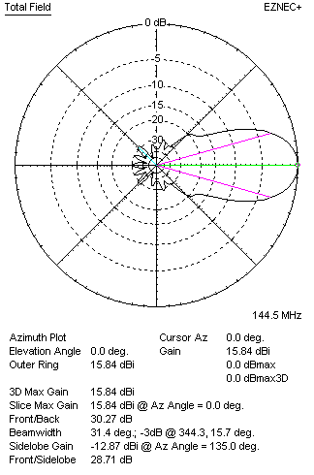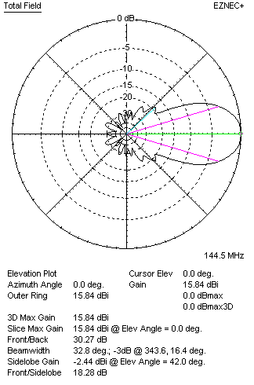
DIAGRAMS (loss included)
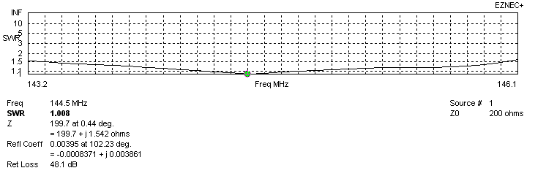
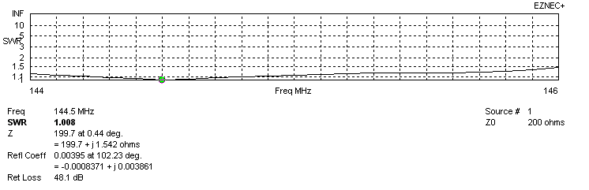
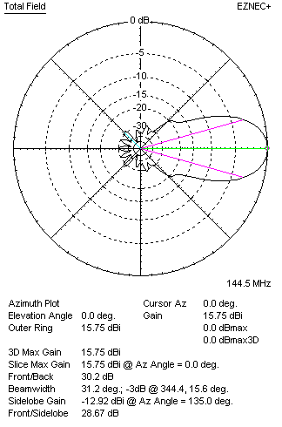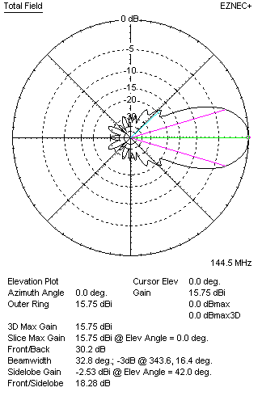

STACKING

QY21208XL4D5 - STACKING TABLE
(including loss for aluminum – AGT = -0.09 dB)
VERTICAL  DISTANCE (cm) | G  (dB) | TA  (°K) | G/T  (dB) | HORIZONTAL  DISTANCE (cm) | G  (dB) | TA  (°K) | G/T  (dB)
100 | 16.08 | 238.4 | -7.69 | 100
110 | 16.37 | 231.1 | -7.27 | 110
120 | 16.59 | 227.3 | -6.98 | 120 | 15.73 | 246.9 | -8.20
130 | 16.76 | 225.5 | -6.77 | 130 | 16.28 | 241.9 | -7.56
140 | 16.90 | 223.7 | -6.60 | 140 | 16.59 | 238.1 | -7.18
150 | 17.05 | 221.0 | -6.39 | 150 | 16.82 | 235.0 | -6.89
160 | 17.18 | 218.2 | -6.21 | 160 | 17.00 | 232.6 | -6.67
170 | 17.30 | 216.6 | -6.06 | 170 | 17.14 | 230.8 | -6.49
180 | 17.41 | 216.1 | -5.94 | 180 | 17.27 | 229.4 | -6.34
190 | 17.51 | 216.5 | -5.84 | 190 | 17.39 | 228.3 | -6.19
200 | 17.60 | 217.4 | -5.77 | 200 | 17.49 | 227.3 | -6.08
210 | 17.69 | 218.7 | -5.71 | 210 | 17.59 | 226.5 | -5.96
220 | 17.77 | 220.2 | -5.66 | 220 | 17.68 | 225.7 | -5.86
230 | 17.85 | 221.7 | -5.61 | 230 | 17.76 | 225.1 | -5.76
240 | 17.92 | 222.8 | -5.56 | 240 | 17.84 | 224.4 | -5.67
250 | 18.00 | 223.5 | -5.49 | 250 | 17.92 | 223.7 | -5.58
260 | 18.08 | 223.7 | -5.42 | 260 | 18.00 | 223.1 | -5.49
270 | 18.15 | 223.5 | -5.34 | 270 | 18.08 | 222.5 | -5.39
280 | 18.23 | 223.1 | -5.25 | 280 | 18.15 | 222.0 | -5.31
290 | 18.30 | 222.6 | -5.18 | 290 | 18.22 | 221.5 | -5.23
300 | 18.37 | 222.2 | -5.10 | 300 | 18.29 | 221.0 | -5.15
310 | 18.44 | 221.9 | -5.02 | 310 | 18.35 | 220.6 | -5.09
320 | 18.50 | 221.8 | -4.96 | 320 | 18.41 | 220.4 | -5.02
330 | 18,55 | 222.0 | -4.91 | 330 | 18.47 | 220.2 | -4.96
340 | 18.60 | 222.4 | -4.87 | 340 | 18.52 | 220.2 | -4.91
350 | 18.64 | 222.9 | -4.84 | 350 | 18.56 | 220.2 | -4.87
360 | 18.67 | 223.4 | -4.82 | 360 | 18.60 | 220.4 | -4.83
370 | 18.71 | 223.9 | -4.79 | 370 | 18.64 | 220.5 | -4.80
380 | 18.73 | 224.2 | -4.78 | 380 | 18.67 | 220.8 | -4.77
390 | 18.75 | 224.4 | -4.76 | 390 | 18.69 | 221.1 | -4.76
400 | 18.77 | 224.6 | -4.74 | 400 | 18.71 | 221.4 | -4.74
410 | 18.79 | 224.7 | -4.73 | 410 | 18.73 | 221.7 | -4.73
420 | 18.80 | 224.7 | -4.72 | 420 | 18.75 | 222.1 | -4.71
430 | 18.80 | 224.6 | -4.71 | 430 | 18.76 | 222.4 | -4.71
440 |  |  |  | 440 | 18.77 | 222.6 | -4.71
450 |  |  |  | 450
460 |  |  |  | 460
470 |  |  |  | 470
480 |  |  |  | 480
490 |  |  |  | 490
500 |  |  |  | 500
510 |  |  |  | 510
520 |  |  |  | 520
530 |  |  |  | 530
540 |  |  |  | 540
550 |  |  |  | 550
Remark: brown colour letters show not consistent data!

TWO ANTENNAS VERTICALLY STACKED AT 420CM
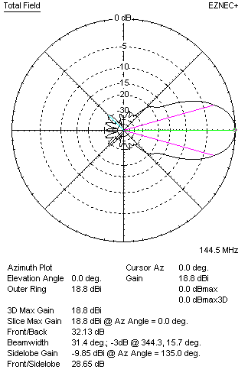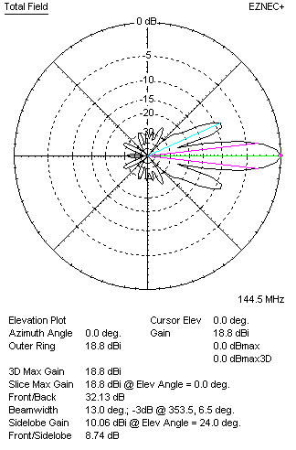

Performances
TYPE | Condition | G  (dBi) | F/B  (dB) | F/Sh  (dBi) | F/Sv (dBi) | Hor  (◦) | Ver  (◦) | Temp (◦K) | G/T (dB) | B (MHz)  for SWR=1.5
2xQY21208XL4D5 | No losss | 18.88 | 32.19 | 19.52 | 8.71 | 31.6 | 13.0 | 223.1 | -4.60 | 143.210- 146.020
2xQY21208XL4D5 | Aluminum | 18.80 | 32.13 | 19.52 | 8.74 | 31.4 | 13.0 | 224.7 | -4.72 | 143.210- 146.020

FOUR ANTENNAS VERTICALLY STACKED AT 420+420+420 CM
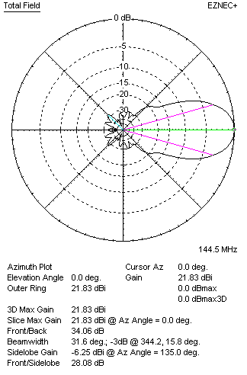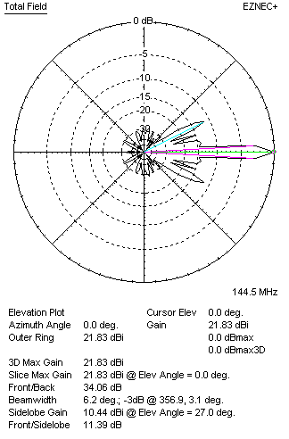
Performances
TYPE | Condition | G  (dBi) | F/B  (dB) | F/Sh  (dBi) | F/Sv (dBi) | Hor  (◦) | Ver  (◦) | Temp (◦K) | G/T (dB) | B (MHz)  for SWR=1.5
4xQY21208XL4D5 | No losss | 21.92 | 33.81 | 19.61 | 11.37 | 31.6 | 6.2 | 227.0 | -1.64 | 143.210- 146.020
4xQY21208XL4D5 | Aluminum | 21.83 | 34.06 | 19.60 | 11.39 | 31.6 | 6.1 | 228.5 | -1.76 | 143.210- 146.020

FOUR ANTENNAS IN H- STACK, H=420 CM, V=420 CM
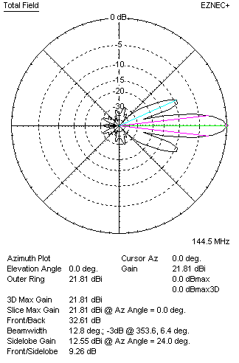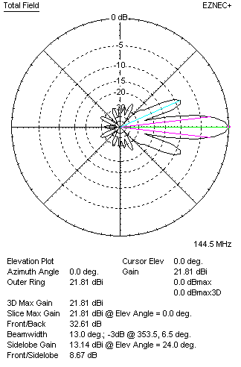
Performances
TYPE | Condition | G  (dBi) | F/B  (dB) | F/Sh  (dBi) | F/Sv (dBi) | Hor  (◦) | Ver  (◦) | Temp (◦K) | G/T (dB) | B (MHz)  for SWR=1.5
4xQY21208XL4D5 | No losss | 21.89 | 32.71 | 9.23 | 8.64 | 12.8 | 13.0 | 223.1 | -1.60 | 143.210- 146.020
4xQY21208XL4D5 | Aluminum | 21.81 | 32.61 | 9.26 | 8.67 | 12.8 | 13.0 | 224.7 | -1.71 | 143.210- 146.020

XPOL VERSION

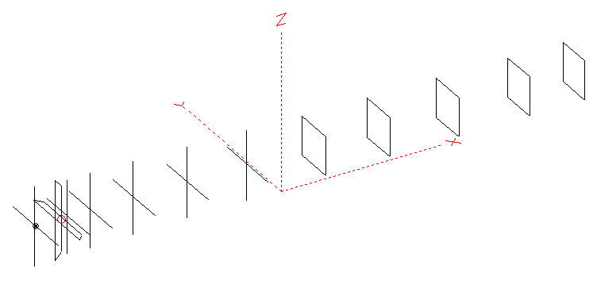
Horizontal components: Same as above
Vertical components: Same as above, except:
- All vertical yagi elements positioned 20 mm backward regarding horizontals.
- All crossed elements must cross each other in their centerlines

HORIZONTAL PERFORMANCES
Everything as the above data

VERTICAL PERFORMANCES with no corrections
Loss included condition (for Aluminum)
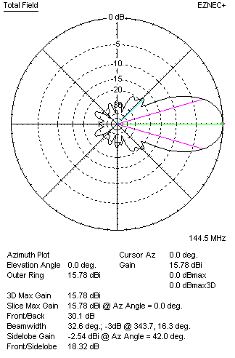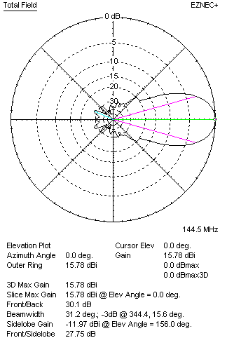
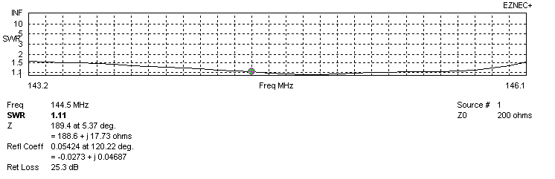
VERTICAL PERFORMANCES after corrections, loss included condition
If you want to get better SWR diagram for vertical antenna you can do the following:
- Change length of D1 from 942 to 945 mm
- Change length of D2 from 951 to 952 mm
- Change length of D3 from 925 to 923 mm
- Change length of D4 from 907 to 906 mm
- Change length of D5 from 887 to 886 mm
- Change position od D1 for +1 mm.

In this case the SWR diagram will be like this:
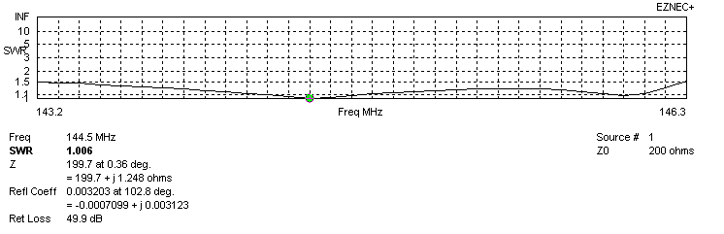
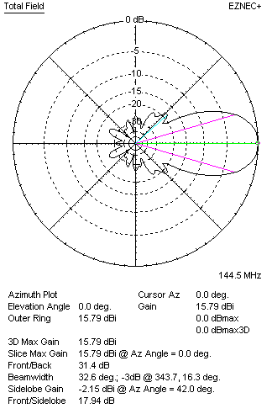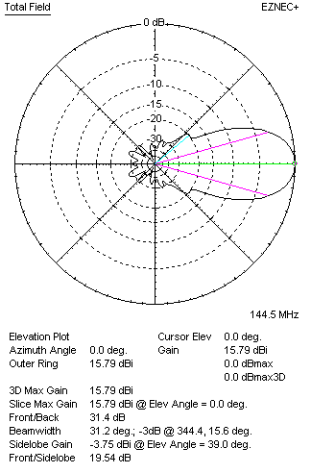

PERFORMANCES
 | TYPE | Condition | G  (dBi) | F/B  (dB) | F/Sh  (dBi) | F/Sv (dBi) | Hor  (◦) | Ver  (◦) | Temp (◦K) | G/T (dB) | B (MHz)  for SWR=1.5
 | Horizontal  part | No losss | 15.84 | 30.27 | 28.71 | 18.28 | 31.4 | 32.8 | 221.6 | -7.62 | 143.210- 146.020
 | Horizontal  part | Aluminum | 15.75 | 30.20 | 28.67 | 18.28 | 31.2 | 32.8 | 223.3 | -7.74 | 143.210- 146.020
 | Vertical  part | No losss | 15.88 | 31.19 | 17.93 | 19.57 | 32.6 | 31.2 | 223.0 | -7.60 | 143.200 – 146.300
 | Vertical  part | Aluminum | 15.79 | 31.40 | 17.94 | 19.54 | 32.6 | 31.2 | 224.6 | -7.72 | 143.200 – 146.300

