ANTENNA QY21206XL5D5
Very good stacking characteristics at any vertical and horizontal distances
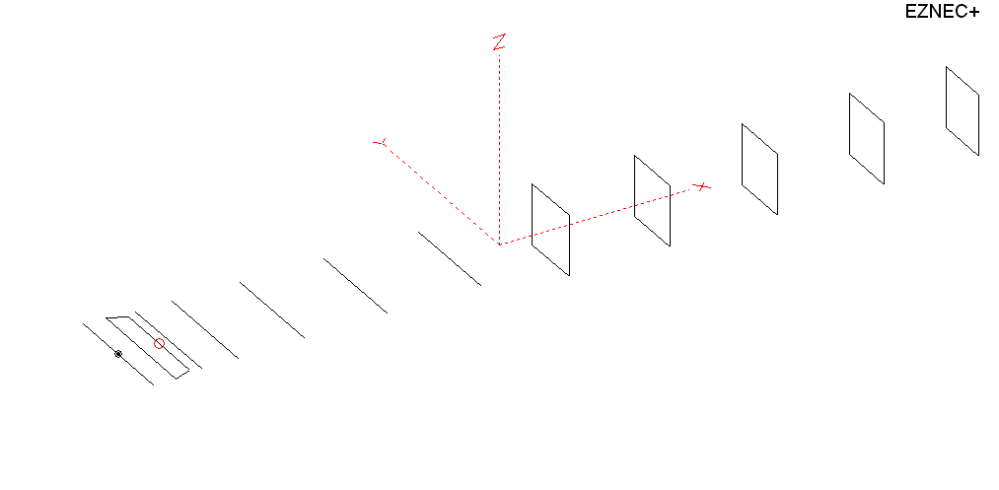
PERFORMANCES: (No loss condition)
TYPE | ELE | L (mm) | G (dBi) | F/B (dB) | F/Sh (dBi) | F/Sv (dBi) | Hor (◦) | Ver (◦) | Temp (◦K) | G/T (dB) | ΔF * (kHz)
QY21206XL5D5 | 12 | 6855 | 15.69 | 35.70 | 19.70 | 18.28 | 32.4 | 34.4 | 217.9 | -7.69 | 4400
* ΔF given for SWR=1.5

PERFORMANCES: (Losses included)
Element material | G (dBi) | Temp (◦K) | G/T (dB)
Aluminum rods | 15.61 | 219.5 | -7.81

DIMENSIONS:
 | Ref | De1 | De2 | D1 | D2 | D3 | D4 | D5 | DQ1 | DQ2 | DQ3 | DQ4 | DQ5 | REMARKS :  All elements made of Al rods Ǿ6 mm  The height of the rectangle is 500 mm  All dimensions given in milimetres
Pos | 0 | 275 | 355 | 424 | 727 | 1289 | 1964 | 2735 | 3555 | 4375 | 5255 | 6142 | 6855
Length | 1016 | 1016 | 866 | 942 | 952 | 924 | 910 | 890 | 518 | 496 | 492 | 470 | 462
Building hints: No boom correction included.

COMPARISON
Antenna | Boomlength (mm) | Material | Gain (dBi) | TA (◦K) | G/T (dB) | Bandwidth  (MHz)
QY21206XL5D5 | 6855 | No loss | 15.69 | 217.9 | -7.69 | 142.500- 146.900
QY21206XL5D5 | 6855 | Aluminum | 15.61 | 219.5 | -7.81 | 142.500- 146.900
G0KSC  12ELKKA | 6906 | No loss | 15.69 | 222.4 | -7.78 | 142.600-145.450
G0KSC  12ELKKA | 6906 | Aluminum | 15.61 | 223.8 | -7.89 | 142.600-145.450
EF0212-5 | 7260 | No loss | 15.91 | 224.0 | -7.59 | 143.300-144.820
EF0212-5 | 7260 | Aluminum | 15.81 | 226.0 | -7.73 | 143.300-144.820

DIAGRAMS (no loss included)
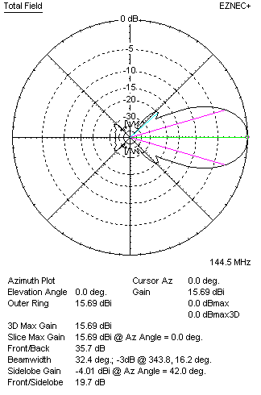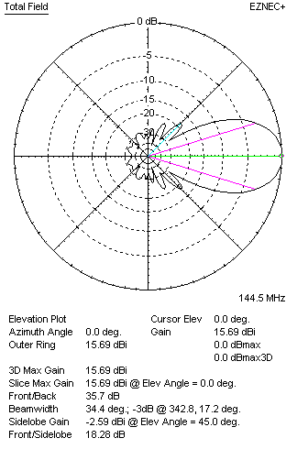
DIAGRAMS (loss included)
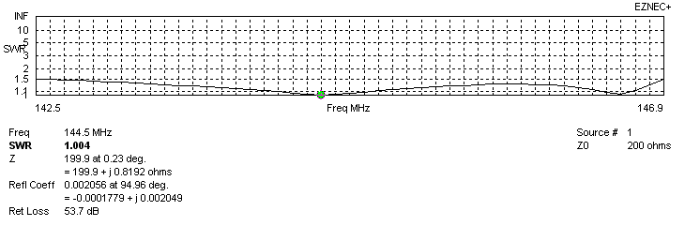
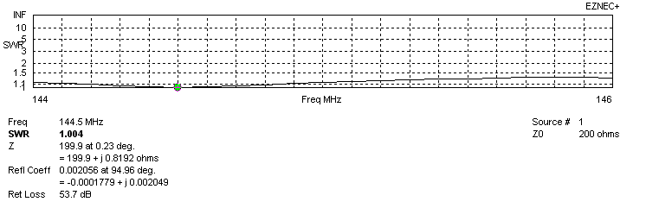
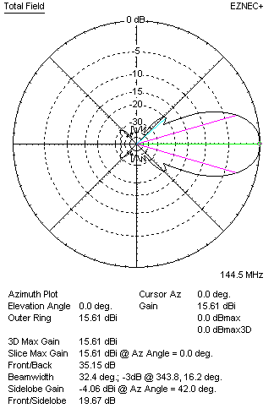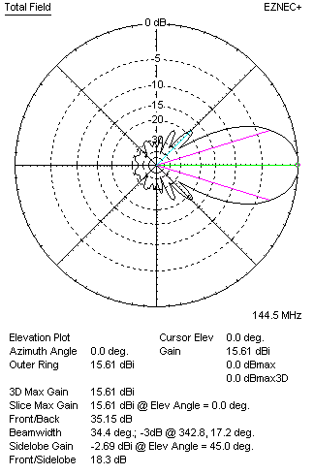

STACKING

QY21206XL5D5 - STACKING TABLE
(including loss for aluminum – AGT = -0.08 dB)
VERTICAL  DISTANCE (cm) | G  (dB) | TA  (°K) | G/T  (dB) | HORIZONTAL  DISTANCE (cm) | G  (dB) | TA  (°K) | G/T  (dB)
100 | 16.43 | 226.8 | -7.13 | 100
110 | 16.62 | 221.5 | -6.83 | 110
120 | 16.76 | 218.6 | -6.64 | 120 | 16.24 | 241.0 | -7.58
130 | 16.89 | 217.3 | -6.48 | 130 | 16.56 | 235.5 | -7.16
140 | 16.99 | 216.3 | -6.36 | 140 | 16.77 | 231.4 | -6.87
150 | 17.09 | 215.2 | -6.24 | 150 | 16.92 | 228.5 | -6.67
160 | 17.18 | 214.6 | -6.14 | 160 | 17.05 | 226.6 | -6.50
170 | 17.26 | 214.8 | -6.06 | 170 | 17.16 | 225.4 | -6.37
180 | 17.35 | 215.4 | -5.98 | 180 | 17.25 | 224.5 | -6.26
190 | 17.42 | 216.3 | -5.93 | 190 | 17.34 | 223.8 | -6.16
200 | 17.50 | 217.5 | -5.87 | 200 | 17.43 | 223.1 | -6.06
210 | 17.57 | 218.9 | -5.83 | 210 | 17.51 | 222.5 | -5.96
220 | 17.65 | 220.3 | -5.78 | 220 | 17.58 | 221.9 | -5.88
230 | 17.72 | 221.4 | -5.73 | 230 | 17.65 | 221.2 | --5.80
240 | 17.79 | 222.1 | -5.68 | 240 | 17.73 | 220.6 | -5.71
250 | 17.86 | 222.3 | -5.61 | 250 | 17.80 | 219.9 | -5.62
260 | 17.94 | 221.9 | -5.52 | 260 | 17.87 | 219.3 | -5.54
270 | 18.02 | 221.2 | -5.43 | 270 | 17.94 | 218.7 | -5.46
280 | 18.10 | 220.3 | -5.33 | 280 | 18.01 | 218.2 | -5.38
290 | 18.17 | 219.3 | -5.24 | 290 | 18.08 | 217.8 | -5.30
300 | 18.25 | 218.5 | -5.14 | 300 | 18.15 | 217.4 | -5.22
310 | 18.31 | 217.9 | -5.07 | 310 | 18.22 | 217.1 | -5.15
320 | 18.38 | 217.5 | -4.99 | 320 | 18.28 | 216.9 | -5.08
330 | 18.43 | 217.4 | -4.94 | 330 | 18.34 | 216.8 | -5.02
340 | 18.48 | 217.6 | -4.90 | 340 | 18.39 | 216.9 | -4.97
350 | 18.53 | 217.9 | -4.85 | 350 | 18.44 | 217.0 | -4.92
360 | 18.56 | 218.3 | -4.83 | 360 | 18.48 | 217.1 | -4.89
370 | 18.59 | 218.8 | -4.81 | 370 | 18.52 | 217.4 | -4.85
380 | 18.62 | 219.3 | -4.79 | 380 | 18.55 | 217.7 | -4.83
390 | 18.64 | 219.9 | -4.78 | 390 | 18.57 | 218.0 | -4.82
400 | 18.65 | 220.3 | -4.78 | 400 | 18.60 | 218.4 | -4.79
 |  |  |  | 410 | 18.62 | 218.8 | -4.78
 |  |  |  | 420 | 18.63 | 219.1 | -4.78
Remark: brown colour letters show not consistent data!

TWO ANTENNAS VERTICALLY STACKED AT 350CM
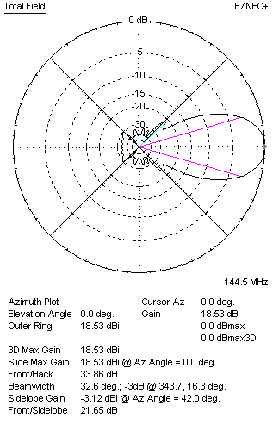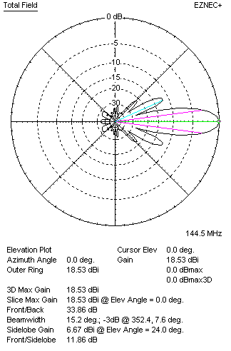

Performances
TYPE | Condition | G  (dBi) | F/B  (dB) | F/Sh  (dBi) | F/Sv (dBi) | Hor  (◦) | Ver  (◦) | Temp (◦K) | G/T (dB) | B (MHz)  for SWR=1.5
2xQY21205XL5D5 | No losss | 18.61 | 34.36 | 21.70 | 11.83 | 32.6 | 15.2 | 216.2 | -4.74 | 142.500- 146.900
2xQY21205XL5D5 | Aluminum | 18.53 | 33.86 | 21.65 | 11.86 | 32.6 | 15.2 | 217.9 | -4.85 | 142.500- 146.900

FOUR ANTENNAS VERTICALLY STACKED AT 365+365+365 CM
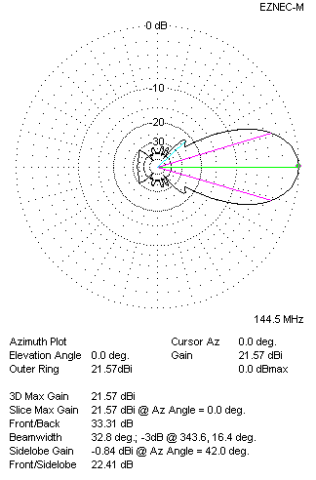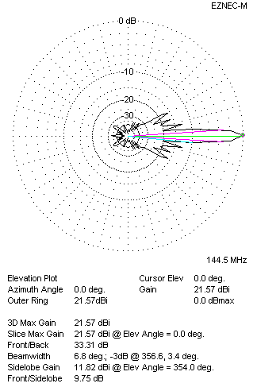
Performances
TYPE | Condition | G  (dBi) | F/B  (dB) | F/Sh  (dBi) | F/Sv (dBi) | Hor  (◦) | Ver  (◦) | Temp (◦K) | G/T (dB) | B (MHz)  for SWR=1.5
4xQY21205XL5D5 | No losss | 21.66 | 33.81 | 22.46 | 12.54 | 33.0 | 6.8 | 215.9 | -1.68 | 142.500- 146.900
4xQY21205XL5D5 | Aluminum | 21.57 | 33.31 | 22.41 | 12.54 | 32.8 | 6.8 | 217.6 | -1.81 | 142.500- 146.900

FOUR ANTENNAS IN H- STACK, H=410 CM, V=365 CM
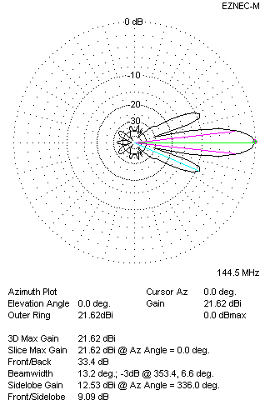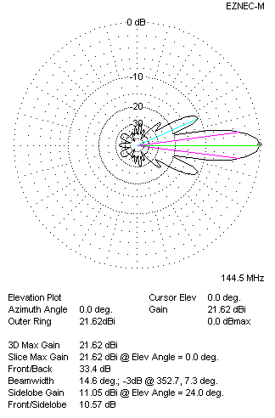
Performances
TYPE | Condition | G  (dBi) | F/B  (dB) | F/Sh  (dBi) | F/Sv (dBi) | Hor  (◦) | Ver  (◦) | Temp (◦K) | G/T (dB) | B (MHz)  for SWR=1.5
4xQY21205XL5D5 | No losss | 21.71 | 33.89 | 9.07 | 10.54 | 13.2 | 14.6 | 217.7 | -1.67 | 142.500- 146.900
4xQY21205XL5D5 | Aluminum | 21.62 | 33.40 | 9.09 | 10.57 | 13.2 | 14.6 | 219.3 | -1.79 | 142.500- 146.900

XPOL VERSION

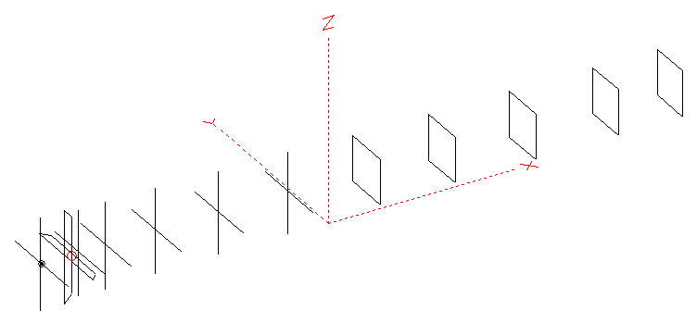
Horizontal components: Same as above
Vertical components: Same as above, except:
- All vertical yagi elements positioned 20 mm backward regarding horizontals.
- All crossed elements must cross each other in their centerlines

HORIZONTAL PERFORMANCES
Everything as the above data

VERTICAL PERFORMANCES with no corrections
Loss included condition (for Aluminum)
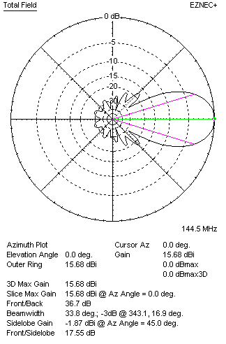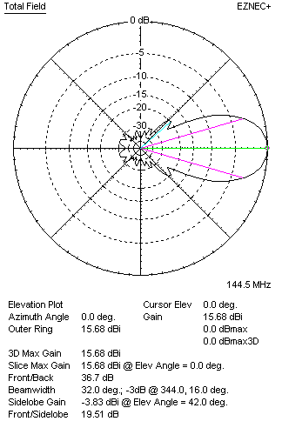
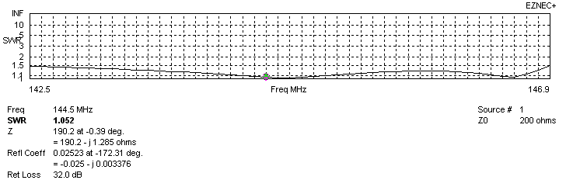
VERTICAL PERFORMANCES after corrections, loss included condition
If you want to get better SWR diagram for vertical antenna you can do the following:
- Change length of DE2 from 866 to 878 mm
- Change length of D1 from 942 to 946 mm
- Change length of D2 from 952 to 954 mm
- Change position of D1 for +3 mm.

In this case the SWR diagram will be like this:
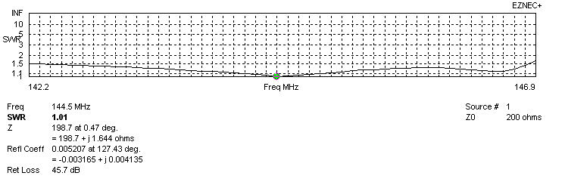
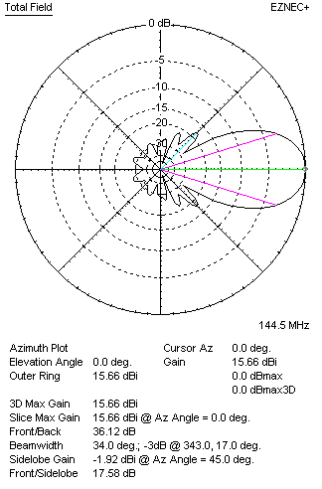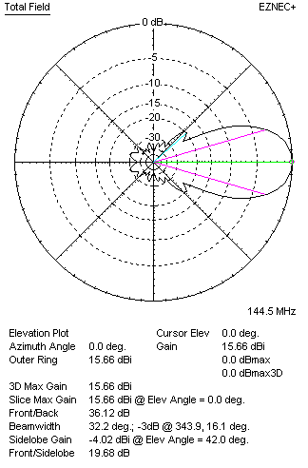

PERFORMANCES
 | TYPE | Condition | G  (dBi) | F/B  (dB) | F/Sh  (dBi) | F/Sv (dBi) | Hor  (◦) | Ver  (◦) | Temp (◦K) | G/T (dB) | B (MHz)  for SWR=1.5
 | Horizontal  part | No losss | 15.69 | 35.70 | 19.70 | 18.28 | 32.4 | 34.4 | 217.9 | -7.69 | 143.100- 146.100
 | Horizontal  part | Aluminum | 15.61 | 35.15 | 19.67 | 18.30 | 32.4 | 34.4 | 219.5 | -7.81 | 143.100- 146.100
 | Vertical  part | No losss | 15.75 | 42.17 | 17.56 | 19.70 | 34.8 | 32.2 | 218.7 | -7.65 | 142.200 – 146.800
 | Vertical  part | Aluminum | 15.66 | 36.12 | 17.58 | 19.68 | 34.8 | 32.2 | 220.5 | -7.77 | 142.200 – 146.800

