ANTENNA QY21205XL4D5
Good stacking characteristics at big vertical and horizontal distances
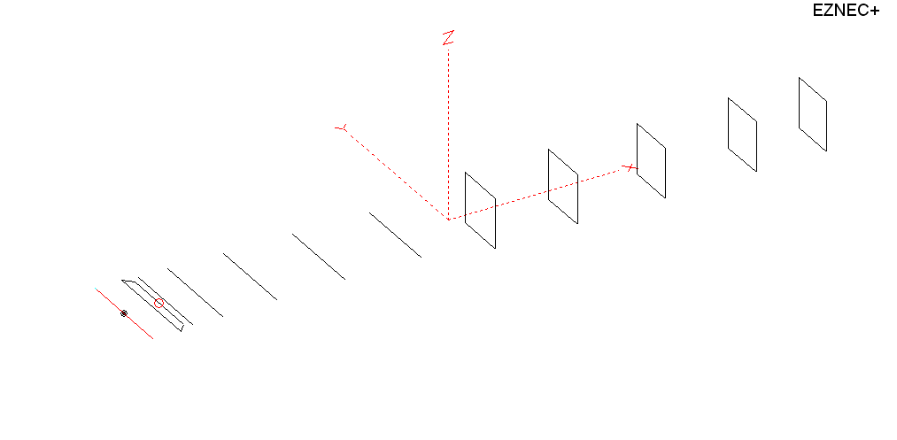
PERFORMANCES: (No loss condition)
TYPE | ELE | L (mm) | G (dBi) | F/B (dB) | F/Sh (dBi) | F/Sv (dBi) | Hor (◦) | Ver (◦) | Temp (◦K) | G/T (dB) | ΔF * (kHz)
QY21205XL4D5 | 12 | 6838 | 15.77 | 28.75 | 18.93 | 18.04 | 31.8 | 33.6 | 219.6 | -7.65 | 3000
* ΔF given for SWR=1.5

PERFORMANCES: (Losses included)
Element material | G (dBi) | Temp (◦K) | G/T (dB)
Aluminum rods | 15.66 | 221.7 | -7.80

DIMENSIONS:
 | Ref | De1 | De2 | D1 | D2 | D3 | D4 | D5 | DQ1 | DQ2 | DQ3 | DQ4 | DQ5 | REMARKS :  - All elements made of Al rods Ǿ5 mm  - The height of the rectangle is 500 mm  - All dimensions given in milimetres
Pos | 0 | 265 | 345 | 415 | 705 | 1252 | 1934 | 2695 | 3535 | 4355 | 5233 | 6138 | 6838
Length | 1018 | 1018 | 830 | 946 | 958 | 932 | 916 | 900 | 534 | 502 | 492 | 482 | 468
Building hints: No boom correction included.

COMPARISON
Antenna | Boomlength (mm) | Material | Gain (dBi) | TA (◦K) | G/T (dB) | Bandwidth  (MHz)
QY21205XL4D5 | 6838 | No loss | 15.77 | 219.6 | -7.65 | 143.100- 146.100
QY21205XL4D5 | 6838 | Aluminum | 15.66 | 221.7 | -7.80 | 143.100- 146.100
G0KSC  12ELKKA | 6906 | No loss | 15.69 | 222.4 | -7.78 | 142.600- 145.450
G0KSC  12ELKKA | 6906 | Aluminum | 15.61 | 223.8 | -7.89 | 142.600- 145.450
EF0212-5 | 7260 | No loss | 15.91 | 224.0 | -7.59 | 143.300-144.820
EF0212-5 | 7260 | Aluminum | 15.81 | 226.0 | -7.73 | 143.300-144.820

DIAGRAMS (no loss included)
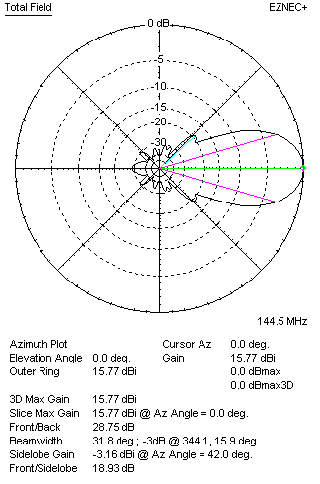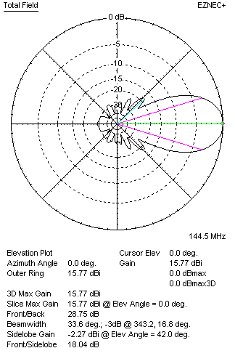
DIAGRAMS (loss included)
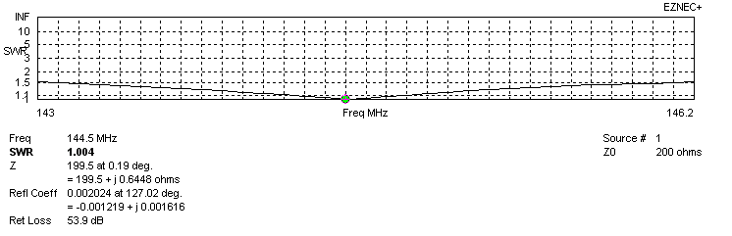
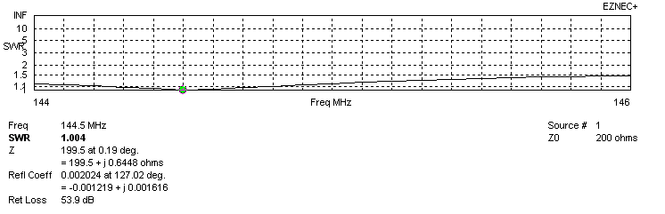
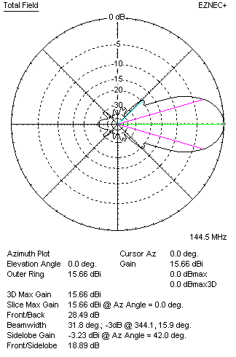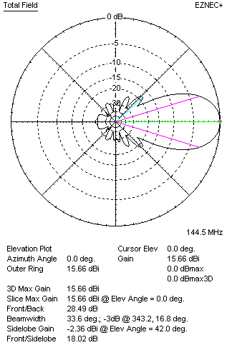

STACKING

QY21205XL4D5 - STACKING TABLE
(including loss for aluminum – AGT = -0.10 dB)
VERTICAL  DISTANCE (cm) | G  (dB) | TA  (°K) | G/T  (dB) | HORIZONTAL  DISTANCE (cm) | G  (dB) | TA  (°K) | G/T  (dB)
100 | 16.24 | 235.9 | -7.49 | 100
110 | 16.49 | 228.7 | -7.10 | 110 | 15.06 | 257.3 | -9.04
120 | 16.67 | 224.7 | -6.85 | 120 | 15.99 | 250.1 | -7.99
130 | 16.81 | 222.5 | -6.66 | 130 | 16.41 | 243.1 | -7.45
140 | 16.94 | 220.7 | -6.50 | 140 | 16.68 | 237.7 | -7.08
150 | 17.06 | 218.3 | -6.33 | 150 | 16.87 | 233.9 | -6.82
160 | 17.17 | 217.0 | -6.20 | 160 | 17.02 | 231.4 | -6.62
170 | 17.26 | 216.6 | -6.10 | 170 | 17.14 | 229.6 | -6.47
180 | 17.35 | 216.9 | -6.01 | 180 | 17.25 | 228.3 | -6.33
190 | 17.44 | 217.7 | -5.94 | 190 | 17.35 | 227.2 | -6.21
200 | 17.52 | 218.9 | -5.88 | 200 | 17.44 | 226.3 | -6.11
210 | 17.60 | 220.2 | -5.83 | 210 | 17.53 | 225.5 | -6.00
220 | 17.67 | 221.6 | -5.78 | 220 | 17.61 | 224.7 | -5.91
230 | 17.75 | 222.8 | -5.73 | 230 | 17.68 | 223.9 | -5.82
240 | 17.83 | 223.6 | -5.66 | 240 | 17.76 | 223.2 | -5.73
250 | 17.90 | 223.9 | -5.60 | 250 | 17.83 | 222.4 | -5.64
260 | 17.98 | 223.7 | -5.52 | 260 | 17.91 | 221.7 | -5.55
270 | 18.06 | 223.1 | -5.42 | 270 | 17.98 | 221.1 | -5.47
280 | 18.14 | 222.3 | -5.33 | 280 | 18.05 | 220.5 | -5.38
290 | 18.22 | 221.5 | -5.23 | 290 | 18.12 | 220.0 | -5.30
300 | 18.29 | 220.7 | -5.15 | 300 | 18.19 | 219.6 | -5.23
310 | 18.36 | 220.2 | -5.07 | 310 | 18.26 | 219.2 | -5.15
320 | 18.42 | 219.8 | -5.00 | 320 | 18.32 | 219.0 | -5.08
330 | 18.48 | 219.8 | -4.94 | 330 | 18.31 | 218.9 | -5.02
340 | 18.53 | 220.0 | -4.89 | 340 | 18.43 | 218.9 | -4.97
350 | 18.57 | 220.3 | -4.86 | 350 | 18.48 | 218.9 | -4.92
360 | 18.61 | 220.8 | -4.83 | 360 | 18.52 | 219.1 | -4.89
370 | 18.64 | 221.4 | -4.81 | 370 | 18.56 | 219.3 | -4.85
380 | 18.66 | 221.9 | -4.80 | 380 | 18,59 | 219.6 | -4.83
390 | 18.68 | 222.3 | -4.79 | 390 | 18.62 | 219.9 | -4.80
400 | 18.70 | 222.8 | -4.78 | 400 | 18.64 | 220.3 | -4.79
410 | 18.71 | 223.1 | -4.77 | 410 | 18.66 | 220.7 | -4.78
420 | 18.72 | 223.2 | -4.77 | 420 | 18.68 | 221.0 | -4.76
 |  |  |  | 430 | 18.69 | 221.4 | -4.76
 |  |  |  | 440 | 18.70 | 221.6 | -4.76
 |  |  |  | 450 | 18.71 | 221.9 | -4.75
Remark: brown colour letters show not consistent data!

TWO ANTENNAS VERTICALLY STACKED AT 410CM
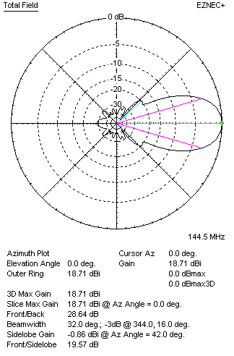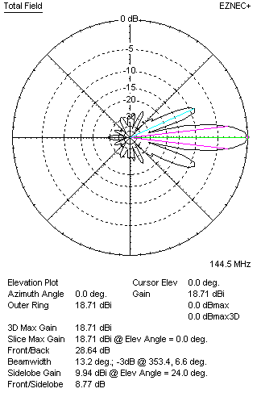

Performances
TYPE | Condition | G  (dBi) | F/B  (dB) | F/Sh  (dBi) | F/Sv (dBi) | Hor  (◦) | Ver  (◦) | Temp (◦K) | G/T (dB) | B (MHz)  for SWR=1.5
2xQY21205XL4D5 | No losss | 18.82 | 28.91 | 19.61 | 8.74 | 32.2 | 13.2 | 221.0 | -4.62 | 143.100- 146.100
2xQY21205XL4D5 | Aluminum | 18.71 | 28.64 | 19.57 | 8.77 | 32.0 | 13.2 | 223.0 | -4.77 | 143.100- 146.100

FOUR ANTENNAS VERTICALLY STACKED AT 400+400+400CM
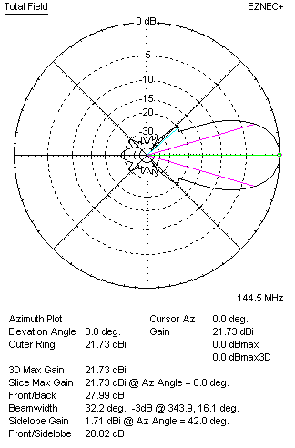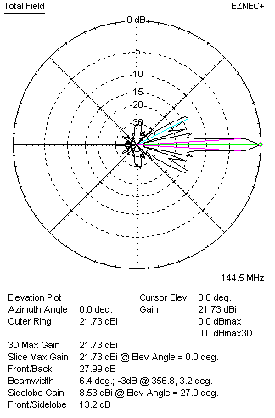
Performances
TYPE | Condition | G  (dBi) | F/B  (dB) | F/Sh  (dBi) | F/Sv (dBi) | Hor  (◦) | Ver  (◦) | Temp (◦K) | G/T (dB) | B (MHz)  for SWR=1.5
4xQY21205XL4D5 | No losss | 21.85 | 28.27 | 20.06 | 13.16 | 32.2 | 6.4 | 223.8 | -1.65 | 143.100- 146.100
4xQY21205XL4D5 | Aluminum | 21.73 | 27.99 | 20.06 | 13.20 | 32.2 | 6.4 | 225.8 | -1.81 | 143.100- 146.100

FOUR ANTENNAS IN H- STACK, H=459 CM, V=405 CM
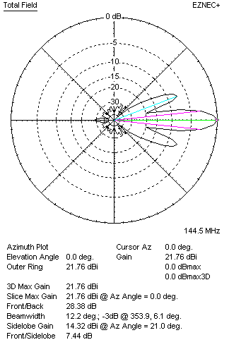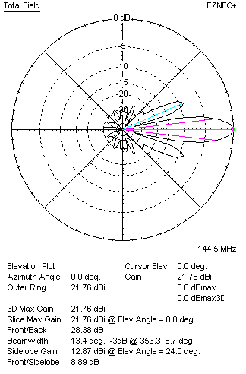
Performances
TYPE | Condition | G  (dBi) | F/B  (dB) | F/Sh  (dBi) | F/Sv (dBi) | Hor  (◦) | Ver  (◦) | Temp (◦K) | G/T (dB) | B (MHz)  for SWR=1.5
4xQY21205XL4D5 | No losss | 21.87 | 28.65 | 7.42 | 8.86 | 12.2 | 13.4 | 222.7 | -1.61 | 143.100- 146.100
4xQY21205XL4D5 | Aluminum | 21.76 | 28.38 | 7.44 | 8.89 | 12.2 | 13.4 | 224.7 | -1.76 | 143.100- 146.100

XPOL VERSION

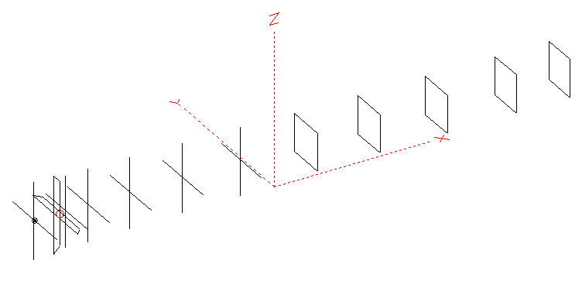
Horizontal components: Same as above
Vertical components: Same as above, except:
- All vertical yagi elements positioned 20 mm backward regarding horizontals.
- All crossed elements must cross each other in their centerlines

HORIZONTAL PERFORMANCES
Everything as the above data

VERTICAL PERFORMANCES with no corrections
Loss included condition (for Aluminum)
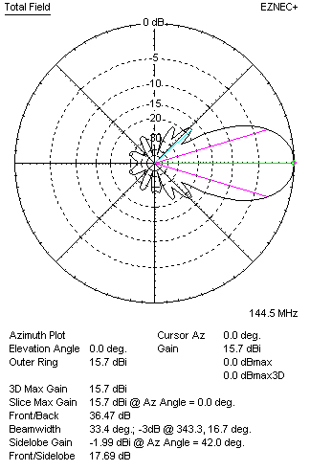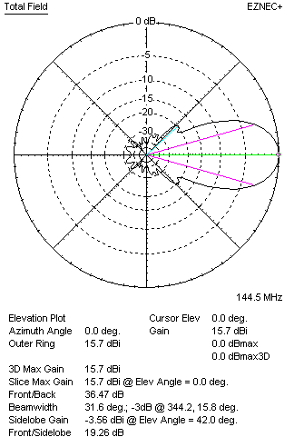
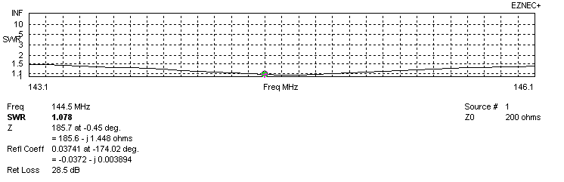
VERTICAL PERFORMANCES after corrections, loss included condition
If you want to get better SWR diagram for vertical antenna you can do the following:
- Change length of DE2 from 830 to 898 mm
- Change length of D1 from 946 to 950 mm
- Change length of D2 from 958 to 956 mm
- Change length of D3 from 932 to 928 mm
- Change length of D5 from 900 to 948 mm

In this case the SWR diagram will be like this:
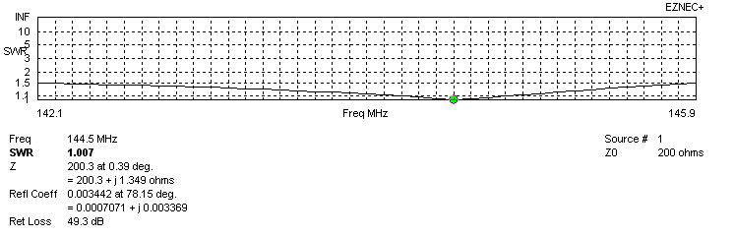
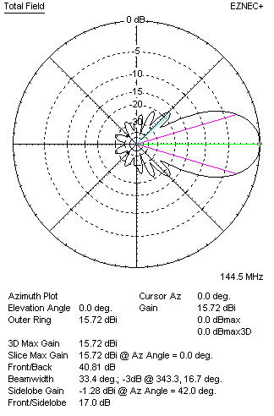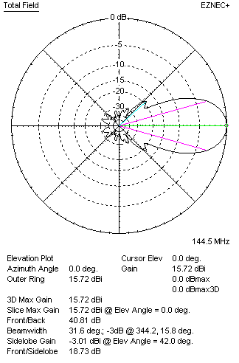

PERFORMANCES
 | TYPE | Condition | G  (dBi) | F/B  (dB) | F/Sh  (dBi) | F/Sv (dBi) | Hor  (◦) | Ver  (◦) | Temp (◦K) | G/T (dB) | B (MHz)  for SWR=1.5
 | Horizontal  part | No losss | 15.77 | 28.75 | 18.93 | 18.04 | 31.8 | 33.6 | 219.6 | -7.65 | 143.100- 146.100
 | Horizontal  part | Aluminum | 15.66 | 28.49 | 18.89 | 18.02 | 31.8 | 33.6 | 221.7 | -7.80 | 143.100- 146.100
 | Vertical  part | No losss | 15.82 | 42.17 | 17.01 | 18.76 | 33.4 | 31.8 | 220.0 | -7.60 | 142.100 – 145.900
 | Vertical  part | Aluminum | 15.72 | 40.81 | 17.00 | 18.73 | 33.4 | 31.6 | 222.0 | -7.74 | 142.100 – 145.900

