ANTENNA QY21110XL4D4
Good stacking characteristics at moderate vertical distances and big horizontal distances
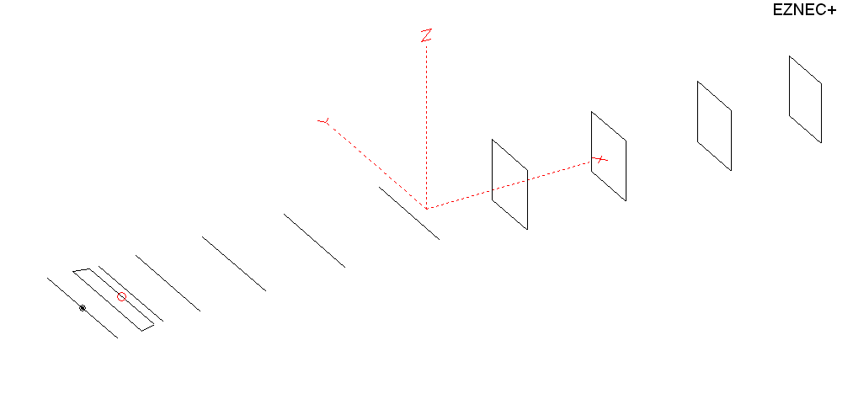
PERFORMANCES: (No loss condition)
TYPE | ELE | L (mm) | G (dBi) | F/B (dB) | F/Sh (dBi) | F/Sv (dBi) | Hor (◦) | Ver (◦) | Temp (◦K) | G/T (dB) | ΔF * (kHz)
QY21110XL4D4 | 11 | 6000 | 15.31 | 29.41 | 19.01 | 18,02 | 33.4 | 36.0 | 222.3 | -8.16 | 3400
* ΔF given for SWR=1,5

PERFORMANCES: (Losses included)
Element material | G (dBi) | Temp (◦K) | G/T (dB)
Aluminum rods | 15.26 | 223.3 | -8.23

DIMENSIONS:
 | Ref | De1 | De2 | D1 | D2 | D3 | D4 | D5 | DQ1 | DQ2 | DQ3 | DQ4 | REMARKS  -All elements made of Al rods Ǿ10 mm  - The height of the rectangle is 500 mm  - All dimensions given in milimetres
Pos | 0 | 205 | 325 | 405 | 709 | 1259 | 1926 | 2715 | 3545 | 4368 | 5242 | 6000
Length | 1012 | 990 | 924 | 928 | 936 | 910 | 890 | 872 | 512 | 496 | 490 | 458
Building hints: No boom correction included.

COMPARISON
Antenna | Boomlength (mm) | Material | Gain (dBi) | TA (◦K) | G/T (dB) | Bandwidth  (MHz)
QY21110XL4D4 | 6000 | No loss | 15.31 | 222.3 | -8.16 | 142.700- 146.100
QY21110XL4D4 | 6000 | Aluminum | 15.26 | 223.3 | -8.23 | 142.700- 146.100
GOKSC  11ELKKA | 6048 | No loss | 15.22 | 228.7 | -8.37 | 142.500- 145.470
GOKSC  11ELKKA | 6048 | Aluminum | 15.14 | 229.8 | -8.47 | 142.500- 145.470
EF0211-5 | 6325 | No loss | 15.24 | 226.7 | -8.31 | 142.500- 144.750
EF0211-5 | 6325 | Aluminum | 15.14 | 228.5 | -8.45 | 142.500- 144.750

DIAGRAMS (no loss included)
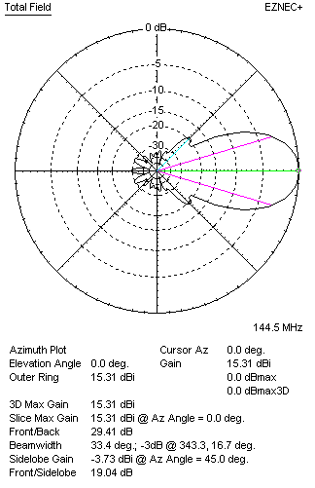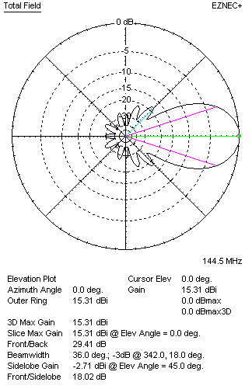
DIAGRAMS (loss included)
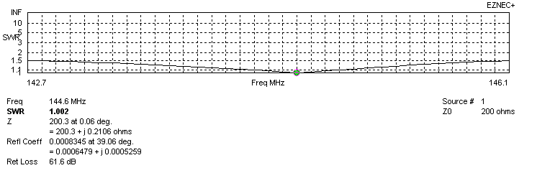
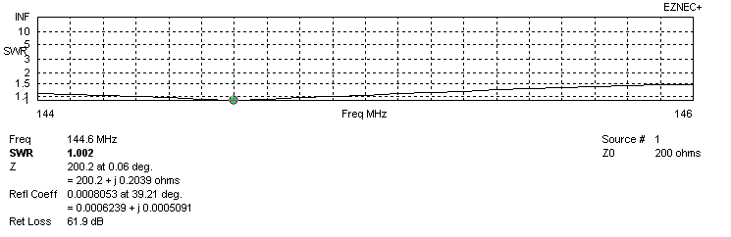
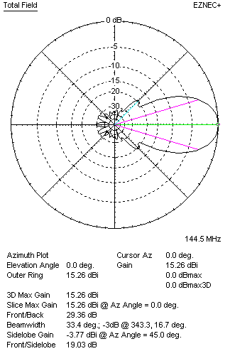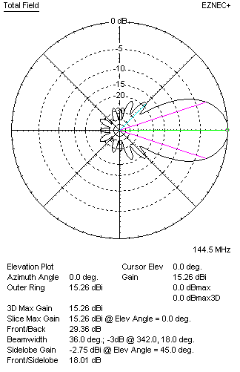

STACKING

QY21110XL4D4 - STACKING TABLE
(including loss for aluminum – AGT = -0.05 dB)
VERTICAL  DISTANCE (cm) | G  (dB) | TA  (°K) | G/T  (dB) | HORIZONTAL  DISTANCE (cm) | G  (dB) | TA  (°K) | G/T  (dB)
100 | 16.16 | 233.1 | -7.52 | 100
110 | 16.32 | 227.4 | -7.25 | 110 | 15.42 | 255.2 | -8.65
120 | 16.46 | 224.4 | -7.05 | 120 | 15.95 | 251.6 | -8.06
130 | 16.57 | 222.8 | -6.91 | 130 | 16.25 | 244.0 | -7.62
140 | 16.68 | 221.3 | -6.77 | 140 | 16.46 | 238.4 | -7.31
150 | 16.78 | 219.1 | -6.63 | 150 | 16.62 | 234.5 | -7.08
160 | 16.88 | 217.3 | -6.49 | 160 | 16.75 | 231.9 | -6.90
170 | 16.97 | 216.7 | -6.39 | 170 | 16.86 | 230.0 | -6.76
180 | 17.06 | 217.0 | -6.30 | 180 | 16.96 | 228.5 | -6.63
190 | 17.14 | 217.9 | -6.24 | 190 | 17.05 | 227.3 | -6.52
200 | 17.22 | 219.3 | -6.19 | 200 | 17.13 | 226.3 | -6.42
210 | 17.30 | 220.9 | -6.14 | 210 | 17.21 | 225.4 | -6.32
220 | 17.37 | 222.4 | 6.10 | 220 | 17.29 | 224.5 | -6.22
230 | 17.45 | 223.5 | -6.04 | 230 | 17.37 | 223.8 | -6.13
240 | 17.52 | 224.0 | -5.98 | 240 | 17.44 | 223.2 | -6.05
250 | 17.60 | 223.9 | -5.90 | 250 | 17.51 | 222.6 | -5.96
260 | 17.69 | 223.4 | -5.80 | 260 | 17.59 | 222.1 | -5.87
270 | 17.77 | 222.7 | -5.71 | 270 | 17.66 | 221.7 | -5.80
280 | 17.85 | 221.9 | -5.61 | 280 | 17.81 | 221.0 | -5.63
290 | 17.92 | 221.4 | -5.53 | 290 | 17.87 | 220.8 | -5.57
300 | 17.99 | 221.1 | -5.46 | 300 | 17.94 | 220.7 | -5.50
310 | 18.06 | 221.1 | -5.39 | 310 | 18.00 | 220.7 | -5.44
320 | 18.11 | 221.3 | -5.34 | 320 | 18.05 | 220.8 | -5.39
330 | 18.16 | 221.9 | -5.30 | 330 | 18.10 | 220.9 | -5.34
340 | 18.21 | 222.7 | -5.27 | 340 | 18.14 | 221.1 | -5.31
350 | 18.24 | 223.5 | -5.25 | 350 | 18.18 | 221.4 | -5.27
360 | 18.27 | 224.4 | -5.24 | 360 | 18.21 | 221.7 | -5.25
370 | 18.29 | 225.2 | -5.24 | 370 | 18.24 | 222.1 | -5.22
380 | 18.31 | 225.9 | -5.23 | 380 | 18.26 | 222.4 | -5.21
390 | 18.32 | 226.4 | -5.23 | 390 | 18.28 | 222.8 | -5.20
400 |  |  |  | 400 | 18.30 | 223.2 | -5.19
410 |  |  |  | 410 | 18.31 | 223.6 | -5.18
420 |  |  |  | 420 | 18.32 | 223.8 | -5.18
430 |  |  |  | 430 | 18.32 | 224.1 | -5.18

TWO ANTENNAS VERTICALLY STACKED AT 350CM
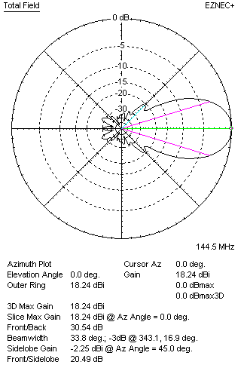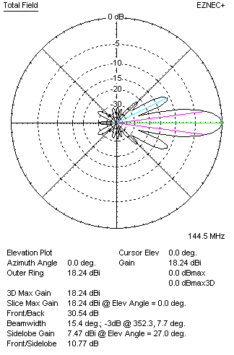

Performances
TYPE | Condition | G  (dBi) | F/B  (dB) | F/Sh  (dBi) | F/Sv (dBi) | Hor  (◦) | Ver  (◦) | Temp (◦K) | G/T (dB) | B (MHz)  for SWR=1.5
2xQY21110XL4D4 | No losss | 18.29 | 30.67 | 20.51 | 10.75 | 33.8 | 15.4 | 222.6 | -5.19 | 142.700- 146.100
2xQY21110XL4D4 | Aluminum | 18.24 | 30.54 | 20.49 | 10.77 | 33.8 | 15.4 | 223.5 | -5.25 | 142.700- 146.100

FOUR ANTENNAS VERTICALLY STACKED AT 350+350+350CM
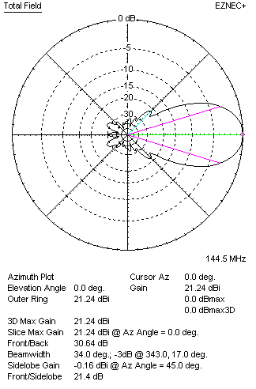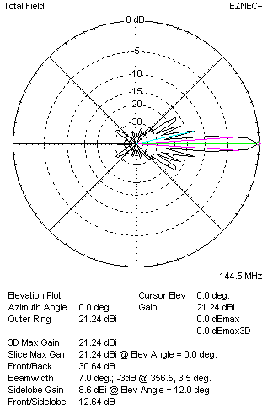
Performances
TYPE | Condition | G  (dBi) | F/B  (dB) | F/Sh  (dBi) | F/Sv (dBi) | Hor  (◦) | Ver  (◦) | Temp (◦K) | G/T (dB) | B (MHz)  for SWR=1.5
4xQY21110XL4D4 | No losss | 21.29 | 30.78 | 21.42 | 12.63 | 34.0 | 7.0 | 220.0 | -2.13 | 142.700- 146.100
4xQY21110XL4D4 | Aluminum | 21.29 | 30.64 | 21.40 | 12.64 | 34.0 | 7.0 | 221.0 | -2.20 | 142.700- 146.100

FOUR ANTENNAS IN H- STACK, H=400 CM, V=344 CM
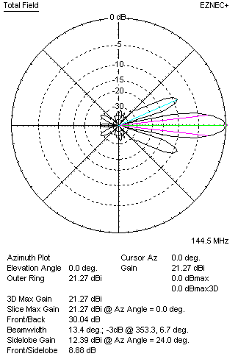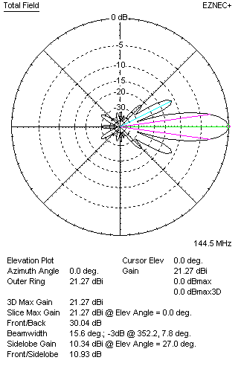
Performances
TYPE | Condition | G  (dBi) | F/B  (dB) | F/Sh  (dBi) | F/Sv (dBi) | Hor  (◦) | Ver  (◦) | Temp (◦K) | G/T (dB) | B (MHz)  for SWR=1.5
4xQY21110XL4D4 | No losss | 21.32 | 30.16 | 8.87 | 10.91 | 13.4 | 15.6 | 223.6 | -2.17 | 142.700- 146.100
4xQY21110XL4D4 | Aluminum | 21.27 | 30.04 | 8.88 | 10.93 | 13.4 | 15.6 | 224.5 | -2.24 | 142.700- 146.100

XPOL VERSION

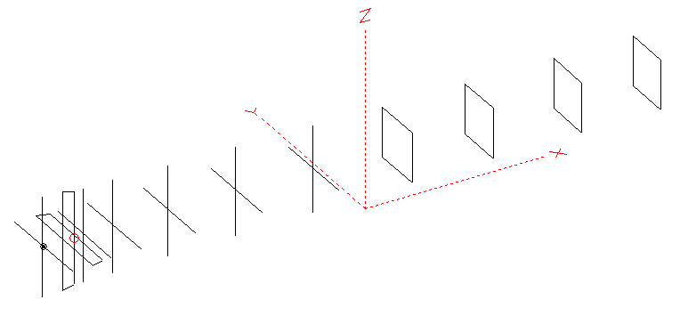
Horizontal components: Same as above
Vertical components: Same as above, except:
- All vertical yagi elements positioned 20 mm backward regarding horizontals.
- All crossed elements must cross each other in their centerlines

HORIZONTAL PERFORMANCES
Everything as the above data

VERTICAL PERFORMANCES with no corrections
Loss included condition (for Aluminum)
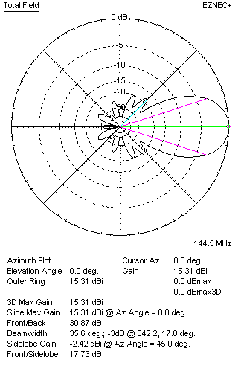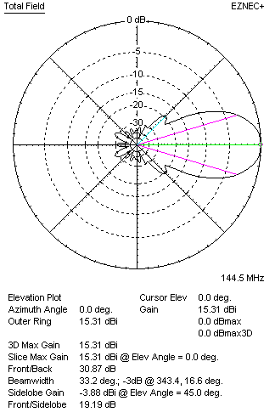
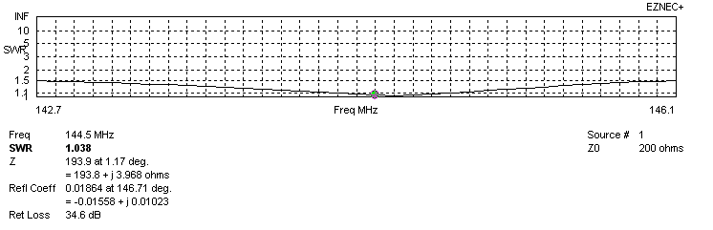
VERTICAL PERFORMANCES after corrections, loss included condition
If you want to get better SWR diagram for vertical antenna you can do the following:
- Change position of D1 for -2 mm
- Change length of DE2 from 924 to 932 mm

In this case the SWR diagram will be like this:
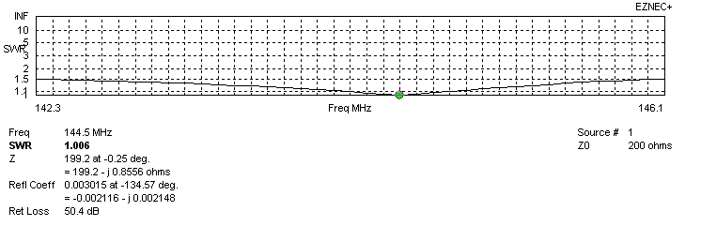
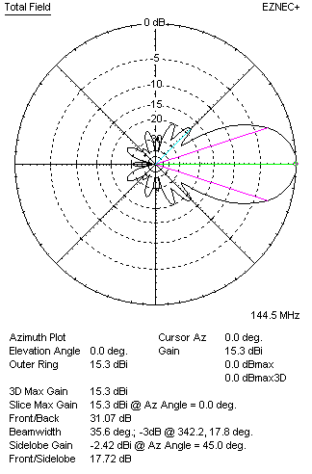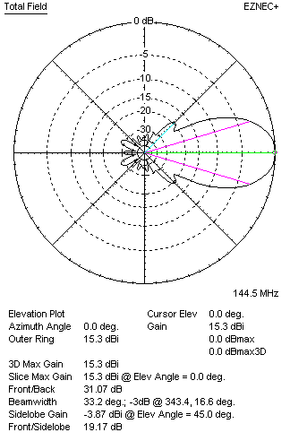

PERFORMANCES
 | TYPE | Condition | G  (dBi) | F/B  (dB) | F/Sh  (dBi) | F/Sv (dBi) | Hor  (◦) | Ver  (◦) | Temp (◦K) | G/T (dB) | B (MHz)  for SWR=1.5
 | Horizontal  part | No losss | 15.31 | 29.41 | 19.01 | 18.02 | 33.4 | 36.0 | 222.3 | -8.16 | 142.700- 146.100
 | Horizontal  part | Aluminum | 15.26 | 29.36 | 19.03 | 18.01 | 33.4 | 36.0 | 223.3 | -8.23 | 142.700- 146.100
 | Vertical  part | No losss | 15.35 | 31.07 | 17.72 | 19.18 | 35.6 | 33.2 | 223.5 | -8.14 | 142.300 – 146.050
 | Vertical  part | Aluminum | 15.30 | 31.07 | 17.72 | 19.17 | 35.6 | 33.2 | 224.5 | -8.21 | 142.300 – 146.050

