ANTENNA QY21108XL4D4
Good stacking characteristics at any vertical and horizontal distances
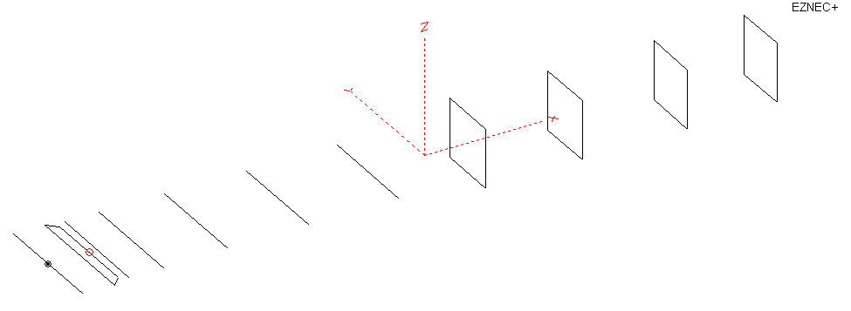
PERFORMANCES: (No loss condition)
TYPE | ELE | L (mm) | G (dBi) | F/B (dB) | F/Sh (dBi) | F/Sv (dBi) | Hor (◦) | Ver (◦) | Temp (◦K) | G/T (dB) | ΔF * (kHz)
QY21108XL4D4 | 11 | 6000 | 15.39 | 23.96 | 18.24 | 17.94 | 32.8 | 34.8 | 225.8 | -8.15 | 2900
* ΔF given for SWR=1,5

PERFORMANCES: (Loss included for aluminum)
Element material | G (dBi) | Temp (◦K) | G/T (dB)
Aluminum rods | 15.31 | 227.2 | -8.25

COMPARISON
Antenna | Boomlength (mm) | Material | Gain  (dBi) | TA  (◦K) | G/T  (dB) | Bandwidth  (MHz)
QY21108XL4D4 | 6000 | No loss | 15.39 | 225.8 | -8.15 | 143.400- 146.300
QY21108XL4D4 | 6000 | Aluminum | 15.31 | 227.2 | -8.25 | 143.400- 146.300
EF0211-5B | 5980 | No loss | 15.13 | 229.1 | -8.47 | 140.500-145.200
EF0211-5B | 5980 | Aluminum | 15.04 | 230.8 | -8.59 | 140.500-145.200
EF0211-05 | 6325 | No loss | 15.24 | 226.7 | -8.32 | 142.600-144.800
EF0211-05 | 6325 | Aluminum | 15.14 | 228.6 | -8.45 | 142.600-144.800

DIMENSIONS:

 | Ref | De1 | De2 | D1 | D2 | D3 | D4 | D5 | DQ1 | DQ2 | DQ3 | DQ4 | REMARKS:  - All elements made of Al rods Ǿ8  - Height of all rectangles 500 mm  - All dimensions given in milimetres
Pos | 0 | 190 | 330 | 406 | 704 | 1255 | 1943 | 2705 | 3525 | 4335 | 5203 | 6000
Length | 1016 | 1000 | 868 | 942 | 948 | 924 | 904 | 886 | 526 | 502 | 496 | 476
Building hints: No boom correction included.

DIAGRAMS (no loss included)
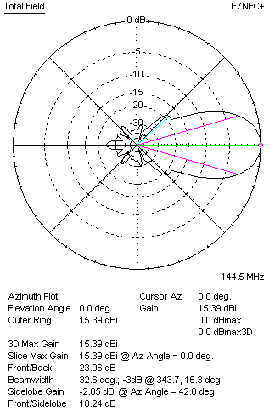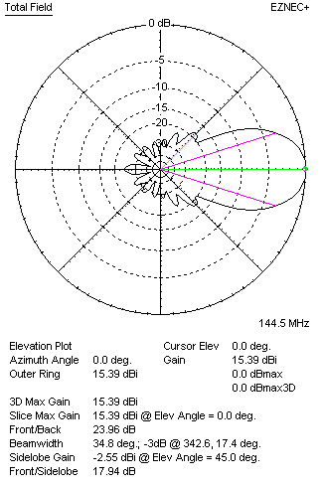
DIAGRAMS (loss included)
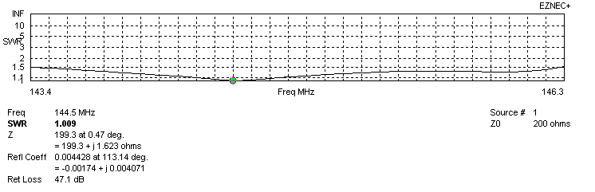
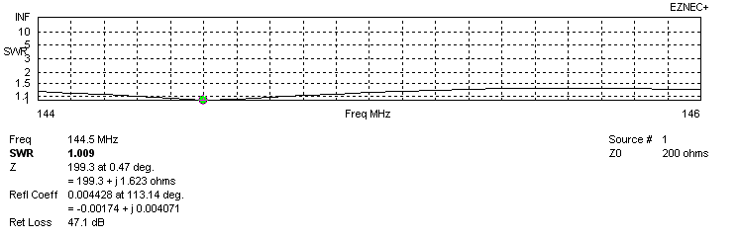
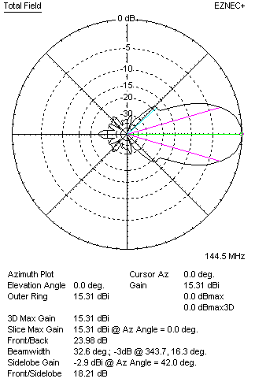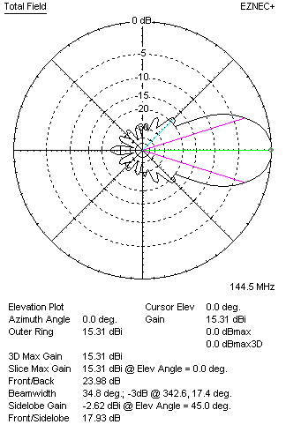
STACKING

QY21106XL4D4 - STACKING TABLE
(including loss for aluminum – AGT = -0.09 dB)
VERTICAL  DISTANCE (cm) | G  (dB) | TA  (°K) | G/T  (dB) | HORIZONTAL  DISTANCE (cm) | G  (dB) | TA  (°K) | G/T  (dB)
100 | 15.89 | 238.5 | -7.89 | 100
110 | 16.13 | 231.7 | -7.52 | 110
120 | 16.31 | 227.7 | -7.26 | 120 | 15.53 | 251.2 | -8.47
130 | 16.46 | 225.5 | -7.07 | 130 | 16.00 | 246.3 | -7.91
140 | 16.60 | 223.6 | -6.89 | 140 | 16.29 | 241.7 | -7.54
150 | 16.73 | 221.1 | -6.72 | 150 | 16.50 | 238.1 | -7.27
160 | 16.85 | 218.9 | -6.55 | 160 | 16.66 | 235.5 | -7.06
170 | 16.96 | 217.8 | -6.42 | 170 | 16.80 | 233.5 | -6.88
180 | 17.06 | 217.9 | -6.32 | 180 | 16.93 | 232.0 | -6.72
190 | 17.16 | 218.7 | -6.24 | 190 | 17.04 | 230.8 | -6.59
200 | 17.25 | 220.0 | -6.17 | 200 | 17.14 | 229.8 | -6.47
210 | 17.34 | 221.7 | -6.12 | 210 | 17.23 | 229.0 | -6.37
220 | 17.42 | 223.3 | -6.07 | 220 | 17.32 | 228.2 | -6.26
230 | 17.50 | 224.5 | -6.01 | 230 | 17.40 | 227.5 | -6.17
240 | 17.58 | 225.3 | -5.95 | 240 | 17.48 | 226.9 | -6.08
250 | 17.66 | 225.5 | -5.87 | 250 | 17.56 | 226.3 | -5.99
260 | 17.74 | 225.4 | -5.79 | 260 | 17.64 | 225.8 | -5.90
270 | 17.82 | 225.2 | -5.70 | 270 | 17.71 | 225.3 | -5.82
280 | 17.90 | 224.9 | -5.62 | 280 | 17.79 | 224.8 | -5.73
290 | 17.97 | 224.8 | -5.55 | 290 | 17.86 | 224.5 | -5.65
300 | 18.04 | 224.8 | -5.48 | 300 | 17.92 | 224.2 | -5.59
310 | 18.10 | 225.2 | -5.43 | 310 | 17.99 | 224.0 | -5.51
320 | 18.15 | 225.7 | -5.39 | 320 | 18.04 | 224.0 | -5.46
330 | 18.20 | 226.5 | -5.35 | 330 | 18.10 | 223.9 | -5.40
340 | 18.24 | 227.4 | -5.33 | 340 | 18.14 | 224.0 | -5.36
350 | 18.27 | 228.3 | -5.32 | 350 | 18.18 | 224.2 | -5.33
360 | 18.30 | 229.2 | -5.30 | 360 | 18.22 | 224.4 | -5.29
370 | 18.32 | 230.1 | -5.30 | 370 | 18.25 | 224.7 | -5.27
380 | 18.34 | 230.7 | -5.29 | 380 | 18.27 | 225.1 | -5.25
390 | 18.35 | 231.2 | -5.29 | 390 | 18.30 | 225.5 | -5.24
400 | 18.36 | 231.5 | -5.28 | 400 | 18.31 | 225.9 | -5.23
 |  |  |  | 410 | 18.33 | 226.3 | -5.22
 |  |  |  | 420 | 18.34 | 226.7 | -5.21

TWO ANTENNAS VERTICALLY STACKED AT 380CM
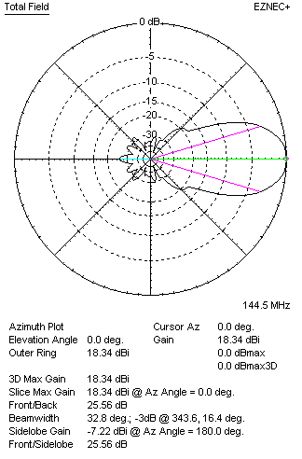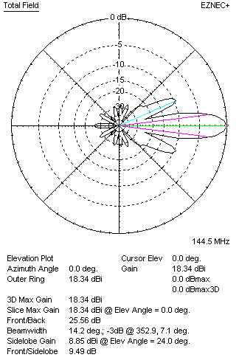

Performances
TYPE | Condition | G  (dBi) | F/B  (dB) | F/Sh  (dBi) | F/Sv (dBi) | Hor  (◦) | Ver  (◦) | Temp (◦K) | G/T (dB) | B (MHz)  for SWR=1.5
2xQY21108XL4D4 | No losss | 18.42 | 25.53 | 18.90 | 9.47 | 32.9 | 14.2 | 229.4 | -5.19 | 143.400- 146.300
2xQY21108XL4D4 | Aluminum | 18.34 | 25.56 | 18.87 | 9.49 | 32.8 | 14.2 | 230.7 | -5.29 | 143.400- 146.300

FOUR ANTENNAS VERTICALLY STACKED AT 380+380+380CM
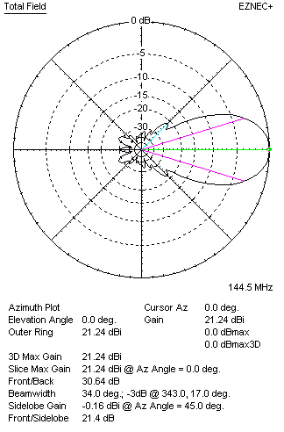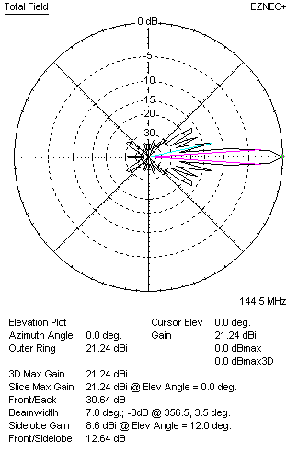
Performances
TYPE | Condition | G  (dBi) | F/B  (dB) | F/Sh  (dBi) | F/Sv (dBi) | Hor  (◦) | Ver  (◦) | Temp (◦K) | G/T (dB) | B (MHz)  for SWR=1.5
4xQY21110XL4D4 | No losss | 21.44 | 26.23 | 19.67 | 12.86 | 33.2 | 6.6 | 234.3 | -2.26 | 143.400- 146.300
4xQY21110XL4D4 | Aluminum | 21.36 | 26.25 | 19.67 | 12.86 | 33.0 | 6.6 | 235.5 | -2.36 | 143.400- 146.300

FOUR ANTENNAS IN H- STACK, H=420 CM, V=380 CM
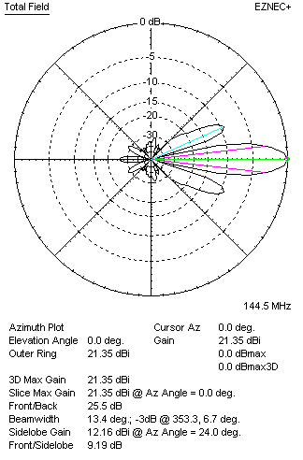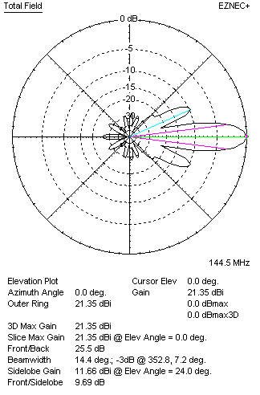
Performances
TYPE | Condition | G  (dBi) | F/B  (dB) | F/Sh  (dBi) | F/Sv (dBi) | Hor  (◦) | Ver  (◦) | Temp (◦K) | G/T (dB) | B (MHz)  for SWR=1.5
4xQY21108XL4D4 | No losss | 21.43 | 25.49 | 9.18 | 9.67 | 13.4 | 14.4 | 229.5 | -2.18 | 143.400- 146.300
4xQY21108XL4D4 | Aluminum | 21.35 | 25.50 | 9.19 | 9.69 | 13.4 | 14.4 | 230.8 | -2.28 | 143.400- 146.300

XPOL VERSION

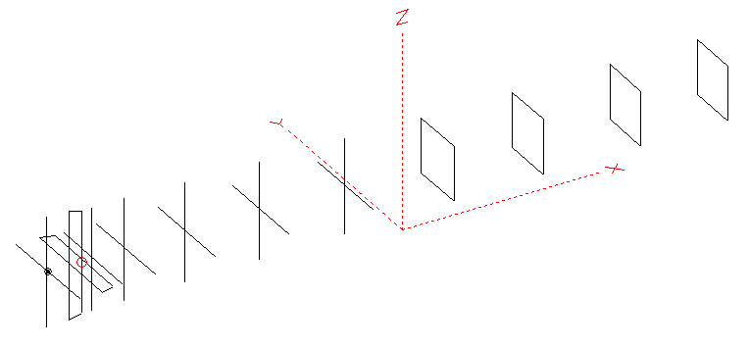
Horizontal components: Same as above
Vertical components: Same as above, except:
- All vertical yagi elements positioned 20 mm backward regarding horizontals.
- All crossed elements must cross each other in their centerlines

HORIZONTAL PERFORMANCES
Everything as the above data

VERTICAL PERFORMANCES with no corrections
Loss included condition (for Aluminum)
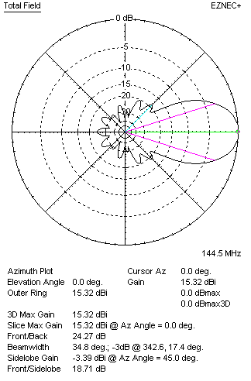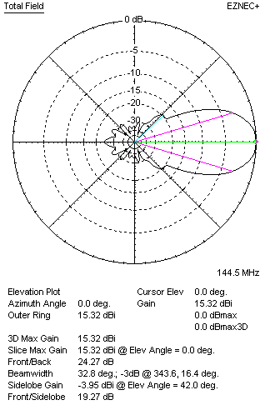
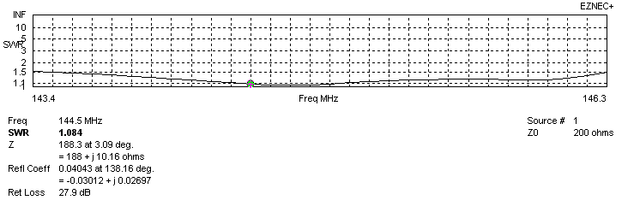
VERTICAL PERFORMANCES after corrections, loss included condition
If you want to get better SWR diagram for vertical antenna you can do the following:
- Change position of D1 for -3 mm
- Change length of D2 from 948 to 949 mm

In this case the SWR diagram will be like this:
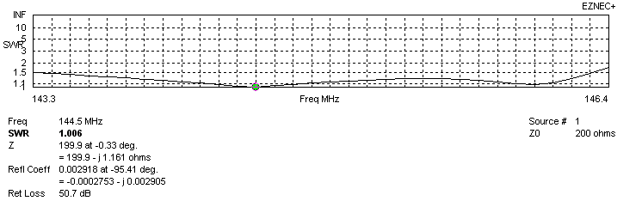
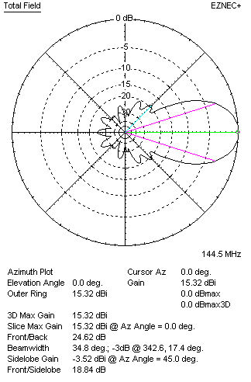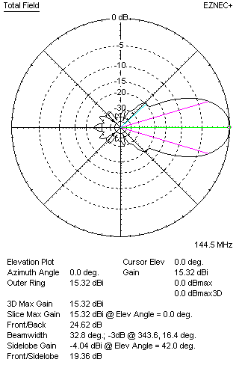

PERFORMANCES
 | TYPE | Condition | G  (dBi) | F/B  (dB) | F/Sh  (dBi) | F/Sv (dBi) | Hor  (◦) | Ver  (◦) | Temp (◦K) | G/T (dB) | B (MHz)  for SWR=1.5
 | Horizontal  part | No losss | 15.39 | 23.96 | 18.24 | 17.94 | 32.8 | 34.8 | 225.8 | -8.15 | 143.400- 146.300
 | Horizontal  part | Aluminum | 15.31 | 23.98 | 18.21 | 17.93 | 32.6 | 34.8 | 227.2 | -8.25 | 143.400- 146.300
 | Vertical  part | No losss | 15.40 | 24.56 | 18.84 | 19.39 | 34.8 | 32.8 | 226.4 | -8.15 | 143.300 – 146.300
 | Vertical  part | Aluminum | 15.32 | 24.62 | 18.84 | 19.36 | 34.8 | 32.8 | 227.8 | -8.26 | 143.300 – 146.300

