ANTENNA QY21106XL4D4
Good stacking characteristics at any vertical and horizontal distances
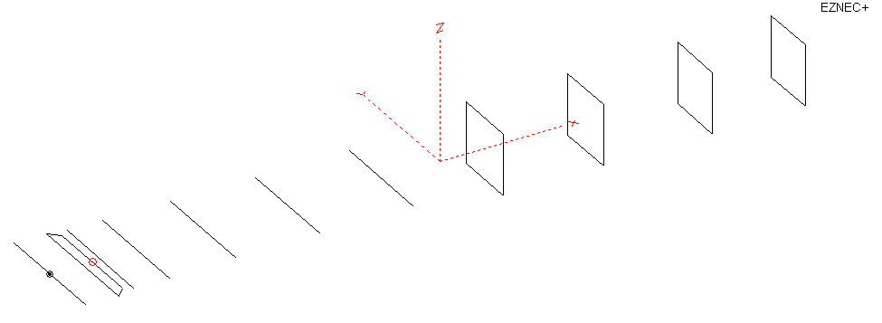
PERFORMANCES: (No loss condition)
TYPE | ELE | L (mm) | G (dBi) | F/B (dB) | F/Sh (dBi) | F/Sv (dBi) | Hor (◦) | Ver (◦) | Temp (◦K) | G/T (dB) | ΔF * (kHz)
QY21106XL4D4 | 11 | 6000 | 15.30 | 29.70 | 20.45 | 20.23 | 33.4 | 35.8 | 221.6 | -8.16 | 3600
* ΔF given for SWR=1,5

PERFORMANCES: (Loss included for aluminum)
Element material | G (dBi) | Temp (◦K) | G/T (dB)
Aluminum rods | 15.20 | 223.5 | -8.29

COMPARISON
Antenna | Boomlength (mm) | Material | Gain  (dBi) | TA  (◦K) | G/T  (dB) | Bandwidth  (MHz)
QY21106XL4D4 | 6000 | No loss | 15.35 | 221.6 | -8.16 | 142.800- 146.400
QY21106XL4D4 | 6000 | Aluminum | 15.20 | 223.5 | -8.29 | 142.800- 146.400
EF0211-5B | 5980 | No loss | 15.13 | 229.1 | -8.47 | 140.500-145.200
EF0211-5B | 5980 | Aluminum | 15.04 | 230.8 | -8.59 | 140.500-145.200
EF0211-05 | 6325 | No loss | 15.24 | 226.7 | -8.32 | 142.600-144.800
EF0211-05 | 6325 | Aluminum | 15.14 | 228.6 | -8.45 | 142.600-144.800

DIMENSIONS:

 | Ref | De1 | De2 | D1 | D2 | D3 | D4 | D5 | DQ1 | DQ2 | DQ3 | DQ4 | REMARKS:  - All elements made of Al rods Ǿ6  - Height of all rectangles 500 mm  - All dimensions given in milimetres
Pos | 0 | 200 | 350 | 428 | 722 | 1278 | 1950 | 2715 | 3525 | 4355 | 5268 | 6000
Length | 1016 | 996 | 896 | 956 | 956 | 930 | 914 | 896 | 518 | 494 | 490 | 484

Building hints: No boom correction included.

DIAGRAMS (no loss included)
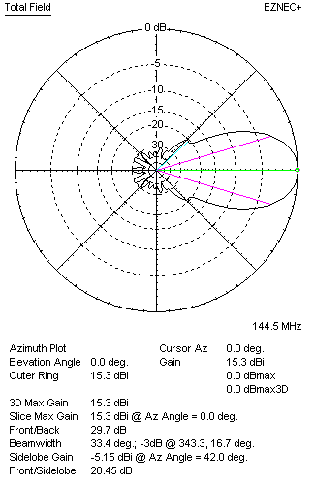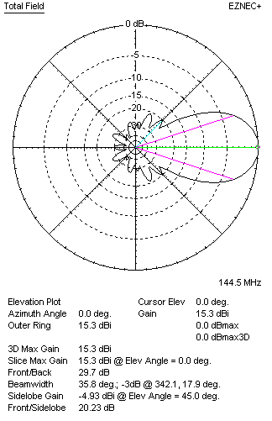
DIAGRAMS (loss included)
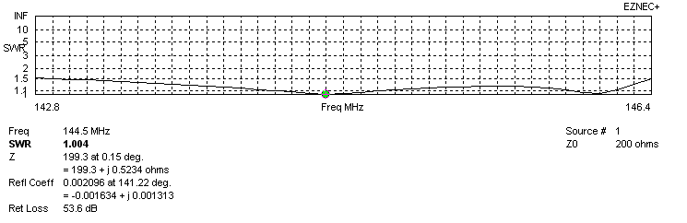
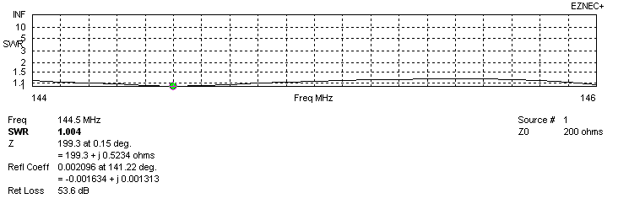
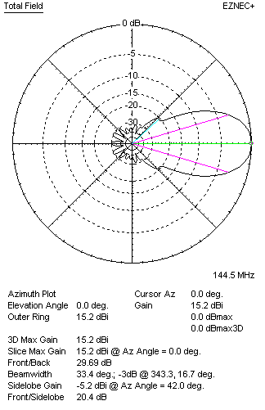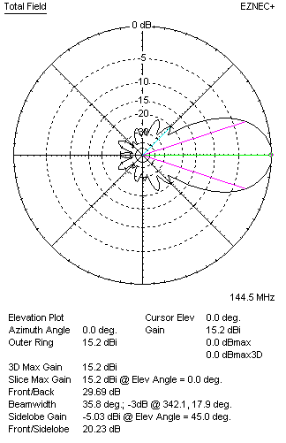
STACKING

QY21106XL4D4 - STACKING TABLE
(including loss for aluminum – AGT = -0.12 dB)
VERTICAL  DISTANCE (cm) | G  (dB) | TA  (°K) | G/T  (dB) | HORIZONTAL  DISTANCE (cm) | G  (dB) | TA  (°K) | G/T  (dB)
100 | 16.02 | 229.1 | -7.58 | 100
110 | 16.21 | 224.1 | -7.29 | 110
120 | 16.36 | 221.3 | -7.09 | 120 | 15.64 | 246.1 | -8.27
130 | 16.49 | 219.8 | -6.93 | 130 | 16.04 | 240.5 | -7.77
140 | 16.61 | 218.5 | -6.78 | 140 | 16.30 | 236.0 | -7.43
150 | 16.72 | 217.1 | -6.65 | 150 | 16.48 | 232.6 | -7.19
160 | 16.83 | 216.6 | -6.53 | 160 | 16.63 | 230.1 | -6.99
170 | 16.92 | 217.2 | -6.45 | 170 | 16.76 | 228.2 | -6.82
180 | 17.01 | 218.3 | -6.38 | 180 | 16.87 | 226.8 | -6.69
190 | 17.09 | 219.4 | -6.32 | 190 | 16.98 | 225.7 | -6.56
200 | 17.18 | 220.5 | -6.25 | 200 | 17.07 | 224.8 | -6.45
210 | 17.26 | 221.4 | -6.19 | 210 | 17.16 | 224.0 | -6.34
220 | 17.34 | 222.0 | -6.12 | 220 | 17.25 | 223.5 | -6.24
230 | 17.42 | 222.4 | -6.05 | 230 | 17.33 | 222.9 | -6.15
240 | 17.50 | 222.3 | -5.97 | 240 | 17.41 | 222.5 | -6.06
250 | 17.58 | 221.9 | -5.88 | 250 | 17.49 | 222.1 | -5.98
260 | 17.66 | 221.3 | -5.79 | 260 | 17.56 | 221.8 | -5.90
270 | 17.74 | 220.7 | -5.70 | 270 | 17.64 | 221.6 | -5.81
280 | 17.82 | 220.2 | -5.61 | 280 | 17.71 | 221.4 | -5.74
290 | 17.89 | 219.9 | -5.53 | 290 | 17.78 | 221.2 | -5.67
300 | 17.96 | 219.9 | -5.46 | 300 | 17.85 | 221.1 | -5.60
310 | 18.02 | 220.2 | -5.41 | 310 | 17.91 | 221.0 | -5.53
320 | 18.07 | 220.7 | -5.37 | 320 | 17.96 | 221.0 | -5.48
330 | 18.12 | 221.4 | -5.33 | 330 | 18.01 | 221.1 | -5.44
340 | 18.16 | 222.3 | -5.31 | 340 | 18.06 | 221.2 | -5.39
350 | 18.19 | 223.3 | -5.30 | 350 | 18.10 | 221.4 | -5.35
360 | 18.21 | 224.2 | -5.29 | 360 | 18.13 | 221.6 | -5.33
370 | 18.24 | 225.2 | -5.28 | 370 | 18.16 | 221.9 | -5.30
380 | 18.25 | 226.1 | -5.29 | 380 | 18.19 | 222.2 | -5.29
390 | 18.26 | 227.0 | -5.30 | 390 | 18.20 | 222.5 | -5.27
400 |  |  |  | 400 | 18.22 | 222.8 | -5.26
 |  |  |  | 410 | 18.23 | 223.1 | -5.26
 |  |  |  | 420 | 18.24 | 223.5 | -5.25

TWO ANTENNAS VERTICALLY STACKED AT 370CM
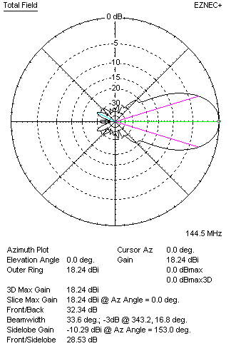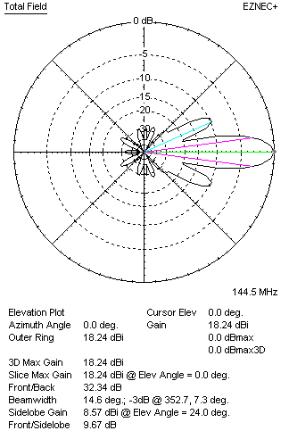

Performances
TYPE | Condition | G  (dBi) | F/B  (dB) | F/Sh  (dBi) | F/Sv (dBi) | Hor  (◦) | Ver  (◦) | Temp (◦K) | G/T (dB) | B (MHz)  for SWR=1.5
2xQY21106XL4D4 | No losss | 18.34 | 32.40 | 22.82 | 9.65 | 33.8 | 14.6 | 223.4 | -5.15 | 142.800- 146.400
2xQY21106XL4D4 | Aluminum | 18.24 | 32.34 | 22.84 | 9.67 | 33.6 | 14.6 | 225.2 | -5.28 | 142.800- 146.400

FOUR ANTENNAS VERTICALLY STACKED AT 370+370+370CM
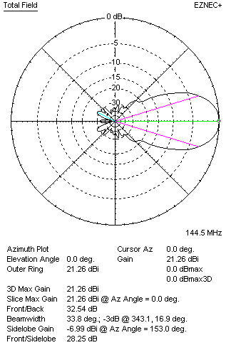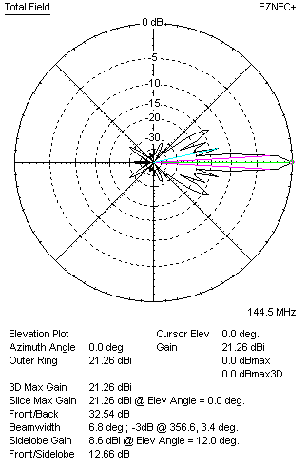
Performances
TYPE | Condition | G  (dBi) | F/B  (dB) | F/Sh  (dBi) | F/Sv (dBi) | Hor  (◦) | Ver  (◦) | Temp (◦K) | G/T (dB) | B (MHz)  for SWR=1.5
4xQY21106XL4D4 | No losss | 21.34 | 32.69 | 21.62 | 12.66 | 34.0 | 6.8 | 227.2 | -2.20 | 142.800- 146.400
4xQY21106XL4D4 | Aluminum | 21.26 | 32.54 | 21.57 | 12.66 | 33.8 | 6.8 | 228.8 | -2.33 | 142.800- 146.400

FOUR ANTENNAS IN H- STACK, H=410 CM, V=360 CM
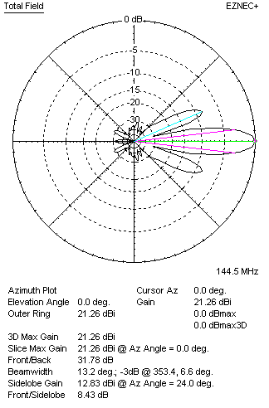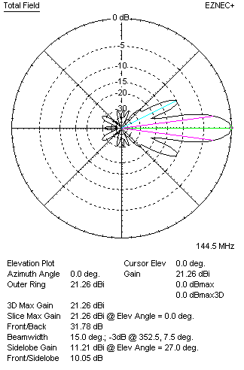
Performances
TYPE | Condition | G  (dBi) | F/B  (dB) | F/Sh  (dBi) | F/Sv (dBi) | Hor  (◦) | Ver  (◦) | Temp (◦K) | G/T (dB) | B (MHz)  for SWR=1.5
4xQY21106XL3D3 | No losss | 21.36 | 31.89 | 8.41 | 10.02 | 13.2 | 15.0 | 223.6 | -2.14 | 142.800- 146.400
4xQY21106XL3D3 | Aluminum | 21.26 | 31.78 | 8.43 | 10.05 | 13.2 | 15.0 | 225.4 | -2.27 | 142.800- 146.400

XPOL VERSION

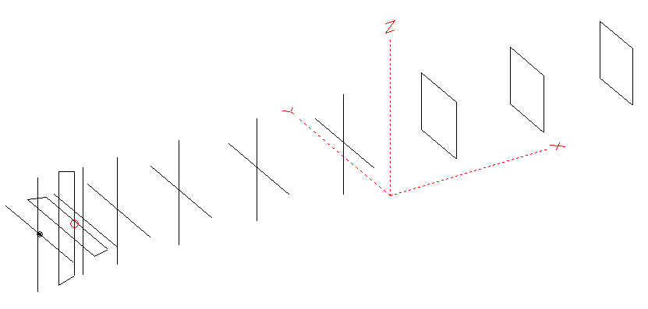
Horizontal components: Same as above
Vertical components: Same as above, except:
- All vertical yagi elements positioned 20 mm backward regarding horizontals.
- All crossed elements must cross each other in their centerlines

HORIZONTAL PERFORMANCES
Everything as the above data

VERTICAL PERFORMANCES with no corrections
Loss included condition (for Aluminum)
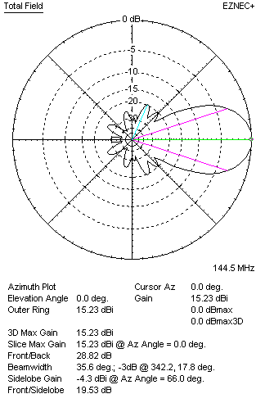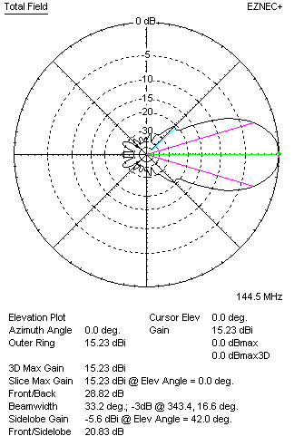
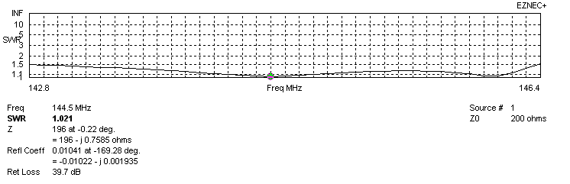
VERTICAL PERFORMANCES after corrections, loss included condition
If you want to get better SWR diagram for vertical antenna you can do the following:
- Change length of D1 from 956 to 954 mm
- Change length of DE2 from 896 to 886 mm
- Change position of D1 for -1 mm

In this case the SWR diagram will be like this:
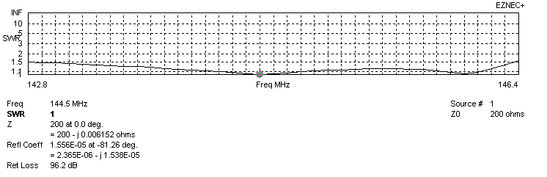
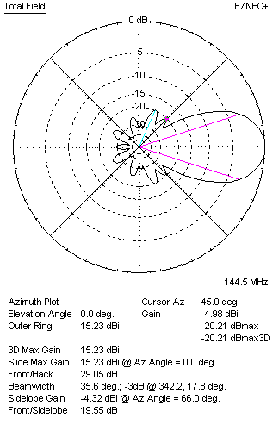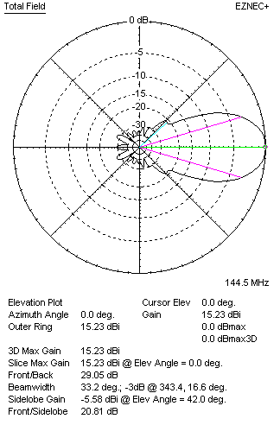

PERFORMANCES: (No loss condition)
 | TYPE | Condition | G  (dBi) | F/B  (dB) | F/Sh  (dBi) | F/Sv (dBi) | Hor  (◦) | Ver  (◦) | Temp (◦K) | G/T (dB) | B (MHz)  for SWR=1.5
 | Horizontal  part | No losss | 15.30 | 29.70 | 20.45 | 20.23 | 33.4 | 35.8 | 221.6 | -8.16 | 142.800- 146.400
 | Horizontal  part | Aluminum | 15.20 | 29.69 | 20.40 | 20.23 | 33.4 | 35.8 | 223.5 | -8.29 | 142.800- 146.400
 | Vertical  part | No losss | 15.33 | 29.04 | 19.58 | 20.86 | 35.6 | 33.2 | 222.8 | -8.15 | 142.800 – 146.350
 | Vertical  part | Aluminum | 15.21 | 29.05 | 19.55 | 20.81 | 35.6 | 33.2 | 224.6 | -8.28 | 142.800 – 146.350

