ANTENNA QY21106XL2D4
Classic folded dipole as radiator. Not recommended for XPOL. If stacking wanted, please, choose the antenna model QY21106XL4D4 instead
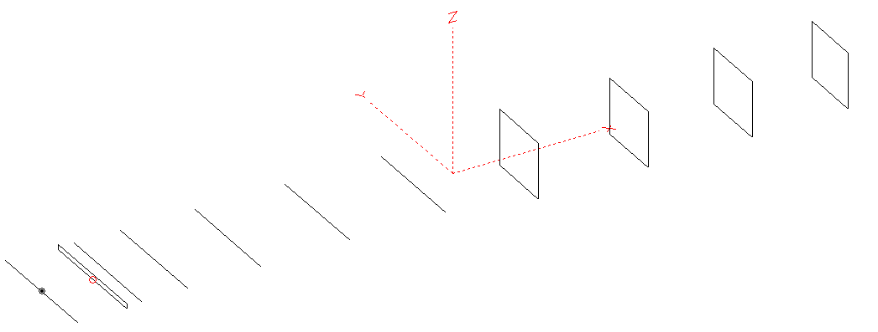
PERFORMANCES: (No loss condition)
TYPE | ELE | L (mm) | G (dBi) | F/B (dB) | F/Sh (dBi) | F/Sv (dBi) | Hor (◦) | Ver (◦) | Temp (◦K) | G/T (dB) | ΔF * (kHz)
QY21106XL2D4 | 11 | 6305 | 15.49 | 22.51 | 19.18 | 18.44 | 32.4 | 34.7 | 227.4 | -8.08 | 4100
* ΔF given for SWR=1,5

PERFORMANCES: (Loss included for aluminum)
Element material | G (dBi) | Temp (◦K) | G/T (dB)
Aluminum rods | 15.41 | 229.0 | -8.19

COMPARISON
Antenna | Boomlength (mm) | Material | Gain  (dBi) | TA  (◦K) | G/T  (dB) | Bandwidth  (MHz)
QY21106XL2D4 | 6305 | No loss | 15.49 | 227.4 | -8.08 | 142.200- 146.300
QY21106XL2D4 | 6305 | Aluminum | 15.41 | 229.0 | -8.19 | 142.200- 146.300
EF0211-05 | 6325 | No loss | 15.24 | 226.7 | -8.32 | 142.600-144.800
EF0211-05 | 6325 | Aluminum | 15.14 | 228.6 | -8.45 | 142.600-144.800

DIMENSIONS:

 | Ref | De1 | D1 | D2 | D3 | D4 | D5 | DQ1 | DQ2 | DQ3 | DQ4 | REMARKS:  - All elements made of Al rods Ǿ6  - Height of all rectangles 450 mm  - All dimensions given in milimetres
Pos | 0 | 405 | 531 | 895 | 1489 | 2205 | 2975 | 3816 | 4698 | 5529 | 6305
Length | 1012 | 954 | 944 | 944 | 926 | 906 | 892 | 544 | 532 | 528 | 510
Building hints:
- No boom correction included.
- Radiator is in classic, folded shape, dimension 954+40+(2x472) mm, with a gap 10 mm included.

DIAGRAMS (no loss included)
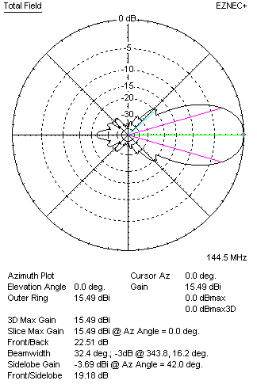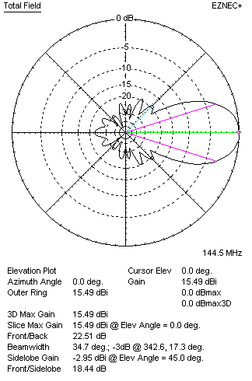
DIAGRAMS (loss included)
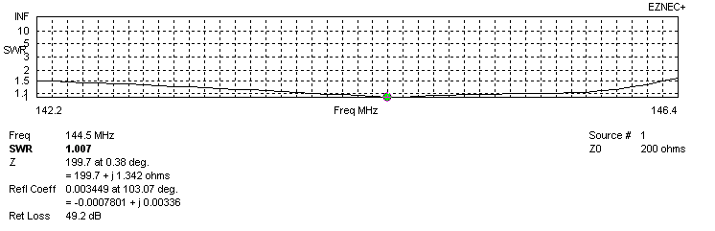
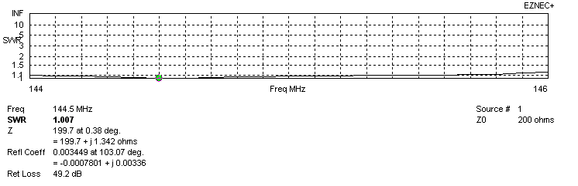

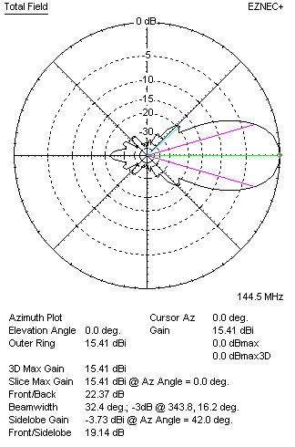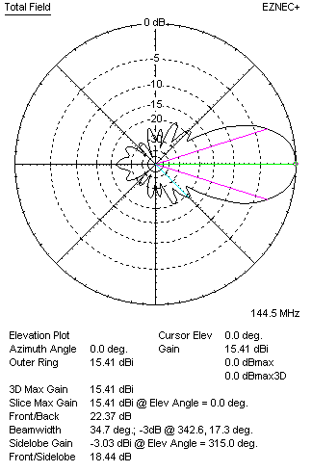
STACKING

QY21106XL4D4 - STACKING TABLE
(including loss for aluminum – AGT = -0.08 dB)
VERTICAL  DISTANCE (cm) | G  (dB) | TA  (°K) | G/T  (dB) | HORIZONTAL  DISTANCE (cm) | G  (dB) | TA  (°K) | G/T  (dB)
100 | 16.18 | 236.6 | -7.56 | 100
110 | 16.38 | 229.8 | -7.23 | 110
120 | 16.52 | 227.1 | -7.04 | 120 | 15.41 | 229.0 | -8.19
130 | 16.62 | 229.6 | -6.99 | 130 | 16.18 | 248.6 | -7.77
140 | 16.68 | 235.2 | -7.03 | 140 | 16.43 | 247.0 | -7.50
150 | 16.76 | 237.7 | -7.00 | 150 | 16.48 | 232.6 | -7.19
160 | 16.87 | 235.1 | -6.84 | 160 | 16.61 | 244.6 | -7.27
170 | 16.99 | 231.6 | -6.66 | 170 | 16.88 | 239.9 | -6.92
180 | 17.10 | 229.3 | -6.50 | 180 | 17.00 | 238.1 | -6.77
190 | 17.20 | 228.4 | -6.39 | 190 | 17.10 | 236.4 | -6.64
200 | 17.30 | 228.5 | -6.29 | 200 | 17.20 | 234.9 | -6.51
210 | 17.39 | 229.1 | -6.21 | 210 | 17.29 | 233.6 | -6.39
220 | 17.47 | 229.9 | -6.15 | 220 | 17.38 | 232.3 | -6.28
230 | 17.55 | 230.5 | -6.08 | 230 | 17.46 | 231.2 | -6.18
240 | 17.63 | 230.6 | -6.00 | 240 | 17.54 | 230.2 | -6.08
250 | 17.71 | 230.2 | -5.91 | 250 | 17.61 | 229.2 | -5.99
260 | 17.79 | 221.3 | -5.79 | 260 | 17.69 | 228.4 | -5.90
270 | 17.88 | 228.2 | 5.70 | 270 | 17.76 | 227.7 | -5.81
280 | 17.96 | 227.0 | -5.60 | 280 | 17.84 | 227.1 | -5.72
290 | 18.04 | 225.9 | -5.50 | 290 | 17.91 | 226.6 | -5.64
300 | 18.11 | 225.1 | -5.41 | 300 | 17.98 | 226.3 | -5.57
310 | 18.18 | 224.7 | -5.34 | 310 | 18.04 | 226.0 | -5.50
320 | 18.24 | 224.7 | -5.28 | 320 | 18.10 | 225.9 | -5.44
330 | 18.29 | 225.2 | -5.24 | 330 | 18.16 | 225.9 | -5.38
340 | 18.33 | 226.3 | -5.22 | 340 | 18.21 | 226.0 | -5.33
350 | 18.36 | 227.8 | -5.22 | 350 | 18.25 | 226.1 | -5.29
360 | 18.38 | 229.6 | -5.23 | 360 | 18.29 | 226.3 | -5.26
370 | 18.39 | 231.0 | -5.24 | 370 | 18.33 | 226.6 | -5.22
380 | 18.41 | 231.8 | -5.24 | 380 | 18.36 | 226.9 | -5.20
390 | 18.43 | 232.3 | -5.24 | 390 | 18.38 | 227.2 | -5.18
400 |  |  |  | 400 | 18.40 | 227.6 | -5.17
 |  |  |  | 410 | 18.42 | 227.9 | -5.16
 |  |  |  | 420 | 18.43 | 228.3 | -5.15

TWO ANTENNAS VERTICALLY STACKED AT 340CM
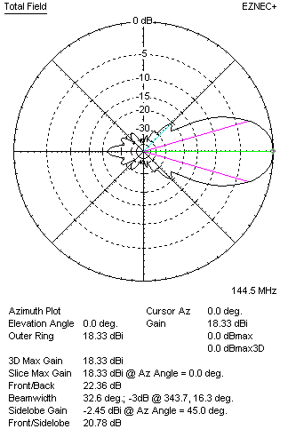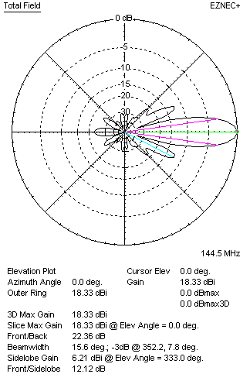

Performances
TYPE | Condition | G  (dBi) | F/B  (dB) | F/Sh  (dBi) | F/Sv (dBi) | Hor  (◦) | Ver  (◦) | Temp (◦K) | G/T (dB) | B (MHz)  for SWR=1.5
2xQY21106XL2D4 | No losss | 18.41 | 22.49 | 20.79 | 12.09 | 32.6 | 15.6 | 224.7 | -5.11 | 142.200- 146.300
2xQY21106XL2D4 | Aluminum | 18.33 | 22.36 | 20.78 | 12.12 | 32.6 | 15.6 | 226.3 | -5.22 | 142.200- 146.300

FOUR ANTENNAS VERTICALLY STACKED AT 340+340+340CM
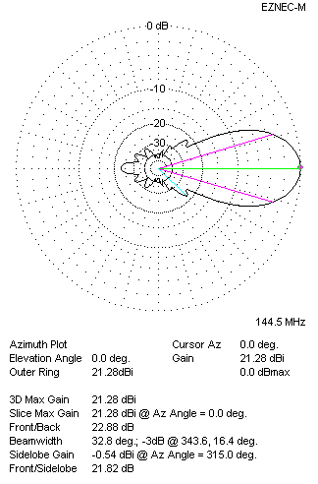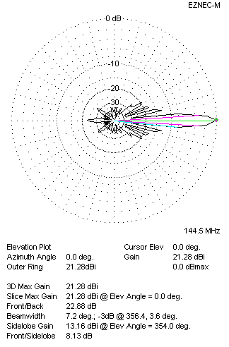
Performances
TYPE | Condition | G  (dBi) | F/B  (dB) | F/Sh  (dBi) | F/Sv (dBi) | Hor  (◦) | Ver  (◦) | Temp (◦K) | G/T (dB) | B (MHz)  for SWR=1.5
4xQY21106XL2D4 | No losss | 21.37 | 23.02 | 21.85 | 8.13 | 32.8 | 7.2 | 219.7 | -2.05 | 142.200- 146.300
4xQY21106XL2D4 | Aluminum | 21.28 | 22.88 | 21.82 | 8.13 | 32.8 | 7.2 | 221.3 | -2.17 | 142.200- 146.300

FOUR ANTENNAS IN H- STACK, H=420 CM, V=340 CM
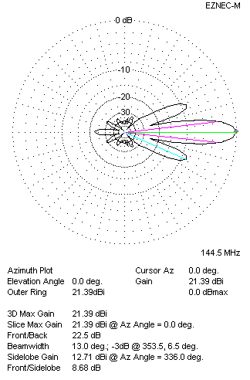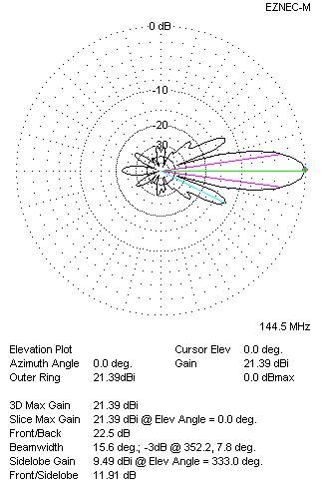
Performances
TYPE | Condition | G  (dBi) | F/B  (dB) | F/Sh  (dBi) | F/Sv (dBi) | Hor  (◦) | Ver  (◦) | Temp (◦K) | G/T (dB) | B (MHz)  for SWR=1.5
4xQY21106XL2D4 | No losss | 21.48 | 22.64 | 8.66 | 11.87 | 13.0 | 15.6 | 225.5 | -2.05 | 142.200- 146.300
4xQY21106XL2D4 | Aluminum | 21.39 | 22.50 | 8.68 | 11.91 | 13.0 | 15.6 | 226.9 | -2.17 | 142.200- 146.300

