ANTENNA QY21005XL5D4
Good stacking characteristics at moderate vertical distances and big horizontal distances
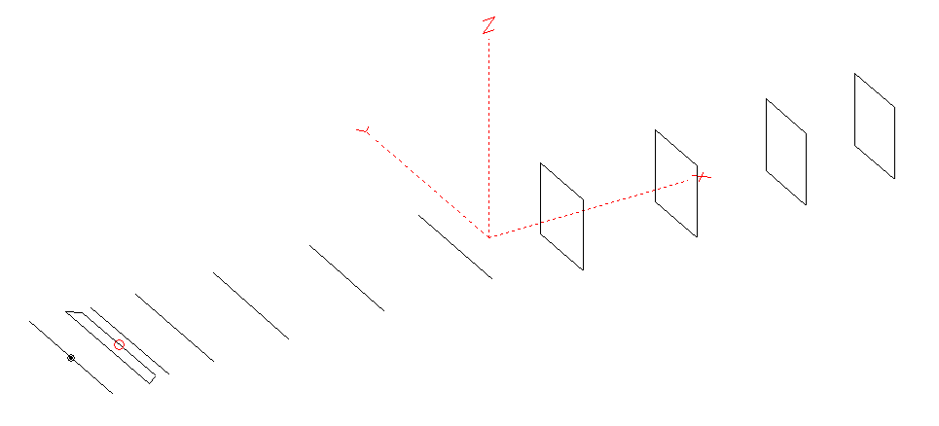
PERFORMANCES: (No loss condition)
TYPE | ELE | L (mm) | G (dBi) | F/B (dB) | F/Sh (dBi) | F/Sv (dBi) | Hor (◦) | Ver (◦) | Temp (◦K) | G/T (dB) | ΔF * (kHz)
QY21005XL5D4 | 11 | 5615 | 15.04 | 24.74 | 18.51 | 17.52 | 34.2 | 36.8 | 229.6 | -8.57 | 5400
* ΔF given for SWR=1,5

PERFORMANCES: (Loss included)
Element material | G (dBi) | Temp (◦K) | G/T (dB)
Aluminum rods | 14.95 | 231.2 | -8.69

DIMENSIONS:
 | Ref | De1 | De2 | D1 | D2 | D3 | D4 | D5 | DQ1 | DQ2 | DQ3 | DQ4 | REMARKS: -All elements made of Al rodsǾ5 mm  - The height of the rectangle is 500 mm  - All dimensions given in milimetres
Pos | 0 | 255 | 335 | 412 | 724 | 1259 | 1928 | 2687 | 3425 | 4228 | 4995 | 5615
Length | 1020 | 1012 | 888 | 944 | 954 | 928 | 914 | 900 | 518 | 502 | 492 | 478
Building hints: No boom correction included.

COMPARISON
Antenna | Boomlength (mm) | Material | Gain (dBi) | TA (◦K) | G/T (dB) | Bandwidth  (MHz)
QY21005XL5D4 | 5615 | No loss | 15.04 | 229.6 | -8.57 | 141.600- 147.000
QY21005XL5D4 | 5615 | Aluminum | 14.95 | 231.2 | -8.69 | 141.600- 147.000
EF0210-5 | 5290 | No loss | 14.77 | 233.8 | -8.92 | 140.190- 145.450
EF0210-5 | 5290 | Aluminum | 14.67 | 235.4 | -9.05 | 140.190- 145.450

DIAGRAMS (no loss included)
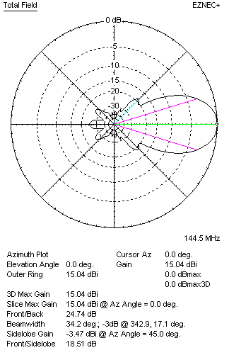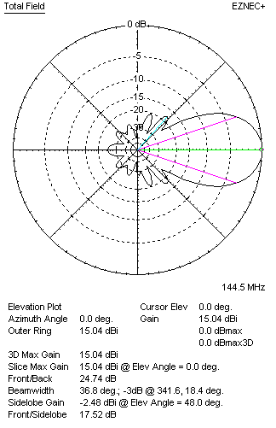
DIAGRAMS (loss included)
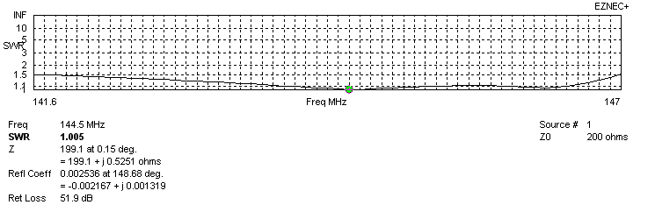
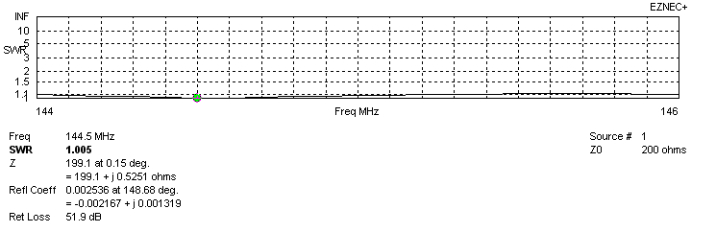
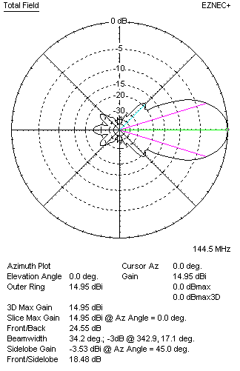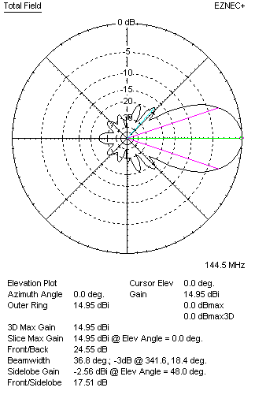

STACKING

QY21005XL5D4 - STACKING TABLE
(including loss for aluminum – AGT = -0.10 dB)
VERTICAL  DISTANCE  (cm) | G  (dB) | TA  (°K) | G/T  (dB) | HORIZONTAL  DISTANCE (cm) | G  (dB) | TA  (°K) | G/T  (dB)
100 | 15.79 | 228.3 | -7.80 | 100
110 | 15.97 | 224.2 | -7.54 | 110
120 | 16.12 | 222.5 | -7.35 | 120 | 15.58 | 252.6 | -8.44
130 | 16.25 | 222.8 | -7.23 | 130 | 15.88 | 246.9 | -8.04
140 | 16.36 | 223.6 | -7.13 | 140 | 16.10 | 242.5 | -7.75
150 | 16.47 | 223.4 | -7.02 | 150 | 16.27 | 239.4 | -7.52
160 | 16.57 | 223.1 | -6.91 | 160 | 16.41 | 237.1 | -7.34
170 | 16.66 | 223.7 | -6.84 | 170 | 16.53 | 235.4 | -7.19
180 | 16.75 | 225.2 | -6.78 | 180 | 16.64 | 234.2 | -7.06
190 | 16.83 | 227.1 | -6.73 | 190 | 16.74 | 233.2 | -6.94
200 | 16.91 | 229.2 | -6.69 | 200 | 16.83 | 232.3 | -6.83
210 | 16.99 | 230.9 | -6.64 | 210 | 16.92 | 231.6 | -6.73
220 | 17.08 | 232.0 | -6.57 | 220 | 17.00 | 231.0 | -6.64
230 | 17.16 | 232.3 | -6.50 | 230 | 17.08 | 230.4 | -6.54
240 | 17.25 | 231.8 | -6.40 | 240 | 17.16 | 229.9 | -6.46
250 | 17.34 | 230.8 | -6.29 | 250 | 17.24 | 229.5 | -6.37
260 | 17.43 | 229.5 | -6.18 | 260 | 17.32 | 229.2 | -6.28
270 | 17.51 | 228.3 | -6.08 | 270 | 17.39 | 228.9 | -6.21
280 | 17.60 | 227.4 | -5.97 | 280 | 17.47 | 228.8 | -6.12
290 | 17.67 | 226.9 | -5.89 | 290 | 17.54 | 228.6 | -6.05
300 | 17.74 | 226.7 | -5.81 | 300 | 17.61 | 228.6 | -5.98
310 | 17.80 | 227.0 | -5.76 | 310 | 17.67 | 228.6 | -5.92
320 | 17.86 | 227.5 | -5.71 | 320 | 17.73 | 228.7 | -5.86
330 | 17.90 | 228.4 | -5.69 | 330 | 17.78 | 228.8 | -5.81
340 | 17.94 | 229.5 | -5.67 | 340 | 17.82 | 229.0 | -5.78
350 | 17.97 | 230.7 | -5.66 | 350 | 17.86 | 229.3 | -5.74
360 | 17.99 | 231.9 | -5.66 | 360 | 17.89 | 229.5 | -5.72
370 | 18.01 | 233.0 | -5.66 | 370 | 17.92 | 229.8 | -5.69
380 | 18.03 | 234.9 | -5.68 | 380 | 17.95 | 230.2 | -5.67
 |  |  |  | 390 | 17.97 | 230.5 | -5.66
 |  |  |  | 400 | 17.98 | 230.9 | -5.65
 |  |  |  | 410 | 17.99 | 231.3 | -5.65

TWO ANTENNAS VERTICALLY STACKED AT 350CM
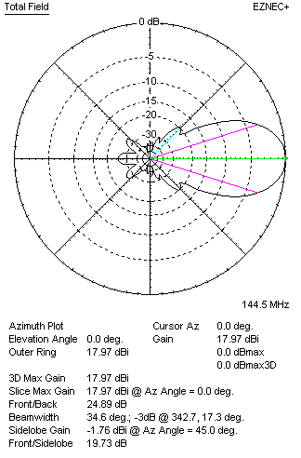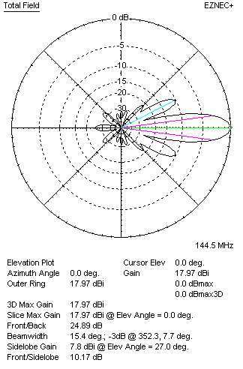

Performances
TYPE | Condition | G  (dBi) | F/B  (dB) | F/Sh  (dBi) | F/Sv (dBi) | Hor  (◦) | Ver  (◦) | Temp (◦K) | G/T (dB) | B (MHz)  for SWR=1.5
2xQY21105XL5D4 | No losss | 18.06 | 25.10 | 19.78 | 10.14 | 34.6 | 15.4 | 229.1 | -5.54 | 141.600- 147.000
2xQY21105XL5D4 | Aluminum | 17.97 | 24.89 | 19.73 | 10.17 | 34.6 | 15.4 | 230.7 | -5.66 | 141.600- 147.000

FOUR ANTENNAS VERTICALLY STACKED AT 350+350+350CM
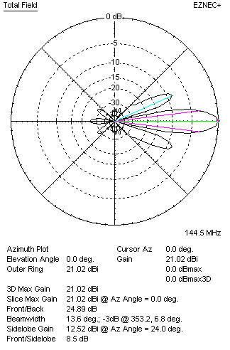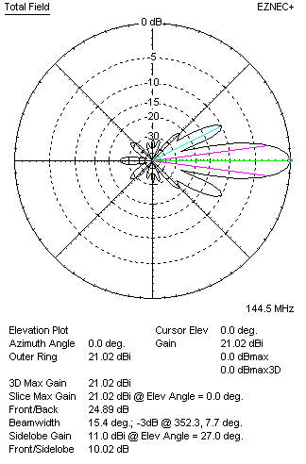
Performances
TYPE | Condition | G  (dBi) | F/B  (dB) | F/Sh  (dBi) | F/Sv (dBi) | Hor  (◦) | Ver  (◦) | Temp (◦K) | G/T (dB) | B (MHz)  for SWR=1.5
4xQY21105XL5D4 | No losss | 21.08 | 25.31 | 20.48 | 12.72 | 34.8 | 7.0 | 227.3 | -2.49 | 141.600- 147.000
4xQY21105XL5D4 | Aluminum | 20.99 | 25.09 | 20.44 | 12.72 | 34.8 | 7.4 | 228.8 | -2.61 | 141.600- 147.000

FOUR ANTENNAS IN H- STACK, H=400 CM, V=340 CM
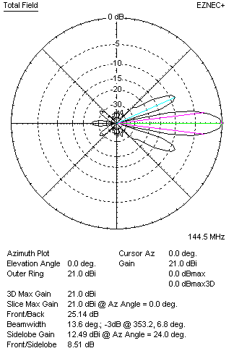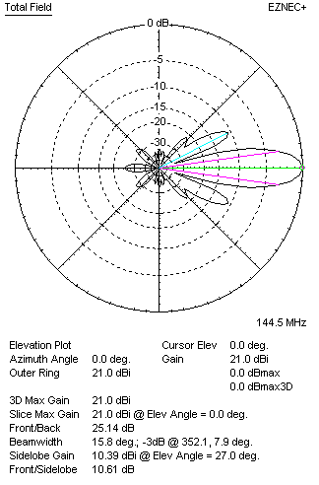
Performances
TYPE | Condition | G  (dBi) | F/B  (dB) | F/Sh  (dBi) | F/Sv (dBi) | Hor  (◦) | Ver  (◦) | Temp (◦K) | G/T (dB) | B (MHz)  for SWR=1.5
4xQY21105XL5D4 | No losss | 21.09 | 25.35 | 8.49 | 10.58 | 13.6 | 15.8 | 230.2 | -2.53 | 141.600- 147.000
4xQY21105XL5D4 | Aluminum | 21.00 | 25.14 | 8.51 | 10.61 | 13.6 | 15.8 | 231.7 | -2.65 | 141.600- 147.000

XPOL VERSION

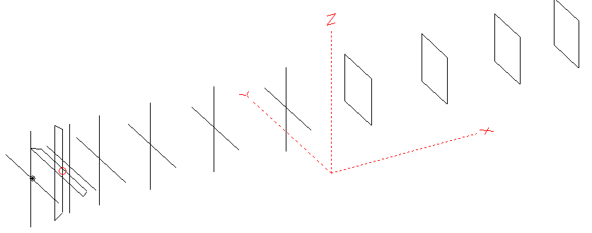
Horizontal components: Same as above
Vertical components: Same as above, except:
- All vertical yagi elements positioned 20 mm backward regarding horizontals.
- All crossed elements must cross each other in their centerlines

HORIZONTAL PERFORMANCES
Everything as the above data

VERTICAL PERFORMANCES with no corrections
Loss included condition (for Aluminum)
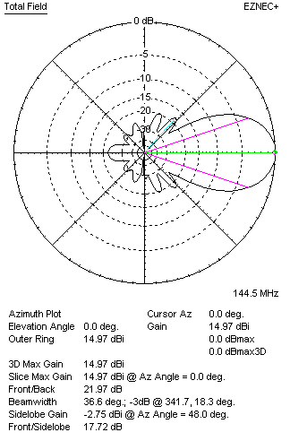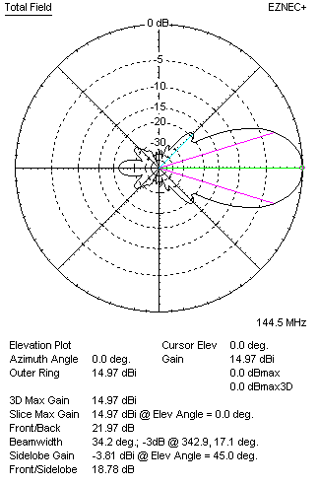
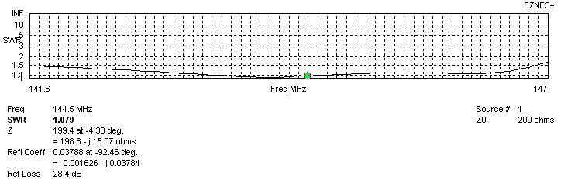
VERTICAL PERFORMANCES after corrections, loss included condition
If you want to get better SWR diagram for vertical antenna you can do the following:
- Change length of DE2 from 888 to 904 mm
- Change position od D1 for +4 mm.

In this case the SWR diagram will be like this:
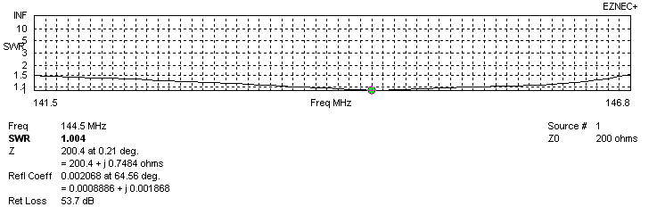
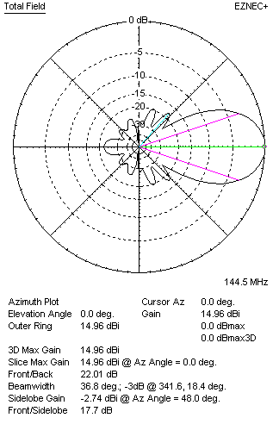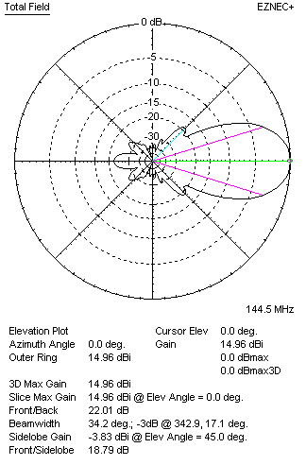

PERFORMANCES: (No loss condition)
 | TYPE | Condition | G  (dBi) | F/B  (dB) | F/Sh  (dBi) | F/Sv (dBi) | Hor  (◦) | Ver  (◦) | Temp (◦K) | G/T (dB) | B (MHz)  for SWR=1.5
 | Horizontal  part | No losss | 15.04 | 24.74 | 18.51 | 17.52 | 34.2 | 36.8 | 229.6 | -8.57 | 141.600- 147.000
 | Horizontal  part | Aluminum | 14.95 | 24.55 | 18.48 | 17.51 | 34.2 | 36.8 | 231.2 | -8.69 | 141.600- 147.000
 | Vertical  part | No losss | 15.05 | 22.14 | 17.70 | 18.82 | 36.8 | 34.2 | 228.7 | -8.54 | 141.500 – 146.800
 | Vertical  part | Aluminum | 14.96 | 22.01 | 17.70 | 18.79 | 36.8 | 34.2 | 230.3 | -8.66 | 141.500 – 146.800

