ANTENNA QY21105XL4D4
Good stacking characteristics at moderate vertical distances and big horizontal distances
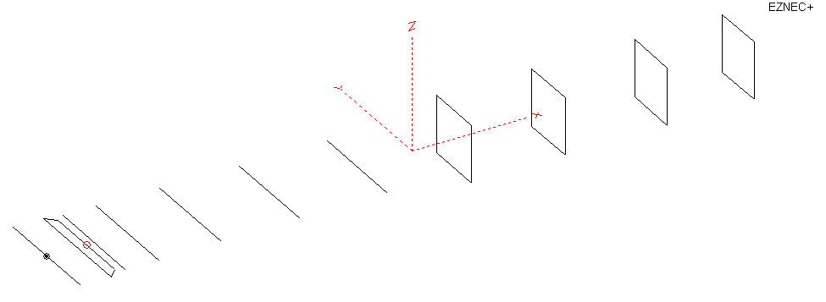
PERFORMANCES: (No loss condition)
TYPE | ELE | L (mm) | G (dBi) | F/B (dB) | F/Sh (dBi) | F/Sv (dBi) | Hor (◦) | Ver (◦) | Temp (◦K) | G/T (dB) | ΔF * (kHz)
QY21105XL4D4 | 11 | 6000 | 15.34 | 27.70 | 19.30 | 18.59 | 33.4 | 35.6 | 221.5 | -8.11 | 3200
* ΔF given for SWR=1,5

PERFORMANCES: (Loss included for aluminum)
Element material | G (dBi) | Temp (◦K) | G/T (dB)
Aluminum rods | 15.23 | 223.5 | -8.26

COMPARISON
Antenna | Boomlength (mm) | Material | Gain  (dBi) | TA  (◦K) | G/T  (dB) | Bandwidth  (MHz)
QY21105XL4D4 | 6000 | No loss | 15.34 | 221.5 | -8.11 | 143.200- 146.400
QY21105XL4D4 | 6000 | Aluminum | 15.23 | 223.5 | -8.26 | 143.200- 146.400
EF0211-5B | 5980 | No loss | 15.13 | 229.1 | -8.47 | 140.500-145.200
EF0211-5B | 5980 | Aluminum | 15.04 | 230.8 | -8.59 | 140.500-145.200
EF0211-05 | 6325 | No loss | 15.24 | 226.7 | -8.32 | 142.600-144.800
EF0211-05 | 6325 | Aluminum | 15.14 | 228.6 | -8.45 | 142.600-144.800

DIMENSIONS:

 | Ref | De1 | De2 | D1 | D2 | D3 | D4 | D5 | DQ1 | DQ2 | DQ3 | DQ4 | REMARKS  - All elements made of Al rods Ǿ5  - Height of all rectangles 500 mm  - All dimensions given in milimetres
Pos | 0 | 266 | 356 | 420 | 705 | 1250 | 1944 | 2695 | 3535 | 4355 | 5245 | 6000
Length | 1018 | 1018 | 840 | 948 | 960 | 934 | 916 | 900 | 522 | 498 | 494 | 478

Building hints: No boom correction included.

DIAGRAMS (no loss included)
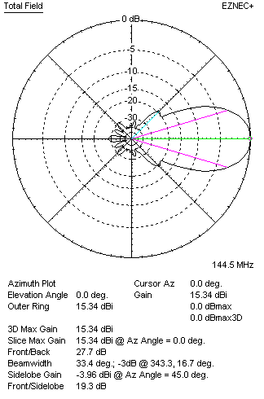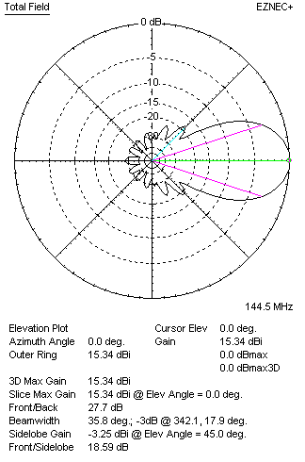
DIAGRAMS (loss included)
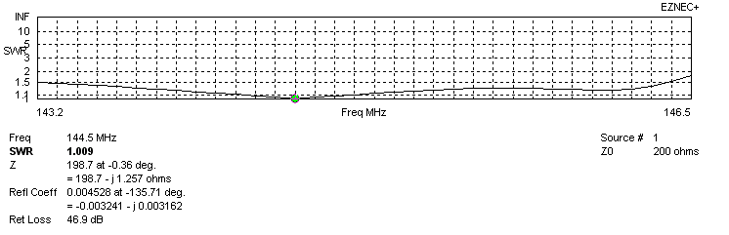
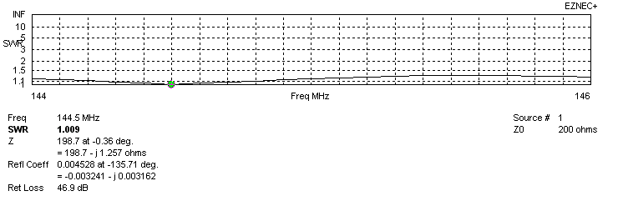
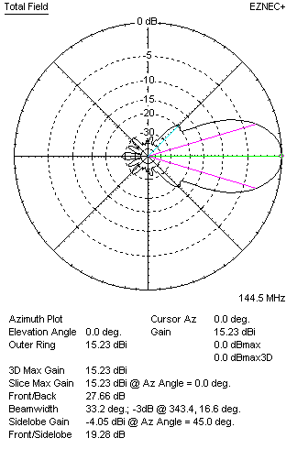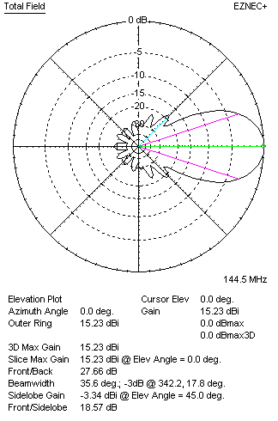

STACKING

QY21105XL4D4 - STACKING TABLE
(including loss for aluminum – AGT = -0.13 dB)
VERTICAL  DISTANCE (cm) | G  (dB) | TA  (°K) | G/T  (dB) | HORIZONTAL  DISTANCE (cm) | G  (dB) | TA  (°K) | G/T  (dB)
100 |  |  |  | 100
110 | 16.21 | 228.0 | -7.37 | 110
120 | 16.37 | 224.2 | -7.14 | 120 | 15.70 | 248.5 | -8.25
130 | 16.50 | 222.0 | -6.96 | 130 | 16.10 | 242.5 | -7.75
140 | 16.62 | 220.2 | -6.81 | 140 | 16.35 | 237.6 | -7.41
150 | 16.74 | 218.2 | -6.65 | 150 | 16.53 | 233.9 | -7.16
160 | 16.84 | 216.8 | -6.52 | 160 | 16.68 | 231.3 | -6.96
170 | 16.93 | 216.6 | -5.43 | 170 | 16.81 | 229.4 | -6.81
180 | 17.02 | 217.1 | -6.35 | 180 | 16.91 | 227.9 | -6.67
190 | 17.11 | 218.2 | -6.28 | 190 | 17.01 | 226.8 | -6.55
200 | 17.19 | 219.5 | -6.22 | 200 | 17.10 | 225.9 | -6.44
210 | 17.27 | 221.0 | -6.17 | 210 | 17.18 | 225.1 | -6.34
220 | 17.35 | 222.3 | -6.12 | 220 | 17.26 | 224.4 | -6.25
230 | 17.42 | 223.1 | -6.07 | 230 | 17.34 | 223.9 | -6.16
240 | 17.50 | 223.5 | -5.99 | 240 | 17.42 | 223.4 | -6.07
250 | 17.59 | 223.3 | -5.90 | 250 | 17.49 | 222.9 | -5.99
260 | 17.67 | 222.8 | -5.81 | 260 | 17.57 | 222.5 | -5.90
270 | 17.75 | 222.1 | -5.72 | 270 | 17.64 | 222.1 | -5.83
280 | 17.83 | 221.5 | -5.62 | 280 | 17.71 | 221.8 | -5.75
290 | 17.90 | 221.1 | -5.55 | 290 | 17.78 | 221.6 | -5.67
300 | 17.97 | 221.0 | -5.47 | 300 | 17.85 | 221.4 | -5.60
310 | 18.03 | 221.1 | -5.42 | 310 | 17.92 | 221.2 | -5.53
320 | 18.09 | 221.5 | -5.36 | 320 | 17.97 | 221.2 | -5.48
330 | 18.13 | 222.1 | -5.34 | 330 | 18.03 | 221.2 | -5.42
340 | 18.18 | 222.9 | -5.30 | 340 | 18.07 | 221.2 | -5.38
350 | 18.21 | 223.7 | -5.29 | 350 | 18.11 | 221.4 | -5.34
360 | 18.24 | 224.6 | -5.27 | 360 | 18.15 | 221.6 | -5.31
370 | 18.26 | 225.5 | -5.27 | 370 | 18.18 | 221.8 | -5.28
380 | 18.28 | 226.2 | -5.27 | 380 | 18.21 | 222.1 | -5.26
390 | 18.29 | 226.9 | -5.27 | 390 | 18.23 | 222.4 | -5.24
 |  |  |  | 400 | 18.25 | 222.7 | -5.23
 |  |  |  | 410 | 18.26 | 223.0 | -5.22
 |  |  |  | 420 | 18.27 | 223.3 | -5.22

TWO ANTENNAS VERTICALLY STACKED AT 360CM
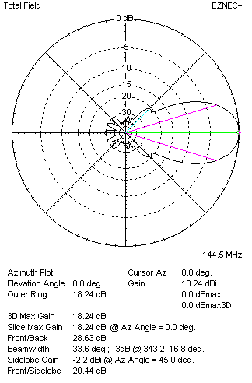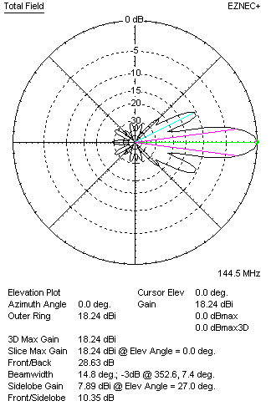

Performances
TYPE | Condition | G  (dBi) | F/B  (dB) | F/Sh  (dBi) | F/Sv (dBi) | Hor  (◦) | Ver  (◦) | Temp (◦K) | G/T (dB) | B (MHz)  for SWR=1.5
2xQY21105XL4D4 | No losss | 18.35 | 28.76 | 20.46 | 10.31 | 33.6 | 15.0 | 222.6 | -5.13 | 143.200- 146.400
2xQY21105XL4D4 | Aluminum | 18.24 | 28.63 | 20.44 | 10.35 | 33.6 | 14.8 | 224.6 | -5.27 | 143.200- 146.400

FOUR ANTENNAS VERTICALLY STACKED AT 360+360+360CM
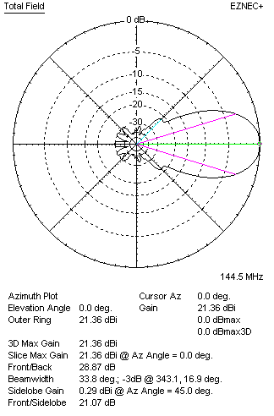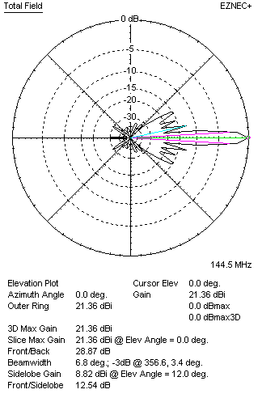
Performances
TYPE | Condition | G  (dBi) | F/B  (dB) | F/Sh  (dBi) | F/Sv (dBi) | Hor  (◦) | Ver  (◦) | Temp (◦K) | G/T (dB) | B (MHz)  for SWR=1.5
4xQY21105XL4D4 | No losss | 21.36 | 28.87 | 21.07 | 12.54 | 33.8 | 6.8 | 222.9 | -2.12 | 143.200- 146.400
4xQY21105XL4D4 | Aluminum | 21.25 | 28.70 | 21.05 | 12.55 | 33.8 | 6.8 | 224.8 | -2.27 | 143.200- 146.400

FOUR ANTENNAS IN H- STACK, H=405 CM, V=359 CM
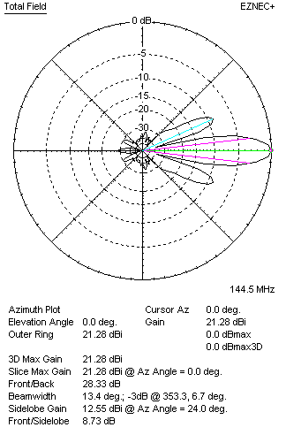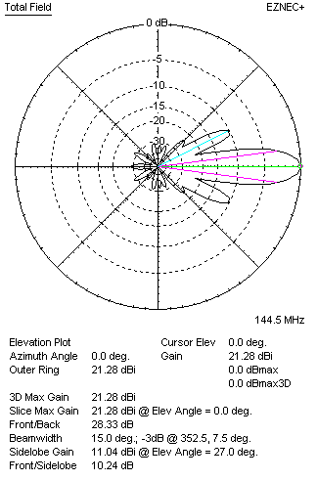
Performances
TYPE | Condition | G  (dBi) | F/B  (dB) | F/Sh  (dBi) | F/Sv (dBi) | Hor  (◦) | Ver  (◦) | Temp (◦K) | G/T (dB) | B (MHz)  for SWR=1.5
4xQY21105XL4D4 | No losss | 21.39 | 28.48 | 8.70 | 10.20 | 13.4 | 15.0 | 223.9 | -2.11 | 143.200- 146.400
4xQY21105XL4D4 | Aluminum | 21.28 | 28.33 | 8.73 | 10.24 | 13.4 | 15.0 | 225.8 | -2.28 | 143.200- 146.400

XPOL VERSION

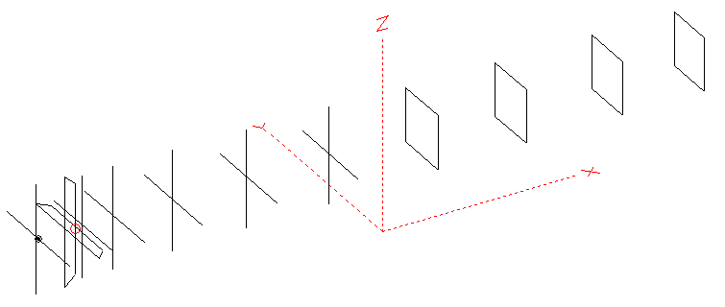
Horizontal components: Same as above
Vertical components: Same as above, except:
- All vertical yagi elements positioned 20 mm backward regarding horizontals.
- All crossed elements must cross each other in their centerlines

HORIZONTAL PERFORMANCES
Everything as the above data

VERTICAL PERFORMANCES with no corrections
Loss included condition (for Aluminum)
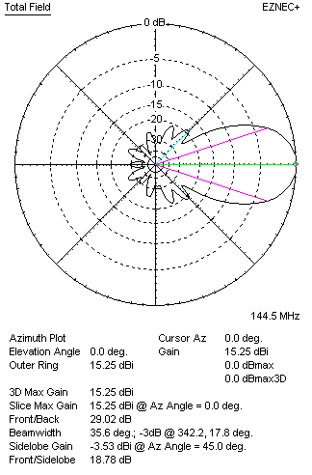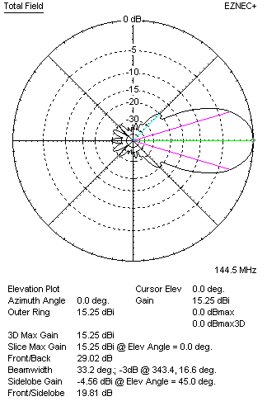
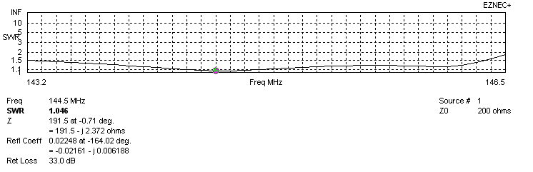
VERTICAL PERFORMANCES after corrections, loss included condition
If you want to get better SWR diagram for vertical antenna you can do the following:
- Change length of D1 from 948 to 946 mm
- Change position of D3 for +3 mm

In this case the SWR diagram will be like this:
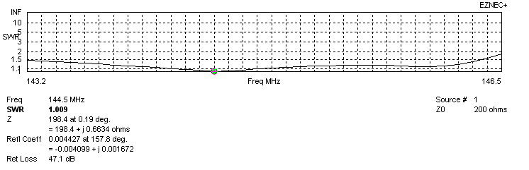
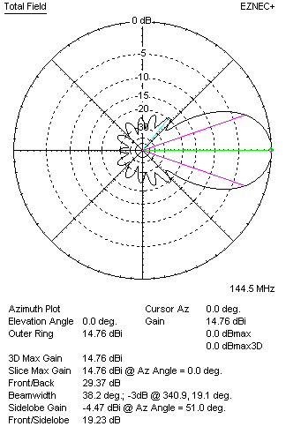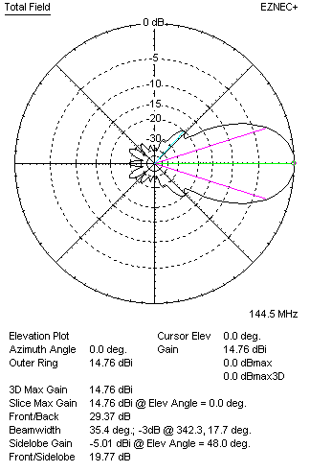

PERFORMANCES
 | TYPE | Condition | G  (dBi) | F/B  (dB) | F/Sh  (dBi) | F/Sv (dBi) | Hor  (◦) | Ver  (◦) | Temp (◦K) | G/T (dB) | B (MHz)  for SWR=1.5
 | Horizontal  part | No losss | 15.34 | 27.70 | 19.30 | 18.59 | 33.4 | 35.6 | 221.5 | -8.11 | 142.900- 146.950
 | Horizontal  part | Aluminum | 15.23 | 27.66 | 19.28 | 18.57 | 33.2 | 35.6 | 223.5 | -8.26 | 142.900- 146.950
 | Vertical  part | No losss | 15.36 | 28.33 | 19.59 | 19.75 | 35.6 | 33.2 | 221.8 | -8.10 | 143.200 – 146.350
 | Vertical  part | Aluminum | 15.25 | 28.33 | 18.58 | 19.73 | 35.6 | 33.2 | 223.7 | -8.25 | 143.200 – 146.350

