ANTENNA QY21010XL1D3
Good stacking characteristics at moderate vertical distances and any horizontal distances
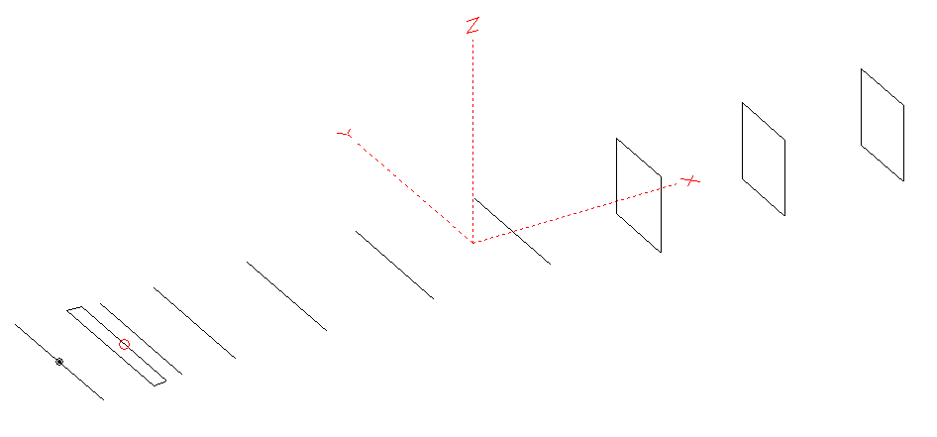
PERFORMANCES: (No loss condition)
TYPE | ELE | L (mm) | G (dBi) | F/B (dB) | F/Sh (dBi) | F/Sv (dBi) | Hor (◦) | Ver (◦) | Temp (◦K) | G/T (dB) | ΔF * (kHz)
QY21010XL1D3 | 10 | 5405 | 14.93 | 20.34 | 19.33 | 18.99 | 34.6 | 37.4 | 228.8 | -8.66 | 4230
* ΔF given for SWR=1.5

PERFORMANCES: (Loss included)
Element material | G (dBi) | Temp (◦K) | G/T (dB)
Aluminum rods | 14.87 | 229.7 | -8.74

DIMENSIONS:
 | Ref | De1 | De2 | D1 | D2 | D3 | D4 | D5 | DQ1 | DQ2 | DQ3 | REMARKS: : -All elements made of Al rods Ǿ10 mm  - The height of the rectangle is 500 mm  - All dimensions given in milimetres
Pos | 0 | 330 | 420 | 535 | 889 | 1495 | 2205 | 2975 | 3805 | 4625 | 5405
Length | 1010 | 990 | 970 | 938 | 932 | 910 | 892 | 872 | 510 | 492 | 482
Building hints: No boom correction included.

COMPARISON
Antenna | Boomlength (mm) | Material | Gain (dBi) | TA (◦K) | G/T (dB) | Bandwidth  (MHz)
QY21010XL1D3 | 5405 | No loss | 14.93 | 228.8 | -8.66 | 141.500- 146.370
QY21010XL1D3 | 5405 | Aluminum | 14.87 | 229.7 | -8.74 | 141.500- 146.370
EF0210-5 | 5290 | No loss | 14.77 | 233.8 | -8.92 | 140.190- 145.450
EF0210-5 | 5290 | Aluminum | 14.67 | 235.4 | -9.05 | 140.190- 145.450

DIAGRAMS (no loss included)
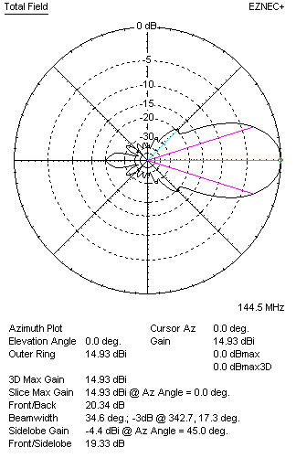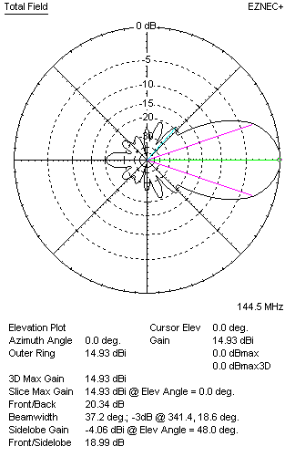
DIAGRAMS (loss included)
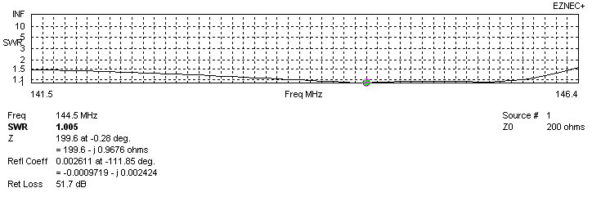
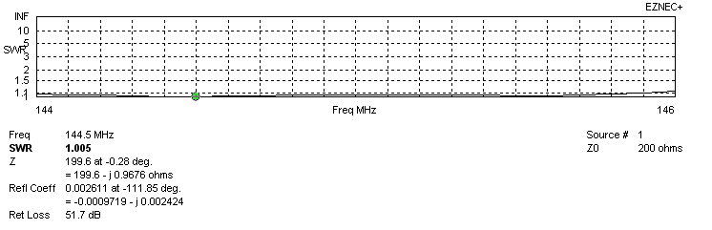
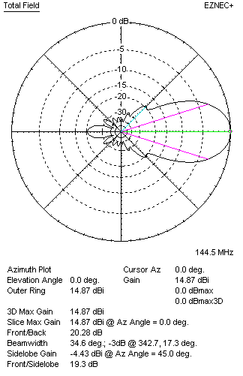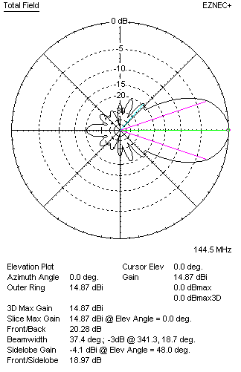
STACKING

QY21010XL1D3 - STACKING TABLE
(including loss for aluminum – AGT = -0.06 dB)
VERTICAL  DISTANCE (cm) | G  (dB) | TA  (°K) | G/T  (dB) | HORIZONTAL  DISTANCE (cm) | G  (dB) | TA  (°K) | G/T  (dB)
100 | 15.77 | 230.3 | -7.85 | 100
110 | 15.94 | 225.7 | -7.59 | 110
120 | 16.08 | 223.8 | -7.42 | 120 | 15.35 | 247.2 | -8.58
130 | 16.20 | 224.7 | -7.32 | 130 | 15.75 | 243.7 | -8.12
140 | 16.29 | 226.7 | -7.26 | 140 | 15.99 | 241.0 | -7.83
150 | 16.39 | 226.8 | -7.17 | 150 | 16.18 | 238.5 | -7.60
160 | 16.50 | 225.2 | -7.03 | 160 | 16.33 | 236.4 | -7.41
170 | 16.61 | 224.1 | -6.89 | 170 | 16.46 | 234.6 | -7.24
180 | 16.71 | 223.8 | -6.79 | 180 | 16.57 | 233.1 | -7.11
190 | 16.81 | 224.1 | -6.69 | 190 | 16.68 | 231.8 | -6.97
200 | 16.90 | 224.7 | -6.62 | 200 | 16.78 | 230.6 | -6.85
210 | 17.00 | 225.2 | -6.52 | 210 | 16.87 | 229.6 | -6.74
220 | 17.09 | 225.4 | -6.44 | 220 | 16.96 | 228.8 | -6.63
230 | 17.17 | 225.3 | -6.36 | 230 | 17.05 | 228.1 | -6.53
240 | 17.26 | 224.8 | -6.26 | 240 | 17.13 | 227.6 | -6.44
250 | 17.35 | 224.3 | -6.16 | 250 | 17.22 | 227.2 | -6.34
260 | 17.43 | 224.0 | -6.07 | 260 | 17.29 | 227.0 | -6.27
270 | 17.51 | 223.8 | -5.99 | 270 | 17.37 | 226.9 | -6.19
280 | 17.59 | 224.1 | -5.91 | 280 | 17.44 | 226.9 | -6.12
290 | 17.65 | 224.7 | -5.87 | 290 | 17.51 | 227.0 | -6.05
300 | 17.71 | 225.6 | -5.82 | 300 | 17.57 | 227.1 | -5.99
310 | 17.77 | 226.9 | -5.79 | 310 | 17.63 | 227.4 | -5.94
320 | 17.81 | 228.3 | -5.78 | 320 | 17.68 | 227.6 | -5.89
330 | 17.85 | 230.0 | -5.77 | 330 | 17.73 | 227.9 | -5.85
340 | 17.88 | 231.7 | -5.77 | 340 | 17.77 | 228.3 | -5.81
350 | 17.90 | 233.4 | -5.78 | 350 | 17.80 | 228.6 | -5.79
360 |  |  |  | 360 | 17.83 | 229.0 | -5.77
370 |  |  |  | 370 | 17.86 | 229.4 | -5.75
380 |  |  |  | 380 | 17.88 | 229.8 | -5.73
390 |  |  |  | 390 | 17.89 | 230.2 | -5.73
400 |  |  |  | 400 | 17.90 | 230.5 | -5.73
 |  |  |  | 410 | 17.91 | 230.8 | -5.72
Remark: brown colour letters show not consistent data!

TWO ANTENNAS VERTICALLY STACKED AT 330CM
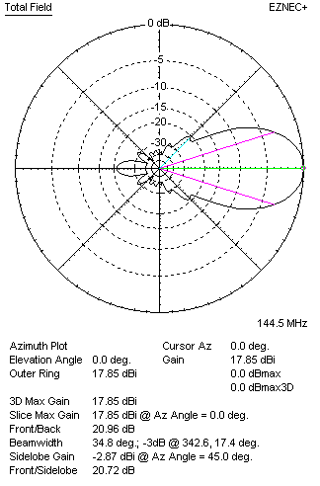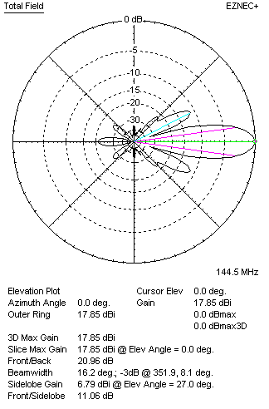

Performances
TYPE | Condition | G  (dBi) | F/B  (dB) | F/Sh  (dBi) | F/Sv (dBi) | Hor  (◦) | Ver  (◦) | Temp (◦K) | G/T (dB) | B (MHz)  for SWR=1.5
2xQY21010XL1D3 | No losss | 17.90 | 21.01 | 20.75 | 11.04 | 34.8 | 16.2 | 229.1 | -5.70 | 141.500- 146.370
2xQY21010XL1D3 | Aluminum | 17.85 | 20.96 | 20.72 | 11.06 | 34.8 | 16.2 | 230.0 | -5.77 | 141.500- 146.370

FOUR ANTENNAS VERTICALLY STACKED AT 330+330+330CM
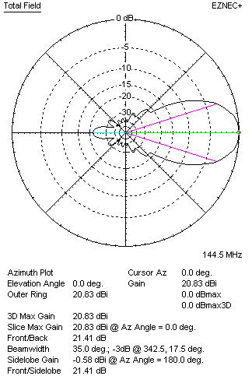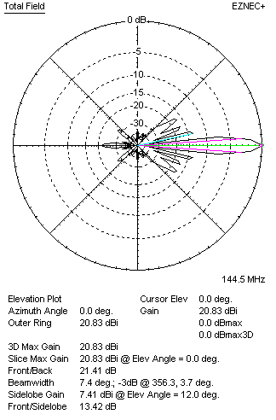
Performances
TYPE | Condition | G  (dBi) | F/B  (dB) | F/Sh  (dBi) | F/Sv (dBi) | Hor  (◦) | Ver  (◦) | Temp (◦K) | G/T (dB) | B (MHz)  for SWR=1.5
4xQY21010XL1D3 | No losss | 20.89 | 21.48 | 21.89 | 13.43 | 35.0 | 7.4 | 223.7 | -2.61 | 141.500- 146.370
4xQY21010XL1D3 | Aluminum | 20.83 | 21.41 | 21.87 | 13.42 | 35.0 | 7.4 | 224.7 | -2.69 | 141.500- 146.370

FOUR ANTENNAS IN H- STACK, H=380 CM, V=320 CM
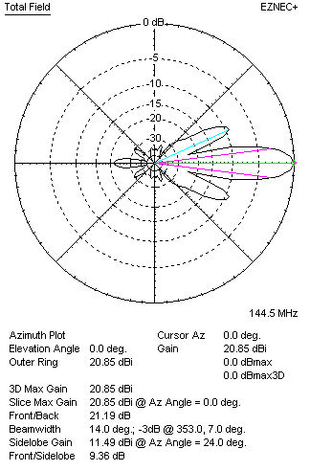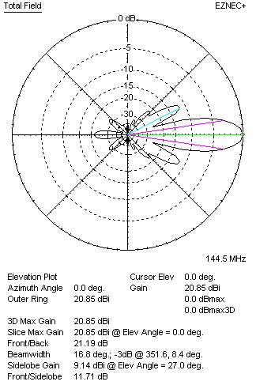
Performances
TYPE | Condition | G  (dBi) | F/B  (dB) | F/Sh  (dBi) | F/Sv (dBi) | Hor  (◦) | Ver  (◦) | Temp (◦K) | G/T (dB) | B (MHz)  for SWR=1.5
4xQY21010XL1D3 | No losss | 20.90 | 21.24 | 9.35 | 11.69 | 14.0 | 16.8 | 229.8 | -2.71 | 141.500- 146.370
4xQY21010XL1D3 | Aluminum | 20.85 | 21.19 | 9.36 | 11.71 | 14.0 | 16.8 | 230.6 | -2.78 | 141.500- 146.370

XPOL VERSION

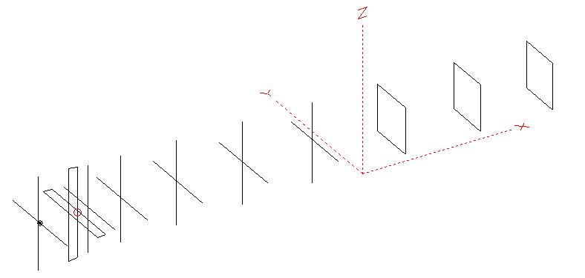
Horizontal components: Same as above
Vertical components: Same as above, except:
- All vertical yagi elements positioned 20 mm back regarding horizontals.
- All crossed elements must cross each other in their centerlines

HORIZONTAL PERFORMANCES
Everything as the above data

VERTICAL PERFORMANCES with no corrections
Loss included condition (for Aluminum)
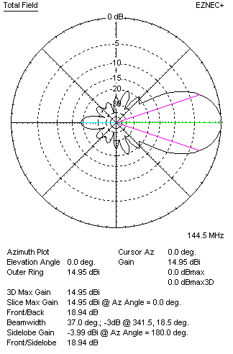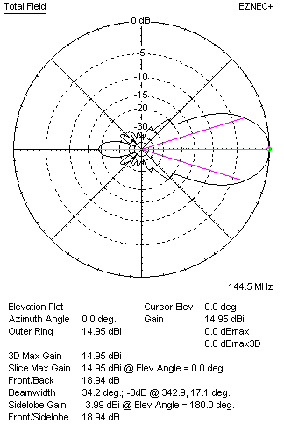
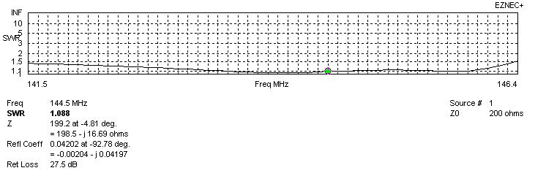
VERTICAL PERFORMANCES after corrections, loss included condition
If you want to get better SWR diagram for vertical antenna you can do the following:
- Change position of D1 for +6 mm

In this case the SWR diagram will be like this:
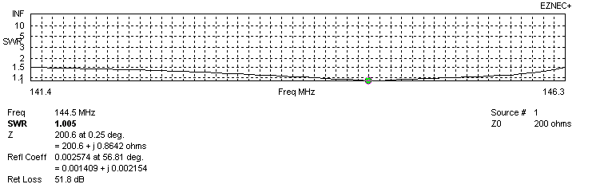
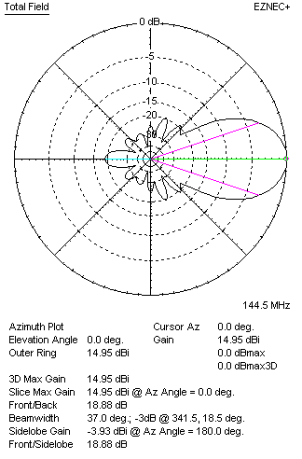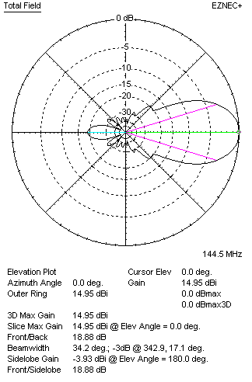

PERFORMANCES
 | TYPE | Condition | G  (dBi) | F/B  (dB) | F/Sh  (dBi) | F/Sv (dBi) | Hor  (◦) | Ver  (◦) | Temp (◦K) | G/T (dB) | B (MHz)  for SWR=1.5
 | Horizontal  part | No losss | 14.93 | 20.34 | 19.33 | 18.99 | 34.6 | 37.4 | 228.8 | -8.66 | 141.500- 146.370
 | Horizontal  part | Aluminum | 14.87 | 20.28 | 19.30 | 18.97 | 34.6 | 37.4 | 229.7 | -8.74 | 141.500- 146.370
 | Vertical  part | No losss | 15.00 | 18.92 | 19.23 | 19.92 | 37.0 | 34.2 | 229.2 | -8.60 | 141.400 – 146.300
 | Vertical  part | Aluminum | 14.95 | 18.88 | 19.22 | 19.91 | 37.0 | 34.2 | 230.1 | -8.67 | 141.400 – 146.300

