ANTENNA QY21008XL4D3
Good stacking characteristics at any vertical and horizontal distances
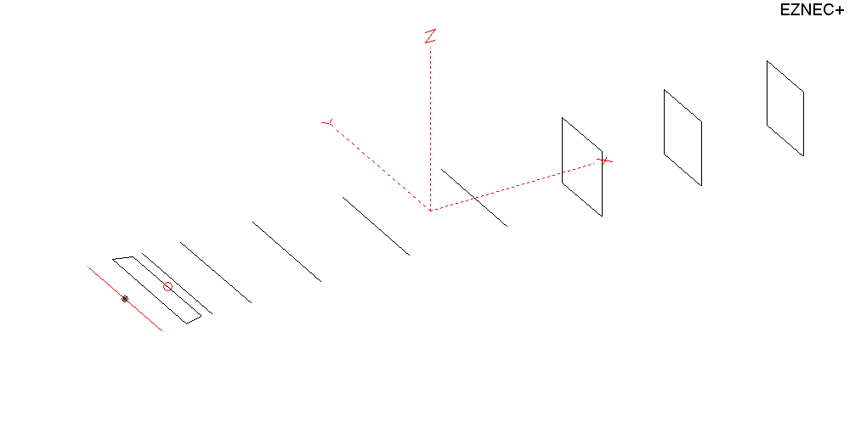
PERFORMANCES: (No loss condition)
TYPE | ELE | L (mm) | G (dBi) | F/B (dB) | F/Sh (dBi) | F/Sv (dBi) | Hor (◦) | Ver (◦) | Temp (◦K) | G/T (dB) | ΔF * (kHz)
QY21008XL4D3 | 10 | 5105 | 14.81 | 23.03 | 18.43 | 17.98 | 34.6 | 37.4 | 230.8 | -8.82 | 3380
* ΔF given for SWR=1.5

PERFORMANCES: (Loss included)
Element material | G (dBi) | Temp (◦K) | G/T (dB)
Aluminum rods | 14.74 | 232.1 | -8.92

DIMENSIONS:
 | Ref | De1 | De2 | D1 | D2 | D3 | D4 | D5 | DQ1 | DQ2 | DQ3 | REMARKS: : -All elements made of Al rods Ǿ8 mm  - The height of the rectangle is 500 mm  - All dimensions given in milimetres
Pos | 0 | 190 | 330 | 406 | 705 | 1255 | 1943 | 2705 | 3535 | 4315 | 5105
Length | 1012 | 1000 | 920 | 942 | 948 | 924 | 904 | 884 | 526 | 502 | 484
Building hints: No boom correction included.

COMPARISON
Antenna | Boomlength (mm) | Material | Gain (dBi) | TA (◦K) | G/T (dB) | Bandwidth  (MHz)
QY21008XL4D3 | 5105 | No loss | 14.81 | 230.8 | -8.82 | 142.700- 146.080
QY21008XL4D3 | 5105 | Aluminum | 14.74 | 232.1 | -8.92 | 142.700- 146.080
EF0210-5 | 5290 | No loss | 14.77 | 233.8 | -8.92 | 140.190- 145.450
EF0210-5 | 5290 | Aluminum | 14.67 | 235.4 | -9.05 | 140.190- 145.450

DIAGRAMS (no loss included)
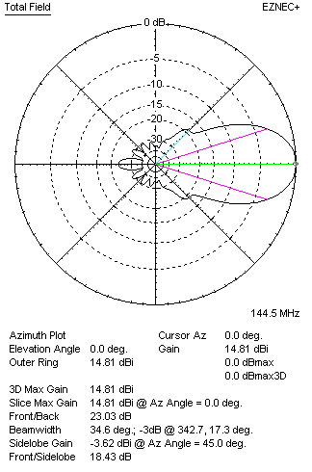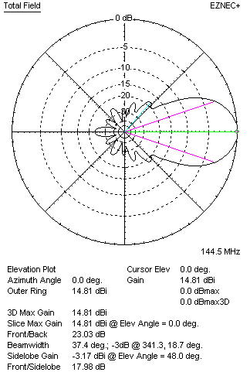
DIAGRAMS (loss included)
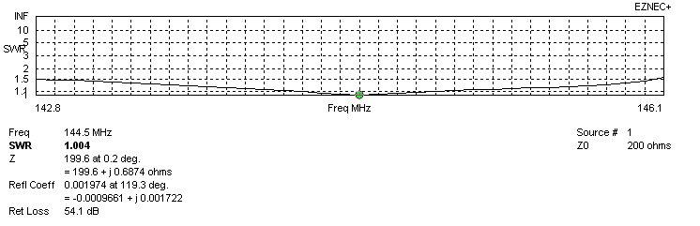
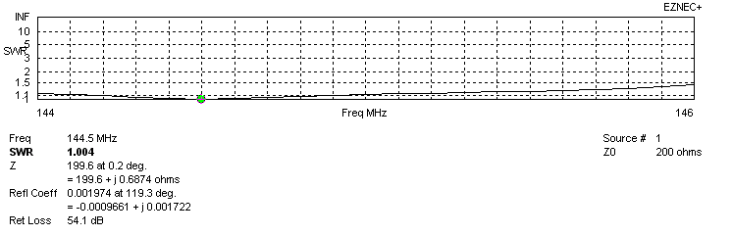
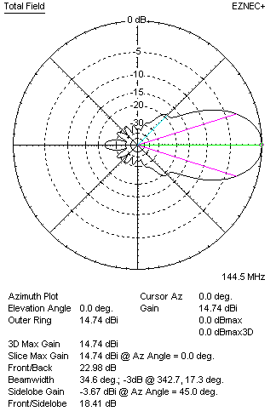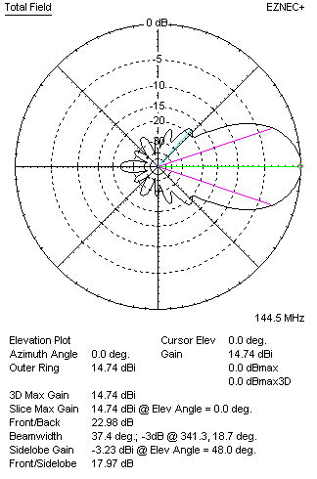
STACKING

QY20908XL4D3 - STACKING TABLE
(including loss for aluminum – AGT = -0.08 dB)
VERTICAL  DISTANCE (cm) | G  (dB) | TA  (°K) | G/T  (dB) | HORIZONTAL  DISTANCE (cm) | G  (dB) | TA  (°K) | G/T  (dB)
100 | 15.52 | 236.3 | -8.21 | 100
110 | 15.71 | 230.2 | -7.91 | 110
120 | 15.88 | 226.9 | -7.68 | 120
130 | 16.02 | 225.6 | -7.51 | 130
140 | 16.15 | 224.6 | -7.36 | 140 | 15.82 | 245.7 | -8.08
150 | 16.27 | 222.7 | -7.21 | 150 | 16.03 | 241.7 | -7.80
160 | 16.40 | 220.4 | -7.03 | 160 | 16.19 | 238.7 | -7.59
170 | 16.51 | 219.1 | -6.90 | 170 | 16.33 | 236.4 | -7.41
180 | 16.62 | 219.1 | -6.79 | 180 | 16.45 | 234.6 | -7.25
190 | 16.72 | 220.1 | -6.71 | 190 | 16.56 | 233.2 | -7.12
200 | 16.81 | 221.7 | -6.65 | 200 | 16.67 | 232.1 | -6.99
210 | 16.90 | 223.4 | -6.59 | 210 | 16.76 | 231.2 | -6.88
220 | 16.98 | 224.7 | -6.54 | 220 | 16.85 | 230.5 | -6.78
230 | 17.07 | 225.5 | -6.46 | 230 | 16.94 | 230.0 | -6.68
240 | 17.16 | 225.8 | -6.38 | 240 | 17.02 | 229.6 | -6.59
250 | 17.24 | 225.9 | -6.30 | 250 | 17.10 | 229.3 | -6.50
260 | 17.33 | 226.1 | -6.21 | 260 | 17.18 | 229.1 | -6.42
270 | 17.40 | 226.6 | -6.15 | 270 | 17.26 | 229.0 | -6.34
280 | 17.47 | 227.3 | -6.10 | 280 | 17.33 | 229.0 | -6.27
290 | 17.54 | 228.3 | -6.05 | 290 | 17.40 | 229.1 | -6.20
300 | 17.59 | 229.6 | -6.02 | 300 | 17.46 | 229.2 | -6.14
310 | 17.64 | 231.2 | -6.00 | 310 | 17.52 | 229.4 | -6.09
320 | 17.68 | 232.8 | -5.99 | 320 | 17.57 | 229.6 | -6.04
330 | 17.72 | 234.5 | -5.98 | 330 | 17.61 | 229.9 | -6.00
340 | 17.74 | 236.1 | -5.99 | 340 | 17.65 | 230.2 | -5.97
350 |  |  |  | 350 | 17.68 | 230.5 | -5.95
360 |  |  |  | 360 | 17.71 | 230.9 | -5.92
370 |  |  |  | 370 | 17.73 | 231.3 | -5.91
380 |  |  |  | 380 | 17.75 | 231.7 | -5.90
390 |  |  |  | 390 | 17.76 | 232.1 | -5.90
400 |  |  |  | 400 | 17.77 | 232.5 | -5.89

TWO ANTENNAS VERTICALLY STACKED AT 330CM
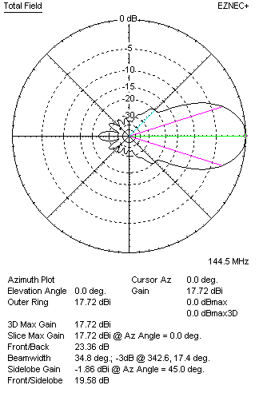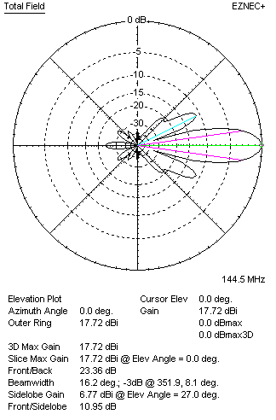

Performances
TYPE | Condition | G  (dBi) | F/B  (dB) | F/Sh  (dBi) | F/Sv (dBi) | Hor  (◦) | Ver  (◦) | Temp (◦K) | G/T (dB) | B (MHz)  for SWR=1.5
2xQY21108XL4D3 | No losss | 17.79 | 19.61 | 18.90 | 10.92 | 34.8 | 16.2 | 233.3 | -5.89 | 142.700- 146.080
2xQY21108XL4D3 | Aluminum | 17.72 | 19.62 | 18.87 | 10.95 | 34.8 | 16.2 | 234.5 | -5.98 | 142.700- 146.080

FOUR ANTENNAS VERTICALLY STACKED AT 330+330+330CM
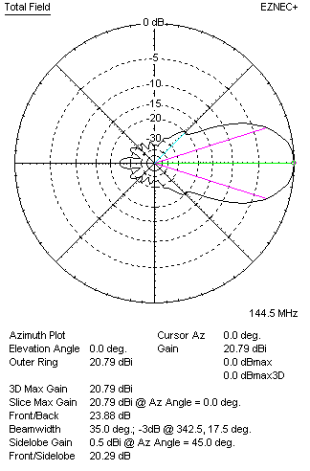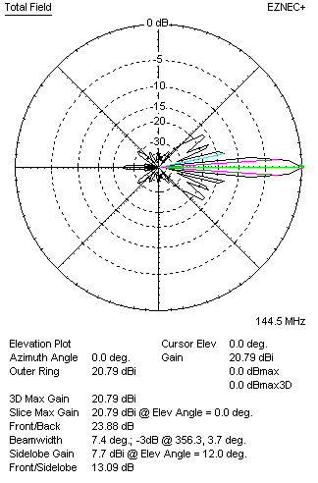
Performances
TYPE | Condition | G  (dBi) | F/B  (dB) | F/Sh  (dBi) | F/Sv (dBi) | Hor  (◦) | Ver  (◦) | Temp (◦K) | G/T (dB) | B (MHz)  for SWR=1.5
4xQY21108XL4D4 | No losss | 20.79 | 23.88 | 20.29 | 13.09 | 35.0 | 7.4 | 227.9 | -2.79 | 142.700- 146.080
4xQY21108XL4D4 | Aluminum | 20.71 | 23.80 | 20.25 | 13.09 | 35.0 | 7.4 | 229.2 | -2.89 | 142.700- 146.080

FOUR ANTENNAS IN H- STACK, H=380 CM, V=330 CM
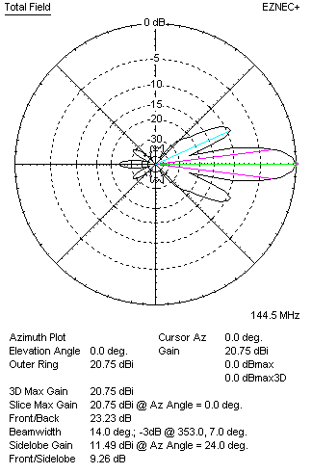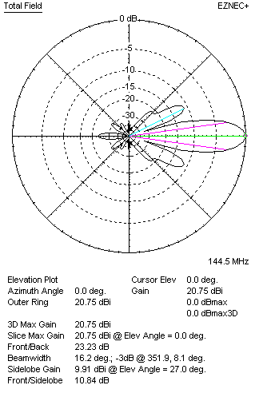
Performances
TYPE | Condition | G  (dBi) | F/B  (dB) | F/Sh  (dBi) | F/Sv (dBi) | Hor  (◦) | Ver  (◦) | Temp (◦K) | G/T (dB) | B (MHz)  for SWR=1.5
4xQY21108XL4D4 | No losss | 20.82 | 23.29 | 9.24 | 10.81 | 14.2 | 16.4 | 235.5 | -2.90 | 142.700- 146.080
4xQY21108XL4D4 | Aluminum | 20.75 | 23.23 | 9.26 | 10.84 | 14.0 | 16.2 | 236.6 | -2.99 | 142.700- 146.080

XPOL VERSION

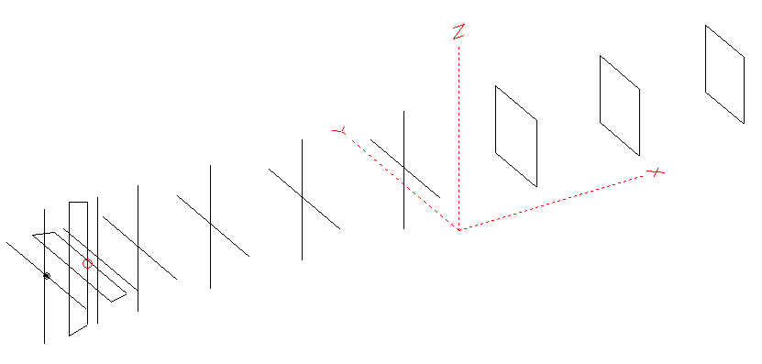
Horizontal components: Same as above
Vertical components: Same as above, except:
- All vertical yagi elements positioned 20 mm backward regarding horizontals.
- All crossed elements must cross each other in their centerlines

HORIZONTAL PERFORMANCES
Everything as the above data

VERTICAL PERFORMANCES with no corrections
Loss included condition (for Aluminum)
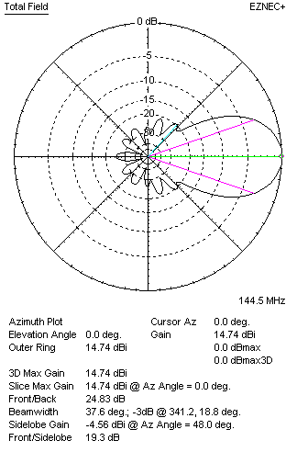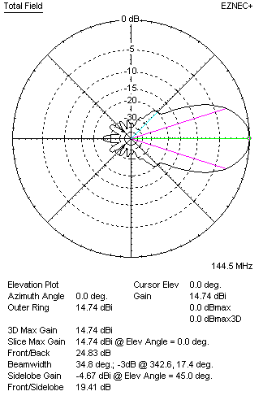
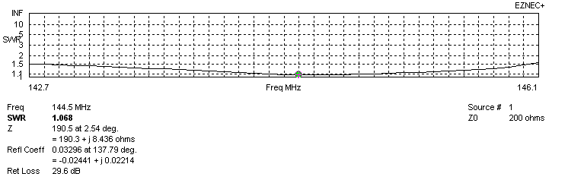
VERTICAL PERFORMANCES after corrections, loss included condition
If you want to get better SWR diagram for vertical antenna you can do the following:
- Change length of D1 from 942 to 944 mm
- Change length of D2 from 948 to 950 mm

In this case the SWR diagram will be like this:
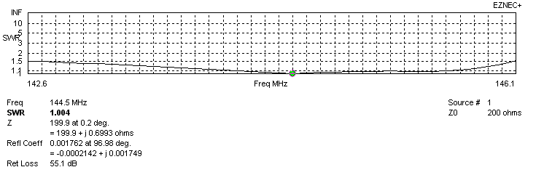
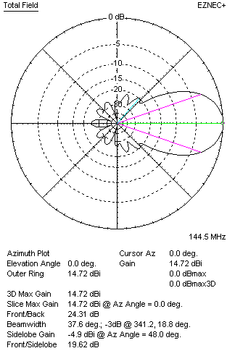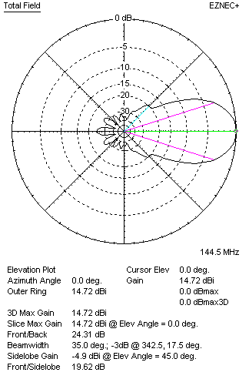

PERFORMANCES
 | TYPE | Condition | G  (dBi) | F/B  (dB) | F/Sh  (dBi) | F/Sv (dBi) | Hor  (◦) | Ver  (◦) | Temp (◦K) | G/T (dB) | B (MHz)  for SWR=1.5
 | Horizontal  part | No losss | 14.81 | 23.03 | 18.43 | 17.98 | 34.6 | 37.4 | 230.8 | -8.82 | 142.700- 146.080
 | Horizontal  part | Aluminum | 14.74 | 22.98 | 18.41 | 17.97 | 34.4 | 34.8 | 232.1 | -8.92 | 142.700- 146.080
 | Vertical  part | No losss | 14.80 | 24.39 | 19.63 | 19.66 | 37.6 | 35.0 | 228.5 | -8.79 | 142.600 – 146.100
 | Vertical  part | Aluminum | 14.72 | 24.31 | 19.62 | 19.62 | 37.6 | 35.0 | 229.8 | -8.89 | 142.600 – 146.100

