ANTENNA QY21005XL4D3
Good stacking characteristics at moderate vertical distances and big horizontal distances
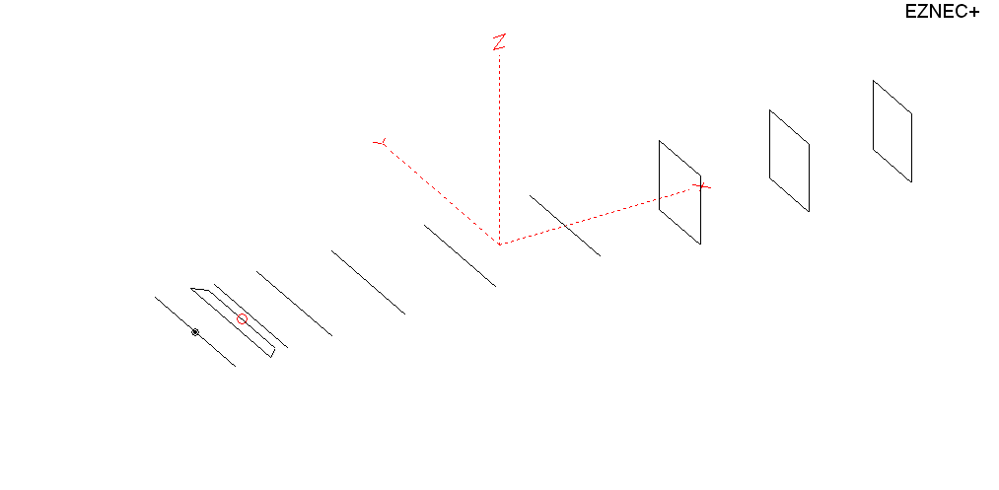
PERFORMANCES: (No loss condition)
TYPE | ELE | L (mm) | G (dBi) | F/B (dB) | F/Sh (dBi) | F/Sv (dBi) | Hor (◦) | Ver (◦) | Temp (◦K) | G/T (dB) | ΔF * (kHz)
QY21005XL4D3 | 10 | 5085 | 14.79 | 27.78 | 19.21 | 18.37 | 35.2 | 38.0 | 228.1 | -8.79 | 4150
* ΔF given for SWR=1.5

PERFORMANCES: (Losses included)
Element material | G (dBi) | Temp (◦K) | G/T (dB)
Aluminum rods | 14.69 | 229.7 | -8.92

DIMENSIONS:
 | Ref | De1 | De2 | D1 | D2 | D3 | D4 | D5 | DQ1 | DQ2 | DQ3 | REMARKS: : -All elements made of Al rods Ǿ5 mm  - The height of the rectangle is 500 mm  - All dimensions given in milimetres
Pos | 0 | 255 | 335 | 405 | 722 | 1259 | 1928 | 2697 | 3535 | 4335 | 5085
Length | 1020 | 1010 | 840 | 943 | 954 | 933 | 911 | 896 | 518 | 502 | 490
Building hints: No boom correction included.

COMPARISON
Antenna | Boomlength (mm) | Material | Gain (dBi) | TA (◦K) | G/T (dB) | Bandwidth  (MHz)
QY21005XL4D3 | 5085 | No loss | 14.79 | 228.1 | -8.79 | 142.900- 146.950
QY21005XL4D3 | 5085 | Aluminum | 14.69 | 229.7 | -8.92 | 142.900- 146.950
EF0210-5 | 5290 | No loss | 14.77 | 233.8 | -8.92 | 140.190- 145.450
EF0210-5 | 5290 | Aluminum | 14.67 | 235.4 | -9.05 | 140.190- 145.450

DIAGRAMS (no loss included)
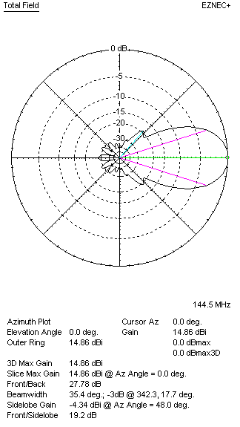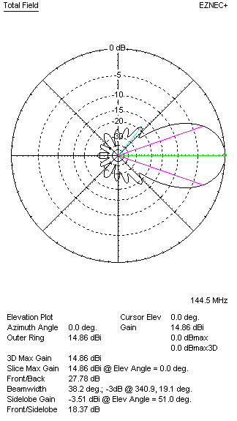
DIAGRAMS (loss included)
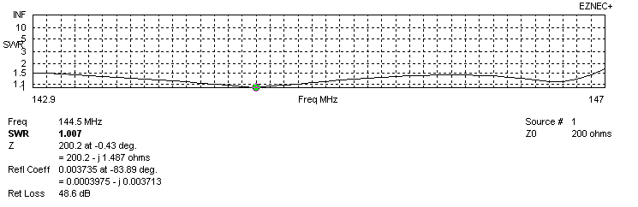
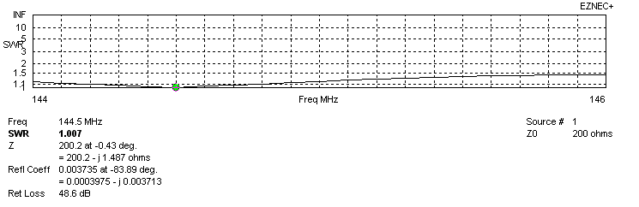
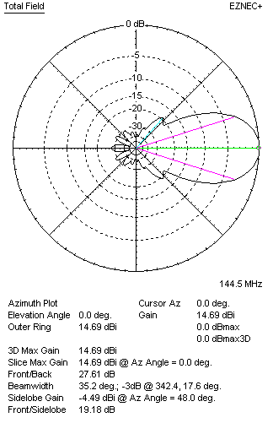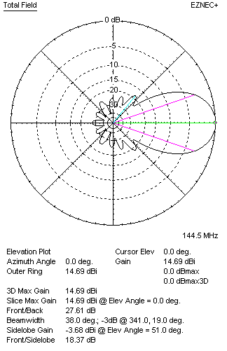
STACKING

QY21005XL4D3 - STACKING TABLE
(including loss for aluminum – AGT = -0.10 dB)
VERTICAL  DISTANCE (cm) | G  (dB) | TA  (°K) | G/T  (dB) | HORIZONTAL  DISTANCE  (cm) | G  (dB) | TA  (°K) | G/T  (dB)
100 | 15.66 | 233.4 | -8.02 | 100
110 | 15.83 | 227.8 | -7.75 | 110 | 14.85 | 258.6 | -9.28
120 | 15.96 | 225.4 | -7.57 | 120 | 15.41 | 255.1 | -8.66
130 | 16.07 | 225.1 | -7.45 | 130 | 15.72 | 248.4 | -8.23
140 | 16.17 | 225.2 | -7.36 | 140 | 15.93 | 242.8 | -7.92
150 | 16.28 | 224.1 | -7.22 | 150 | 16.10 | 238.8 | -7.68
160 | 16.39 | 221.9 | -7.07 | 160 | 16.23 | 235.9 | -7.50
170 | 16.49 | 220.6 | -6.95 | 170 | 16.35 | 233.8 | -7.34
180 | 16.59 | 220.6 | -6.85 | 180 | 16.46 | 232.2 | -7.20
190 | 16.68 | 221.6 | -6.78 | 190 | 16.55 | 231.0 | -7.09
200 | 16.76 | 223.3 | -6.73 | 200 | 16.64 | 230.1 | -6.98
210 | 16.84 | 224.9 | -6.68 | 210 | 16.73 | 229.5 | -6.88
220 | 16.92 | 225.9 | -6.62 | 220 | 16.81 | 228.9 | -6.79
230 | 17.00 | 226.3 | -6.55 | 230 | 16.89 | 228.5 | -6.70
240 | 17.09 | 226.1 | -6.45 | 240 | 16.97 | 228.2 | -6.61
250 | 17.17 | 225.7 | -6.36 | 250 | 17.05 | 228.0 | -6.53
260 | 17.26 | 225.2 | -6.26 | 260 | 17.12 | 227.9 | -6.46
270 | 17.34 | 224.9 | -6.18 | 270 | 17.20 | 227.8 | -6.38
280 | 17.42 | 225.0 | -6.10 | 280 | 17.27 | 227.7 | -6.30
290 | 17.49 | 225.5 | -6.04 | 290 | 17.34 | 227.7 | -6.23
300 | 17.55 | 226.3 | -6.00 | 300 | 17.41 | 227.8 | -6.17
310 | 17.60 | 227.4 | -5.97 | 310 | 17.47 | 227.8 | -6.11
320 | 17.65 | 228.8 | -5.94 | 320 | 17.52 | 228.0 | -6.06
330 | 17.68 | 230.4 | -5.94 | 330 | 17.56 | 228.1 | -6.02
340 | 17.71 | 232.0 | -5.95 | 340 | 17.61 | 228.4 | -5.98
350 | 17.73 | 233.8 | -5.96 | 350 | 17.64 | 228.6 | -5.95
360 | 17.75 | 235.3 | -5.97 | 360 | 17.67 | 228.9 | -5.93
370 | 17.76 | 236.5 | -5.98 | 370 | 17.69 | 229.2 | -5.91
380 |  |  |  | 380 | 17.71 | 229.5 | -5.90
390 |  |  |  | 390 | 17.73 | 229.8 | -5.88
400 |  |  |  | 400 | 17.74 | 230.1 | -5.88

TWO ANTENNAS VERTICALLY STACKED AT 330CM
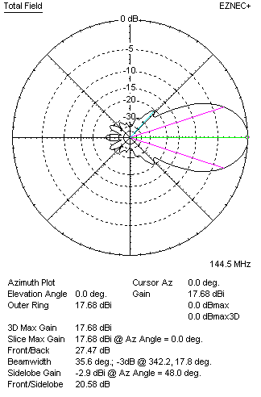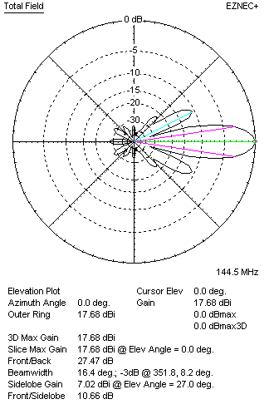

Performances
TYPE | Condition | G  (dBi) | F/B  (dB) | F/Sh  (dBi) | F/Sv (dBi) | Hor  (◦) | Ver  (◦) | Temp (◦K) | G/T (dB) | B (MHz)  for SWR=1.5
2xQY21005XL4D3 | No losss | 17.78 | 27.67 | 20.62 | 10.63 | 35.6 | 16.4 | 228.8 | -5.81 | 142.900- 146.950
2xQY21005XL4D3 | Aluminum | 17.68 | 27.47 | 20.58 | 10.66 | 35.6 | 16.4 | 230.3 | -5.94 | 142.900- 146.950

FOUR ANTENNAS VERTICALLY STACKED AT 330+330+330CM
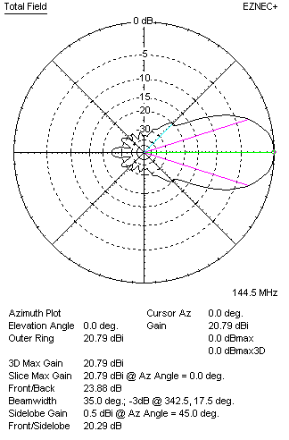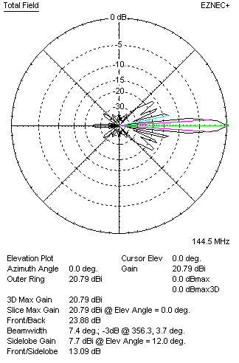
Performances
TYPE | Condition | G  (dBi) | F/B  (dB) | F/Sh  (dBi) | F/Sv (dBi) | Hor  (◦) | Ver  (◦) | Temp (◦K) | G/T (dB) | B (MHz)  for SWR=1.5
4xQY21005XL4D3 | No losss | 20.78 | 28.31 | 21.46 | 13.16 | 35.8 | 7.4 | 222.8 | -2.70 | 142.900- 146.950
4xQY21005XL4D3 | Aluminum | 20.71 | 23.80 | 20.25 | 13.09 | 35.0 | 7.4 | 229 | -2.89 | 142.900- 146.950

FOUR ANTENNAS IN H- STACK, H=390 CM, V=320 CM
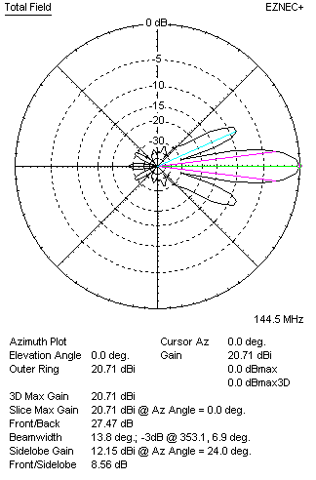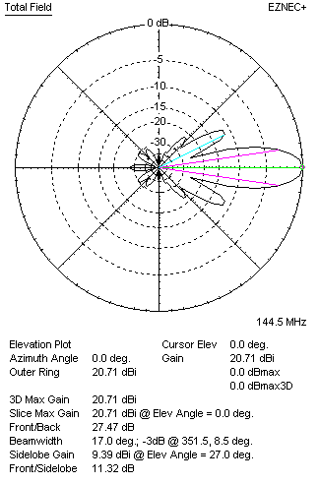
Performances
TYPE | Condition | G  (dBi) | F/B  (dB) | F/Sh  (dBi) | F/Sv (dBi) | Hor  (◦) | Ver  (◦) | Temp (◦K) | G/T (dB) | B (MHz)  for SWR=1.5
4xQY21005XL4D3 | No losss | 20.80 | 23.29 | 8.53 | 11.28 | 13.8 | 16.4 | 229.8 | -2.81 | 142.900- 146.950
4xQY21005XL4D3 | Aluminum | 20.71 | 27.47 | 8.56 | 11.32 | 13.8 | 17.0 | 231.3 | -2.93 | 142.900- 146.950

XPOL VERSION

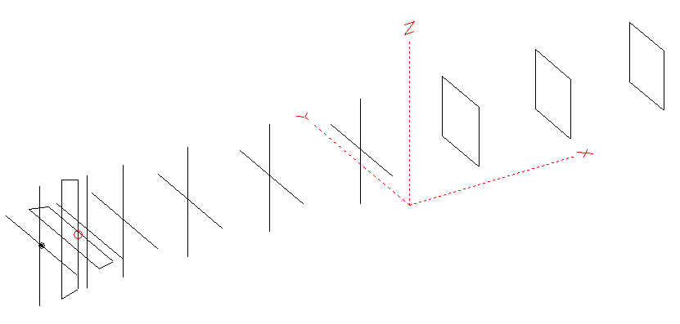
Horizontal components: Same as above
Vertical components: Same as above, except:
- All vertical yagi elements positioned 20 mm backward regarding horizontals.
- All crossed elements must cross each other in their centerlines

HORIZONTAL PERFORMANCES
Everything as the above data

VERTICAL PERFORMANCES with no corrections
Loss included condition (for Aluminum)
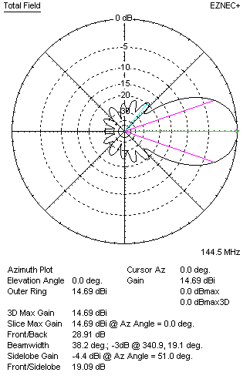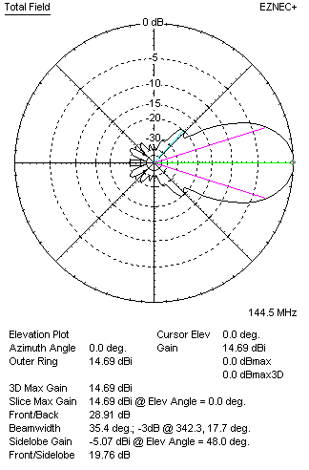
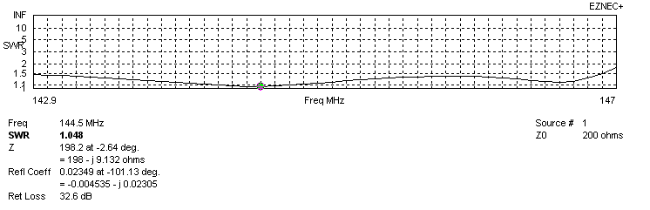
VERTICAL PERFORMANCES after corrections, loss included condition
If you want to get better SWR diagram for vertical antenna you can do the following:
- Change length of D1 from 942 to 938 mm
- Change length of DE2 from 840 to 830 mm

In this case the SWR diagram will be like this:
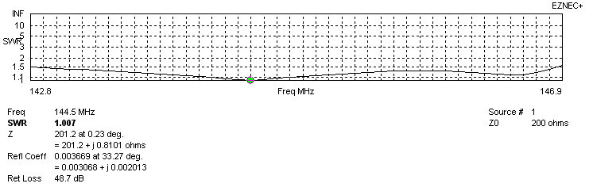
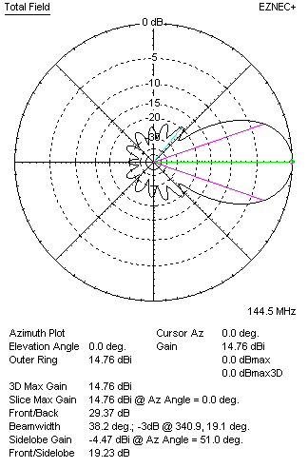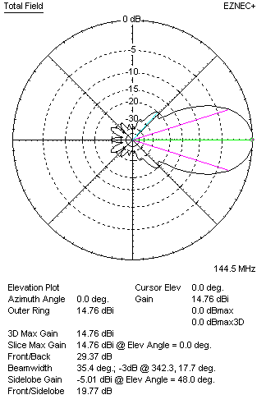

PERFORMANCES
 | TYPE | Condition | G  (dBi) | F/B  (dB) | F/Sh  (dBi) | F/Sv (dBi) | Hor  (◦) | Ver  (◦) | Temp (◦K) | G/T (dB) | B (MHz)  for SWR=1.5
 | Horizontal  part | No losss | 14.79 | 27.78 | 19.21 | 18.37 | 35.2 | 38.0 | 228.1 | -8.79 | 142.900- 146.950
 | Horizontal  part | Aluminum | 14.69 | 27.61 | 18.18 | 18.37 | 35.2 | 38.0 | 229.7 | -8.92 | 142.900- 146.950
 | Vertical  part | No losss | 14.86 | 29.61 | 19.22 | 19.80 | 38.2 | 35.4 | 226.1 | -8.68 | 142.800 – 146.850
 | Vertical  part | Aluminum | 14.76 | 29.37 | 19.23 | 19.77 | 38.2 | 35.4 | 229.8 | -8.89 | 142.800 – 146.850

