ANTENNA QY20910XL4D2
Good stacking characteristics at moderate both vertical and horizontal distances
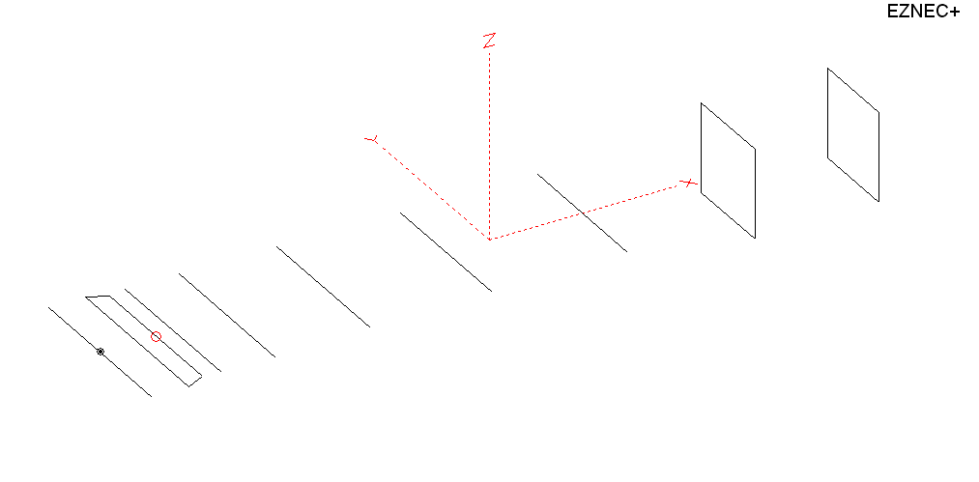
PERFORMANCES: (No loss condition)
TYPE | ELE | L (mm) | G (dBi) | F/B (dB) | F/Sh (dBi) | F/Sv (dBi) | Hor (◦) | Ver (◦) | Temp (◦K) | G/T (dB) | ΔF * (kHz)
QY20910XL4D2 | 9 | 4205 | 14.11 | 22.63 | 20.66 | 18.70 | 37.6 | 41.8 | 235.4 | -9.61 | 4000
* ΔF given for SWR=1.5

PERFORMANCES: (Loss included)
Element material | G (dBi) | Temp (◦K) | G/T (dB)
Aluminum rods | 14.06 | 236.2 | -9.67

DIMENSIONS:
 | Ref | De1 | De2 | D1 | D2 | D3 | D4 | D5 | DQ1 | DQ2 | REMARKS: : -All elements made of Al rods Ǿ10 mm  - The height of the rectangle is 500 mm  - All dimensions given in milimetres
Pos | 0 | 205 | 310 | 392 | 698 | 1245 | 1932 | 2695 | 3519 | 4205
Length | 1008 | 1008 | 880 | 930 | 942 | 910 | 890 | 870 | 516 | 490
Building hints: No boom correction included.

COMPARISON
Antenna | Boomlength (mm) | Material | Gain (dBi) | TA (◦K) | G/T (dB) | Bandwidth  (MHz)
QY20910XL4D2 | 4205 | No loss | 14.11 | 235.4 | -9.61 | 142.700- 146.700
QY20910XL4D2 | 4205 | Aluminum | 14.06 | 236.2 | -9.67 | 142.700- 146.700
GOKSC  9EL WB | 4447 | No loss | 14.12 | 239.6 | -9.68 | 142.700- 145.550
GOKSC  9EL WB | 4447 | Aluminum | 14.04 | 240.9 | -9.78 | 142.700- 145.550
EF0208-5 | 4490 | No loss | 14.06 | 239.8 | -9.74 | 140.100- 145.480
EF0208-5 | 4490 | Aluminum | 13.99 | 240.9 | -9.83 | 140.100- 145.480

DIAGRAMS (no loss included)
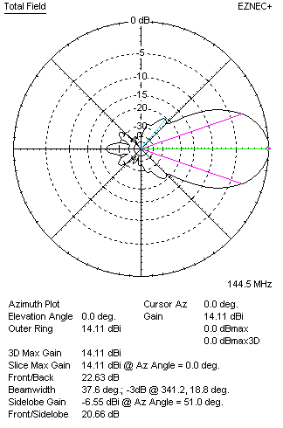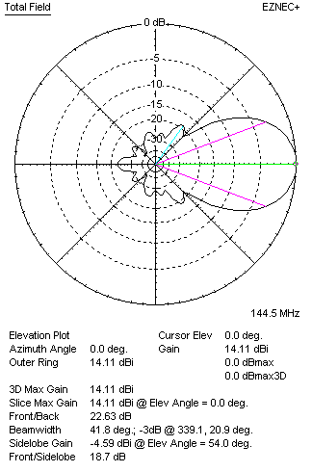
DIAGRAMS (loss included)
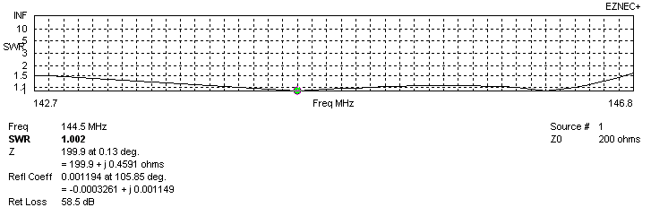
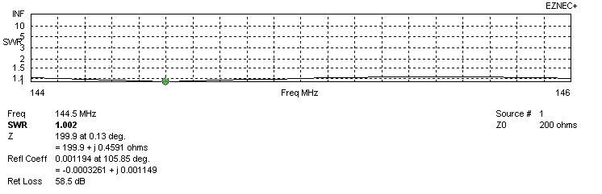
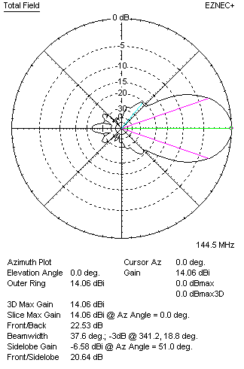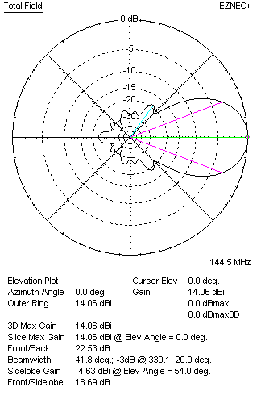
STACKING

Q20910XL4D2 - STACKING TABLE
(including loss for aluminum – AGT = -0.06 dB)
VERTICAL  DISTANCE (cm) | G  (dB) | TA  (°K) | G/T  (dB) | HORIZONTAL  DISTANCE  (cm) | G  (dB) | TA  (°K) | G/T  (dB)
100 | 15.21 | 235.5 | -8.51 | 100
110 | 15.37 | 229.5 | -8.24 | 110 | 14.43 | 276.6 | -9.99
120 | 15.51 | 226.1 | -8.03 | 120 | 14.95 | 266.8 | -9.31
130 | 15.63 | 224.6 | -7.88 | 130 | 15.23 | 257.8 | -8.88
140 | 15.75 | 223.6 | -7.75 | 140 | 15.44 | 251.1 | -8.56
150 | 15.86 | 222.2 | -7.61 | 150 | 15.61 | 246.2 | -8.30
160 | 15.97 | 221.1 | -7.48 | 160 | 15.75 | 242.7 | -8.10
170 | 16.07 | 221.6 | -7.39 | 170 | 15.87 | 240.1 | -7.93
180 | 16.16 | 223.4 | -7.33 | 180 | 15.99 | 238.3 | -7.78
190 | 16.24 | 225.7 | -7.30 | 190 | 16.09 | 237.0 | -7.66
200 | 16.33 | 227.7 | -7.24 | 200 | 16.19 | 236.1 | -7.54
210 | 16.42 | 228.8 | -7.17 | 210 | 16.28 | 235.5 | -7.44
220 | 16.51 | 229.1 | -7.09 | 220 | 16.37 | 235.3 | -7.35
230 | 16.61 | 228.9 | -6.99 | 230 | 16.46 | 235.3 | -7.26
240 | 16.70 | 228.7 | -6.89 | 240 | 16.54 | 235.4 | -7.18
250 | 16.79 | 229.0 | -6.81 | 250 | 16.62 | 235.7 | -7.10
260 | 16.87 | 229.7 | -6.74 | 260 | 16.70 | 236.0 | -7.03
270 | 16.94 | 231.1 | -6.70 | 270 | 16.77 | 236.4 | -6.97
280 | 17.00 | 233.0 | -6.67 | 280 | 16.84 | 236.8 | -6.90
290 | 17.06 | 235.3 | -6.66 | 290 | 16.90 | 237.3 | -6.85
300 | 17.10 | 237.8 | -6.66 | 300 | 16.96 | 237.7 | -6.80
310 | 17.14 | 240.3 | -6.67 | 310 | 17.01 | 238.0 | -6.76
320 | 17.17 | 242.6 | -6.68 | 320 | 17.05 | 238.4 | -6.72
330 |  |  |  | 330 | 17.09 | 238.7 | -6.69
340 |  |  |  | 340 | 17.12 | 239.0 | -6.66
350 |  |  |  | 350 | 17.14 | 239.3 | -6.65
360 |  |  |  | 360 | 17.16 | 239.5 | -6.63
370 |  |  |  | 370 | 18.18 | 239.7 | -6.62
380 |  |  |  | 380 | 17.19 | 239.9 | -6.61
390 |  |  |  | 390 | 17.19 | 240.1 | -6.61
400 |  |  |  | 400 | 17.20 | 240.2 | -6.61

TWO ANTENNAS VERTICALLY STACKED AT 290CM
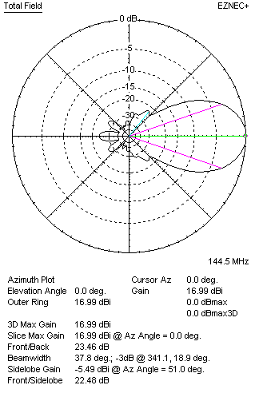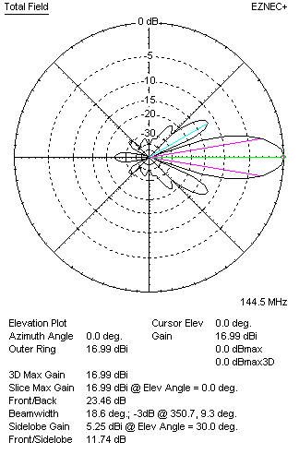

Performances
TYPE | Condition | G  (dBi) | F/B  (dB) | F/Sh  (dBi) | F/Sv (dBi) | Hor  (◦) | Ver  (◦) | Temp (◦K) | G/T (dB) | B (MHz)  for SWR=1.5
2x QY20910XL4D2 | No losss | 17.04 | 23.56 | 22.50 | 11.73 | 37.8 | 18.6 | 233.0 | -6.63 | 142.700- 146.700
2x QY20910XL4D2 | Aluminum | 16.99 | 23.46 | 22.48 | 11.74 | 37.8 | 18.6 | 233.7 | -6.70 | 142.700- 146.700

FOUR ANTENNAS VERTICALLY STACKED AT 290+290+290CM
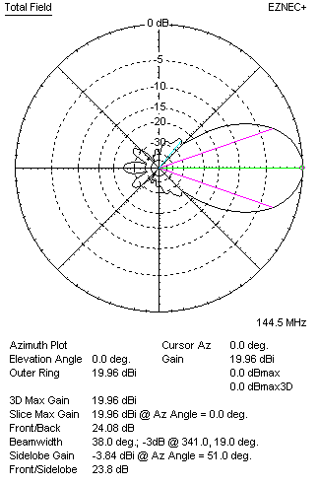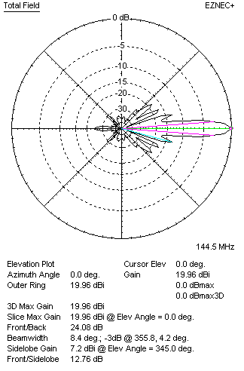
Performances
TYPE | Condition | G  (dBi) | F/B  (dB) | F/Sh  (dBi) | F/Sv (dBi) | Hor  (◦) | Ver  (◦) | Temp (◦K) | G/T (dB) | B (MHz)  for SWR=1.5
4xQY20910XL4D2 | No losss | 20.02 | 24.20 | 23.84 | 12.77 | 38.0 | 8.4 | 220.0 | -3.40 | 142.700- 146.700
4xQY20910XL4D2 | Aluminum | 19.96 | 24.08 | 23.80 | 12.76 | 38.0 | 8.4 | 221.0 | -3.48 | 142.700- 146.700

FOUR ANTENNAS IN H- STACK, H=368 CM, V=282 CM
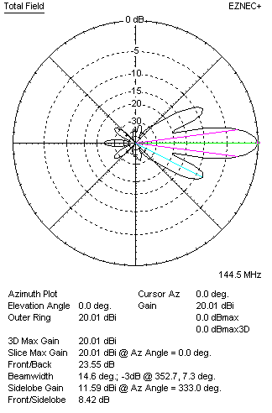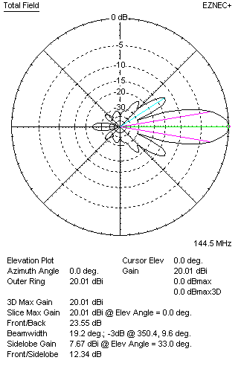
Performances
TYPE | Condition | G  (dBi) | F/B  (dB) | F/Sh  (dBi) | F/Sv (dBi) | Hor  (◦) | Ver  (◦) | Temp (◦K) | G/T (dB) | B (MHz)  for SWR=1.5
4xQY20910XL4D2 | No losss | 20.06 | 23.65 | 8.40 | 12.32 | 14.6 | 19.2 | 234.4 | -3.64 | 142.700- 146.700
4xQY20910XL4D2 | Aluminum | 20.01 | 23.55 | 8.42 | 12.34 | 14.6 | 19.2 | 235.2 | -3.70 | 142.700- 146.700

XPOL VERSION

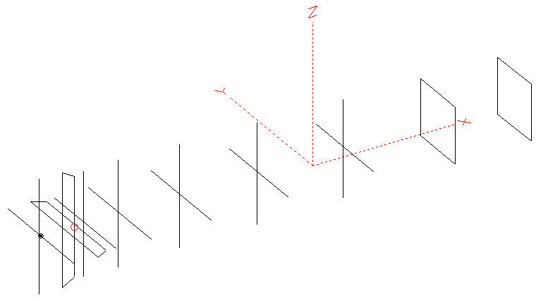
Horizontal components: Same as above
Vertical components: Same as above, except:
- All vertical yagi elements positioned 20 mm back regarding horizontals.
- All crossed elements must cross each other in their centerlines

HORIZONTAL PERFORMANCES
Everything as the above data

VERTICAL PERFORMANCES with no corrections
Loss included condition (for Aluminum)
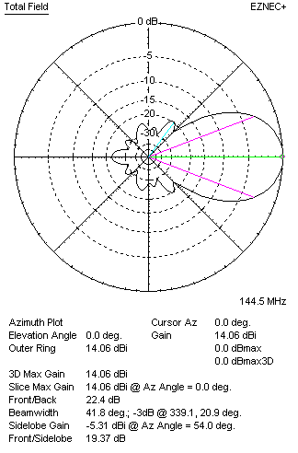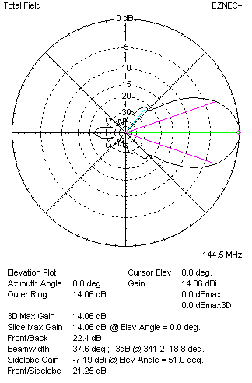
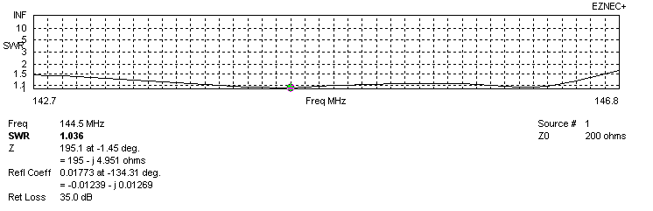
VERTICAL PERFORMANCES after corrections, loss included condition
If you want to get better SWR diagram for vertical antenna you can do the following:
- Change length of D1 from 880 to 892 mm

In this case the SWR diagram will be like this:
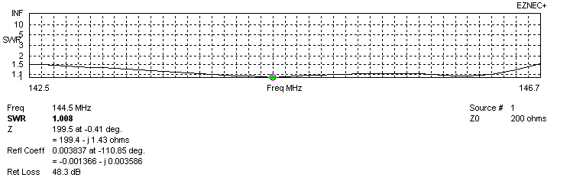
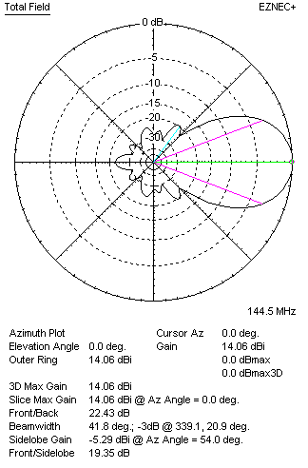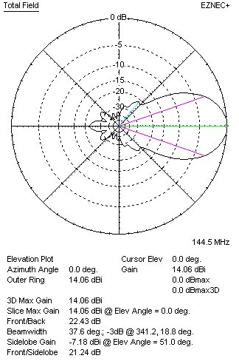

PERFORMANCES
 | TYPE | Condition | G  (dBi) | F/B  (dB) | F/Sh  (dBi) | F/Sv (dBi) | Hor  (◦) | Ver  (◦) | Temp (◦K) | G/T (dB) | B (MHz)  for SWR=1.5
 | Horizontal  part | No losss | 14.11 | 22.63 | 20.66 | 18.70 | 37.6 | 41.8 | 235.4 | -9.61 | 142.700- 146.700
 | Horizontal  part | Aluminum | 14.06 | 22.53 | 20.64 | 18.69 | 37.6 | 41.8 | 236.2 | -9.67 | 142.700- 146.700
 | Vertical  part | No losss | 14.11 | 22.52 | 19.36 | 21.26 | 41.8 | 37.6 | 229.8 | -9.50 | 142.500 – 146.650
 | Vertical  part | Aluminum | 14.06 | 22.43 | 19.35 | 21.24 | 41.8 | 37.6 | 230.6 | -9.57 | 142.500 – 146.650

