ANTENNA QY20908XL4D2
Good stacking characteristics at moderate vertical and big horizontal distances
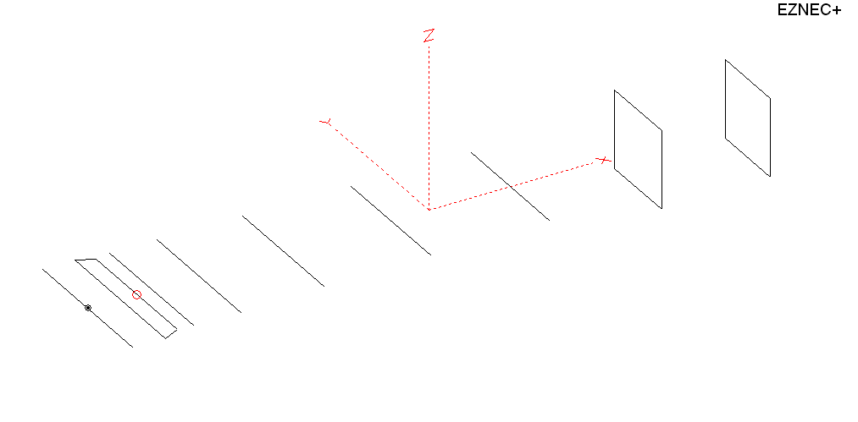
PERFORMANCES: (No loss condition)
TYPE | ELE | L (mm) | G (dBi) | F/B (dB) | F/Sh (dBi) | F/Sv (dBi) | Hor (◦) | Ver (◦) | Temp (◦K) | G/T (dB) | ΔF * (kHz)
QY20908XL4D2 | 9 | 4265 | 14.15 | 20.35 | 20.67 | 18.07 | 37.4 | 41.4 | 236.1 | -9.58 | 3500
* ΔF given for SWR=1.5

PERFORMANCES: (Loss included)
Element material | G (dBi) | Temp (◦K) | G/T (dB)
Aluminum rods | 14.08 | 237.0 | -9.67

DIMENSIONS:
 | Ref | De1 | De2 | D1 | D2 | D3 | D4 | D5 | DQ1 | DQ2 | REMARKS: : -All elements made of Al rods Ǿ8 mm  - The height of the rectangle is 500 mm  - All dimensions given in milimetres
Pos | 0 | 182 | 330 | 407 | 690 | 1255 | 1943 | 2695 | 3525 | 4625
Length | 1010 | 1010 | 890 | 940 | 948 | 918 | 902 | 884 | 510 | 490
Building hints: No boom correction included.

COMPARISON
Antenna | Boomlength (mm) | Material | Gain (dBi) | TA (◦K) | G/T (dB) | Bandwidth  (MHz)
QY20908XL4D2 | 4265 | No loss | 14.15 | 236.1 | -9.58 | 142.700- 146.200
QY20908XL4D2 | 4265 | Aluminum | 14.08 | 237.0 | -9.67 | 142.700- 146.200
GOKSC  9EL WB | 4447 | No loss | 14.12 | 239.6 | -9.68 | 142.700- 145.550
GOKSC  9EL WB | 4447 | Aluminum | 14.04 | 240.9 | -9.78 | 142.700- 145.550
EF0208-5 | 4490 | No loss | 14.06 | 239.8 | -9.74 | 140.100- 145.480
EF0208-5 | 4490 | Aluminum | 13.99 | 240.9 | -9.83 | 140.100- 145.480

DIAGRAMS (no loss included)
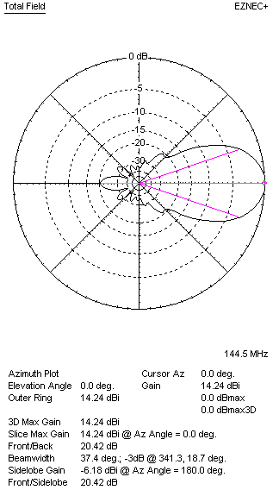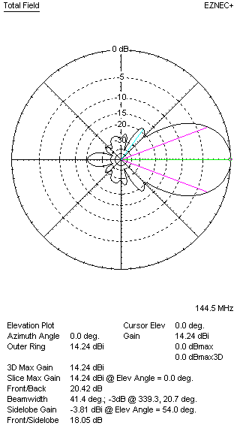
DIAGRAMS (loss included)
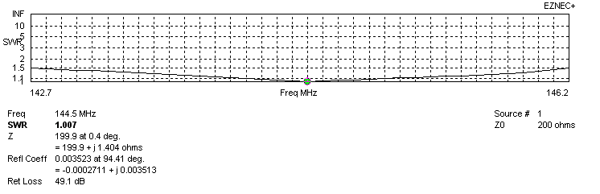
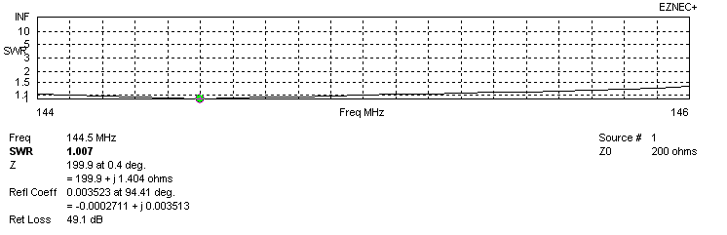
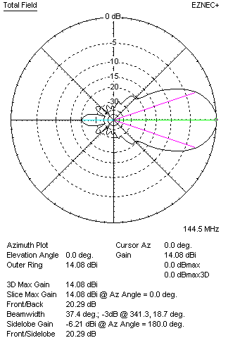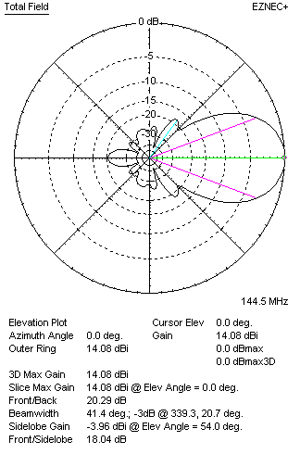

STACKING

QY20908XL4D2 - STACKING TABLE
(including loss for aluminum – AGT = -0.07 dB)
VERTICAL  DISTANCE (cm) | G  (dB) | TA  (°K) | G/T  (dB) | HORIZONTAL  DISTANCE (cm) | G  (dB) | TA  (°K) | G/T  (dB)
100 | 15.19 | 232.5 | -8.48 | 100
110 | 15.34 | 227.4 | -8.23 | 110
120 | 15.48 | 224.2 | -8.03 | 120 | 14.84 | 261.0 | -9.33
130 | 15.61 | 222.5 | -7.86 | 130 | 15.17 | 252.5 | -8.85
140 | 15.72 | 221.3 | -7.73 | 140 | 15.39 | 246.4 | -8.53
150 | 15.83 | 220.3 | -7.60 | 150 | 15.56 | 242.1 | -8.28
160 | 15.93 | 220.0 | -7.49 | 160 | 15.71 | 239.0 | -8.07
170 | 16.02 | 220.9 | -7.42 | 170 | 15.83 | 236.8 | -7.91
180 | 16.12 | 222.2 | -7.35 | 180 | 15.95 | 235.3 | -7.77
190 | 16.21 | 223.6 | -7.28 | 190 | 16.05 | 234.3 | -7.65
200 | 16.30 | 224.6 | -7.21 | 200 | 16.15 | 233.7 | -7.54
210 | 16.40 | 225.0 | -7.12 | 210 | 16.25 | 233.4 | -7.43
220 | 16.49 | 225.0 | -7.03 | 220 | 16.34 | 233.4 | -7.34
230 | 16.59 | 225.0 | -6.93 | 230 | 16.43 | 233.6 | -7.25
240 | 16.68 | 225.2 | -6.85 | 240 | 16.51 | 234.0 | -7.18
250 | 16.76 | 226.0 | -6.78 | 250 | 16.59 | 234.4 | -7.11
260 | 16.84 | 227.4 | -6.73 | 260 | 16.67 | 234.9 | -7.04
270 | 16.90 | 229.4 | -6.71 | 270 | 16.74 | 235.4 | -6.98
280 | 16.96 | 231.9 | -6.69 | 280 | 16.80 | 236.0 | -6.93
290 | 17.01 | 234.6 | -6.69 | 290 | 16.86 | 236.4 | -6.88
300 | 17.06 | 237.4 | -6.70 | 300 | 16.91 | 236.9 | -6.83
 |  |  |  | 310 | 16.96 | 237.2 | -6.79
 |  |  |  | 320 | 17.00 | 237.6 | -6.76
 |  |  |  | 330 | 17.03 | 237.8 | -6.73
 |  |  |  | 340 | 17.06 | 238.1 | -6.71
 |  |  |  | 350 | 17.08 | 238.3 | -6.69
 |  |  |  | 360 | 17.10 | 238.5 | -6.68
 |  |  |  | 370 | 17.11 | 238.7 | -6.67
 |  |  |  | 380 | 17.12 | 238.8 | -6.66
 |  |  |  | 390 | 17.13 | 238.9 | -6.65
 |  |  |  | 400 | 17.13 | 239.0 | -6.65

TWO ANTENNAS VERTICALLY STACKED AT 280CM
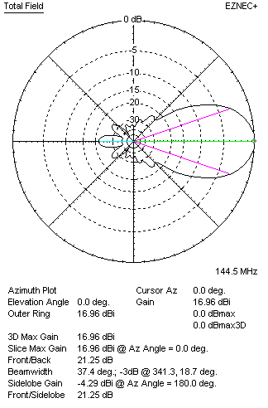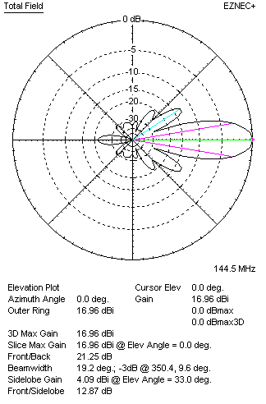

Performances
TYPE | Condition | G  (dBi) | F/B  (dB) | F/Sh  (dBi) | F/Sv (dBi) | Hor  (◦) | Ver  (◦) | Temp (◦K) | G/T (dB) | B (MHz)  for SWR=1.5
2x QY20908XL4D2 | No losss | 17.03 | 21.32 | 23.03 | 12.85 | 37.4 | 19.2 | 230.8 | -6.60 | 142.700- 146.200
2x QY20908XL4D2 | Aluminum | 16.96 | 21.25 | 23.02 | 12.87 | 37.4 | 19.2 | 231.9 | -6.69 | 142.700- 146.200

FOUR ANTENNAS VERTICALLY STACKED AT 280+280+280CM
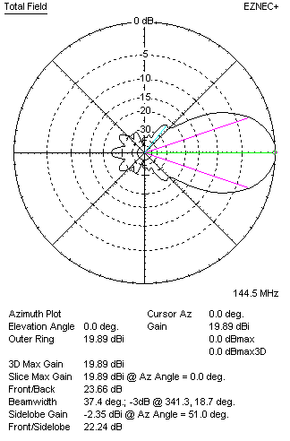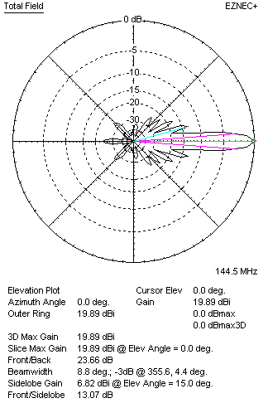
Performances
TYPE | Condition | G  (dBi) | F/B  (dB) | F/Sh  (dBi) | F/Sv (dBi) | Hor  (◦) | Ver  (◦) | Temp (◦K) | G/T (dB) | B (MHz)  for SWR=1.5
4xQY20908XL4D2 | No losss | 19.96 | 22.03 | 24.25 | 13.01 | 37.6 | 8.8 | 219.9 | -3.46 | 142.700- 146.200
4xQY20908XL4D2 | Aluminum | 19.90 | 21.96 | 24.20 | 13.01 | 37.6 | 8.8 | 221.0 | -3.54 | 142.700- 146.200

FOUR ANTENNAS IN H- STACK, H=380 CM, V=270 CM
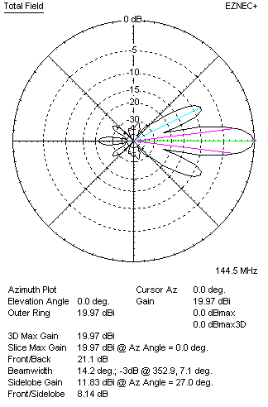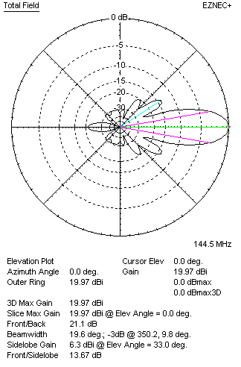
Performances
TYPE | Condition | G  (dBi) | F/B  (dB) | F/Sh  (dBi) | F/Sv (dBi) | Hor  (◦) | Ver  (◦) | Temp (◦K) | G/T (dB) | B (MHz)  for SWR=1.5
4xQY20908XL4D2 | No losss | 20.03 | 21.16 | 8.12 | 13.64 | 14.2 | 19.8 | 231.8 | -3.62 | 142.700- 146.200
4xQY20908XL4D2 | Aluminum | 19.97 | 21.10 | 8.14 | 13.67 | 14.2 | 19.6 | 232.8 | -3.70 | 142.700- 146.200

XPOL VERSION

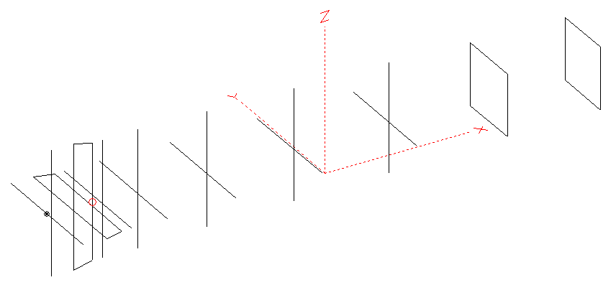
Horizontal components: Same as above
Vertical components: Same as above, except:
- All vertical yagi elements positioned 20 mm back regarding horizontals.
- All crossed elements must cross each other in their centerlines

HORIZONTAL PERFORMANCES
Everything as the above data

VERTICAL PERFORMANCES with no corrections
Loss included condition (for Aluminum)
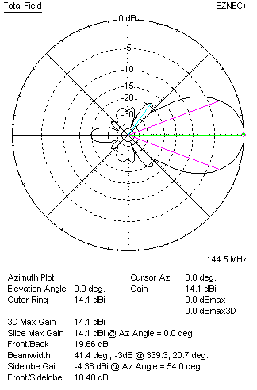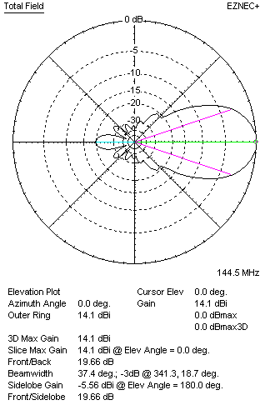
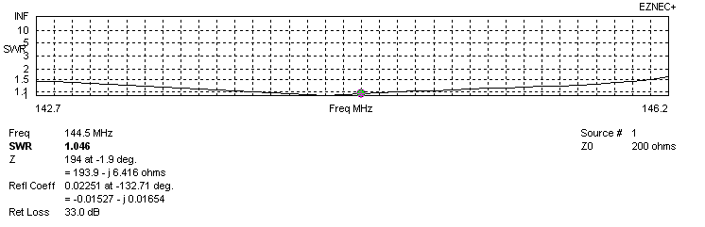
VERTICAL PERFORMANCES after corrections, loss included condition
If you want to get better SWR diagram for vertical antenna you can do the following:
- Change length of D1 from 940 to 938 mm

In this case the SWR diagram will be like this:
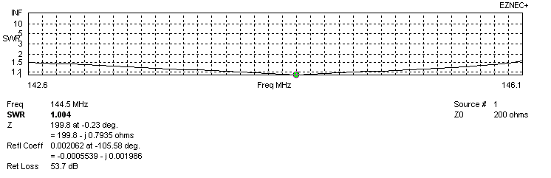
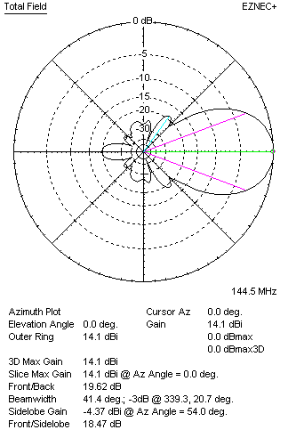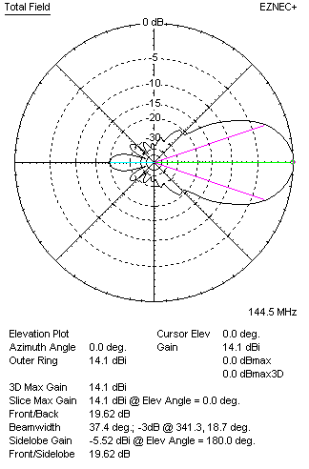

PERFORMANCES: (No loss condition)
 | TYPE | Condition | G  (dBi) | F/B  (dB) | F/Sh  (dBi) | F/Sv (dBi) | Hor  (◦) | Ver  (◦) | Temp (◦K) | G/T (dB) | B (MHz)  for SWR=1.5
 | Horizontal  part | No losss | 14.15 | 20.35 | 20.67 | 18.07 | 37.4 | 41.4 | 236.1 | -9.58 | 142.700- 146.200
 | Horizontal  part | Aluminum | 14.08 | 20.29 | 20.65 | 18.04 | 37.4 | 41.4 | 237.0 | -9.67 | 142.700- 146.200
 | Vertical  part | No losss | 14.16 | 19.67 | 18.50 | 20.95 | 41.4 | 37.4 | 230.7 | -9.47 | 142.600 – 146.000
 | Vertical  part | Aluminum | 14.10 | 19.62 | 18.47 | 20.93 | 41.2 | 37.4 | 231.7 | -9.55 | 142.600 – 146.000

