ANTENNA QY20906XL3D3
Good stacking characteristics at moderate vertical distances and big horizontal distances
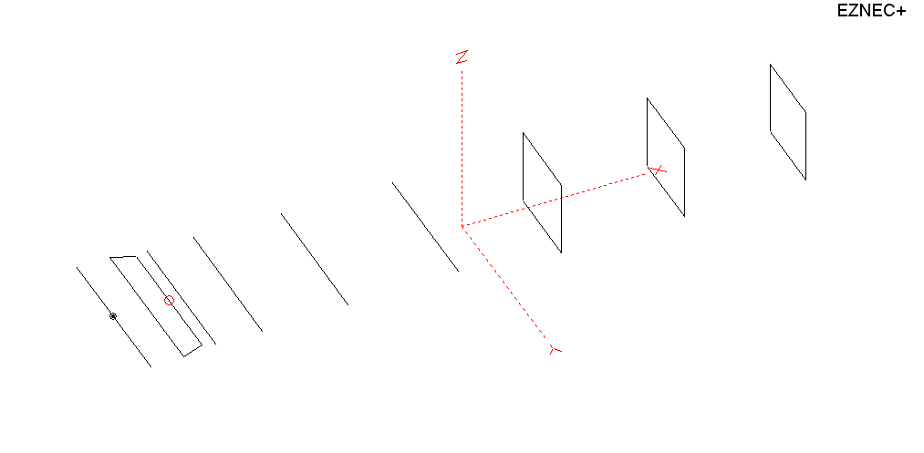
PERFORMANCES: (No loss condition)
TYPE | ELE | L (mm) | G (dBi) | F/B (dB) | F/Sh (dBi) | F/Sv (dBi) | Hor (◦) | Ver (◦) | Temp (◦K) | G/T (dB) | ΔF * (kHz)
QY20906XL3D3 | 9 | 4255 | 14.18 | 21.08 | 19.17 | 18.92 | 37.4 | 40.8 | 234.7 | -9.53 | 3700
* ΔF given for SWR=1.5

PERFORMANCES: (Loss included)
Element material | G (dBi) | Temp (◦K) | G/T (dB)
Aluminum rods | 14.10 | 236.0 | -9.63

DIMENSIONS:
 | Ref | De1 | De2 | D1 | D2 | D3 | D4 | DQ1 | DQ2 | DQ3 | REMARKS: -All elements made of Al rods Ǿ6 mm  - The height of the rectangle is 500 mm  - All dimensions given in milimetres
Pos | 0 | 210 | 350 | 426 | 718 | 1265 | 1965 | 2705 | 3485 | 4255
Length | 1016 | 1000 | 896 | 945 | 953 | 928 | 906 | 530 | 510 | 490
Building hints: No boom correction included.

COMPARISON
Antenna | Boomlength (mm) | Material | Gain (dBi) | TA (◦K) | G/T (dB) | Bandwidth  (MHz)
QY20906XL3D3 | 4255 | No loss | 14.18 | 234.7 | -9.53 | 142.450- 146.150
QY20906XL3D3 | 4255 | Aluminum | 14.10 | 236.0 | -9.63 | 142.450- 146.150
G0KSC  9ELWB | 4447 | No loss | 14.12 | 239.6 | -9.68 | 142.700- 145.550
G0KSC  9ELWB | 4447 | Aluminum | 14.04 | 240.9 | -9.78 | 142.700- 145.550
EF0209-5 | 4490 | No loss | 14.06 | 239.8 | -9.74 | 140.100 - 145.480
EF0209-5 | 4490 | Aluminum | 13.99 | 240.9 | -9.83 | 140.100 - 145.480

DIAGRAMS (no loss included)
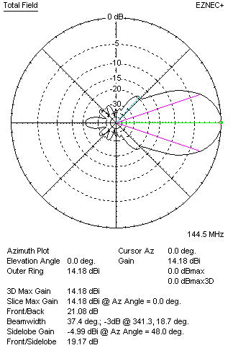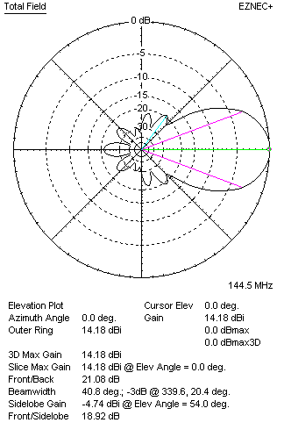
DIAGRAMS (loss included)
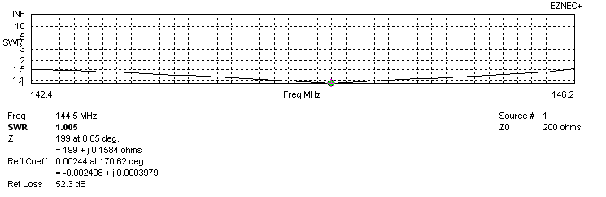
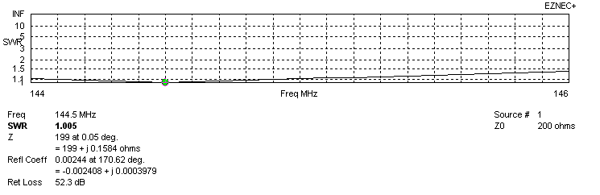
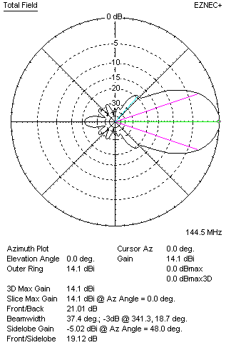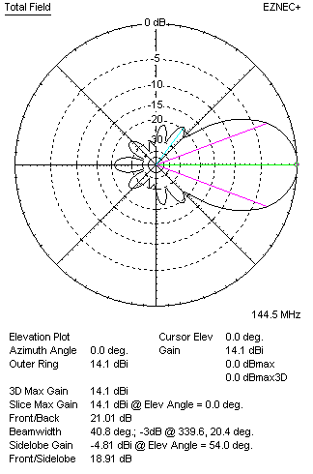
STACKING

QY20906XL3D3 - STACKING TABLE
(including loss for aluminum – AGT = -0.09 dB)
VERTICAL  DISTANCE (cm) | G  (dB) | TA  (°K) | G/T  (dB) | HORIZONTAL  DISTANCE (cm) | G  (dB) | TA  (°K) | G/T  (dB)
100 | 15.10 | 234.6 | -8.60 | 100
110 | 15.27 | 229.0 | -8.33 | 110
120 | 15.42 | 226.2 | -8.13 | 120 | 14.84 | 254.6 | -9.22
130 | 15.55 | 225.4 | -7.98 | 130 | 15.17 | 248.7 | -8.79
140 | 15.67 | 224.9 | -7.85 | 140 | 15.39 | 244.0 | -8.48
150 | 15.78 | 223.7 | -7.72 | 150 | 15.57 | 240.4 | -8.24
160 | 15.90 | 222.3 | -7.57 | 160 | 15.71 | 237.7 | -8.05
170 | 16.01 | 221.8 | -7.45 | 170 | 15.84 | 235.8 | -7.89
180 | 16.12 | 222.2 | -7.35 | 180 | 15.96 | 234.5 | -7.74
190 | 16.22 | 223.0 | -7.26 | 190 | 16.07 | 233.7 | -7.62
200 | 16.31 | 223.9 | -7.19 | 200 | 16.17 | 233.1 | -7.51
210 | 16.40 | 224.5 | -7.11 | 210 | 16.26 | 232.9 | -7.41
220 | 16.50 | 224.7 | -7.02 | 220 | 16.35 | 232.9 | -7.32
230 | 16.59 | 224.8 | -6.93 | 230 | 16.44 | 233.1 | -7.24
240 | 16.68 | 225.1 | -6.84 | 240 | 16.52 | 233.5 | -7.16
250 | 16.76 | 225.7 | -6.77 | 250 | 16.60 | 233.8 | -7.09
260 | 16.83 | 226.9 | -6.73 | 260 | 16.68 | 234.3 | -7.02
270 | 16.90 | 228.6 | -6.69 | 270 | 16.75 | 234.7 | -6.96
280 | 16.96 | 230.7 | -6.67 | 280 | 16.82 | 235.1 | -6.89
290 | 17.01 | 233.2 | -6.67 | 290 | 16.88 | 235.5 | -6.84
300 | 17.06 | 235.8 | -6.66 | 300 | 16.93 | 235.8 | -6.80
310 | 17.09 | 238.4 | -6.68 | 310 | 16.98 | 236.2 | -6.75
320 | 17.12 | 240.9 | -6.70 | 320 | 17.01 | 236.4 | -6.73
330 | 17.14 | 243.2 | -6.72 | 330 | 17.05 | 236.6 | -6.69
340 |  |  |  | 340 | 17.08 | 236.8 | -6.66
350 |  |  |  | 350 | 17.10 | 237.0 | -6.65
360 |  |  |  | 360 | 17.12 | 237.1 | -6.63
370 |  |  |  | 370 | 17.13 | 237.2 | -6.62
380 |  |  |  | 380 | 17.14 | 237.3 | -6.61
390 |  |  |  | 390 | 17.15 | 237.4 | -6.60
400 |  |  |  | 400 | 17.15 | 237.4 | -6.61

TWO ANTENNAS VERTICALLY STACKED AT 280CM
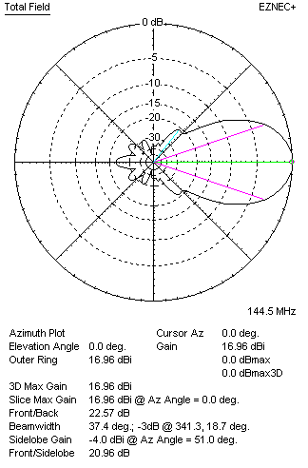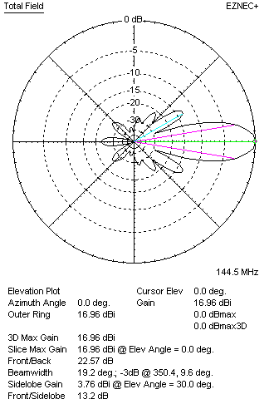

Performances
TYPE | Condition | G  (dBi) | F/B  (dB) | F/Sh  (dBi) | F/Sv (dBi) | Hor  (◦) | Ver  (◦) | Temp (◦K) | G/T (dB) | B (MHz)  for SWR=1.5
2x QY20906XL3D3 | No losss | 17.04 | 22.65 | 21.01 | 13.17 | 37.4 | 19.2 | 229.4 | -6.57 | 142.450- 146.150
2x QY20906XL3D3 | Aluminum | 16.96 | 22.57 | 20.96 | 13.20 | 37.4 | 19.2 | 230.7 | -6.67 | 142.450- 146.150

FOUR ANTENNAS VERTICALLY STACKED AT 280+280+280CM
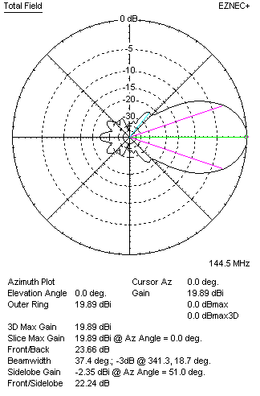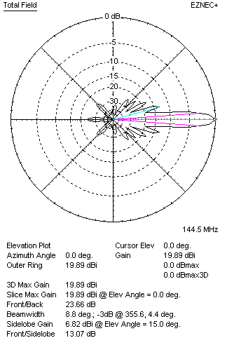
Performances
TYPE | Condition | G  (dBi) | F/B  (dB) | F/Sh  (dBi) | F/Sv (dBi) | Hor  (◦) | Ver  (◦) | Temp (◦K) | G/T (dB) | B (MHz)  for SWR=1.5
4xQY20906XL3D3 | No losss | 19.97 | 23.75 | 22.29 | 13.06 | 37.4 | 8.8 | 219.7 | -3.45 | 142.450- 146.150
4xQY20906XL3D3 | Aluminum | 19.89 | 23.66 | 22.24 | 13.07 | 37.4 | 8.8 | 221.2 | -3.56 | 142.450- 146.150

FOUR ANTENNAS IN H- STACK, H=390 CM, V=280 CM
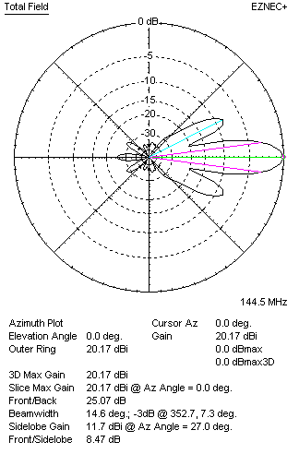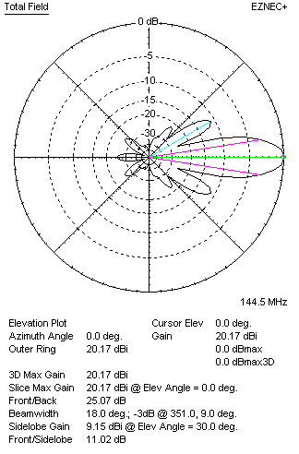
Performances
TYPE | Condition | G  (dBi) | F/B  (dB) | F/Sh  (dBi) | F/Sv (dBi) | Hor  (◦) | Ver  (◦) | Temp (◦K) | G/T (dB) | B (MHz)  for SWR=1.5
4xQY20906XL3D3 | No losss | 20.11 | 22.46 | 7.74 | 13.06 | 14.0 | 19.2 | 232.4 | -3.55 | 142.450- 146.150
4xQY20906XL3D3 | Aluminum | 20.03 | 22.38 | 7.77 | 13.10 | 13.9 | 19.2 | 233.6 | -3.65 | 142.450- 146.150

XPOL VERSION

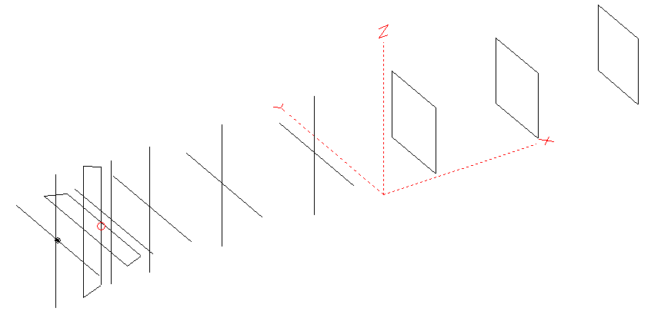
Horizontal components: Same as above
Vertical components: Same as above, except:
- All vertical yagi elements positioned 20 mm back regarding horizontals.
- All crossed elements must cross each other in their centerlines

HORIZONTAL PERFORMANCES
Everything as the above data

VERTICAL PERFORMANCES with no corrections
Loss included condition (for Aluminum)
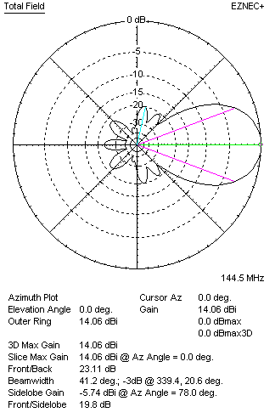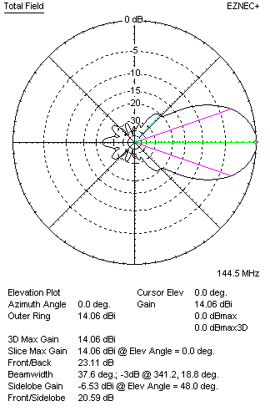
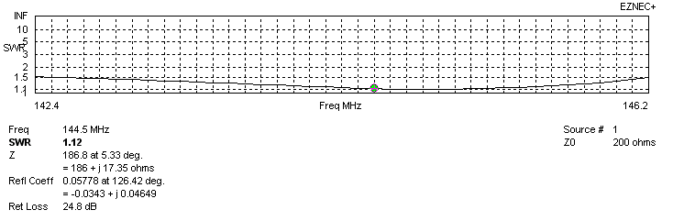
VERTICAL PERFORMANCES after corrections, loss included condition
If you want to get better SWR diagram for vertical antenna you can do the following:
- Change length of D3 from 928 to 923 mm
- Change length of DE2 from 896 to 890 mm
- Change position of D1 for +1 mm

In this case the SWR diagram will be like this:
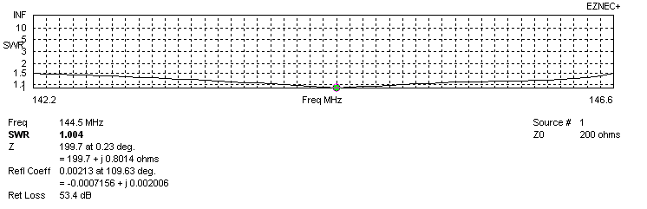
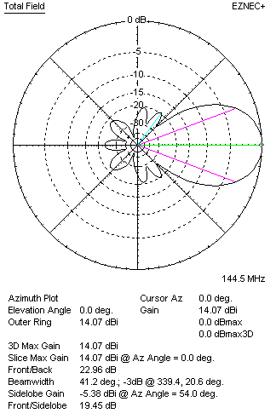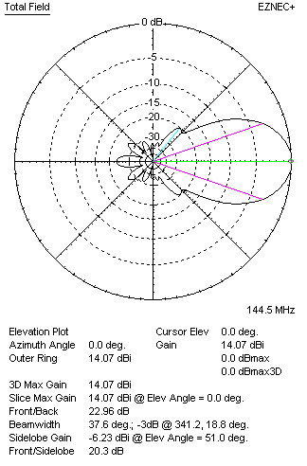

PERFORMANCES
 | TYPE | Condition | G  (dBi) | F/B  (dB) | F/Sh  (dBi) | F/Sv (dBi) | Hor  (◦) | Ver  (◦) | Temp (◦K) | G/T (dB) | B (MHz)  for SWR=1.5
 | Horizontal  part | No losss | 14.18 | 21.08 | 19.17 | 18.92 | 37.4 | 40.8 | 234.7 | -9.53 | 142.450- 146.150
 | Horizontal  part | Aluminum | 14.10 | 21.01 | 19.12 | 18.91 | 37.4 | 40.8 | 236.0 | -9.63 | 142.450- 146.150
 | Vertical  part | No losss | 14.15 | 23.06 | 19.46 | 20.34 | 41.2 | 37.8 | 234.0 | -9.54 | 142.200 – 146.600
 | Vertical  part | Aluminum | 14.07 | 22.96 | 19.45 | 20.30 | 41.2 | 37.6 | 235.3 | -9.65 | 142.200 – 146.600

