ANTENNA QY20905XL9D4
Good stacking characteristics at small vertical and big horizontal distances
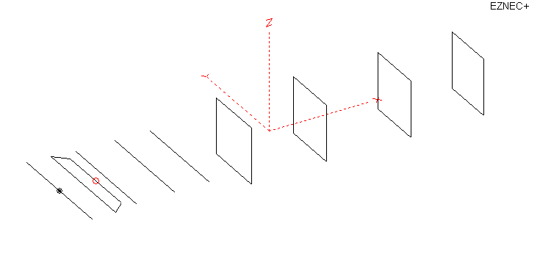
PERFORMANCES: (No loss condition)
TYPE | ELE | L (mm) | G (dBi) | F/B (dB) | F/Sh (dBi) | F/Sv (dBi) | Hor (◦) | Ver (◦) | Temp (◦K) | G/T (dB) | ΔF * (kHz)
QY20905XL9D4 | 9 | 3805 | 13.47 | 23.43 | 24.65 | 17.69 | 41.0 | 44.6 | 239.0 | -10.31 | 6750
* ΔF given for SWR=1,5

PERFORMANCES: (Loss included for aluminum)
Element material | G (dBi) | Temp (◦K) | G/T (dB)
Aluminum rods | 13.42 | 239.8 | -10.38

COMPARISON
Antenna | Boomlength (mm) | Material | Gain  (dBi) | TA  (◦K) | G/T  (dB) | Bandwidth  (MHz)
QY20905XL9D4 | 3805 | No loss | 13.47 | 239.0 | -10.31 | 139.900- 146.550
QY20905XL9D4 | 3805 | Aluminum | 13.42 | 239.8 | -10.38 | 139.900- 146.550
EF0208-5 | 3900 | No loss | 13.53 | 248.2 | -10.42 | 141.220-145.490
EF0208-5 | 3900 | Aluminum | 13.45 | 249.2 | -10.52 | 141.220-145.490

DIMENSIONS:
 | Ref | De1 | De2 | D1 | D2 | D3 | DQ1 | DQ2 | DQ3 | DQ4 | REMARKS: - All elements made of Al rods Ǿ5 mm  - Height of all rectangles 450 mm  - All dimensions given in milimetres
Pos | 0 | 180 | 335 | 420 | 706 | 1065 | 1585 | 2257 | 3075 | 3805
Length | 1020 | 1020 | 820 | 945 | 934 | 912 | 578 | 550 | 524 | 502
Building hints: No boom correction included.

DIAGRAMS (no loss included)
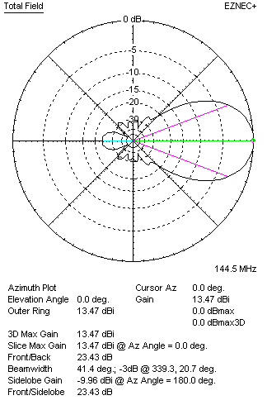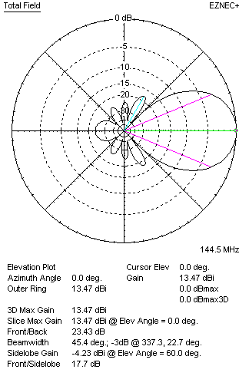
DIAGRAMS (loss included)
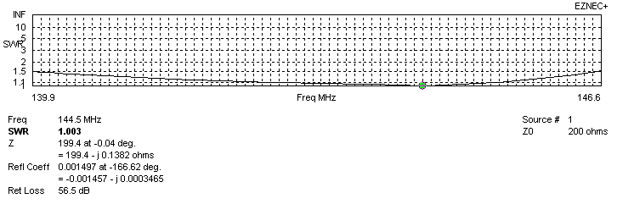
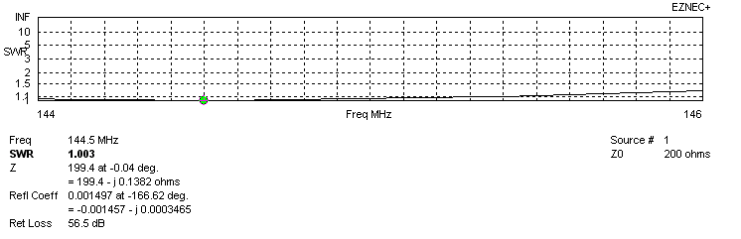
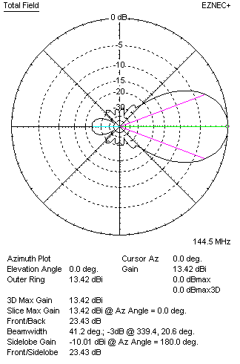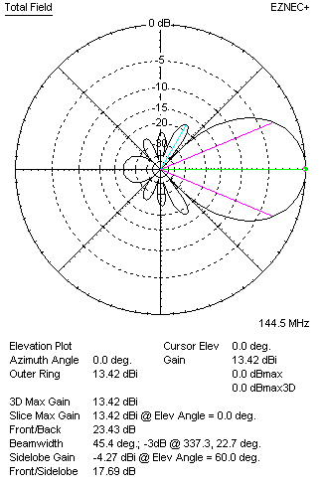
STACKING

QY20905XL9D4 – STACKING TABLE
(including loss for aluminum – AGT = -0.06 dB)
VERTICAL  DISTANCE (cm) | G  (dB) | TA  (°K) | G/T  (dB) | HORIZONTAL  DISTANCE  (cm) | G  (dB) | TA  (°K) | G/T  (dB)
100 | 14.78 | 223.1 | -8.70 | 100
110 | 14.92 | 219.8 | -8.50 | 110
120 | 15.04 | 218.8 | -8.36 | 120 | 14.76 | 239.7 | -9.04
130 | 15.14 | 220.2 | -8.29 | 130 | 14.91 | 236.5 | -8.83
140 | 15.22 | 222.8 | -8.26 | 140 | 15.04 | 234.8 | -8.67
150 | 15.30 | 224.6 | -8.21 | 150 | 15.15 | 234.2 | -8.55
160 | 15.38 | 224.8 | -8.14 | 160 | 15.25 | 234.3 | -8.45
170 | 15.47 | 224.8 | -8.05 | 170 | 15.35 | 234.9 | -8.36
180 | 15.56 | 225.4 | -7.97 | 180 | 15.45 | 235.9 | -8.28
190 | 15.64 | 226.1 | -7.90 | 190 | 15.54 | 237.1 | -8.21
200 | 15.73 | 226.6 | -7.82 | 200 | 15.63 | 238.3 | -8.14
210 | 15.81 | 226.6 | -7.74 | 210 | 15.72 | 239.6 | -8.07
220 | 15.91 | 226.4 | -7.64 | 220 | 15.81 | 240.6 | -8.00
230 | 16.00 | 226.5 | -7.55 | 230 | 15.89 | 241.6 | -7.94
240 | 16.08 | 227.3 | -7.49 | 240 | 15.98 | 242.3 | -7.86
250 | 16.17 | 228.7 | -7.42 | 250 | 16.05 | 242.9 | -7.80
260 | 16.24 | 230.9 | -7.40 | 260 | 16.13 | 243.2 | -7.73
270 | 16.31 | 233.8 | -7.38 | 270 | 16.19 | 243.4 | -7.67
280 | 16.36 | 237.0 | -7.39 | 280 | 16.25 | 243.4 | -7.61
290 | 16.41 | 240.4 | -7.40 | 290 | 16.30 | 243.3 | -7.56
300 | 16.44 | 243.9 | -7.43 | 300 | 16.35 | 243.1 | -7.51
310 |  |  |  | 310 | 16.38 | 242.8 | -7.47
320 |  |  |  | 320 | 16.41 | 242.5 | -7.44
330 |  |  |  | 330 | 16.44 | 242.2 | -7.40
340 |  |  |  | 340 | 16.45 | 241.8 | -7.39
350 |  |  |  | 350 | 16.47 | 241.5 | -7.36
360 |  |  |  | 360 | 16.47 | 241.2 | -7.35
370 |  |  |  | 370 | 16.48 | 241.0 | -7.34
380 |  |  |  | 380
390 |  |  |  | 390
400 |  |  |  | 400

TWO ANTENNAS VERTICALLY STACKED AT 270CM
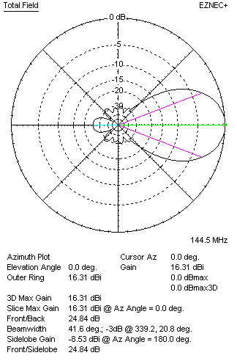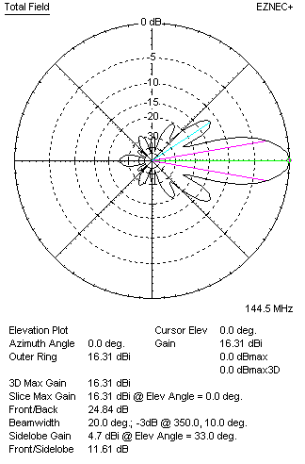

Performances
TYPE | Condition | G  (dBi) | F/B  (dB) | F/Sh  (dBi) | F/Sv (dBi) | Hor  (◦) | Ver  (◦) | Temp (◦K) | G/T (dB) | B (MHz)  for SWR=1.5
2x QY20905XL9D4 | No losss | 16.36 | 24.84 | 28.65 | 11.58 | 41.8 | 20.0 | 233.0 | -7.31 | 139.900- 146.550
2x QY20905XL9D4 | Aluminum | 16.31 | 24.84 | 28.57 | 11.61 | 41.6 | 20.0 | 233.8 | -7.38 | 139.900- 146.550

FOUR ANTENNAS VERTICALLY STACKED AT 270+270+270CM
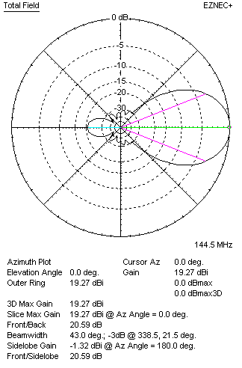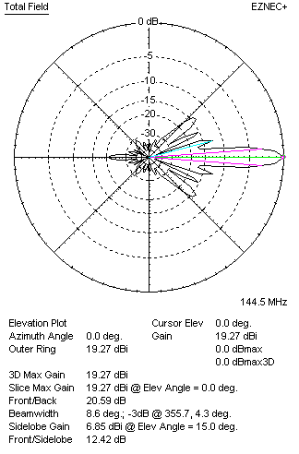
Performances
TYPE | Condition | G  (dBi) | F/B  (dB) | F/Sh  (dBi) | F/Sv (dBi) | Hor  (◦) | Ver  (◦) | Temp (◦K) | G/T (dB) | B (MHz)  for SWR=1.5
4xQY20905XL9D4 | No losss | 19.30 | 25.75 | 29.56 | 12.86 | 42.0 | 9.2 | 220.6 | -4.14 | 139.900- 146.550
4xQY20905XL9D4 | Aluminum | 19.25 | 25.75 | 29.50 | 12.87 | 42.0 | 9.2 | 221.7 | -4.21 | 139.900- 146.550

FOUR ANTENNAS IN H- STACK, H=370 CM, V=260 CM
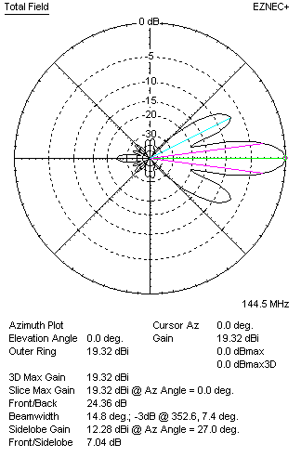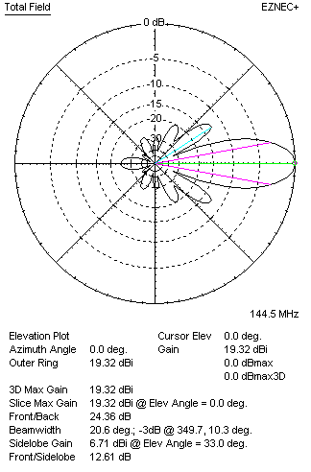
Performances
TYPE | Condition | G  (dBi) | F/B  (dB) | F/Sh  (dBi) | F/Sv (dBi) | Hor  (◦) | Ver  (◦) | Temp (◦K) | G/T (dB) | B (MHz)  for SWR=1.5
4xQY20905XL9D4 | No losss | 19.37 | 24.36 | 7.02 | 12.58 | 14.8 | 20.8 | 231.5 | -4.28 | 139.900- 146.550
4xQY20905XL9D4 | Aluminum | 19.32 | 24.36 | 7.04 | 12.61 | 14.6 | 20.6 | 232.4 | -4.34 | 139.900- 146.550

XPOL VERSION
I do not recommend this antenna for XPOL, though it can be interesting to someone for its very great bandwidth

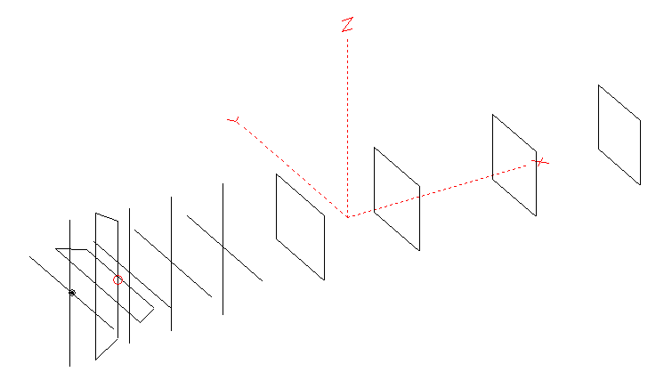
Horizontal components: Same as above
Vertical components: Same as above, except:
- All vertical yagi elements positioned 20 mm back regarding horizontals.
- All crossed elements must cross each other in their centerlines

HORIZONTAL PERFORMANCES
Everything as the above data

VERTICAL PERFORMANCES with no corrections
Loss included condition (for Aluminum)
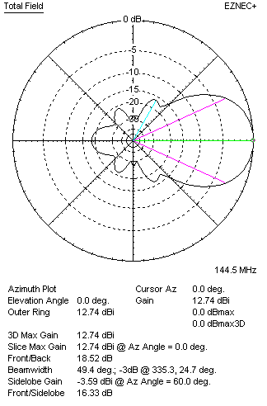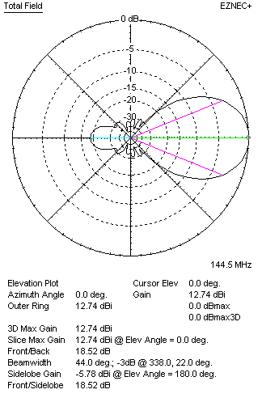
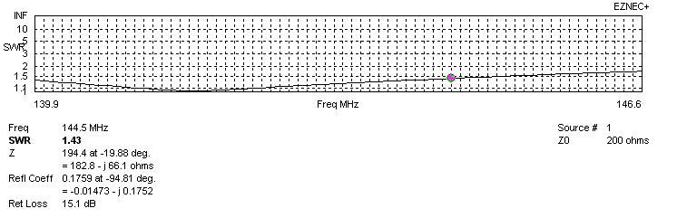
VERTICAL PERFORMANCES after corrections, loss included condition
If you want to get better SWR diagram for vertical antenna you can do the following:
- Change length of DE1 from 1020 to 1000 mm
- Change length of DE2 from 820 to 860 mm
- Change length of D1 from 945 to 934 mm
- Change length of D2 from 934 to 932 mm
- Change position of D1 for +15 mm

In this case the SWR diagram will be like this:
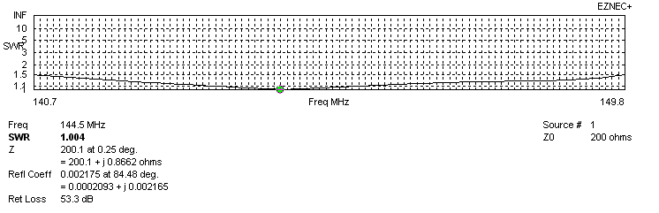
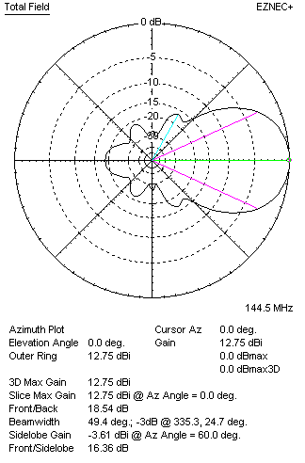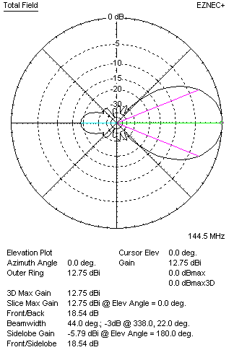

PERFORMANCES
 | TYPE | Condition | G  (dBi) | F/B  (dB) | F/Sh  (dBi) | F/Sv (dBi) | Hor  (◦) | Ver  (◦) | Temp (◦K) | G/T (dB) | B (MHz)  for SWR=1.5
 | Horizontal  part | No losss | 13.47 | 23.43 | 24.65 | 17.69 | 41.0 | 44.6 | 239.0 | -10.31 | 142.300 – 146.600
 | Horizontal  part | Aluminum | 13.42 | 21.39 | 22.18 | 16.91 | 41.0 | 44.6 | 239.8 | -10.38 | 142.300 – 146.600
 | Vertical  part | No losss | 12.80 | 18.57 | 16.36 | 29.33 | 49.4 | 44.0 | 245.3 | -11.10 | 140.700 – 149.800
 | Vertical  part | Aluminum | 12.75 | 18.54 | 16.36 | 29.30 | 49.4 | 44.0 | 247.4 | -11.22 | 140.700 – 149.800

