ANTENNA QY20905XL8D4
Good stacking characteristics at moderate both vertical and horizontal distances
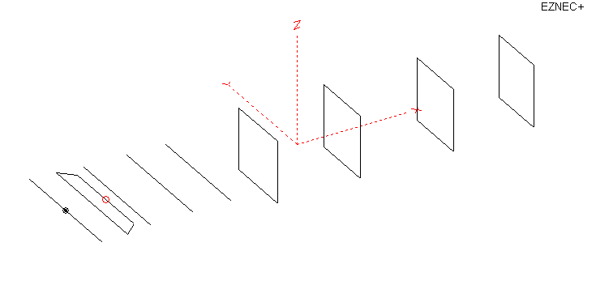
PERFORMANCES: (No loss condition)
TYPE | ELE | L (mm) | G (dBi) | F/B (dB) | F/Sh (dBi) | F/Sv (dBi) | Hor (◦) | Ver (◦) | Temp (◦K) | G/T (dB) | ΔF * (kHz)
QY20905XL8D4 | 9 | 3615 | 13.49 | 21.51 | 22.19 | 16.92 | 41.0 | 44.6 | 244.0 | -10.38 | 4300
* ΔF given for SWR=1,5

PERFORMANCES: (Loss included for aluminum)
Element material | G (dBi) | Temp (◦K) | G/T (dB)
Aluminum rods | 13.44 | 244.9 | -10.45

COMPARISON
Antenna | Boomlength (mm) | Material | Gain  (dBi) | TA  (◦K) | G/T  (dB) | Bandwidth  (MHz)
QY20905XL8D4 | 3615 | No loss | 13.49 | 244.0 | -10.38 | 142.300- 146.600
QY20905XL8D4 | 3615 | Aluminum | 13.44 | 244.9 | -10.45 | 142.300- 146.600
EF0208-5 | 3900 | No loss | 13.53 | 248.2 | -10.42 | 141.220-145.490
EF0208-5 | 3900 | Aluminum | 13.45 | 249.2 | -10.52 | 141.220-145.490

DIMENSIONS:
 | Ref | De1 | De2 | D1 | D2 | D3 | DQ1 | DQ2 | DQ3 | DQ4 | REMARKS: - All elements made of Al rods Ǿ5 mm  - Height of all rectangles 500 mm  - All dimensions given in milimetres
Pos | 0 | 210 | 320 | 415 | 755 | 1065 | 1545 | 2216 | 2965 | 3615
Length | 1016 | 990 | 790 | 930 | 924 | 904 | 540 | 516 | 504 | 482
Building hints: No boom correction included.

DIAGRAMS (no loss included)
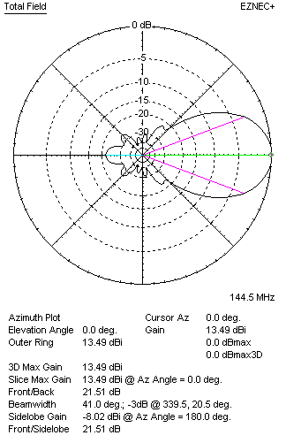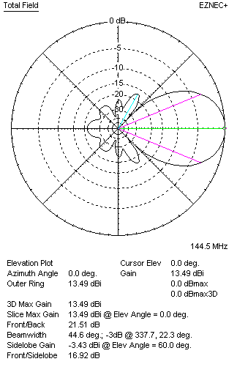
DIAGRAMS (loss included)
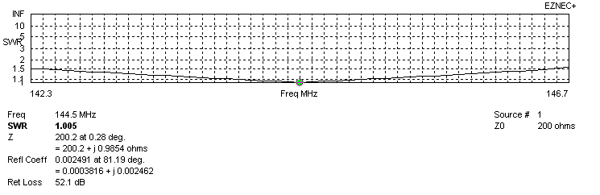
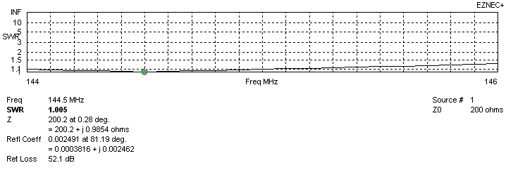
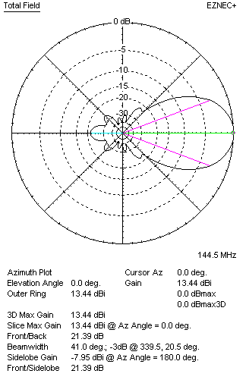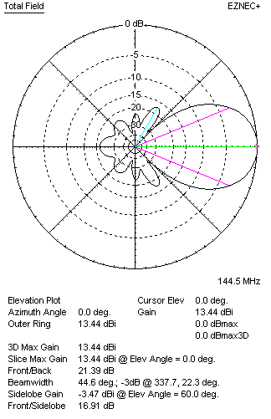
STACKING

QY20905XL8D4 - STACKING TABLE
(including loss for aluminum – AGT = -0.07 dB)
VERTICAL  DISTANCE  (cm) | G  (dB) | TA  (°K) | G/T  (dB) | HORIZONTAL  DISTANCE (cm) | G  (dB) | TA  (°K) | G/T  (dB)
100 | 14.72 | 225.6 | -8.81 | 100
110 | 14.87 | 221.8 | -8.59 | 110 | 14.42 | 260.7 | -9.74
120 | 15.00 | 221.5 | -8.45 | 120 | 14.66 | 252.6 | -9.36
130 | 15.10 | 224.9 | -8.42 | 130 | 14.84 | 247.5 | -9.10
140 | 15.17 | 230.4 | -8.45 | 140 | 14.98 | 244.3 | -8.90
150 | 15.25 | 234.2 | -8.45 | 150 | 15.11 | 242.5 | -8.74
160 | 15.35 | 235.2 | -8.37 | 160 | 15.23 | 241.6 | -8.60
170 | 15.44 | 235.4 | -8.28 | 170 | 15.34 | 241.5 | -8.49
180 | 15.53 | 236.3 | -8.20 | 180 | 15.44 | 241.9 | -8.40
190 | 15.61 | 237.4 | -8.14 | 190 | 15.54 | 242.5 | -8.31
200 | 15.70 | 237.9 | -8.06 | 200 | 15.63 | 243.4 | -8.23
210 | 15.79 | 237.5 | -7.97 | 210 | 15.72 | 244.2 | -8.16
220 | 15.88 | 236.5 | -7.86 | 220 | 15.82 | 245.0 | -8.07
230 | 15.98 | 235.5 | -7.74 | 230 | 15.91 | 245.8 | -8.00
240 | 16.07 | 234.9 | -7.64 | 240 | 15.99 | 246.4 | -7.93
250 | 16.16 | 235.1 | -7.55 | 250 | 16.07 | 246.9 | -7.86
260 | 16.25 | 236.1 | -7.48 | 260 | 16.15 | 247.3 | -7.78
270 | 16.32 | 237.8 | -7.44 | 270 | 16.21 | 247.5 | -7.73
280 | 16.38 | 240.1 | -7.42 | 280 | 16.27 | 247.7 | -7.67
290 | 16.43 | 242.7 | -7.42 | 290 | 16.32 | 247.7 | -7.62
300 | 16.47 | 245.5 | -7.43 | 300 | 16.37 | 247.7 | -7.57
310 | 16.51 | 248.2 | -7.44 | 310 | 16.40 | 247.6 | -7.54
320 | 16.53 | 250.9 | -7.46 | 320 | 16.43 | 247.4 | -7.50
330 | 16.55 | 253.4 | -7.49 | 330 | 16.46 | 247.2 | -7.47
340 | 16.56 | 255.8 | -7.52 | 340 | 16.47 | 247.0 | -7.46
350 | 16.56 | 258.1 | -7.56 | 350 | 16.49 | 246.8 | -7.43
360 |  |  |  | 360 | 16.49 | 246.6 | -7.43
370 |  |  |  | 370 | 16.50 | 246.4 | -7.42
380 |  |  |  | 380
390 |  |  |  | 390
400 |  |  |  | 400

TWO ANTENNAS VERTICALLY STACKED AT 300CM
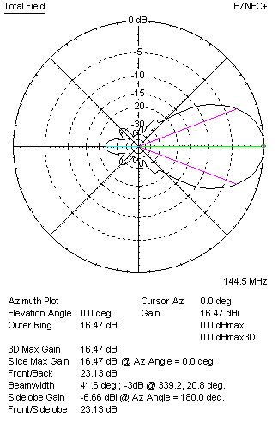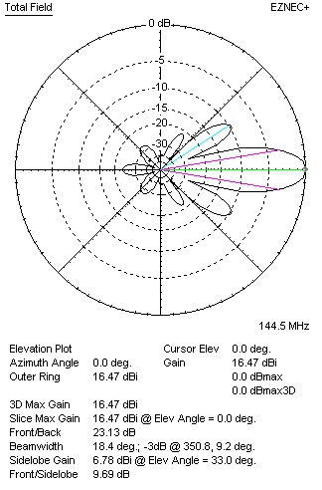

Performances
TYPE | Condition | G  (dBi) | F/B  (dB) | F/Sh  (dBi) | F/Sv (dBi) | Hor  (◦) | Ver  (◦) | Temp (◦K) | G/T (dB) | B (MHz)  for SWR=1.5
2xQY20905XL8D4 | No losss | 16.53 | 23.28 | 23.80 | 9.66 | 41.6 | 18.4 | 244.8 | -7.36 | 142.300- 146.600
2xQY20905XL8D4 | Aluminum | 16.47 | 23.13 | 23.87 | 9.69 | 41.6 | 18.4 | 245.5 | -7.43 | 142.300- 146.600

FOUR ANTENNAS VERTICALLY STACKED AT 300+300+300CM
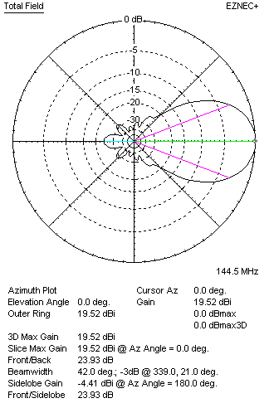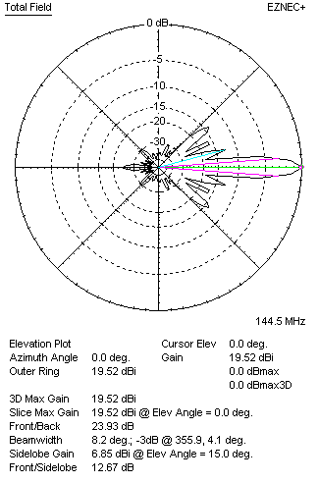
Performances
TYPE | Condition | G  (dBi) | F/B  (dB) | F/Sh  (dBi) | F/Sv (dBi) | Hor  (◦) | Ver  (◦) | Temp (◦K) | G/T (dB) | B (MHz)  for SWR=1.5
4xQY20905XL8D4 | No losss | 19.58 | 24.10 | 24.35 | 12.67 | 42.0 | 8.2 | 229.0 | -4.02 | 142.300- 146.600
4xQY20905XL8D4 | Aluminum | 19.52 | 23.93 | 24.30 | 12.77 | 42.0 | 8.2 | 229.9 | -4.10 | 142.300- 146.600

FOUR ANTENNAS IN H- STACK, H=350 CM, V=278 CM
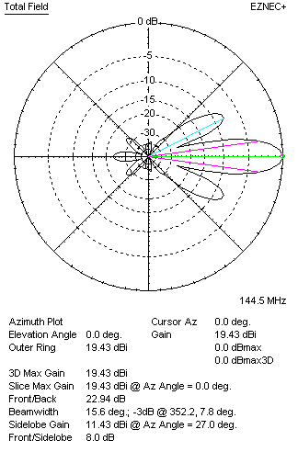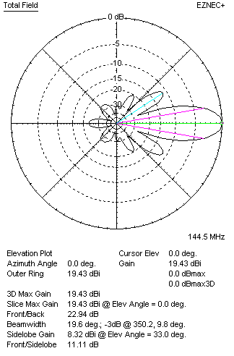
Performances
TYPE | Condition | G  (dBi) | F/B  (dB) | F/Sh  (dBi) | F/Sv (dBi) | Hor  (◦) | Ver  (◦) | Temp (◦K) | G/T (dB) | B (MHz)  for SWR=1.5
4xQY20905XL8D4 | No losss | 19.49 | 23.07 | 7.99 | 11.08 | 15.6 | 19.6 | 242.9 | -4.36 | 142.300- 146.600
4xQY20905XL8D4 | Aluminum | 19.43 | 22.94 | 8.00 | 11.11 | 15.6 | 19.6 | 243.7 | -4.44 | 142.300- 146.600

XPOL VERSION
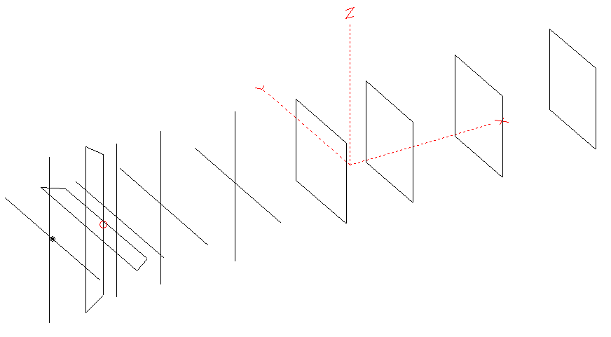
Horizontal components: Same as above
Vertical components: Same as above, except:
- All vertical yagi elements positioned 20 mm back regarding horizontals.
- All crossed elements must cross each other in their centerlines

HORIZONTAL PERFORMANCES
Everything as the above data

VERTICAL PERFORMANCES with no corrections
Loss included condition (for Aluminum)
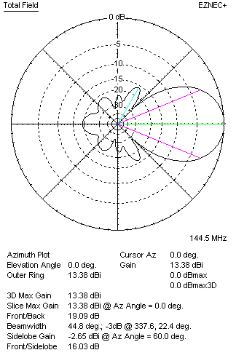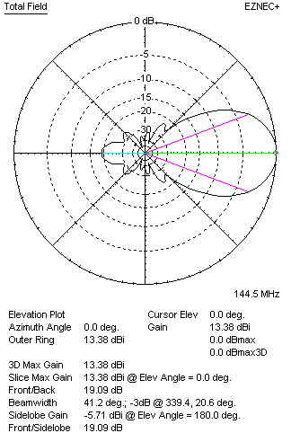

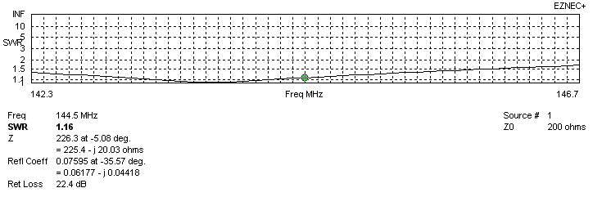
VERTICAL PERFORMANCES after corrections
If you want to get better SWR diagram for vertical antenna you can do the following:
- Change position of D1 for +10 mm.

In this case the SWR diagram will be like this:
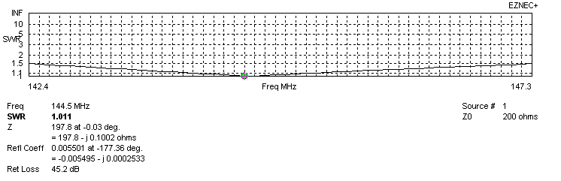
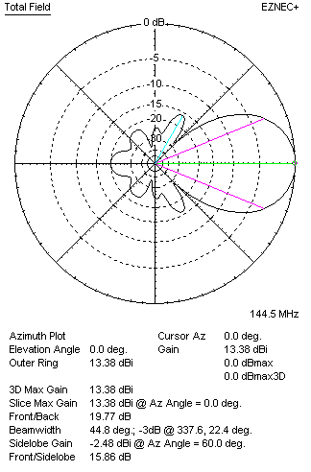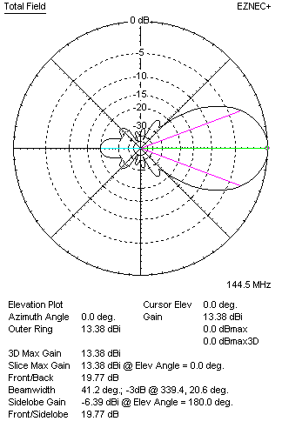

PERFORMANCES
 | TYPE | Condition | G  (dBi) | F/B  (dB) | F/Sh  (dBi) | F/Sv (dBi) | Hor  (◦) | Ver  (◦) | Temp (◦K) | G/T (dB) | B (MHz)  for SWR=1.5
 | Horizontal  part | No losss | 13.49 | 21.51 | 22.19 | 16.92 | 41.0 | 44.6 | 244.0 | -10.38 | 142.300- 146.600
 | Horizontal  part | Aluminum | 13.44 | 21.39 | 22.13 | 16.91 | 41.0 | 44.6 | 244.9 | -10.45 | 142.300- 146.600
 | Vertical  part | No losss | 13.44 | 19.87 | 15.89 | 22.87 | 44.8 | 41.2 | 241.4 | -10.39 | 142.400 – 147.300
 | Vertical  part | Aluminum | 13.38 | 19.77 | 15.86 | 22.83 | 44.8 | 41.2 | 242.3 | -10.46 | 142.400 – 147.300

