ANTENNA QY20905XL5D4
Good stacking characteristics at moderate vertical distances and big horizontal distances
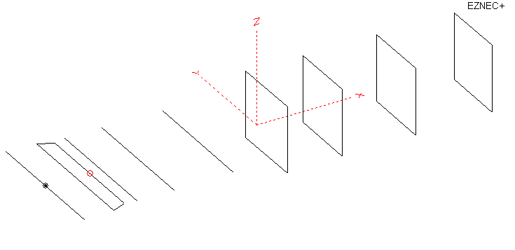
PERFORMANCES: (No loss condition)
TYPE | ELE | L (mm) | G (dBi) | F/B (dB) | F/Sh (dBi) | F/Sv (dBi) | Hor (◦) | Ver (◦) | Temp (◦K) | G/T (dB) | ΔF * (kHz)
QY20905XL5D4 | 9 | 3205 | 13.16 | 32.29 | 20.37 | 17.61 | 42.2 | 46.4 | 248.2 | -10.79 | 8400
* ΔF given for SWR=1.5

PERFORMANCES: (Loss included for aluminum)
Element material | G (dBi) | Temp (◦K) | G/T (dB)
Aluminum rods | 13.10 | 249.0 | -10.86

COMPARISON
Antenna | Boomlength (mm) | Material | Gain  (dBi) | TA  (◦K) | G/T  (dB) | Bandwidth  (MHz)
QY20905XL5D4 | 3205 | No loss | 13.16 | 248.2 | -10.79 | 139.900- 146.500
QY20905XL5D4 | 3205 | Aluminum | 13.10 | 249.0 | -10.86 | 139.900- 146.500
EF0207-5 | 3274 | No loss | 12.91 | 283.0 | -12.61 | 140.400-145.100
EF0207-5 | 3274 | Aluminum | 12.85 | 256.9 | -11.25 | 140.400-145.100
G0KSC  7ELE EU | 2894 | No loss | 12.89 | 260.5 | -11.27 | 141.300 - 145.400
G0KSC  7ELE EU | 2894 | Aluminum | 12.83 | 260.9 | -11.34 | 141.300 - 145.400

DIMENSIONS:
 | Ref | De1 | De2 | D1 | D2 | D3 | DQ1 | DQ2 | DQ3 | DQ4 | REMARKS: - All elements made of Al rods Ǿ5 mm  - Height of all rectangles 500 mm  - All dimensions given in milimetres
Pos | 0 | 221 | 330 | 415 | 687 | 1142 | 1655 | 2075 | 2625 | 3205
Length | 1024 | 1024 | 870 | 946 | 946 | 922 | 538 | 504 | 510 | 490
Building hints: No boom correction included.

DIAGRAMS (no loss included)
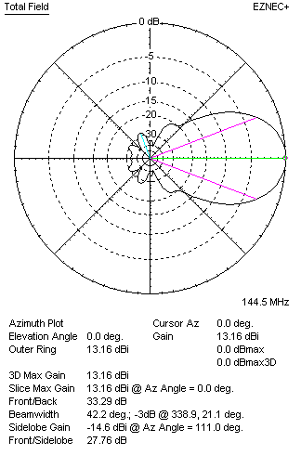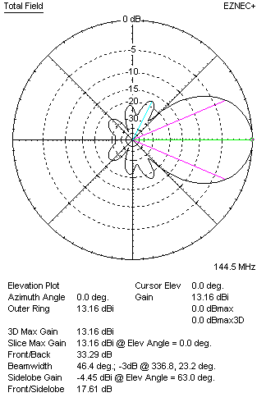
DIAGRAMS (loss included)
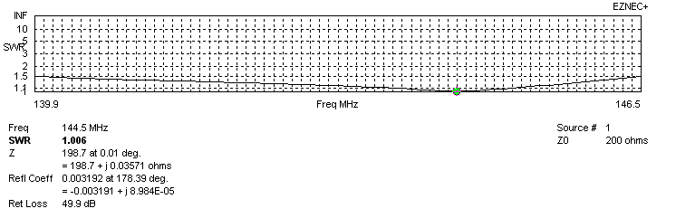
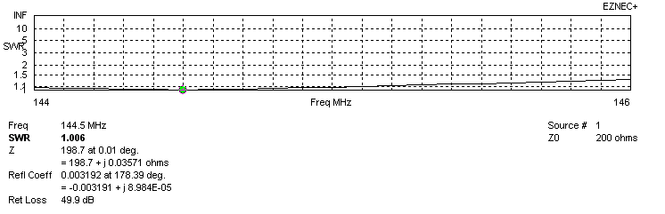
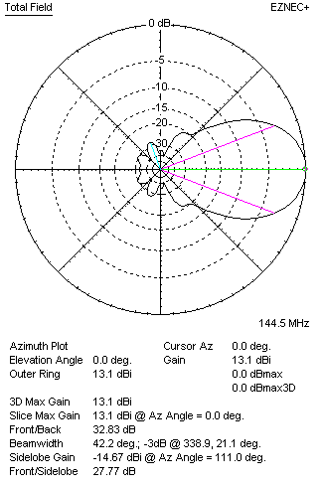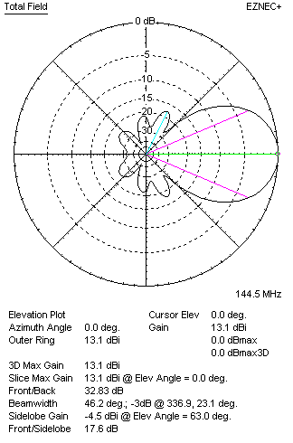

QY20905XL5D4
(including loss for aluminum – AGT = -0.07 to -.06 dB)
VERTICAL  DISTANCE (cm) | G  (dB) | TA  (°K) | G/T  (dB) | HORIZONTAL  DISTANCE (cm) | G  (dB) | TA  (°K) | G/T  (dB)
100 | 14.32 | 231.1 | -9.32 | 100
110 | 14.49 | 227.5 | -9.08 | 110 | 14.00 | 261.3 | -10.17
120 | 14.63 | 226.1 | -8.91 | 120 | 14.28 | 253.3 | -9.76
130 | 14.76 | 226.5 | -8.79 | 130 | 14.49 | 248.7 | -9.47
140 | 14.88 | 227.3 | -8.69 | 140 | 14.66 | 245.8 | -9.25
150 | 14.99 | 227.1 | -8.57 | 150 | 14.81 | 244.2 | -9.07
160 | 15.11 | 226.4 | -8.44 | 160 | 14.94 | 243.6 | -8.93
170 | 15.22 | 226.6 | -8.33 | 170 | 15.06 | 243.7 | -8.81
180 | 15.31 | 227.7 | -8.26 | 180 | 15.17 | 244.3 | -8.71
190 | 15.41 | 228.6 | -8.18 | 190 | 15.28 | 245.2 | -8.61
200 | 15.50 | 228.9 | -8.10 | 200 | 15.38 | 246.3 | -8.53
210 | 15.60 | 228.7 | -7.99 | 210 | 15.47 | 247.4 | -8.46
220 | 15.70 | 228.7 | -7.89 | 220 | 15.56 | 248.4 | -8.39
230 | 15.80 | 229.3 | -7.80 | 230 | 15.65 | 249.3 | -8.32
240 | 15.88 | 230.9 | -7.75 | 240 | 15.73 | 250.1 | -8.25
250 | 15.96 | 233.5 | -7.72 | 250 | 15.81 | 250.7 | -8.18
260 | 16.02 | 236.9 | -7.73 | 260 | 15.88 | 251.1 | -8.12
270 | 16.07 | 241.0 | -7.75 | 270 | 15.93 | 251.4 | -8.07
280 | 16.12 | 245.3 | -7.78 | 280 | 15.99 | 251.4 | -8.01
290 | 16.15 | 249.7 | -7.83 | 290 | 16.03 | 251.4 | -7.97
300 | 16.17 | 254.0 | -7.88 | 300 | 16.07 | 251.3 | -7.93
310 | 16.19 | 257.9 | -7.92 | 310 | 16.10 | 251.0 | -7.90
320 | 16.20 | 261.4 | -7.97 | 320 | 16.12 | 250.7 | -7.87
330 |  |  |  | 330 | 16.14 | 250.4 | -7.85
340 |  |  |  | 340 | 16.15 | 250.1 | -7.83
350 |  |  |  | 350 | 16.16 | 249.8 | -7.82
 |  |  |  | 360 | 16.16 | 249.6 | -7.81

TWO ANTENNAS VERTICALLY STACKED AT 250CM
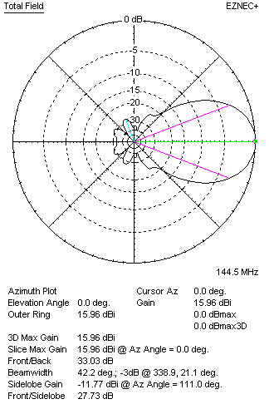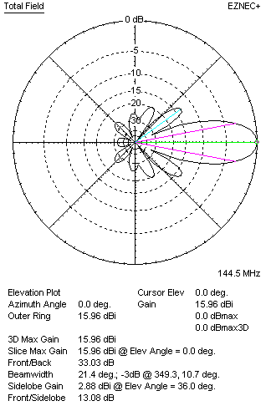
Performances
TYPE | Condition | G  (dBi) | F/B  (dB) | F/Sh  (dBi) | F/Sv (dBi) | Hor  (◦) | Ver  (◦) | Temp (◦K) | G/T (dB) | B (MHz)  for SWR=1.5
2xQY20905XL5D4 | No losss | 16.02 | 33.32 | 23.40 | 13.05 | 42.2 | 21.4 | 232.5 | -7.64 | 139.900- 146.500
2xQY20905XL5D4 | Aluminum | 15.96 | 33.03 | 23.35 | 13.08 | 42.2 | 21.4 | 233.5 | -7.72 | 139.900- 146.500

FOUR ANTENNAS VERTICALLY STACKED AT 250+250+250CM
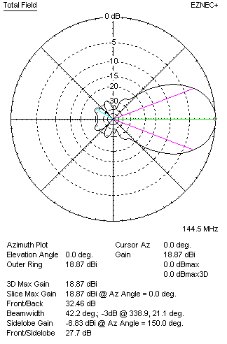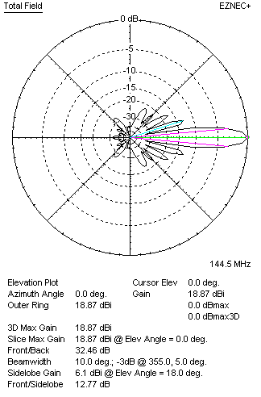
Performances
TYPE | Condition | G  (dBi) | F/B  (dB) | F/Sh  (dBi) | F/Sv (dBi) | Hor  (◦) | Ver  (◦) | Temp (◦K) | G/T (dB) | B (MHz)  for SWR=1.5
4xQY20905XL5D4 | No losss | 18.93 | 32.66 | 25.19 | 12.75 | 42.3 | 10.0 | 224.1 | -4.57 | 139.900- 146.500
4xQY20905XL5D4 | Aluminum | 18.87 | 32.46 | 25.13 | 12.77 | 42.2 | 10.0 | 225.3 | -4.66 | 139.900- 146.500

FOUR ANTENNAS IN H- STACK, H=340 CM, V=242 CM, LOSS INCLUDED FOR ALUMINUM
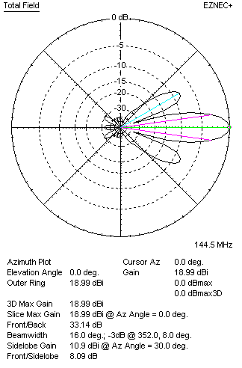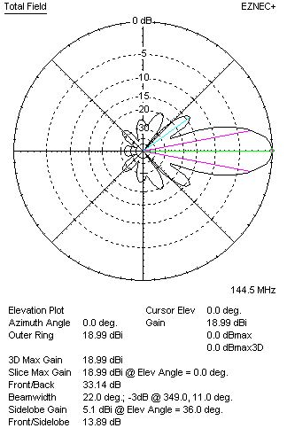
Performances
TYPE | Condition | G  (dBi) | F/B  (dB) | F/Sh  (dBi) | F/Sv (dBi) | Hor  (◦) | Ver  (◦) | Temp (◦K) | G/T (dB) | B (MHz)  for SWR=1.5
4xQY20905XL5D4 | No losss | 19.05 | 33.43 | 8.07 | 13.86 | 16.0 | 22.0 | 230.7 | -4.58 | 139.900- 146.500
4xQY20905XL5D4 | Aluminum | 18.99 | 33.14 | 8.09 | 13.89 | 16.0 | 22.0 | 231.7 | -4.66 | 139.900- 146.500

XPOL VERSION
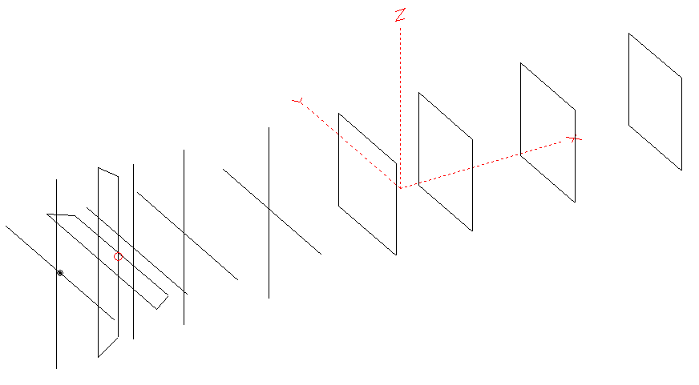
Horizontal components: Same as above
Vertical components: Same as above, except:
- All vertical yagi elements positioned 20 mm back regarding horizontals.
- Vertical director D1 should be shortened for 4 mm

HORIZONTAL PERFORMANCES
Everything as the above data

VERTICAL PERFORMANCES with no corrections
Loss included condition (for Aluminum)
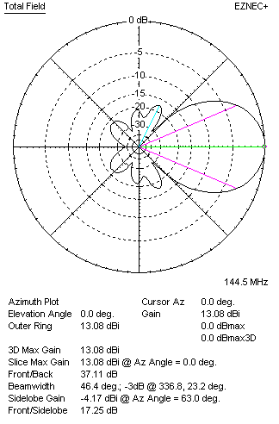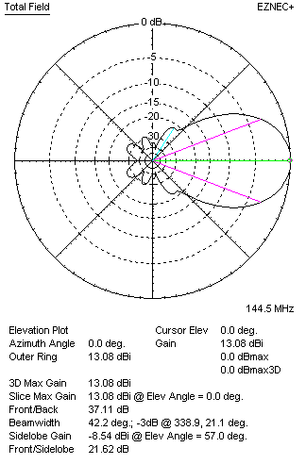

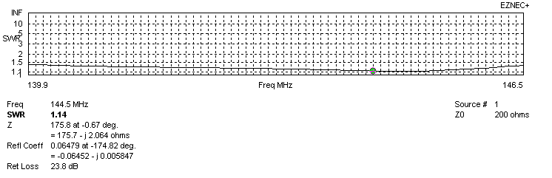
VERTICAL PERFORMANCES after corrections
If you want to get better SWR diagram for vertical antenna you can do the following:
- Change length of DE1 from 870 to 916 mm
- Change length of D2 from 946 to 948 mm
- Change position of D1 for -8 mm.

In this case the SWR diagram will be like this:
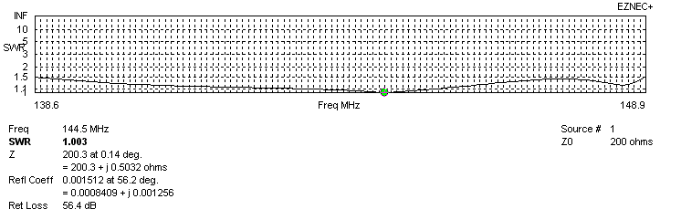
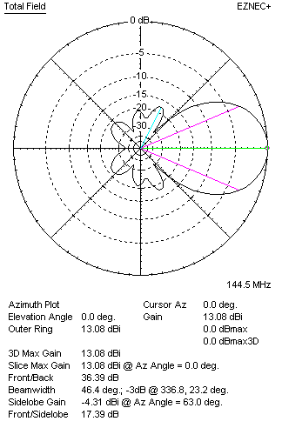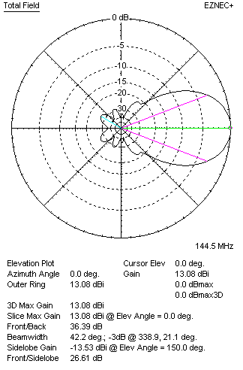

PERFORMANCES
 | TYPE | Condition | G  (dBi) | F/B  (dB) | F/Sh  (dBi) | F/Sv (dBi) | Hor  (◦) | Ver  (◦) | Temp (◦K) | G/T (dB) | B (MHz)  for SWR=1.5
 | Horizontal  part | No losss | 13.16 | 33.29 | 20.37 | 17.61 | 42.2 | 46.4 | 248.2 | -10.79 | 139.900- 146.500
 | Horizontal  part | Aluminum | 13.10 | 32.83 | 20.32 | 17.60 | 42.2 | 46.2 | 249.0 | -10.86 | 139.900- 146.500
 | Vertical  part | No losss | 13.14 | 36.21 | 17.39 | 21.70 | 46.6 | 42.4 | 246.3 | -10.77 | 138.600 – 148.900
 | Vertical  part | Aluminum | 13.08 | 36.39 | 17.39 | 21.65 | 46.4 | 42.2 | 247.2 | -10.85 | 138.600 – 148.900

