ANTENNA QY20905XL4D3
Good stacking characteristics at moderate vertical distances and big horizontal distances
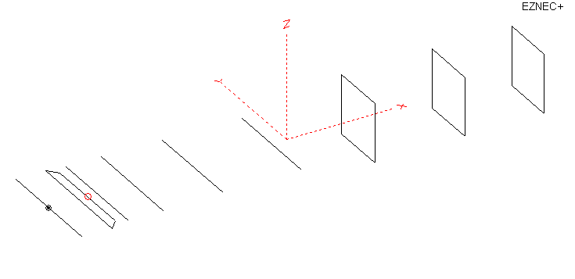
PERFORMANCES: (No loss condition)
 | TYPE | ELE | L (mm) | G (dBi) | F/B (dB) | F/Sh (dBi) | F/Sv (dBi) | Hor (◦) | Ver (◦) | Temp (◦K) | G/T (dB) | ΔF * (kHz)
 | QY20905XL4D3 | 9 | 4205 | 14.23 | 24.07 | 18.99 | 18.05 | 37.2 | 40.4 | 236.4 | -9.51 | 4300
* ΔF given for SWR=1,5

 | PERFORMANCES: (Loss included for aluminum)
Element material |  | G (dBi) | Temp (◦K) | G/T (dB)
Aluminum rods |  | 14.15 | 244.9 | -10.45

COMPARISON
Antenna | Boomlength (mm) | Material | Gain  (dBi) | TA  (◦K) | G/T  (dB) | Bandwidth  (MHz)
QY20905XL4D3 | 4205 | No loss | 14.23 | 236.4 | -9.51 | 142.600- 146.600
QY20905XL4D3 | 4205 | Aluminum | 14.15 | 237.8 | -9.61 | 142.600- 146.600
EF0208-5 | 3900 | No loss | 13.53 | 248.2 | -10.42 | 141.220-145.490
EF0208-5 | 3900 | Aluminum | 13.45 | 249.2 | -10.52 | 141.220-145.490

DIMENSIONS:
 | Ref | De1 | De2 | D1 | D2 | D3 | D4 | DQ2 | DQ3 | DQ4 | REMARKS: - All elements made of Al rods Ǿ5 mm  - Height of all rectangles 520 mm  - All dimensions given in milimetres
Pos | 0 | 265 | 339 | 425 | 732 | 1265 | 1955 | 2719 | 3511 | 4205
Length | 1016 | 1016 | 840 | 944 | 954 | 930 | 906 | 512 | 502 | 490
Building hints: No boom correction included.

DIAGRAMS (no loss included)
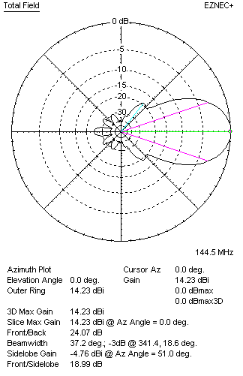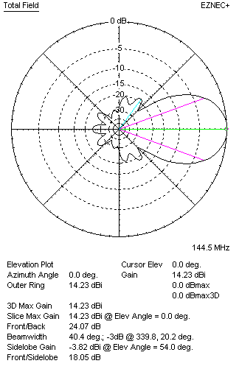
DIAGRAMS (loss included)
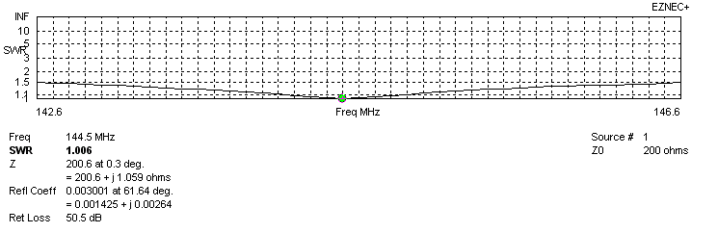
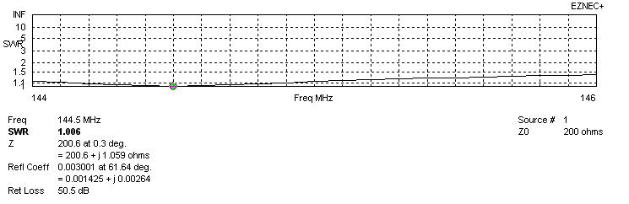
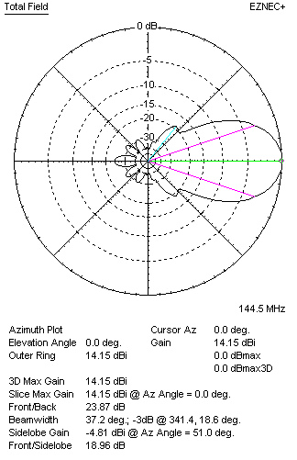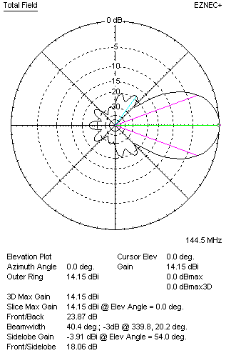

STACKING

QY20905XL4D3 - STACKING TABLE
(including loss for aluminum – AGT = -0.09 dB)
VERTICAL  DISTANCE (cm) | G  (dB) | TA  (°K) | G/T  (dB) | HORIZONTAL  DISTANCE (cm) | G  (dB) | TA  (°K) | G/T  (dB)
100 | 15.15 | 238.0 | -8.62 | 100
110 | 15.33 | 230.3 | -8.29 | 110 | 14.52 | 262.9 | -9.68
120 | 15.48 | 226.3 | -8.07 | 120 | 14.99 | 257.8 | -9.12
130 | 15.61 | 225.4 | -7.92 | 130 | 15.26 | 251.6 | -8.75
140 | 15.72 | 225.7 | -7.82 | 140 | 15.47 | 246.5 | -8.45
150 | 15.83 | 225.4 | -7.70 | 150 | 15.63 | 242.6 | -8.22
160 | 15.94 | 224.6 | -7.57 | 160 | 15.77 | 239.8 | -8.03
170 | 16.04 | 224.9 | -7.48 | 170 | 15.89 | 237.8 | -7.87
180 | 16.13 | 226.5 | -7.42 | 180 | 16.00 | 236.6 | -7.74
190 | 16.22 | 228.6 | -7.37 | 190 | 16.10 | 235.8 | -7.63
200 | 16.30 | 230.6 | -7.33 | 200 | 16.20 | 235.4 | -7.52
210 | 16.39 | 231.8 | -7.26 | 210 | 16.28 | 235.4 | -7.44
220 | 16.47 | 232.1 | -7.19 | 220 | 16.37 | 235.4 | -7.35
230 | 16.57 | 231.7 | -7.08 | 230 | 16.45 | 235.7 | -7.27
240 | 16.66 | 231.1 | -6.98 | 240 | 16.53 | 235.9 | -7.20
250 | 16.75 | 230.6 | -6.88 | 250 | 16.61 | 236.2 | -7.12
260 | 16.83 | 230.5 | -6.80 | 260 | 16.69 | 236.5 | -7.05
270 | 16.91 | 231.0 | -6.73 | 270 | 16.77 | 236.8 | -6.97
280 | 16.98 | 232.0 | -6.68 | 280 | 16.84 | 237.0 | -6.91
290 | 17.04 | 233.5 | -6.64 | 290 | 16.90 | 237.2 | -6.85
300 | 17.09 | 235.2 | -6.63 | 300 | 16.96 | 237.4 | -6.79
310 | 17.14 | 237.1 | -6.61 | 310 | 17.01 | 237.6 | -6.75
320 | 17.17 | 239.1 | -6.62 | 320 | 17.05 | 237.7 | -6.71
330 | 17.20 | 241.1 | -6.62 | 330 | 17.09 | 237.9 | -6.67
340 | 17.22 | 243.0 | -6.64 | 340 | 17.12 | 238.0 | -6.65
350 | 17.23 | 244.8 | -6.66 | 350 | 17.15 | 238.1 | -6.62
360 | 17.24 | 246.4 | -6.68 | 360 | 17.17 | 238.2 | -6.60
370 |  |  |  | 370 | 17.18 | 238.3 | -6.59
380 |  |  |  | 380 | 17.20 | 238.4 | -6.57
390 |  |  |  | 390 | 17.20 | 238.5 | -6.57
400 |  |  |  | 400 | 17.21 | 238.6 | -6.57

TWO ANTENNAS VERTICALLY STACKED AT 310CM
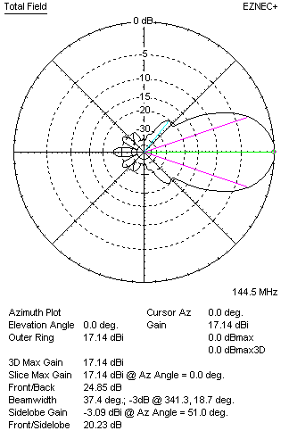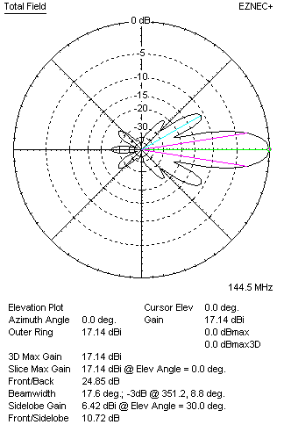

Performances
TYPE | Condition | G  (dBi) | F/B  (dB) | F/Sh  (dBi) | F/Sv (dBi) | Hor  (◦) | Ver  (◦) | Temp (◦K) | G/T (dB) | B (MHz)  for SWR=1.5
2x QY20905XL4D3 | No losss | 17.23 | 25.07 | 20.28 | 10.68 | 37.6 | 17.6 | 235.9 | -6.50 | 142.600- 146.600
2x QY20905XL4D3 | Aluminum | 17.14 | 24.85 | 20.23 | 10.72 | 37.4 | 17.6 | 237.1 | -6.61 | 142.600- 146.600

FOUR ANTENNAS VERTICALLY STACKED AT 310+310+310CM
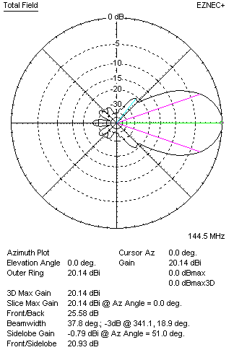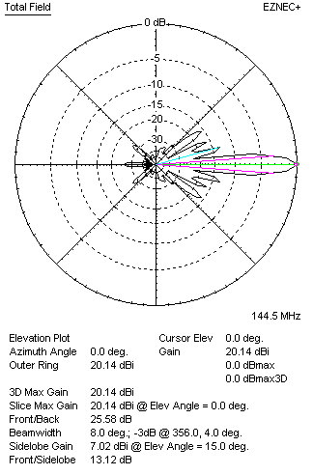
Performances
TYPE | Condition | G  (dBi) | F/B  (dB) | F/Sh  (dBi) | F/Sv (dBi) | Hor  (◦) | Ver  (◦) | Temp (◦K) | G/T (dB) | B (MHz)  for SWR=1.5
4xQY20905XL4D3 | No losss | 20.23 | 25.83 | 20.98 | 13.11 | 37.8 | 8.0 | 224.4 | -3.28 | 142.600- 146.600
4xQY20905XL4D3 | Aluminum | 20.14 | 25.58 | 20.93 | 13.12 | 37.8 | 8.0 | 226.0 | -3.40 | 142.600- 146.600

FOUR ANTENNAS IN H- STACK, H=370 CM, V=304 CM
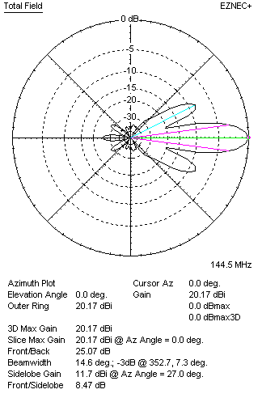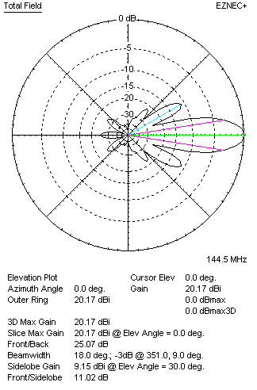
Performances
TYPE | Condition | G  (dBi) | F/B  (dB) | F/Sh  (dBi) | F/Sv (dBi) | Hor  (◦) | Ver  (◦) | Temp (◦K) | G/T (dB) | B (MHz)  for SWR=1.5
4xQY20905XL4D3 | No losss | 20.26 | 25.29 | 8.45 | 10.99 | 14.6 | 18.0 | 238.3 | -3.51 | 142.600- 146.600
4xQY20905XL4D3 | Aluminum | 20.17 | 25.07 | 8.47 | 11.02 | 14.6 | 18.0 | 239.5 | -4.62 | 142.600- 146.600

XPOL VERSION

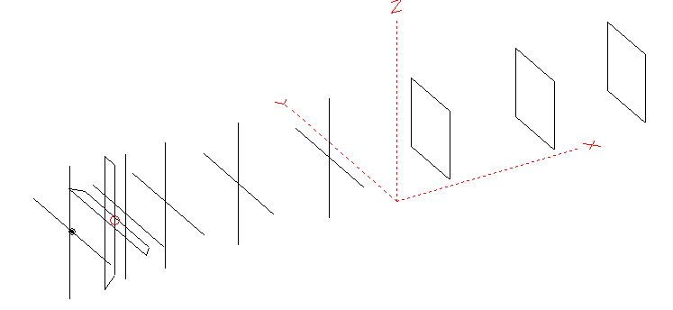
Horizontal components: Same as above
Vertical components: Same as above, except:
- All vertical yagi elements positioned 20 mm back regarding horizontals.
- All crossed elements must cross each other in their centerlines

HORIZONTAL PERFORMANCES
Everything as the above data

VERTICAL PERFORMANCES with no corrections
Loss included condition (for Aluminum)
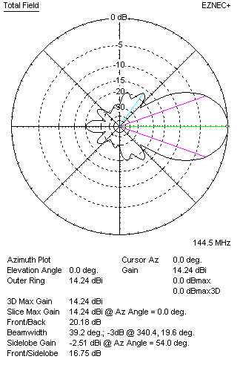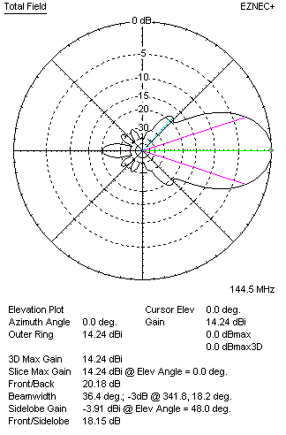
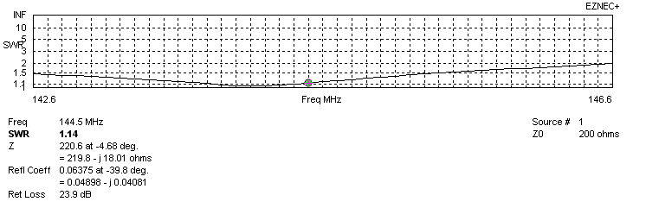
VERTICAL PERFORMANCES after corrections, loss included condition
If you want to get better SWR diagram for vertical antenna you can do the following:
- Change length of D1 from 944 to 948 mm
- Change length of D2 from 954 to 956 mm

In this case the SWR diagram will be like this:
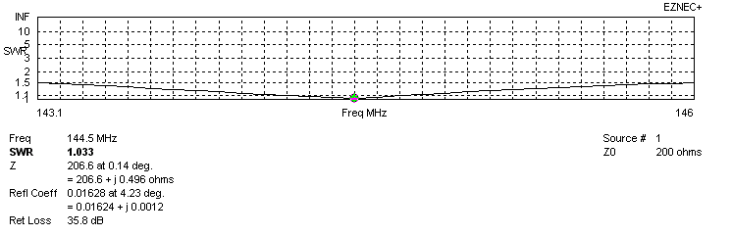
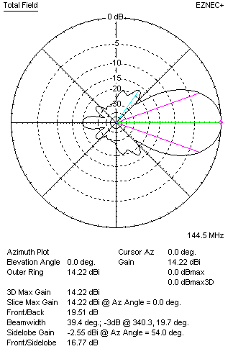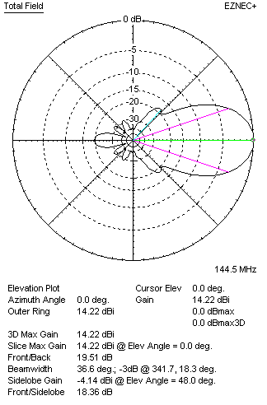

PERFORMANCES
 | TYPE | Condition | G  (dBi) | F/B  (dB) | F/Sh  (dBi) | F/Sv (dBi) | Hor  (◦) | Ver  (◦) | Temp (◦K) | G/T (dB) | B (MHz)  for SWR=1.5
 | Horizontal  part | No losss | 14.23 | 24.07 | 18.99 | 18.05 | 37.2 | 40.4 | 236.4 | -9.51 | 142.300 – 146.600
 | Horizontal  part | Aluminum | 14.15 | 23.87 | 28.96 | 18.06 | 37.2 | 40.4 | 237.8 | -9.61 | 142.300 – 146.600
 | Vertical  part | No losss | 14.31 | 19.62 | 16.77 | 18.38 | 39.4 | 36.6 | 238.6 | -9.47 | 143.100 – 146.000
 | Vertical  part | Aluminum | 14.22 | 19.51 | 16.77 | 18.36 | 39.4 | 36.6 | 240.1 | -9.58 | 143.100 – 146.000

