ANTENNA QY20905XL3D4
The gain of this antenna is a little bit reduced, so that its working bandwidth is significantly increased. Good stacking characteristics at moderate vertical distances and big horizontal distances

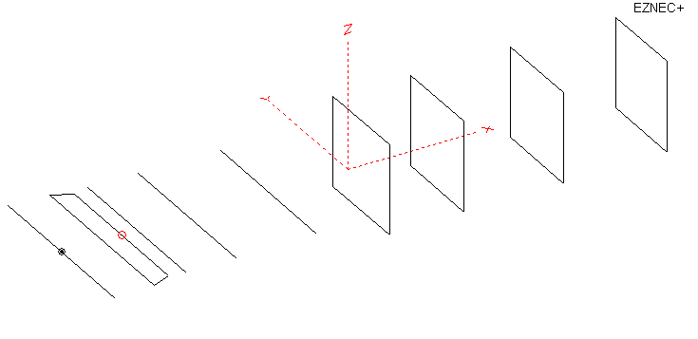
PERFORMANCES: (No loss condition)
 | TYPE | ELE | L (mm) | G (dBi) | F/B (dB) | F/Sh (dBi) | F/Sv (dBi) | Hor (◦) | Ver (◦) | Temp (◦K) | G/T (dB) | ΔF * (kHz)
 | QY20905XL3D4 | 9 | 3785 | 13.33 | 18.85 | 25.89 | 16.99 | 42.0 | 46.2 | 246.0 | -10.58 | 8300
* ΔF given for SWR=1.5

PERFORMANCES: (Loss included for aluminum)
Element material | G (dBi) | Temp (◦K) | G/T (dB)
Aluminum rods | 13.28 | 246.7 | -10.64

COMPARISON
Antenna | Boomlength (mm) | Material | Gain  (dBi) | TA  (◦K) | G/T  (dB) | Bandwidth  (MHz)
QY20905XL3D4 | 3785 | No loss | 13.33 | 246.0 | -10.58 | 139.800- 148.100
QY20905XL3D4 | 3785 | Aluminum | 13.28 | 246.7 | -10.64 | 139.800- 148.100
G0KSC  8 EURO | 3729 | No loss | 13.35 | 236.5 | -10.39 | 141.600-145.450
G0KSC  8 EURO | 3729 | Aluminum | 13.28 | 237.4 | -10.47 | 141.600-145.450
EF0208-5 | 3880 | No loss | 13.52 | 248.2 | -10.43 | 141.220- 145.490
EF0208-5 | 3880 | Aluminum | 13.45 | 249.2 | -10.51 | 141.220- 145.490

DIMENSIONS:
 | Ref | De1 | De2 | D1 | D2 | D3 | DQ1 | DQ2 | DQ3 | DQ4 | REMARKS: - All elements made of Al rods Ǿ5 mm  - Height of all rectangles 500 mm  - All dimensions given in milimetres
Pos | 0 | 180 | 335 | 417 | 694 | 1065 | 1585 | 2247 | 3035 | 3785
Length | 1024 | 1020 | 900 | 940 | 936 | 916 | 526 | 512 | 490 | 470
Building hints: No boom correction included.

DIAGRAMS (no loss included)
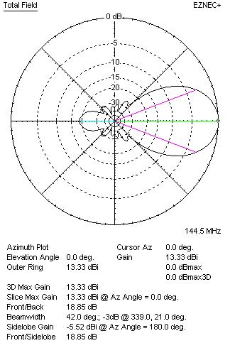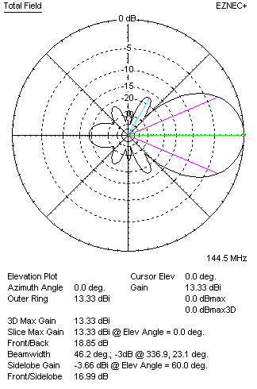
DIAGRAMS (loss included)
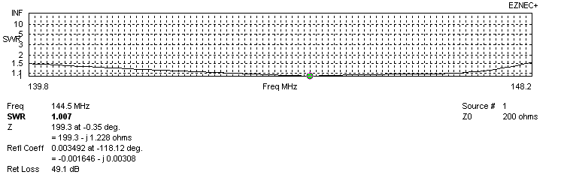
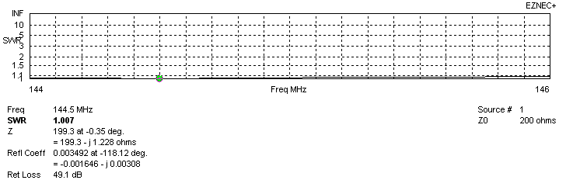
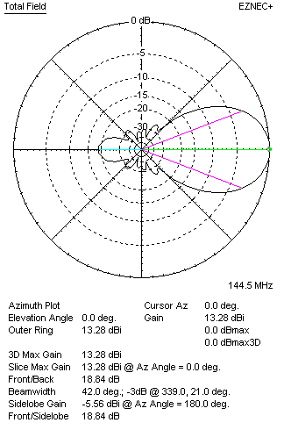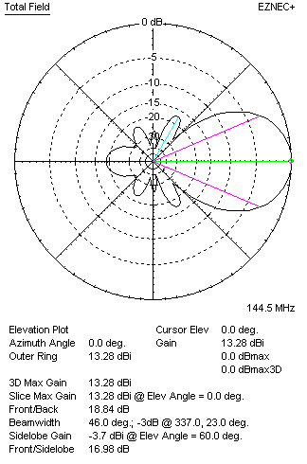

STACKING

QY20905XL3D4
(including loss for aluminum – AGT = -0.06 dB)
VERTICAL  DISTANCE (cm) | G  (dB) | TA  (°K) | G/T  (dB) | HORIZONTAL  DISTANCE (cm) | G  (dB) | TA  (°K) | G/T  (dB)
100 | 14.79 | 223.4 | -8.70 | 100
110 | 14.91 | 221.3 | -8.54 | 110
120 | 15.00 | 222.1 | -8.47 | 120 | 14.69 | 246.9 | -9.24
130 | 15.08 | 226.0 | -8.46 | 130 | 14.83 | 243.9 | -9.04
140 | 15.14 | 230.9 | -8.49 | 140 | 14.94 | 242.3 | -8.90
150 | 15.20 | 233.6 | -8.48 | 150 | 15.05 | 241.9 | -8.79
160 | 15.28 | 234.0 | -8.41 | 160 | 15.14 | 242.2 | -8.70
170 | 15.35 | 234.6 | -8.35 | 170 | 15.23 | 243.2 | -8.63
180 | 15.42 | 236.4 | -8.32 | 180 | 15.32 | 244.5 | -8.56
190 | 15.48 | 238.3 | -8.29 | 190 | 15.41 | 245.9 | -8.50
200 | 15.55 | 239.4 | -8.24 | 200 | 15.50 | 247.4 | -8.43
210 | 15.63 | 239.7 | -8.17 | 210 | 15.58 | 248.7 | -8.38
220 | 15.72 | 239.5 | -8.07 | 220 | 15.67 | 249.8 | -8.31
230 | 15.81 | 239.2 | -7.98 | 230 | 15.75 | 250.7 | -8.24
240 | 15.90 | 239.3 | -7.89 | 240 | 15.84 | 251.4 | -8.16
250 | 15.99 | 240.0 | -7.81 | 250 | 15.91 | 251.8 | -8.10
260 | 16.07 | 241.4 | -7.76 | 260 | 15.99 | 251.9 | -8.02
270 | 16.14 | 243.4 | -7.72 | 270 | 16.05 | 251.9 | -7.96
280 | 16.20 | 245.8 | -7.71 | 280 | 16.11 | 251.7 | -7.90
290 | 16.26 | 248.5 | -7.69 | 290 | 16.16 | 251.4 | -7.84
300 | 16.30 | 251.3 | -7.70 | 300 | 16.21 | 251.0 | -7.79
310 | 16.34 | 253.9 | -7.71 | 310 | 16.25 | 250.6 | -7.74
320 | 16.37 | 256.5 | -7.72 | 320 | 16.28 | 250.1 | -7.70
330 |  |  |  | 330 | 16.30 | 249.6 | -7.67
340 |  |  |  | 340 | 16.32 | 249.1 | -7.64
350 |  |  |  | 350 | 16.33 | 248.7 | -7.63
360 |  |  |  | 360 | 16.34 | 248.3 | -7.61
370 |  |  |  | 370 | 16.34 | 247.9 | -7.60
380 |  |  |  | 380 | 16.35 | 247.6 | -7.59
390 |  |  |  | 390 | 16.34 | 247.3 | -7.59
400 |  |  |  | 400 | 16.34 | 247.1 | -7.59

TWO ANTENNAS VERTICALLY STACKED AT 290CM
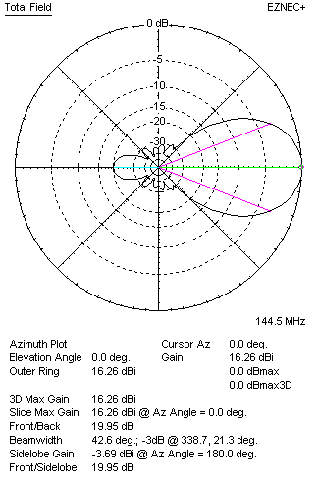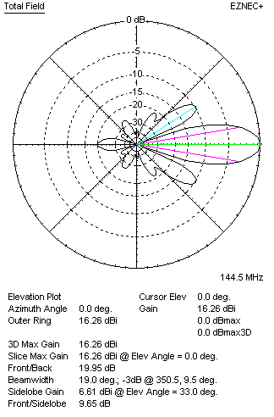

Performances
TYPE | Condition | G  (dBi) | F/B  (dB) | F/Sh  (dBi) | F/Sv (dBi) | Hor  (◦) | Ver  (◦) | Temp (◦K) | G/T (dB) | B (MHz)  for SWR=1.5
2x QY20905XL3D4 | No losss | 16.31 | 19.95 | 28.70 | 9.63 | 42.6 | 19.0 | 248.0 | -7.63 | 139.800- 148.100
2x QY20905XL3D4 | Aluminum | 16.26 | 19.95 | 28.64 | 9.65 | 42.6 | 19.0 | 248.5 | -7.69 | 139.800- 148.100

FOUR ANTENNAS VERTICALLY STACKED AT 290+290+290CM
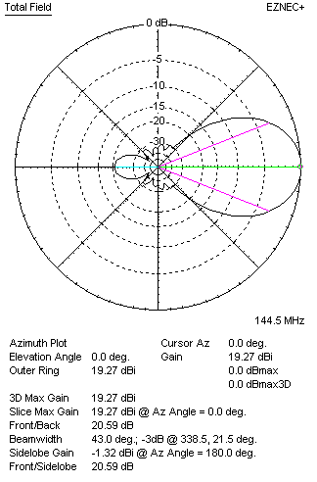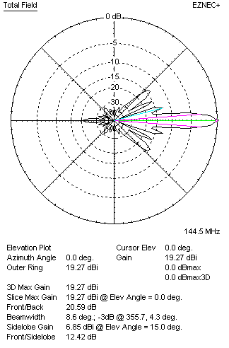
Performances
TYPE | Condition | G  (dBi) | F/B  (dB) | F/Sh  (dBi) | F/Sv (dBi) | Hor  (◦) | Ver  (◦) | Temp (◦K) | G/T (dB) | B (MHz)  for SWR=1.5
4xQY20905XL3D4 | No losss | 19.33 | 20.60 | 24.30 | 12.43 | 43.0 | 8.6 | 231.8 | -4.32 | 139.800- 148.100
4xQY20905XL3D4 | Aluminum | 19.27 | 20.59 | 24.32 | 12.42 | 43.0 | 8.6 | 232.5 | -4.39 | 139.800- 148.100

FOUR ANTENNAS IN H- STACK, H=374 CM, V=280 CM
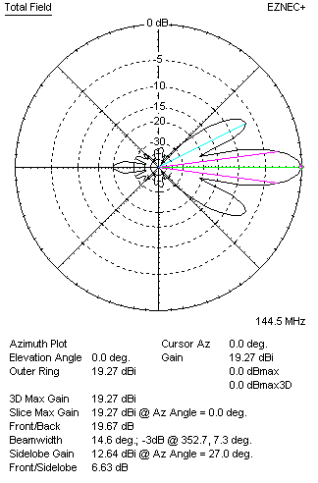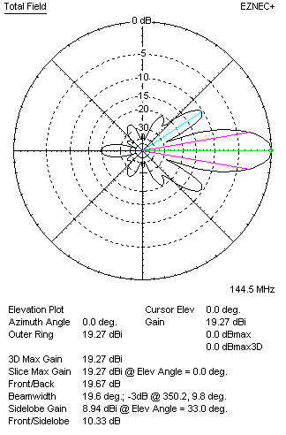
Performances
TYPE | Condition | G  (dBi) | F/B  (dB) | F/Sh  (dBi) | F/Sv (dBi) | Hor  (◦) | Ver  (◦) | Temp (◦K) | G/T (dB) | B (MHz)  for SWR=1.5
4xQY20905XL3D4 | No losss | 19.32 | 19.67 | 6.62 | 10.31 | 14.6 | 19.6 | 247.3 | -4.61 | 139.800- 148.100
4xQY20905XL3D4 | Aluminum | 19.27 | 19.67 | 6.63 | 10.33 | 14.6 | 19.6 | 247.9 | -4.67 | 139.800- 148.100

XPOL VERSION
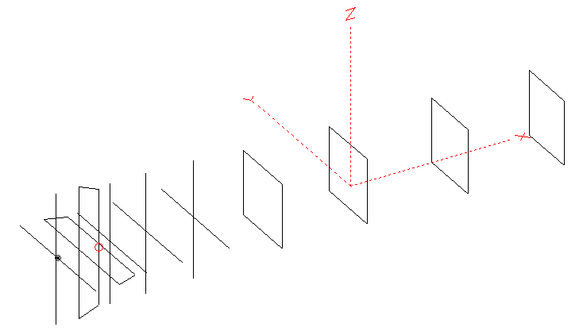
Horizontal components: Same as above
Vertical components: Same as above, except:
- All vertical yagi elements positioned 20 mm back regarding horizontals.
- All crossed elements must cross each other in their centerlines
HORIZONTAL PERFORMANCES
Everything as the above data

VERTICAL PERFORMANCES with no corrections
Loss included condition (for Aluminum)
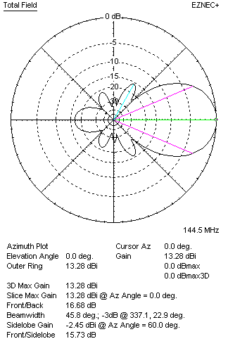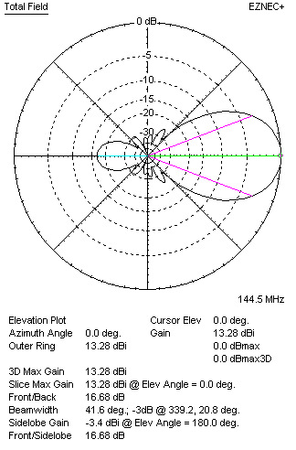

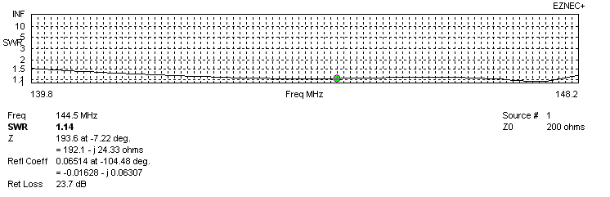
VERTICAL PERFORMANCES after corrections
If you want to get better SWR diagram for vertical antenna you can do the following:
- Change length of DE2 from 900 to 886 mm
- Change length of D1 from 940 to 936 mm
- Change position of D1 for +10 mm.
In this case the SWR diagram will be like this:
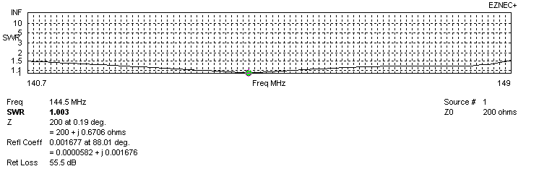
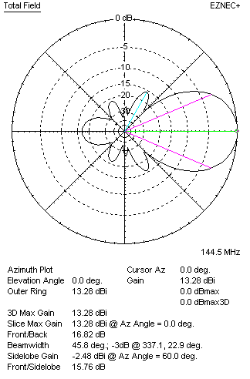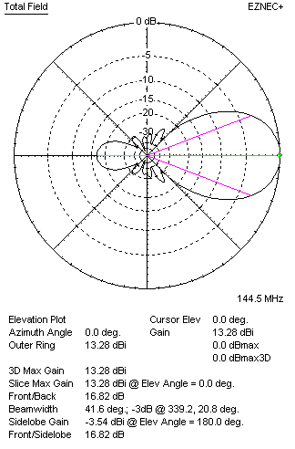

PERFORMANCES
 | TYPE | Condition | G  (dBi) | F/B  (dB) | F/Sh  (dBi) | F/Sv (dBi) | Hor  (◦) | Ver  (◦) | Temp (◦K) | G/T (dB) | B (MHz)  for SWR=1.5
 | Horizontal  part | No losss | 13.33 | 18.85 | 25.89 | 16.99 | 42.0 | 46.2 | 246.0 | -10.58 | 139.600 – 146.800
 | Horizontal  part | Aluminum | 13.28 | 18.84 | 25.87 | 16.98 | 42.0 | 46.0 | 246.7 | -10.64 | 139.600 – 146.800
 | Vertical  part | No losss | 13.33 | 16.83 | 15.76 | 25.54 | 45.8 | 41.8 | 243.9 | -10.54 | 140.700 – 149.000
 | Vertical  part | Aluminum | 13.28 | 16.82 | 15.76 | 25.43 | 45.8 | 41.6 | 244.7 | -10.61 | 140.700 – 149.000

