ANTENNA QY20810XL4D2
Good stacking characteristics at moderate vertical distances and big horizontal distances
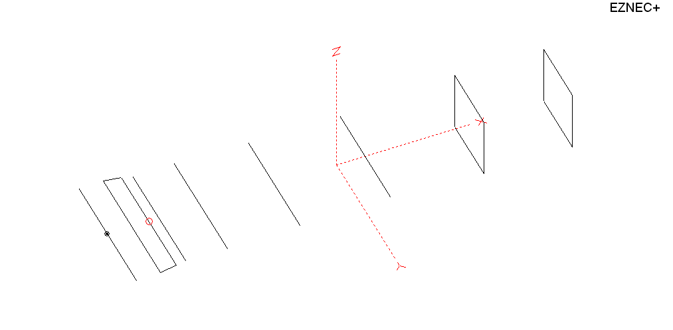
PERFORMANCES: (No loss condition)
TYPE | ELE | L (mm) | G (dBi) | F/B (dB) | F/Sh (dBi) | F/Sv (dBi) | Hor (◦) | Ver (◦) | Temp (◦K) | G/T (dB) | ΔF * (kHz)
QY20810XL4D2 | 8 | 3425 | 13.43 | 21.51 | 21.79 | 20.41 | 40.6 | 45.8 | 245.6 | -10.47 | 5800
* ΔF given for SWR=1.5

PERFORMANCES: (Loss included)
Element material | G (dBi) | Temp (◦K) | G/T (dB)
Aluminum rods | 13.39 | 246.2 | -10.52

DIMENSIONS:
 | Ref | De1 | De2 | D1 | D2 | D3 | D4 | DQ1 | DQ2 | REMARKS : -All elements made of Al rods Ǿ10 mm  - The height of all rectangles is 500 mm  - All dimensions given in milimetres
Pos | 0 | 185 | 315 | 394 | 709 | 1268 | 1958 | 2755 | 3425
Length | 1010 | 1000 | 960 | 928 | 938 | 910 | 884 | 512 | 500
Building hints: No boom correction included.

COMPARISON
Antenna | Boomlength (mm) | Material | Gain (dBi) | TA (◦K) | G/T (dB) | Bandwidth  (MHz)
QY20810XL4D2 | 3425 | No loss | 13.43 | 245.6 | -10.47 | 140.400 - 146.200
QY20810XL4D2 | 3425 | Aluminum | 13.39 | 246.2 | -10.52 | 140.400 - 146.200
G0KSC  8 EURO | 3729 | No loss | 13.35 | 236.5 | -10.39 | 141.600 -145.450
G0KSC  8 EURO | 3729 | Aluminum | 13.28 | 237.4 | -10.47 | 141.600 -145.450
EF0208-5 | 3880 | No loss | 13.52 | 248.2 | -10.43 | 141.220 -145.490
EF0208-5 | 3880 | Aluminum | 13.45 | 249.2 | -10.51 | 141.220 -145.490

DIAGRAMS (no loss included)
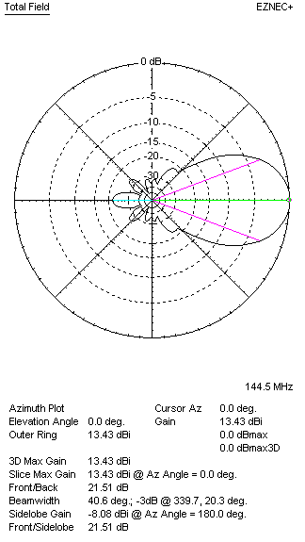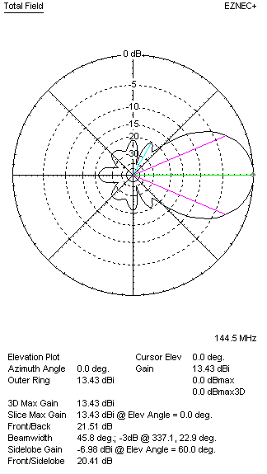
DIAGRAMS (loss included)
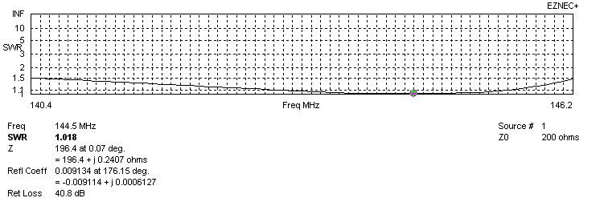
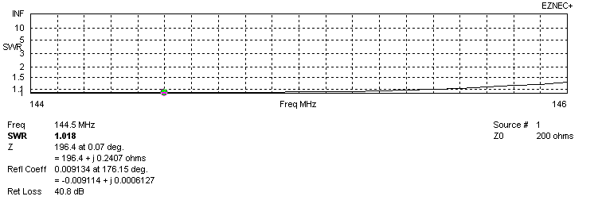
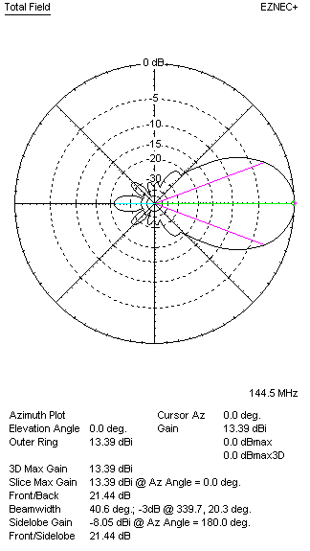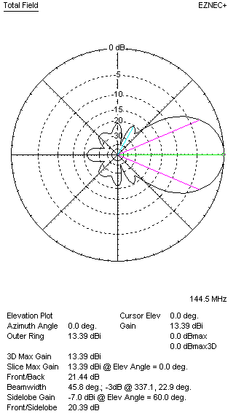
STACKING

QY20810XL4D2 – STACKING TABLE
(including loss for aluminum – AGT = -0.06 dB)
VERTICAL  DISTANCE (cm) | G  (dB) | TA  (°K) | G/T  (dB) | HORIZONTAL  DISTANCE (cm) | G  (dB) | TA  (°K) | G/T  (dB)
100 | 14.62 | 229.7 | -8.99 | 100
110 | 14.77 | 225.5 | -8.76 | 110
120 | 14.90 | 223.9 | -8.60 | 120 | 14.36 | 257.9 | -9.76
130 | 15.02 | 224.5 | -8.49 | 130 | 14.62 | 252.4 | -9.40
140 | 15.12 | 225.9 | -8.42 | 140 | 14.81 | 248.3 | -9.14
150 | 15.22 | 226.0 | -8.32 | 150 | 14.97 | 245.4 | -8.93
160 | 15.33 | 225.3 | -8.20 | 160 | 15.11 | 243.5 | -8.76
170 | 15.44 | 225.2 | -8.09 | 170 | 15.23 | 242.5 | -8.62
180 | 15.54 | 225.5 | -7.99 | 180 | 15.35 | 242.1 | -8.49
190 | 15.64 | 225.7 | -7.90 | 190 | 15.46 | 242.1 | -8.38
200 | 15.74 | 225.6 | -7.79 | 200 | 15.56 | 242.5 | -8.29
210 | 15.84 | 225.3 | -7.69 | 210 | 15.66 | 243.2 | -8.20
220 | 15.93 | 225.4 | -7.60 | 220 | 15.75 | 244.0 | -8.12
230 | 16.03 | 226.4 | -7.52 | 230 | 15.84 | 244.9 | -8.05
240 | 16.11 | 228.3 | -7.48 | 240 | 15.92 | 245.7 | -7.98
250 | 16.18 | 231.3 | -7.46 | 250 | 16.00 | 246.5 | -7.92
260 | 16.24 | 235.1 | -7.47 | 260 | 16.07 | 247.2 | -7.86
270 | 16.29 | 239.4 | -7.50 | 270 | 16.13 | 247.8 | -7.81
280 | 16.33 | 243.9 | -7.54 | 280 | 16.18 | 248.3 | -7.77
290 | 16.37 | 248.5 | -7.58 | 290 | 16.23 | 248.7 | -7.73
300 | 16.39 | 252.9 | -7.64 | 300 | 16.27 | 249.0 | -7.69
 |  |  |  | 310 | 16.30 | 249.1 | -7.66
 |  |  |  | 320 | 16.33 | 249.2 | -7.64
 |  |  |  | 330 | 16.35 | 249.2 | -7.62
 |  |  |  | 340 | 16.36 | 249.1 | -7.60
 |  |  |  | 350 | 16.38 | 249.0 | -7.58
 |  |  |  | 360 | 16.38 | 248.9 | -7.58
 |  |  |  | 370 | 16.39 | 248.7 | -7.57
 |  |  |  | 380 | 16.39 | 248.7 | -7.57

TWO ANTENNAS VERTICALLY STACKED AT 250CM
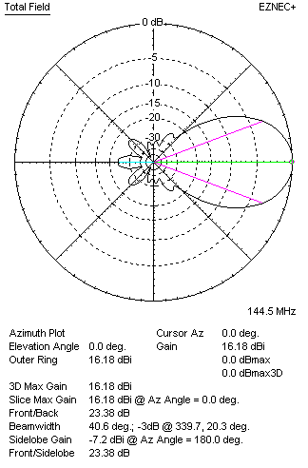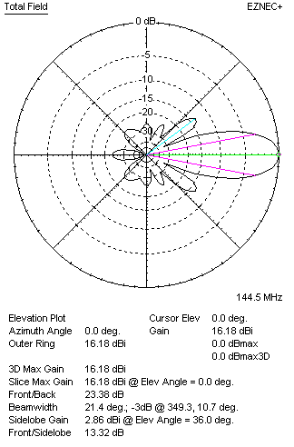
Performances
TYPE | Condition | G  (dBi) | F/B  (dB) | F/Sh  (dBi) | F/Sv (dBi) | Hor  (◦) | Ver  (◦) | Temp (◦K) | G/T (dB) | B (MHz)  for SWR=1.5
QY20810XL4D2 | No losss | 16.22 | 23.45 | 24.16 | 13.29 | 40.8 | 21.4 | 230.6 | -7.41 | 140.400 - 146.200
QY20810XL4D2 | Aluminum | 16.18 | 23.38 | 24.13 | 13.32 | 40.6 | 21.4 | 231.3 | -7.46 | 140.400 - 146.200

FOUR ANTENNAS VERTICALLY STACKED AT 250+250+250CM
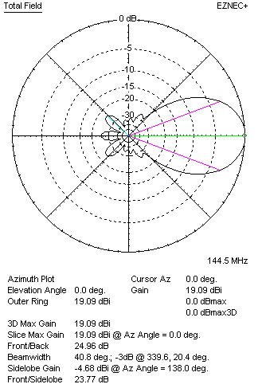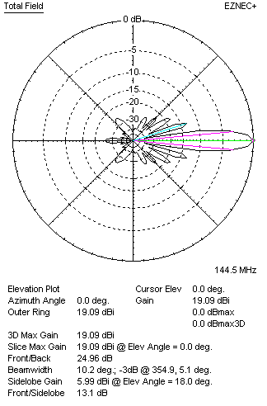
Performances
TYPE | Condition | G  (dBi) | F/B  (dB) | F/Sh  (dBi) | F/Sv (dBi) | Hor  (◦) | Ver  (◦) | Temp (◦K) | G/T (dB) | B (MHz)  for SWR=1.5
4xQY20810XL4D2 | No losss | 19.13 | 25.04 | 26.11 | 13.09 | 40.8 | 10.2 | 221.9 | -4.33 | 140.400 - 146.200
4xQY20810XL4D2 | Aluminum | 19.09 | 24.96 | 26.06 | 13.10 | 40.8 | 10.2 | 222.7 | -4.39 | 140.400 - 146.200

FOUR ANTENNAS IN H- STACK, H=360 CM, V=240 CM, LOSS INCLUDED FOR ALUMINUM
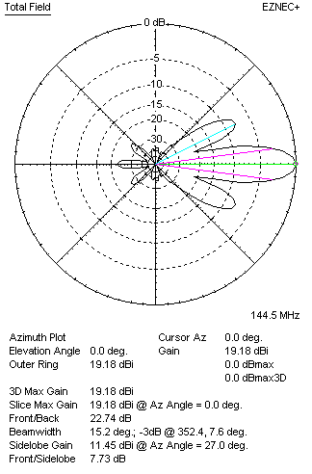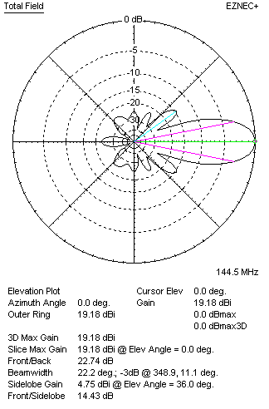
Performances
TYPE | Condition | G  (dBi) | F/B  (dB) | F/Sh  (dBi) | F/Sv (dBi) | Hor  (◦) | Ver  (◦) | Temp (◦K) | G/T (dB) | B (MHz)  for SWR=1.5
4xQY20810XL4D2 | No losss | 19.22 | 22.80 | 7.71 | 14.41 | 15.2 | 22.2 | 230.6 | -4.41 | 140.400 - 146.200
4xQY20810XL4D2 | Aluminum | 19.18 | 22.74 | 7.73 | 14.43 | 15.2 | 22.2 | 231.3 | -4.46 | 140.400 - 146.200

X POL VERSION
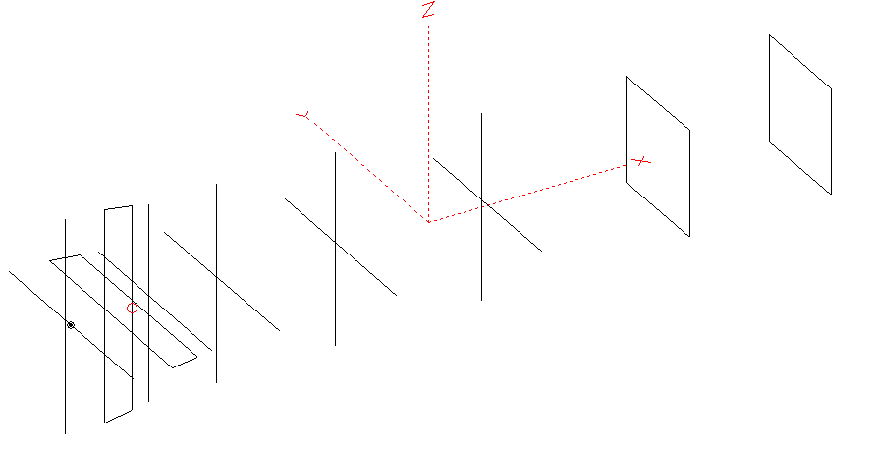
Horizontal components: Same as above
Vertical components: Same as above, except:
- All vertical yagi elements positioned 20 mm back regarding horizontals.
- All crossed elements must cross each other in their centerlines

HORIZONTAL PERFORMANCES
Everything as the above data

VERTICAL PERFORMANCES with no corrections
Loss included condition (for Aluminum)
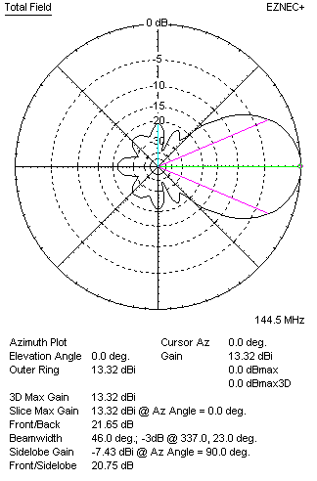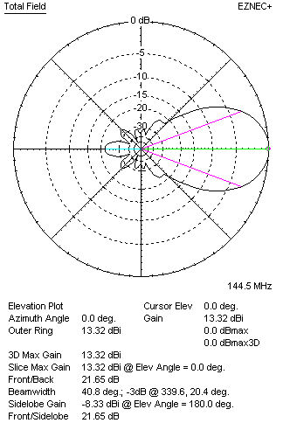

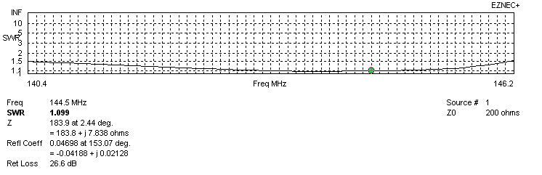
VERTICAL PERFORMANCES after corrections
If you want to get better SWR diagram for vertical antenna you can do the following:
- Change length of DE1 from 1000 to 1010 mm
- Change length of DE2 from 970 to 964 mm
- Change length of D1 from 928 to 926 mm
- Change position of D1 for +1 mm

In this case the SWR diagram will be like this:

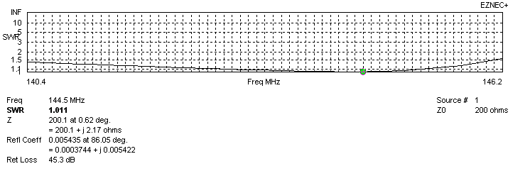
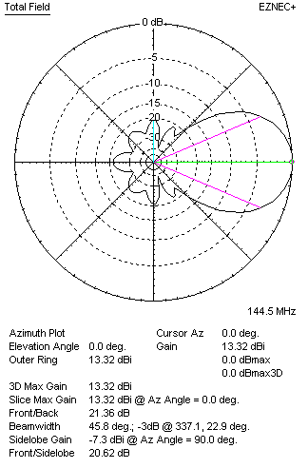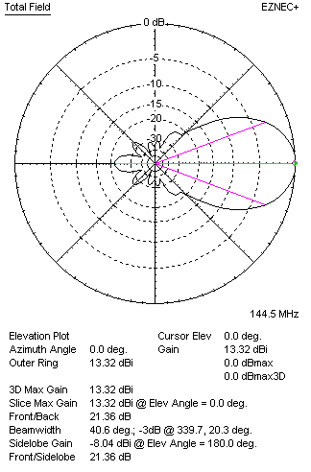

PERFORMANCES
 | TYPE | Condition | G  (dBi) | F/B  (dB) | F/Sh  (dBi) | F/Sv (dBi) | Hor  (◦) | Ver  (◦) | Temp (◦K) | G/T (dB) | B (MHz)  for SWR=1.5
 | Horizontal  part | No losss | 13.43 | 21.51 | 21.79 | 20.41 | 40.6 | 45.8 | 245.6 | -10.47 | 140.400 - 146.200
 | Horizontal  part | Aluminum | 13.33 | 21.40 | 21.99 | 20.41 | 40.6 | 45.8 | 246.7 | -10.59 | 140.400 - 146.200
 | Vertical  part | No losss | 13.36 | 21.42 | 21.24 | 22.29 | 46.0 | 40.8 | 239.7 | -10.44 | 140.200 – 146.100
 | Vertical  part | Aluminum | 13.32 | 21.36 | 21.21 | 22.26 | 45.8 | 40.6 | 240.2 | -10.49 | 140.200 – 146.100

