ANTENNA QY20808XL3D3
Good stacking characteristics at short vertical distances and big horizontal distances
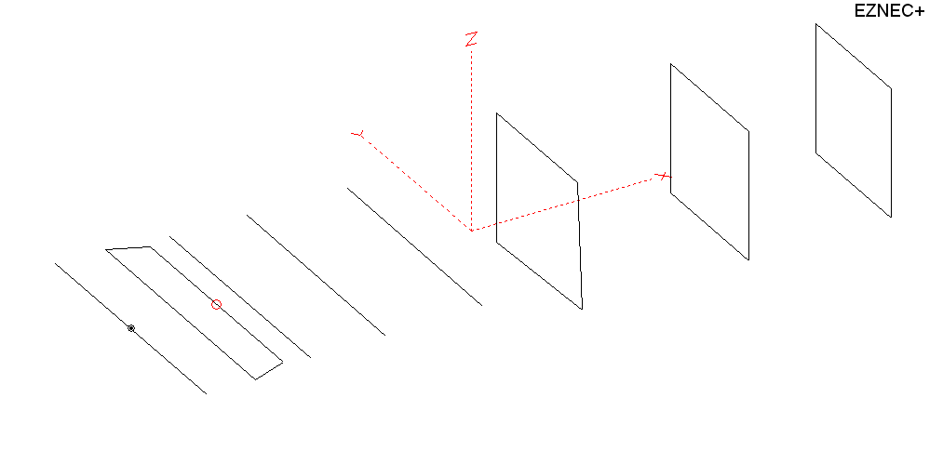
PERFORMANCES: (No loss condition)
TYPE | ELE | L (mm) | G (dBi) | F/B (dB) | F/Sh (dBi) | F/Sv (dBi) | Hor (◦) | Ver (◦) | Temp (◦K) | G/T (dB) | ΔF * (kHz)
QY20808XL3D3 | 8 | 2825 | 12.78 | 24.01 | 21.48 | 17.78 | 43.4 | 48.6 | 259.5 | -10.36 | 6600
* ΔF given for SWR=1,5

PERFORMANCES: (Loss included)
Element material | G (dBi) | Temp (◦K) | G/T (dB)
Aluminum rods | 12.74 | 259.8 | -11.41

DIMENSIONS:
 | Ref | De1 | De2 | D1 | D2 | D3 | DQ1 | DQ2 | DQ3 | REMARKS : -All elements made of Al rods Ǿ8 mm  - The height of the rectangle is 500 mm  - All dimensions given in milimetres
Pos | 0 | 180 | 330 | 416 | 701 | 1085 | 1555 | 2261 | 2825
Length | 1012 | 1012 | 920 | 938 | 930 | 904 | 536 | 524 | 504
Building hints: No boom correction included.

COMPARISON
Antenna | Boomlength (mm) | Material | Gain (dBi) | TA (◦K) | G/T (dB) | Bandwidth  (MHz)
QY20808XL3D3 | 2825 | No loss | 12.78 | 259.5 | -10.36 | 140.100- 146.700
QY20808XL3D3 | 2825 | Aluminum | 12.74 | 259.8 | -11.41 | 140.100- 146.700
EF0207-5 | 3274 | No loss | 12.95 | 255.9 | -11.13 | 140.400- 145.100
EF0207-5 | 3274 | Aluminum | 12.85 | 256.8 | -11.25 | 140.400- 145.100
G0KSC  7ELE EU | 2894 | No loss | 12.89 | 260.5 | -11.27 | 141.300 – 145.400
G0KSC  7ELE EU | 2894 | Aluminum | 12.83 | 260.9 | -11.34 | 141.300 – 145.400

DIAGRAMS (no loss included)
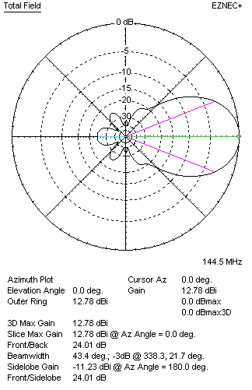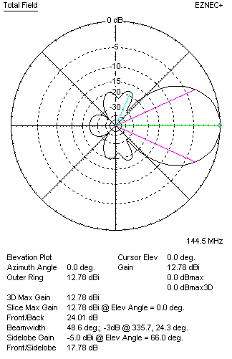
DIAGRAMS (loss included)
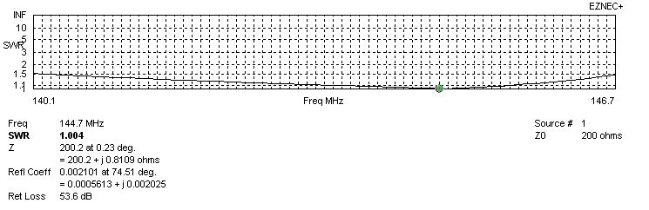
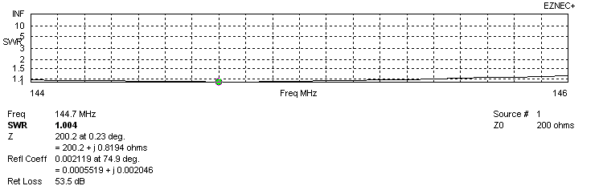
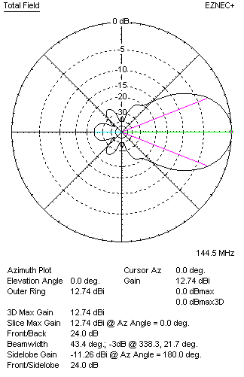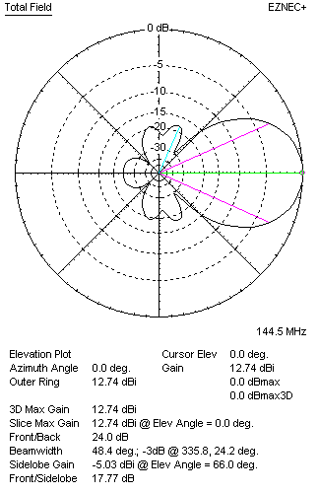
STACKING

QY20808XL3D3 – STACKING TABLE
(including loss for aluminum – AGT = -0.04 dB)
VERTICAL  DISTANCE  (cm) | G  (dBi) | TA  (°K) | G/T  (dB) | HORIZONTAL  DISTANCE  (cm) | G  (dBi) | TA  (°K) | G/T  (dB)
100 | 14.09 | 230.8 | -9.54 | 100
110 | 14.27 | 225.9 | -9.27 | 110
120 | 14.42 | 223.7 | -9.08 | 120 | 13.98 | 263.0 | -10.22
130 | 14.55 | 224.5 | -8.96 | 130 | 14.19 | 258.0 | -9.93
140 | 14.65 | 227.4 | -8.92 | 140 | 14.36 | 254.8 | -9.70
150 | 14.75 | 230.6 | -8.88 | 150 | 14.51 | 253.1 | -9.52
160 | 14.83 | 233.4 | -8.85 | 160 | 14.65 | 252.5 | -9.37
170 | 14.91 | 236.2 | -8.82 | 170 | 14.77 | 252.7 | -9.26
180 | 14.99 | 238.6 | -8.79 | 180 | 14.89 | 253.6 | -9.15
190 | 15.08 | 239.7 | -8.72 | 190 | 14.99 | 254.9 | -9.07
200 | 15.17 | 239.6 | -8.62 | 200 | 15.09 | 256.5 | -9.00
210 | 15.28 | 238.9 | -8.50 | 210 | 15.19 | 258.1 | -8.93
220 | 15.38 | 238.7 | -8.40 | 220 | 15.28 | 259.6 | -8.86
230 | 15.48 | 239.5 | -8.31 | 230 | 15.36 | 260.9 | -8.81
240 | 15.57 | 241.5 | -8.26 | 240 | 15.44 | 262.1 | -8.74
250 | 15.64 | 244.6 | -8.25 | 250 | 15.50 | 262.9 | -8.70
260 | 15.71 | 248.7 | -8.25 | 260 | 15.56 | 263.5 | -8.65
270 | 15.76 | 253.2 | -8.27 | 270 | 15.62 | 263.8 | -8.59
280 |  |  |  | 280 | 15.66 | 263.9 | -8.55
290 |  |  |  | 290 | 15.70 | 263.8 | -8.51
 |  |  |  | 300 | 15.73 | 263.6 | -8.48
 |  |  |  | 310 | 15.75 | 263.2 | -8.45
 |  |  |  | 320 | 15.77 | 262.7 | -8.42
 |  |  |  | 330 | 15.78 | 262.1 | -8.40
 |  |  |  | 340 | 15.79 | 261.5 | -8.39
 |  |  |  | 350 | 15.80 | 261.0 | -8.37
 |  |  |  | 360 | 15.80 | 260.4 | -8.36

TWO ANTENNAS VERTICALLY STACKED AT 250CM
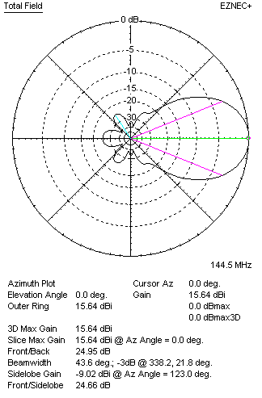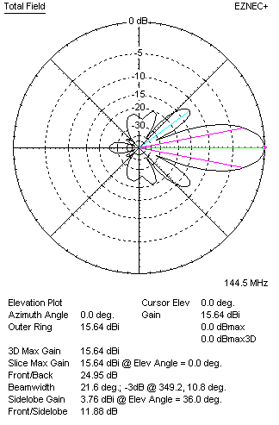
Performances
TYPE | Condition | G  (dBi) | F/B  (dB) | F/Sh  (dBi) | F/Sv (dBi) | Hor  (◦) | Ver  (◦) | Temp (◦K) | G/T (dB) | B (MHz)  for SWR=1.5
QY20808XL3D3 | No losss | 15.68 | 24.96 | 24.36 | 11.86 | 43.8 | 21.6 | 244.2 | -8.20 | 140.100- 146.700
QY20808XL3D3 | Aluminum | 15.64 | 24.95 | 24.33 | 11.88 | 43.6 | 21.6 | 244.6 | -8.25 | 140.100- 146.700

FOUR ANTENNAS VERTICALLY STACKED AT 250+250+250CM
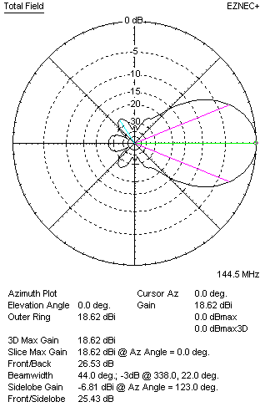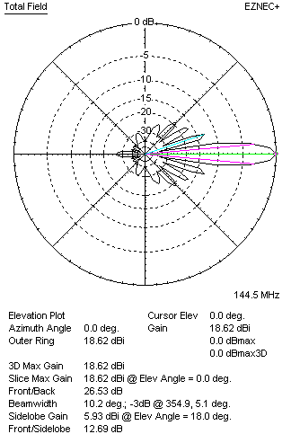
Performances
TYPE | Condition | G  (dBi) | F/B  (dB) | F/Sh  (dBi) | F/Sv (dBi) | Hor  (◦) | Ver  (◦) | Temp (◦K) | G/T (dB) | B (MHz)  for SWR=1.5
4xQY20808XL3D3 | No losss | 18.66 | 26.54 | 25.70 | 12.69 | 44.0 | 10.2 | 229.5 | -4.95 | 140.100- 146.700
4xQY20808XL3D3 | Aluminum | 18.62 | 26.53 | 25.67 | 12.69 | 44.0 | 10.2 | 230.2 | -5.00 | 140.100- 146.700

FOUR ANTENNAS IN H- STACK, H=350 CM, V=240 CM
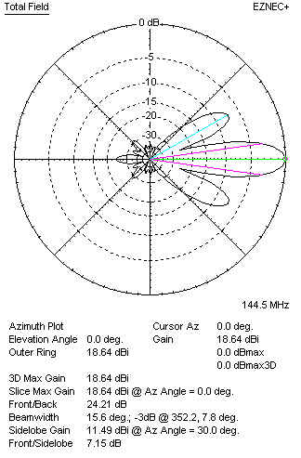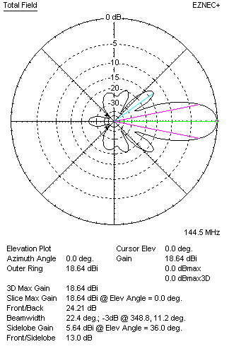
Performances
TYPE | Condition | G  (dBi) | F/B  (dB) | F/Sh  (dBi) | F/Sv (dBi) | Hor  (◦) | Ver  (◦) | Temp (◦K) | G/T (dB) | B (MHz)  for SWR=1.5
4xQY20808XL3D3 | No losss | 18.68 | 24.22 | 7.14 | 12.99 | 15.6 | 22.4 | 242.3 | -5.16 | 140.100- 146.700
4xQY20808XL3D3 | Aluminum | 18.64 | 24.21 | 7.15 | 13.00 | 15.6 | 22.4 | 242.8 | -5.21 | 140.100- 146.700

X POL VERSION
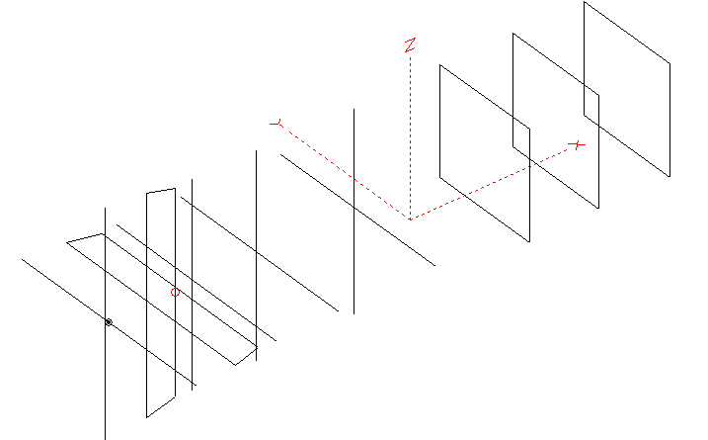
Horizontal components: Same as above
Vertical components: Same as above, except:
- All vertical yagi elements positioned 20 mm back regarding horizontals.
- All crossed elements must cross each other in their centerlines

HORIZONTAL PERFORMANCES
Everything as the above data

VERTICAL PERFORMANCES with no corrections
Loss included condition (for Aluminum)
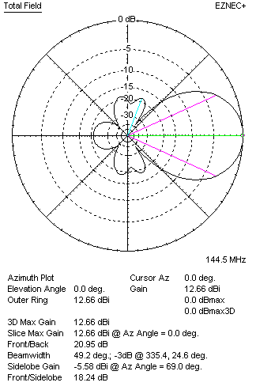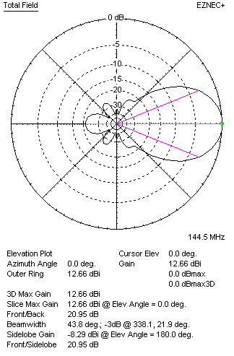

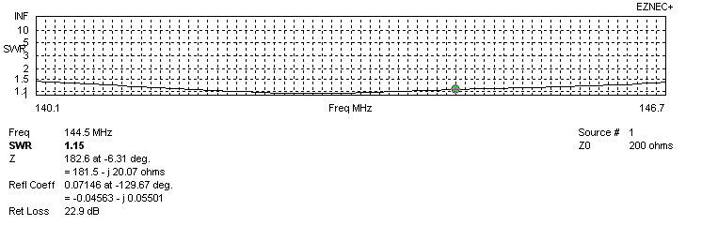
VERTICAL PERFORMANCES after corrections
If you want to get better SWR diagram for vertical antenna you can do the following:
- Change length of D1 from 938 to 934 mm
- Change length of DE2 from 920 to 930 mm
- Change position of D1 for +4 mm

In this case the SWR diagram will be like this:

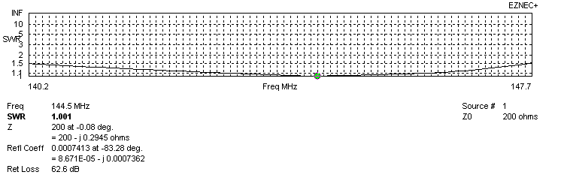
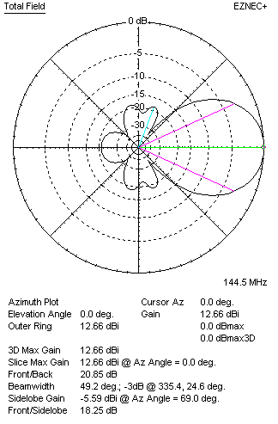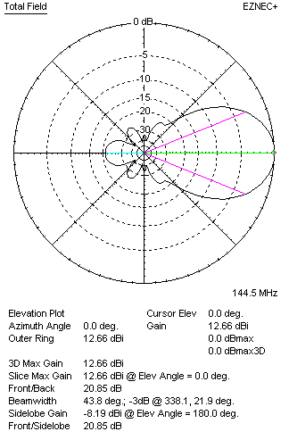

PERFORMANCES
 | TYPE | Condition | G  (dBi) | F/B  (dB) | F/Sh  (dBi) | F/Sv (dBi) | Hor  (◦) | Ver  (◦) | Temp (◦K) | G/T (dB) | B (MHz)  for SWR=1.5
 | Horizontal  part | No losss | 12.78 | 24.01 | 21.48 | 17.78 | 43.4 | 48.6 | 259.5 | -10.36 | 140.100- 146.700
 | Horizontal  part | Aluminum | 12.74 | 24.00 | 21.45 | 17.77 | 43.4 | 48.4 | 259.8 | -11.41 | 140.100- 146.700
 | Vertical  part | No losss | 12.69 | 20.85 | 18.24 | 23.25 | 49.2 | 43.8 | 253.8 | -11.36 | 140.200 – 147.650
 | Vertical  part | Aluminum | 12.66 | 20.85 | 18.25 | 23.23 | 49.2 | 43.8 | 254.3 | -11.39 | 140.200 – 147.650

