ANTENNA QY20808XL1D2
Good stacking characteristics at moderate vertical distances and big horizontal distances
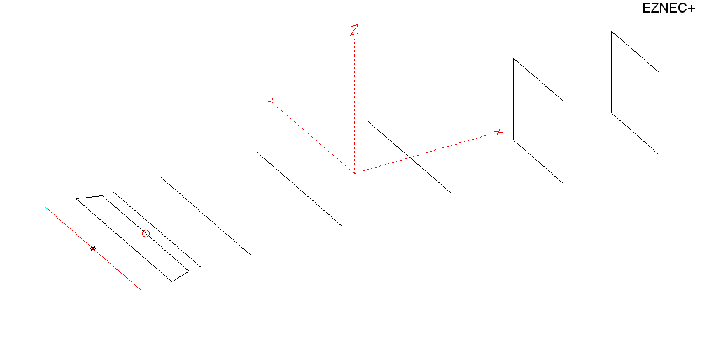
PERFORMANCES: (No loss condition)
TYPE | ELE | L (mm) | G (dBi) | F/B (dB) | F/Sh (dBi) | F/Sv (dBi) | Hor (◦) | Ver (◦) | Temp (◦K) | G/T (dB) | ΔF * (kHz)
QY20808XL1D2 | 8 | 3295 | 13.29 | 25.70 | 20.82 | 17.77 | 41.0 | 46.4 | 248.0 | -10.66 | 5850
* ΔF given for SWR=1,5

PERFORMANCES: (Loss included)
Element material | G (dBi) | Temp (◦K) | G/T (dB)
Aluminum rods | 13.24 | 248.6 | -10.71

DIMENSIONS:
 | Ref | De1 | De2 | D1 | D2 | D3 | D4 | DQ1 | DQ2 | REMARKS : -All elements made of Al rods Ǿ8 mm  - The height of the rectangle is 500 mm  - All dimensions given in milimetres
Pos | 0 | 185 | 320 | 393 | 688 | 1255 | 1925 | 2705 | 3295
Length | 1012 | 1010 | 924 | 940 | 944 | 910 | 890 | 524 | 504
Building hints: No boom correction included.

COMPARISON
Antenna | Boomlength (mm) | Material | Gain  (dBi) | TA  (◦K) | G/T (dB) | Bandwidth  (MHz)
QY20808XL1D2 | 3295 | No loss | 13.29 | 248.0 | -10.66 | 141.300- 147.050
QY20808XL1D2 | 3295 | Aluminum | 13.24 | 248.6 | -10.71 | 141.300- 147.050
EF0207-5 | 3274 | No loss | 12.91 | 283.0 | -12.61 | 140.400-145.100
EF0207-5 | 3274 | Aluminum | 12.85 | 256.9 | -11.25 | 140.400-145.100
G0KSC 7ELE EU | 2894 | No loss | 12.89 | 260.5 | -11.27 | 141.300 – 145.400
G0KSC 7ELE EU | 2894 | Aluminum | 12.83 | 260.9 | -11.34 | 141.300 – 145.400

DIAGRAMS (no loss included)
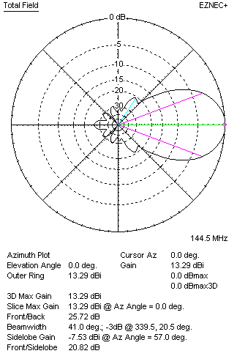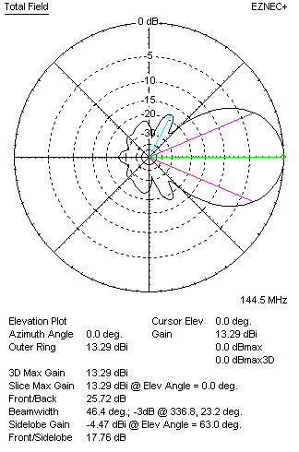
DIAGRAMS (loss included)
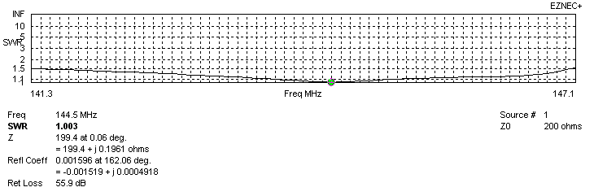
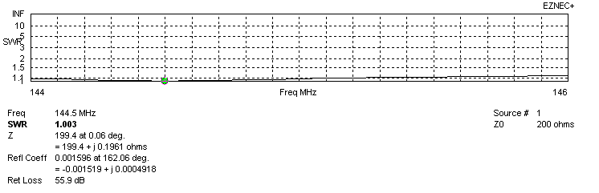
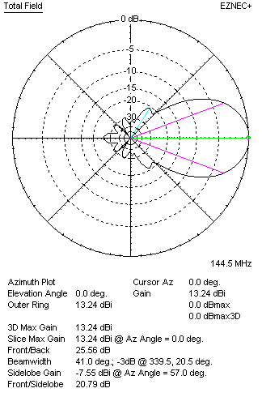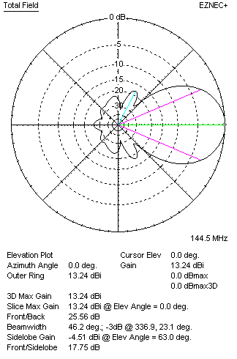
STACKING

QY20808XL1D2 -
(including loss for aluminum – AGT = -0.06)
VERTICAL  DISTANCE (cm) | G  (dB) | TA  (°K) | G/T  (dB) | HORIZONTAL  DISTANCE (cm) | G  (dB) | TA  (°K) | G/T  (dB)
100 | 14.55 | 229.7 | -9.06 | 100
110 | 14.70 | 225.0 | -8.82 | 110
120 | 14.84 | 222.3 | -8.63 | 120 | 14.37 | 258.4 | -9.75
130 | 14.96 | 221.2 | -8.49 | 130 | 14.59 | 252.4 | -9.43
140 | 15.07 | 221.2 | -8.38 | 140 | 14.77 | 248.3 | -9.18
150 | 15.16 | 221.8 | -8.30 | 150 | 14.92 | 245.8 | -8.99
160 | 15.25 | 223.3 | -8.24 | 160 | 15.04 | 244.4 | -8.84
170 | 15.34 | 225.7 | -8.20 | 170 | 15.16 | 243.9 | -8.71
180 | 15.43 | 228.1 | -8.15 | 180 | 15.27 | 244.0 | -8.60
190 | 15.52 | 229.7 | -8.09 | 190 | 15.37 | 244.5 | -8.51
200 | 15.62 | 230.1 | -8.00 | 200 | 15.46 | 245.3 | -8.44
210 | 15.72 | 229.9 | -7.90 | 210 | 15.56 | 246.3 | -8.35
220 | 15.82 | 229.7 | -7.79 | 220 | 15.65 | 247.2 | -8.28
230 | 15.92 | 230.1 | -7.70 | 230 | 15.73 | 248.1 | -8.22
240 | 16.01 | 231.6 | -7.64 | 240 | 15.82 | 248.9 | -8.14
250 | 16.09 | 234.1 | -7.60 | 250 | 15.89 | 248.5 | -8.08
260 | 16.15 | 237.5 | -7.61 | 260 | 15.97 | 250.0 | -8.01
270 | 16.21 | 241.4 | -7.62 | 270 | 16.03 | 250.3 | -7.95
280 | 16.25 | 245.7 | -7.65 | 280 | 16.09 | 250.5 | -7.90
 |  |  |  | 290 | 16.14 | 250.6 | -7.85
 |  |  |  | 300 | 16.18 | 250.7 | -7.81
 |  |  |  | 310 | 16.22 | 250.6 | -7.77
 |  |  |  | 320 | 16.24 | 250.5 | -7.75
 |  |  |  | 330 | 16.27 | 250.4 | -7.72
 |  |  |  | 340 | 16.28 | 250.2 | -7.70
 |  |  |  | 350 | 16.30 | 250.1 | -7.68
 |  |  |  | 360 | 16.30 | 249.9 | -7.68

TWO ANTENNAS VERTICALLY STACKED AT 250CM
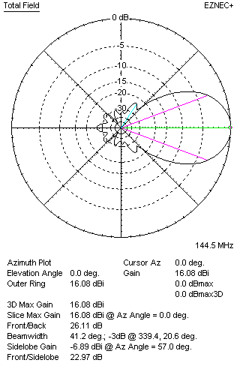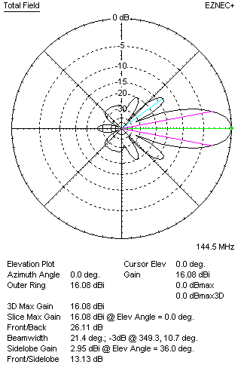
Performances
TYPE | Condition | G  (dBi) | F/B  (dB) | F/Sh  (dBi) | F/Sv (dBi) | Hor  (◦) | Ver  (◦) | Temp (◦K) | G/T (dB) | B (MHz)  for SWR=1.5
QY20808XL1D2 | No losss | 16.13 | 26.26 | 23.01 | 13.11 | 41.2 | 21.4 | 233.4 | -7.55 | 141.300- 147.050
QY20808XL1D2 | Aluminum | 16.08 | 26.11 | 22.97 | 13.13 | 41.2 | 21.4 | 234.1 | -7.61 | 141.300- 147.050

FOUR ANTENNAS VERTICALLY STACKED AT 250+250+250CM
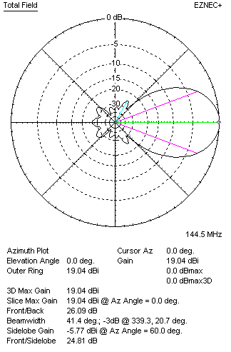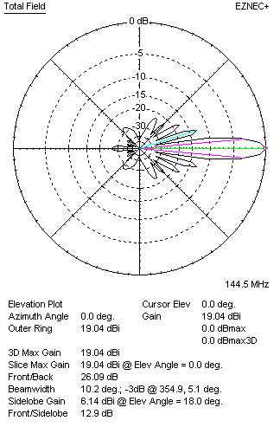
Performances
TYPE | Condition | G  (dBi) | F/B  (dB) | F/Sh  (dBi) | F/Sv (dBi) | Hor  (◦) | Ver  (◦) | Temp (◦K) | G/T (dB) | B (MHz)  for SWR=1.5
4xQY20808XL1D2 | No losss | 19.04 | 26.09 | 24.81 | 12.90 | 41.4 | 10.2 | 225.2 | -4.49 | 141.300- 147.050
4xQY20808XL1D2 | Aluminum | 18.99 | 25.97 | 24.78 | 12.90 | 41.2 | 10.2 | 226.1 | -4.55 | 141.300- 147.050

FOUR ANTENNAS IN H- STACK, H=330 CM, V=250 CM, LOSS INCLUDED FOR ALUMINUM
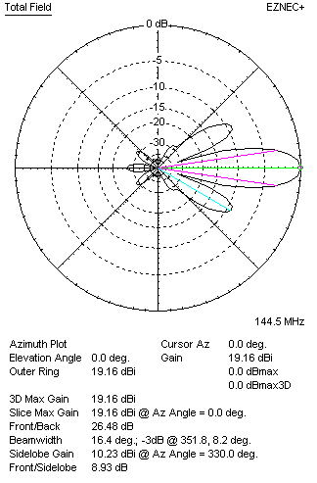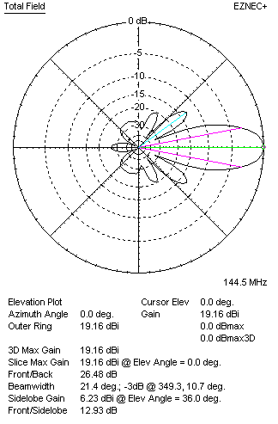
Performances
TYPE | Condition | G  (dBi) | F/B  (dB) | F/Sh  (dBi) | F/Sv (dBi) | Hor  (◦) | Ver  (◦) | Temp (◦K) | G/T (dB) | B (MHz)  for SWR=1.5
4xQY20808XL1D2 | No losss | 19.21 | 26.64 | 8.92 | 12.91 | 16.4 | 21.4 | 235.9 | -4.52 | 141.300- 147.050
4xQY20808XL1D2 | Aluminum | 19.16 | 26.48 | 8.93 | 12.93 | 16.4 | 21.4 | 236.6 | -4.58 | 141.300- 147.050

X POL VERSION
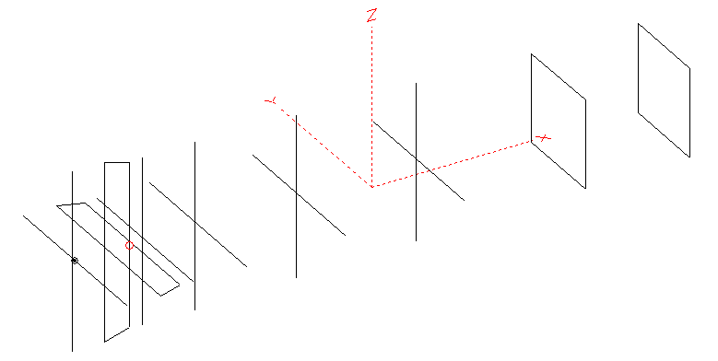
Horizontal components: Same as above
Vertical components: Same as above, except:
- All vertical yagi elements positioned 20 mm back regarding horizontals.
- All crossed elements must cross each other in their centerlines

HORIZONTAL PERFORMANCES
Everything as the above data

VERTICAL PERFORMANCES with no corrections
Loss included condition (for Aluminum)
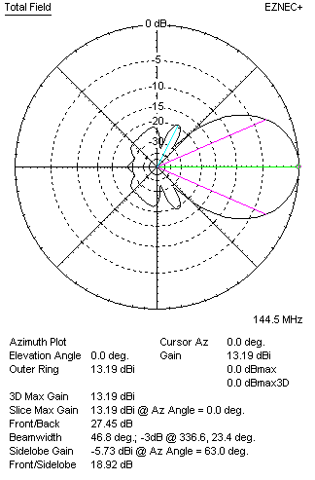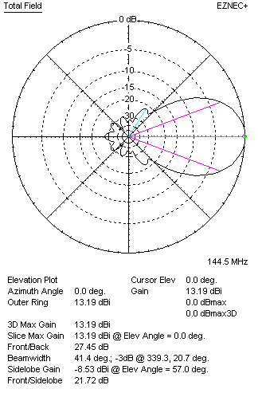

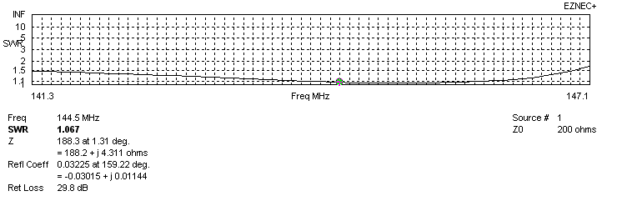
VERTICAL PERFORMANCES after corrections
If you want to get better SWR diagram for vertical antenna you can do the following:
- Change length of D1 from 940 to 938 mm
- Change length of DE2 from 924 to 934 mm
- Change position of D1 for -3 mm
In this case the SWR diagram will be like this:

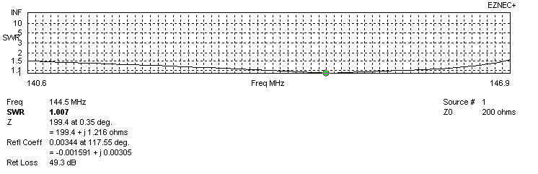
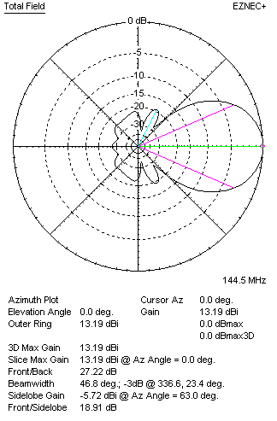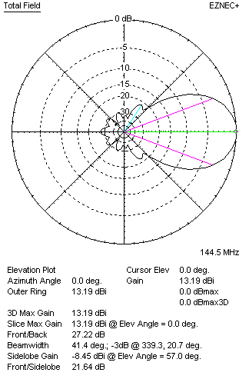

PERFORMANCES
 | TYPE | Condition | G  (dBi) | F/B  (dB) | F/Sh  (dBi) | F/Sv (dBi) | Hor  (◦) | Ver  (◦) | Temp (◦K) | G/T (dB) | B (MHz)  for SWR=1.5
 | Horizontal  part | No losss | 13.29 | 25.70 | 20.82 | 17.77 | 41.0 | 46.4 | 248.0 | -10.66 | 139.600 – 146.800
 | Horizontal  part | Aluminum | 13.24 | 25.56 | 20.79 | 17.75 | 41.0 | 46.2 | 248.6 | -10.71 | 139.600 – 146.800
 | Vertical  part | No losss | 13.24 | 27.40 | 18.91 | 21.67 | 46.8 | 41.4 | 240.1 | -10.56 | 140.600 – 146.850
 | Vertical  part | Aluminum | 13.19 | 27.22 | 18.91 | 21.82 | 46.8 | 41.4 | 240.8 | -10.63 | 140.600 – 146.850

