ANTENNA QY20806XL4D1
Good stacking characteristics at moderate vertical distances and any horizontal distances
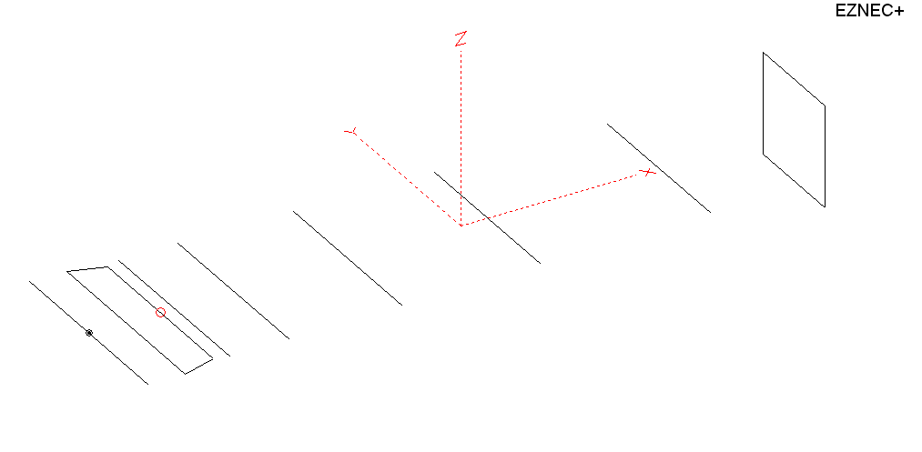
PERFORMANCES: (No loss condition)
TYPE | ELE | L (mm) | G (dBi) | F/B (dB) | F/Sh (dBi) | F/Sv (dBi) | Hor (◦) | Ver (◦) | Temp (◦K) | G/T (dB) | ΔF * (kHz)
QY20806XL4D1 | 8 | 3455 | 13.41 | 21.10 | 23.70 | 18.02 | 40.2 | 45.8 | 250.0 | -10.57 | 5850
* ΔF given for SWR=1,5

PERFORMANCES: (Loss included)
Element material | G (dBi) | Temp (◦K) | G/T (dB)
Aluminum rods | 13.34 | 250.8 | -10.65

DIMENSIONS:
 | Ref | De1 | De2 | D1 | D2 | D3 | D4 | D5 | DQ1 | REMARKS : -All elements made of Al rods Ǿ6 mm  - The height of the rectangle is 500 mm  - All dimensions given in milimetres
Pos | 0 | 180 | 350 | 418 | 709 | 1269 | 1954 | 2795 | 3455
Length | 1014 | 1010 | 914 | 948 | 954 | 926 | 904 | 882 | 522
Building hints: No boom correction included.

COMPARISON
Antenna | Boomlength (mm) | Material | Gain (dBi) | TA (◦K) | G/T (dB) | Bandwidth  (MHz)
QY20806XL4D1 | 3455 | No loss | 13.41 | 250.0 | -10.57 | 140.200- 146.150
QY20806XL4D1 | 3455 | Aluminum | 13.34 | 250.8 | -10.65 | 140.200- 146.150
EF0207-5 | 3274 | No loss | 12.95 | 255.9 | -11.13 | 140.400- 145.100
EF0207-5 | 3274 | Aluminum | 12.85 | 256.8 | -11.25 | 140.400- 145.100
EF0208-5 | 3880 | No loss | 13.52 | 248.2 | -10.43 | 144.220-145.490
EF0208-5 | 3880 | Aluminum | 13.45 | 249.2 | -10.51 | 144.220-145.490
G0KSC  8 EURO | 3729 | No loss | 13.35 | 236.5 | -10.39 | 141.600-145.450
G0KSC  8 EURO | 3729 | Aluminum | 13.28 | 237.4 | -10.47 | 141.600-145.450

DIAGRAMS (no loss included)
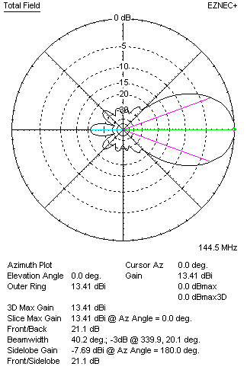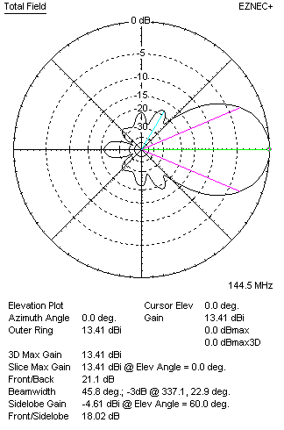
DIAGRAMS (loss included)
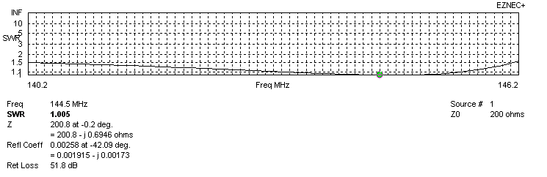
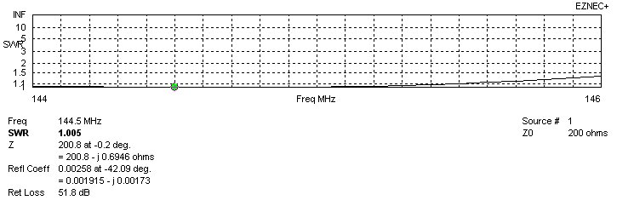
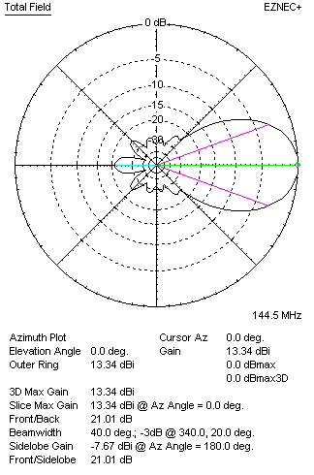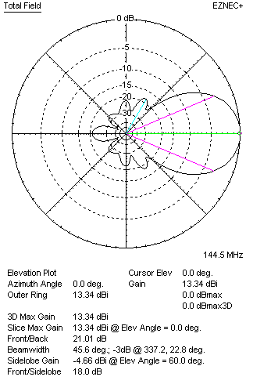
STACKING

ANTENNA QY20806XL4D1
(including loss for aluminum – AGT = -0.08 dB)
VERTICAL  DISTANCE (cm) | G  (dB) | TA  (°K) | G/T  (dB) | HORIZONTAL  DISTANCE (cm) | G  (dB) | TA  (°K) | G/T  (dB)
100 | 14.63 | 233.3 | -9.05 | 100
110 | 14.78 | 228.3 | -8.81 | 110
120 | 14.92 | 225.7 | -8.62 | 120 | 14.33 | 266.1 | -9.92
130 | 15.04 | 225.4 | -8.49 | 130 | 14.61 | 258.4 | -9.51
140 | 15.15 | 226.0 | -8.39 | 140 | 14.81 | 253.0 | -9.22
150 | 15.25 | 226.4 | -8.30 | 150 | 14.96 | 249.4 | -9.01
160 | 15.35 | 226.9 | -8.21 | 160 | 15.10 | 247.2 | -8.83
170 | 15.44 | 228.6 | -8.15 | 170 | 15.22 | 246.0 | -8.69
180 | 15.53 | 230.8 | -8.10 | 180 | 15.34 | 245.5 | -8.56
190 | 15.61 | 232.3 | -8.05 | 190 | 15.44 | 245.7 | -8.46
200 | 15.71 | 232.5 | -7.96 | 200 | 15.54 | 246.2 | -8.37
210 | 15.81 | 232.1 | -7.85 | 210 | 15.64 | 247.0 | -8.29
220 | 15.91 | 231.8 | -7.74 | 220 | 15.73 | 247.9 | -8.21
230 | 16.00 | 232.3 | -7.66 | 230 | 15.81 | 248.8 | -8.15
240 | 16.09 | 233.7 | -7.60 | 240 | 15.90 | 249.7 | -8.07
250 | 16.16 | 236.3 | -7.57 | 250 | 15.97 | 250.5 | -8.02
260 | 16.23 | 239.7 | -7.57 | 260 | 16.05 | 251.2 | -7.95
270 | 16.28 | 243.7 | -7.59 | 270 | 16.11 | 251.7 | -7.90
280 | 16.33 | 248.0 | -7.61 | 280 | 16.17 | 252.2 | -7.85
290 |  |  |  | 290 | 16.22 | 252.4 | -7.80
300 |  |  |  | 300 | 16.26 | 252.6 | -7.76
310 |  |  |  | 310 | 16.29 | 252.7 | -7.74
320 |  |  |  | 320 | 16.32 | 252.7 | -7.71
330 |  |  |  | 330 | 16.35 | 252.6 | -7.67
340 |  |  |  | 340 | 16.36 | 252.6 | -7.66
350 |  |  |  | 350 | 16.38 | 252.5 | -7.64
360 |  |  |  | 360 | 16.39 | 252.4 | -7.63
370 |  |  |  | 370 | 16.39 | 252.3 | -7.63

TWO ANTENNAS VERTICALLY STACKED AT 250CM
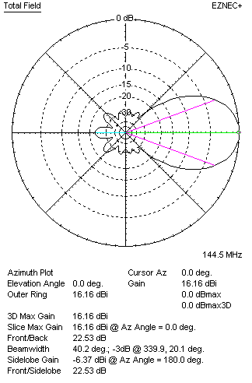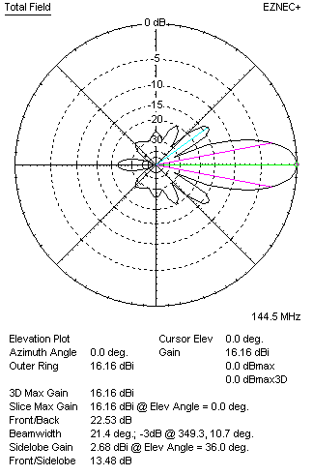
Performances
TYPE | Condition | G  (dBi) | F/B  (dB) | F/Sh  (dBi) | F/Sv (dBi) | Hor  (◦) | Ver  (◦) | Temp (◦K) | G/T (dB) | B (MHz)  for SWR=1.5
QY20806XL4D1 | No losss | 16.24 | 22.65 | 26.70 | 13.45 | 40.2 | 21.4 | 235.2 | -7.48 | 140.200- 146.150
QY20806XL4D1 | Aluminum | 16.16 | 22.53 | 26.67 | 13.48 | 40.2 | 21.4 | 236.3 | -7.57 | 140.200- 146.150

FOUR ANTENNAS VERTICALLY STACKED AT 250+250+250CM
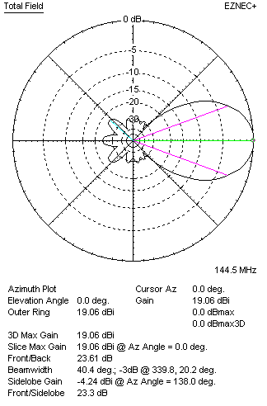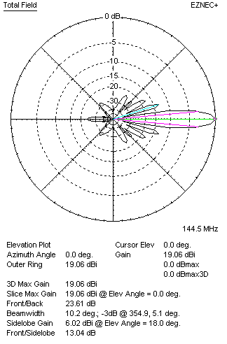
Performances
TYPE | Condition | G  (dBi) | F/B  (dB) | F/Sh  (dBi) | F/Sv (dBi) | Hor  (◦) | Ver  (◦) | Temp (◦K) | G/T (dB) | B (MHz)  for SWR=1.5
4xQY20806XL4D1 | No losss | 19.14 | 23.75 | 29.27 | 13.04 | 40.4 | 10.2 | 226.6 | -4.41 | 140.200- 146.150
4xQY20806XL4D1 | Aluminum | 19.06 | 23.61 | 29.22 | 13.04 | 40.4 | 10.2 | 227.9 | -4.52 | 140.200- 146.150

FOUR ANTENNAS IN H- STACK, H=320 CM, V=230 CM, LOSS INCLUDED FOR ALUMINUM
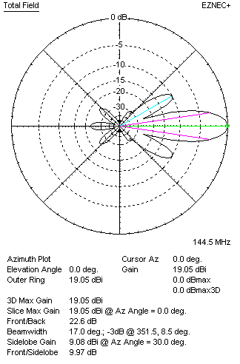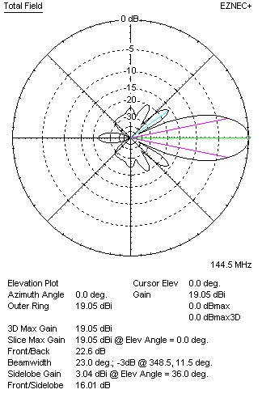
Performances
TYPE | Condition | G  (dBi) | F/B  (dB) | F/Sh  (dBi) | F/Sv (dBi) | Hor  (◦) | Ver  (◦) | Temp (◦K) | G/T (dB) | B (MHz)  for SWR=1.5
4xQY20806XL4D1 | No losss | 19.13 | 22.73 | 9.95 | 15.97 | 17.0 | 23.0 | 231.0 | -4.51 | 140.200- 146.150
4xQY20806XL4D1 | Aluminum | 19.05 | 22.60 | 9.97 | 16.01 | 17.0 | 23.0 | 232.1 | -4.61 | 140.200- 146.150

X POL VERSION
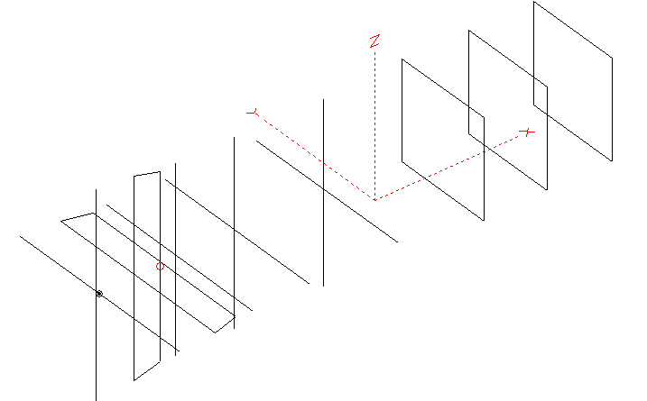
Horizontal components: Same as above
Vertical components: Same as above, except:
- All vertical yagi elements positioned 20 mm back regarding horizontals.
- All crossed elements must cross each other in their centerlines

HORIZONTAL PERFORMANCES
Everything as the above data

VERTICAL PERFORMANCES with no corrections
Loss included condition (for Aluminum)
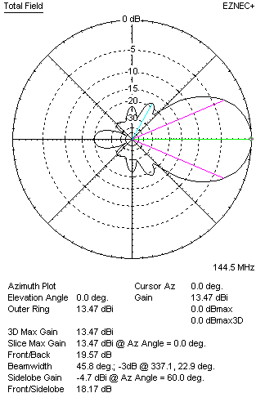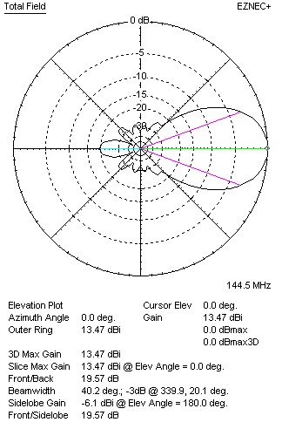

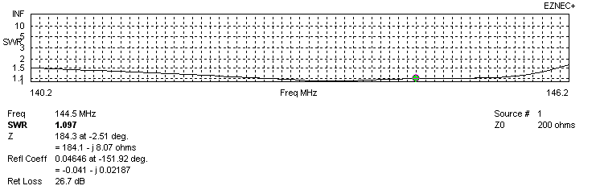
VERTICAL PERFORMANCES after corrections
If you want to get better SWR diagram for vertical antenna you can do the following:
- Change length of DE1 from 1010 to 1014 mm
- Change length of DE2 from 900 to 904 mm
- Change position of D1 for +3 mm
- Change position of D5 for -15 mm

In this case the SWR diagram will be like this:

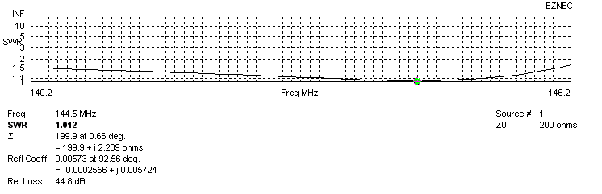
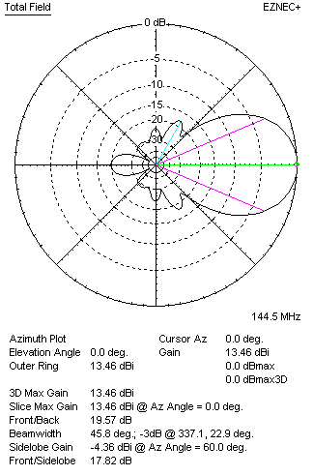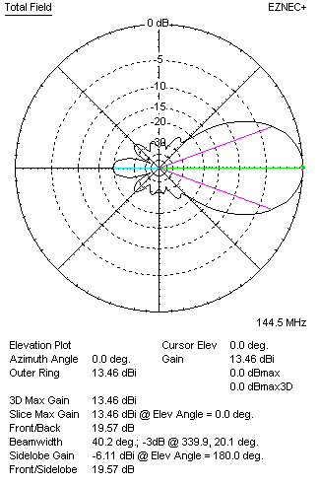

PERFORMANCES
 | TYPE | Condition | G  (dBi) | F/B  (dB) | F/Sh  (dBi) | F/Sv (dBi) | Hor  (◦) | Ver  (◦) | Temp (◦K) | G/T (dB) | B (MHz)  for SWR=1.5
 | Horizontal  part | No losss | 13.41 | 21.10 | 23.70 | 18.02 | 40.2 | 45.8 | 250.0 | -10.57 | 140.200 - 146.150
 | Horizontal  part | Aluminum | 13.34 | 21.01 | 23.65 | 18.00 | 40.0 | 45.6 | 250.8 | -10.65 | 140.200 - 146.150
 | Vertical  part | No losss | 13.54 | 19.65 | 17.85 | 23.72 | 45.8 | 40.2 | 234.6 | -10.16 | 140.200 – 146.050
 | Vertical  part | Aluminum | 13.46 | 19.57 | 17.82 | 23.67 | 45.8 | 40.2 | 235.7 | -10.26 | 140.200 – 146.050

