ANTENNA QY20805XL4D3
The antenna with extremly big working bandwidth. Good for stacking at small vertical distances
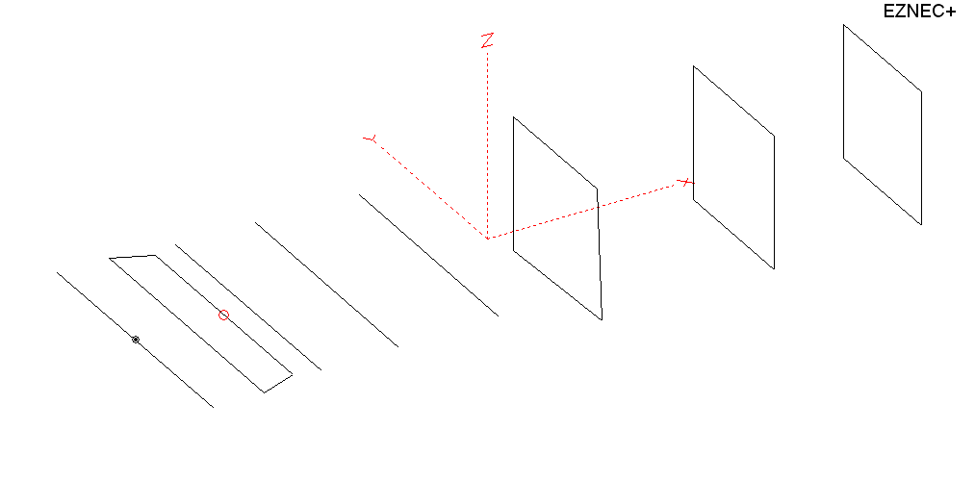
PERFORMANCES: (No loss condition)
TYPE | ELE | L (mm) | G (dBi) | F/B (dB) | F/Sh (dBi) | F/Sv (dBi) | Hor (◦) | Ver (◦) | Temp (◦K) | G/T (dB) | ΔF * (kHz)
QY20805XL4D3 | 8 | 2785 | 12.58 | 20.68 | 23.01 | 17.17 | 44.6 | 50.8 | 262.0 | -11.60 | 7400
* ΔF given for SWR=1,5

PERFORMANCES: (Loss included for aluminum)
Element material | G (dBi) | Temp (◦K) | G/T (dB)
Aluminum rods | 12.53 | 262.4 | -11.66

COMPARISON
Antenna | Boomlength (mm) | Material | Gain  (dBi) | TA  (◦K) | G/T  (dB) | Bandwidth  (MHz)
QY20805XL443 | 2390 | No loss | 12.58 | 262.0 | -11.60 | 141.000 – 148.400
QY20805XL443 | 2390 | Aluminum | 12.53 | 262.4 | -11.66 | 141.000 – 148.400
G0KSC  6 ELE EU | 2349 | No loss | 12.01 | 272.1 | -12.34 | 141.100 - 145.750
G0KSC  6 ELE EU | 2349 | Aluminum | 11.96 | 272.3 | -12.39 | 141.100 - 145.750
EF0206-5 | 2377 | No loss | 11.91 | 283.0 | -12.61 | 140.200 - 145.300
EF0206-5 | 2377 | Aluminum | 11.84 | 283.3 | -12.68 | 140.200 - 145.300

DIMENSIONS:
 | Ref | De1 | De2 | D1 | D2 | D3 | DQ1 | DQ2 | DQ3 | REMARKS: - All elements made of Al rods Ǿ5 mm  - Height of all rectangles 500 mm  - All dimensions given in milimetres
Pos | 0 | 190 | 320 | 414 | 689 | 1055 | 1565 | 2227 | 2785
Length | 1024 | 1010 | 870 | 942 | 930 | 910 | 524 | 514 | 498
Building hints: No boom correction included.

DIAGRAMS (no loss included)
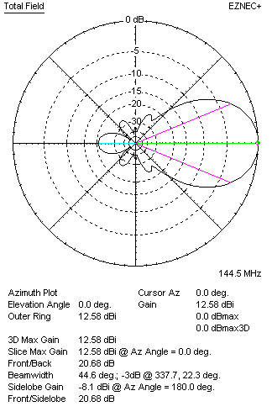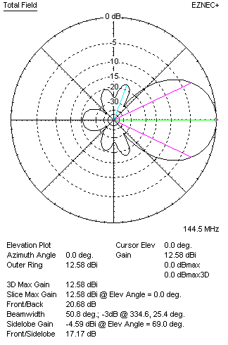
DIAGRAMS (loss included)
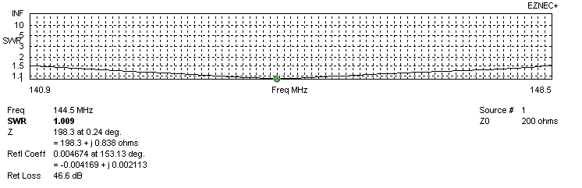
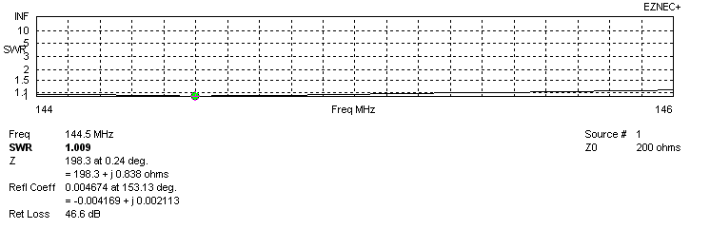
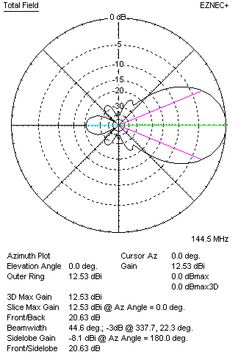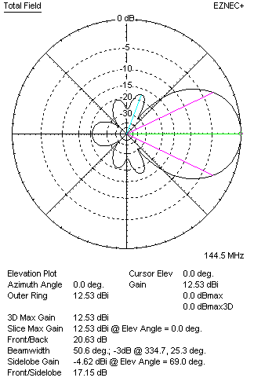
STACKING

QY20805XL4D3 - STACKING TABLE
(including loss for aluminum – AGT = -0.05 dB)
VERTICAL  DISTANCE  (cm) | G  (dBi) | TA  (°K) | G/T  (dB) | HORIZONTAL  DISTANCE  (cm) | G  (dB) | TA  (°K) | G/T  (dB)
100 | 14.05 | 230.3 | -9.57 | 100
110 | 14.19 | 228.0 | -9.39 | 110
120 | 14.31 | 228.3 | -9.28 | 120 | 13.95 | 258.4 | -10.17
130 | 14.41 | 230.7 | -9.22 | 130 | 14.11 | 255.1 | -9.96
140 | 14.49 | 233.7 | -9.20 | 140 | 14.25 | 253.7 | -9.79
150 | 14.57 | 235.4 | -9.15 | 150 | 14.37 | 253.7 | -9.67
160 | 14.66 | 236.1 | -9.07 | 160 | 14.49 | 254.6 | -9.57
170 | 14.73 | 237.3 | -9.02 | 170 | 14.59 | 256.1 | -9.49
180 | 14.81 | 238.7 | -8.97 | 180 | 14.69 | 258.0 | -9.43
190 | 14.89 | 239.5 | -8.90 | 190 | 14.79 | 260.0 | -9.36
200 | 14.98 | 239.6 | -8.82 | 200 | 14.89 | 261.9 | -9.29
210 | 15.08 | 239.6 | -8.71 | 210 | 14.98 | 263.7 | -9.23
220 | 15.19 | 240.0 | -8.61 | 220 | 15.07 | 265.2 | -9.17
230 | 15.28 | 241.7 | -8.55 | 230 | 15.15 | 266.4 | -9.11
240 | 15.37 | 244.5 | -8.51 | 240 | 15.23 | 267.3 | -9.04
250 | 15.44 | 248.4 | -8.51 | 250 | 15.30 | 267.8 | -8.98
260 | 15.50 | 253.1 | -8.53 | 260 | 15.36 | 268.1 | -8.92
270 | 15.55 | 258.2 | -8.57 | 270 | 15.42 | 268.1 | -8.86
280 | 15.59 | 263.4 | -8.62 | 280 | 15.46 | 267.9 | -8.82
290 |  |  |  | 290 | 15.50 | 267.5 | -8.77
300 |  |  |  | 300 | 15.53 | 267.0 | -8.74
310 |  |  |  | 310 | 15.55 | 266.4 | -8.71
320 |  |  |  | 320 | 15.57 | 265.8 | -8.67
330 |  |  |  | 330 | 15.58 | 265.1 | -8.65
340 |  |  |  | 340 | 15.59 | 264.4 | -8.63
350 |  |  |  | 350 | 15.60 | 263.7 | -8.61
360 |  |  |  | 360 | 15.60 | 263.1 | -8.60

TWO ANTENNAS VERTICALLY STACKED AT 240CM
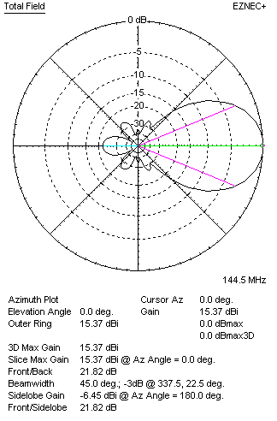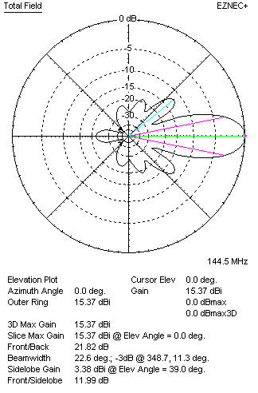
Performances
TYPE | Condition | G  (dBi) | F/B  (dB) | F/Sh  (dBi) | F/Sv (dBi) | Hor  (◦) | Ver  (◦) | Temp (◦K) | G/T (dB) | B (MHz)  for SWR=1.5
QY20805XL4D3 | No losss | 15.42 | 21.89 | 26.31 | 12.08 | 45.0 | 22.6 | 243.9 | -8.45 | 141.000–148.400
QY20805XL4D3 | Aluminum | 15.37 | 21.82 | 26.25 | 11.99 | 45.0 | 22.6 | 244.5 | -8.51 | 141.000–148.400

FOUR ANTENNAS VERTICALLY STACKED AT 250+250+250CM
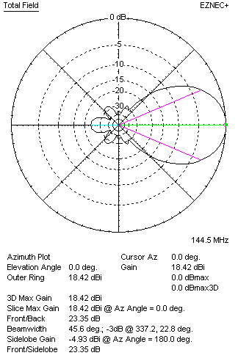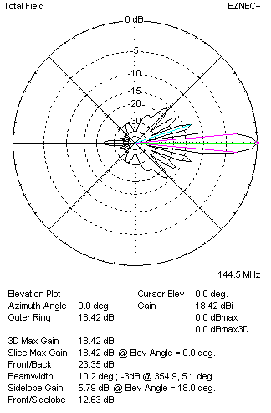
Performances
TYPE | Condition | G  (dBi) | F/B  (dB) | F/Sh  (dBi) | F/Sv (dBi) | Hor  (◦) | Ver  (◦) | Temp (◦K) | G/T (dB) | B (MHz)  for SWR=1.5
4xQY20805XL4D3 | No losss | 18.46 | 23.42 | 28.22 | 12.53 | 45.8 | 12.62 | 232.9 | -5.21 | 141.000–148.400
4xQY20805XL4D3 | Aluminum | 18.42 | 23.35 | 28.18 | 12.63 | 45.6 | 12.63 | 233.6 | -5.26 | 141.000–148.400

FOUR ANTENNAS IN H- STACK, H=340CM, V=240 CM, LOSS INCLUDED FOR ALUMINUM
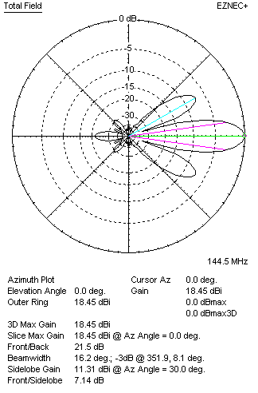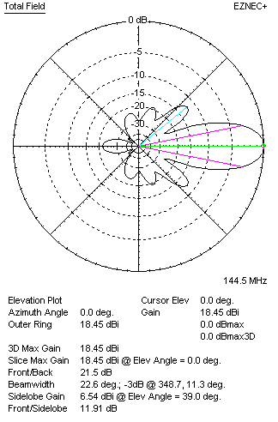
Performances
TYPE | Condition | G  (dBi) | F/B  (dB) | F/Sh  (dBi) | F/Sv (dBi) | Hor  (◦) | Ver  (◦) | Temp (◦K) | G/T (dB) | B (MHz)  for SWR=1.5
4xQY20805XL4D3 | No losss | 18.50 | 21.56 | 7.13 | 11.89 | 16.2 | 22.6 | 246.3 | -5.42 | 141.000 – 148.400
4xQY20805XL4D3 | Aluminum | 18.45 | 21.50 | 7.14 | 11.91 | 16.2 | 22.6 | 246.9 | -5.48 | 141.000 – 148.400

EIGHT ANTENNAS IN H- STACK, H=340 CM, V=240+240+240 CM, LOSS INCLUDED FOR ALUMINUM
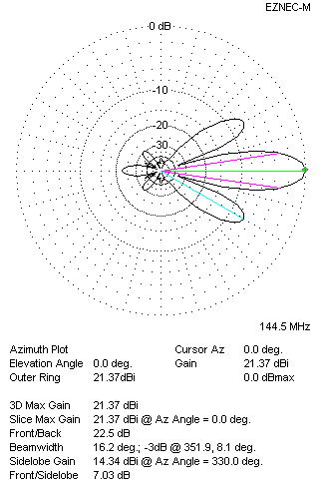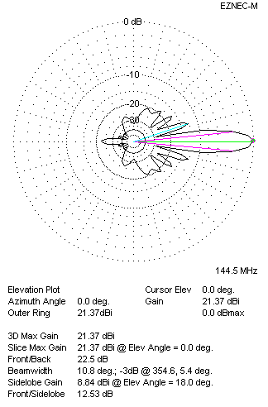
Performances
TYPE | Condition | G  (dBi) | F/B  (dB) | F/Sh  (dBi) | F/Sv (dBi) | Hor  (◦) | Ver  (◦) | Temp (◦K) | G/T (dB) | B (MHz)  for SWR=1.5
8xQY20805XL4D3 | No losss | 21.42 | 22.57 | 7.02 | 12.52 | 16.2 | 10.8 | 235.7 | -2.3 | 141.000 – 148.400
8xQY20805XL4D3 | Aluminum | 21.37 | 22.50 | 7.03 | 12.53 | 16.2 | 10.8 | 236.4 | -2.37 | 141.000 – 148.400

XPOL VERSION
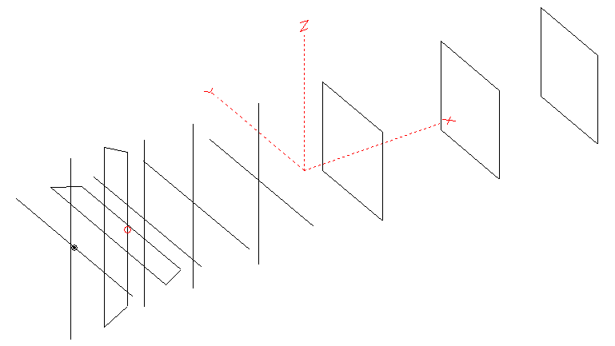
Horizontal components: Same as above
Vertical components: Same as above, except:
- All vertical yagi elements positioned 20 mm back regarding horizontals.
- All crossed elements must cross each other in their centerlines
HORIZONTAL PERFORMANCES
Everything as the above data

VERTICAL PERFORMANCES with no corrections
Loss included condition (for Aluminum)

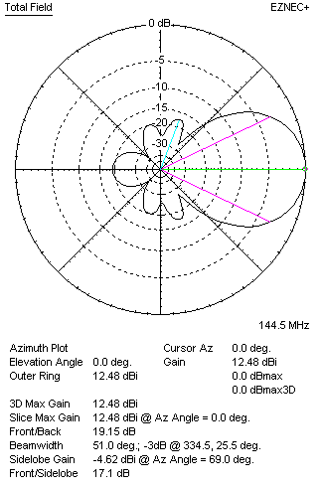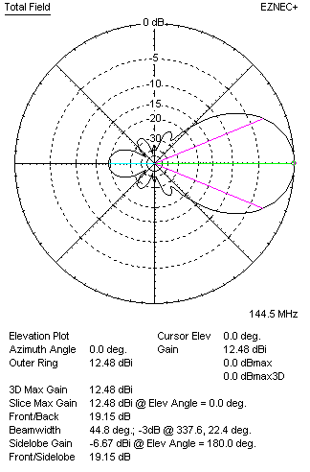
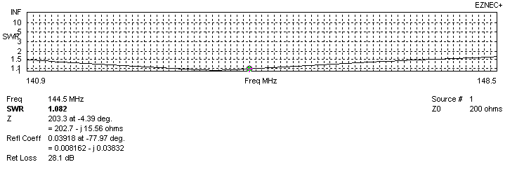

VERTICAL PERFORMANCES after corrections
If you want to get better SWR diagram for vertical antenna you can do the following:
- To change position of D1 for +6 mm
In this case the SWR diagram will be like this:
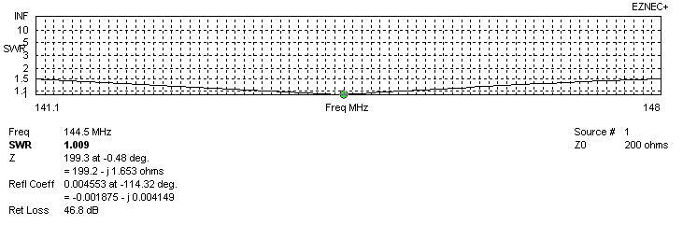
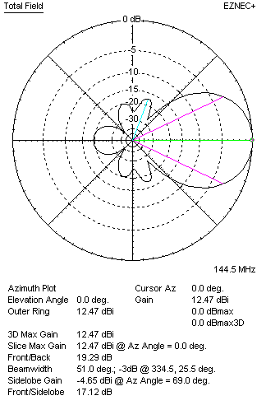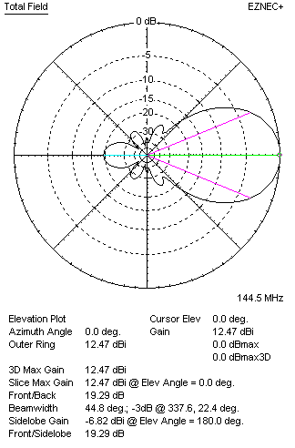
PERFORMANCES
TYPE | Condition | G  (dBi) | F/B  (dB) | F/Sh  (dBi) | F/Sv (dBi) | Hor  (◦) | Ver  (◦) | Temp (◦K) | G/T (dB) | B (MHz)  for SWR=1.5
Horizontal  part | No losss | 12.58 | 20.68 | 23.01 | 17.17 | 44.6 | 50.8 | 262.0 | -11.60 | 141.000 – 148.400
Horizontal  part | Aluminum | 12.53 | 20.63 | 23.03 | 17.15 | 44.6 | 50.8 | 262.4 | -11.66 | 141.000 – 148.400
Vertical  part | No losss | 12.52 | 19.34 | 17.13 | 23.63 | 51.0 | 44.8 | 251.6 | -11.49 | 141.100 – 148.000
Vertical  part | Aluminum | 12.47 | 19.29 | 17.12 | 23.59 | 51.0 | 44.8 | 252.3 | -11.55 | 141.100 – 148.000

