ANTENNA QY20706XL7D2
Good stacking characteristics at small vertical distances and any horizontal distances
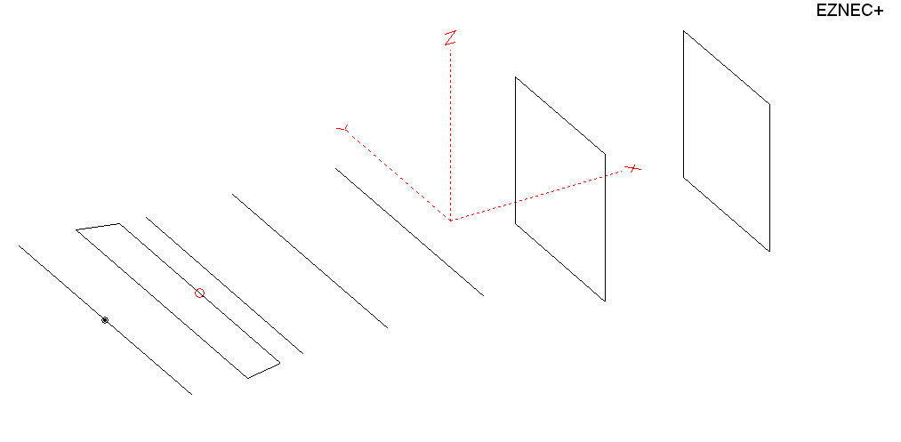
PERFORMANCES: (No loss condition)
TYPE | ELE | L (mm) | G (dBi) | F/B (dB) | F/Sh (dBi) | F/Sv (dBi) | Hor (◦) | Ver (◦) | Temp (◦K) | G/T (dB) | ΔF * (kHz)
QY20706XL7D2 | 7 | 2110 | 11,67 | 20.76 | 24.76 | 20,83 | 48,4 | 57,8 | 285.7 | -12,89 | 8600
* ΔF given for SWR=1,5

PERFORMANCES: (Loss included)
Element material | G (dBi) | Temp (◦K) | G/T (dB)
Aluminum rods | 11,64 | 284.7 | -12,90

DIMENSIONS:
 | Ref | De1 | De2 | D1 | D2 | D3 | DQ1 | DQ2 |  | REMARKS: -All elements made of Al rods Ǿ6 mm  - The height of the rectangle is 500 mm  - All dimensions given in milimetres
Pos | 0 | 190 | 320 | 405 | 695 | 1035 | 1555 | 2110
Length | 1024 | 1010 | 930 | 938 | 928 | 902 | 524 | 504
Building hints: No boom correction included.

COMPARISON
Antenna | Boomlength (mm) | Material | Gain (dBi) | TA (◦K) | G/T (dB) | Bandwidth  (MHz)
QY20706XL7D2 | 2110 | No loss | 11,67 | 285.7 | -12,89 | 138.900- 147.500
QY20706XL7D2 | 2110 | Aluminum | 11,64 | 284.7 | -12,90 | 138.900- 147.500
EF0206-5 | 2377 | No loss | 11,91 | 283,0 | -12,61 | 140,200 - 145,300
EF0206-5 | 2377 | Aluminum | 11,84 | 283,3 | -12,68 | 140,200 - 145,300
G0KSC  6ELE EU | 2349 | No loss | 12,01 | 272,1 | -12,34 | 141,100 - 145,750
G0KSC  6ELE EU | 2349 | Aluminum | 11,96 | 272,3 | -12,39 | 141,100 - 145,750

DIAGRAMS (no loss included)
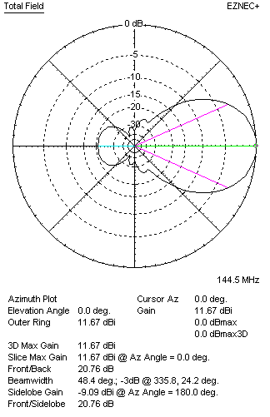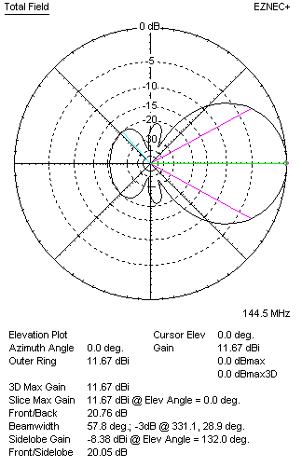
DIAGRAMS (loss included)
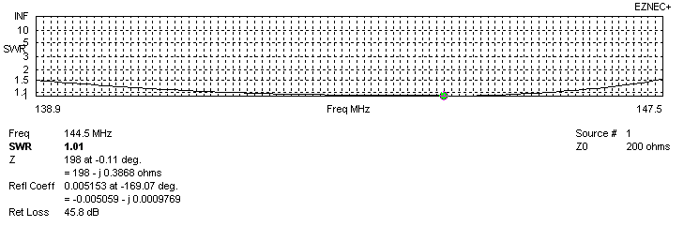
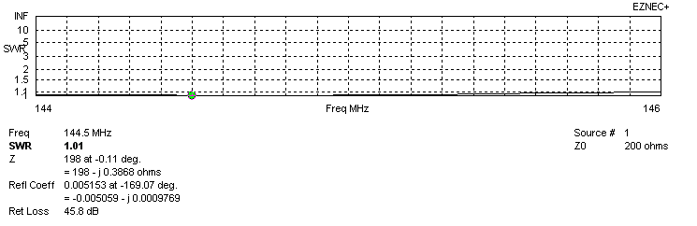
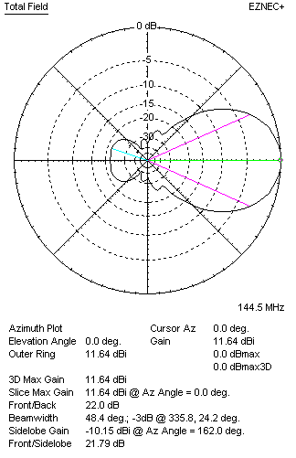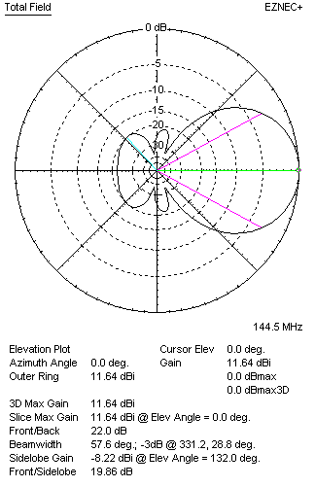

QY20706XL7D2 – STACKING TABLE
(including loss for aluminum – AGT = -0.05 to -0.04 dB)
VERTICAL  DISTANCE (cm) | G  (dB) | TA  (°K) | G/T  (dB) | HORIZONTAL  DISTANCE (cm) | G  (dB) | TA  (°K) | G/T  (dB)
100 | 13.33 | 236.8 | -10.41 | 100
110 | 13.47 | 233.7 | -10.22 | 110 | 12.95 | 282.3 | -11.56
120 | 13.60 | 232.7 | -10.07 | 120 | 13.16 | 277.5 | -11.27
130 | 13.72 | 233.5 | 9.96 | 130 | 13.33 | 275.0 | -11.06
140 | 13.83 | 234.4 | -9.87 | 140 | 13.48 | 274.2 | -10.90
150 | 13.93 | 233.6 | -9.76 | 150 | 13.62 | 274.6 | -10.77
160 | 14.04 | 231.8 | -9.61 | 160 | 13.75 | 276.0 | -10.66
170 | 14.15 | 231.1 | -9.49 | 170 | 13.87 | 277.9 | -10.57
180 | 14.25 | 232.1 | -9.41 | 180 | 13.98 | 280.0 | -10.49
190 | 14.35 | 234.5 | -9.35 | 190 | 14.08 | 282.2 | -10.43
200 | 14.44 | 238.2 | -9.33 | 200 | 14.18 | 284.3 | -10.36
210 | 14.51 | 243.3 | -9.35 | 210 | 14.28 | 286.0 | -10.28
220 | 14.58 | 249.8 | -9.40 | 220 | 14.36 | 287.5 | -10.23
230 | 14.63 | 257.4 | -9.48 | 230 | 14.44 | 288.5 | -10.16
240 | 14.67 | 265.9 | -9.58 | 240 | 14.50 | 289.2 | -10.11
250 | 14.70 | 274.6 | -9.69 | 250 | 14.56 | 289.6 | -10.06
260 |  |  |  | 260 | 14.60 | 289.7 | -10.02
270 |  |  |  | 270 | 14.64 | 289.5 | -9.98
280 |  |  |  | 280 | 14.66 | 289.2 | -9.95
290 |  |  |  | 290 | 14.68 | 288.7 | -9.92
300 |  |  |  | 300 | 14.70 | 288.1 | -9.90
310 |  |  |  | 310 | 14.71 | 287.5 | -9.88
320 |  |  |  | 320 | 14.71 | 286.8 | -9.87
330 |  |  |  | 330 | 14.71 | 286.2 | -9.86
340 |  |  |  | 340 | 14.71 | 285.6 | -9.85
350 |  |  |  | 350 | 14.70 | 285.0 | -9.85
360 |  |  |  | 360 | 14.70 | 284.6 | -9.84
370 |  |  |  | 370 | 14.69 | 284.2 | -9.85

FOUR ANTENNAS IN H STACK
Recommended stacking distances: 340 cm horizontally and 198 cm vertically
Antenna | Stacking distance |  | Material | Gain  (dBi) | TA  (◦K) | G/T  (dB)
Antenna | Horizontally | Vertically
QY20705XL7D2 | 340 cm | 198 cm | No loss | 17.54 | 236.1 | -6.19
QY20705XL7D2 | 340 cm | 198 cm | Aluminum | 17.50 | 236.8 | -6.24

X POL VERSION
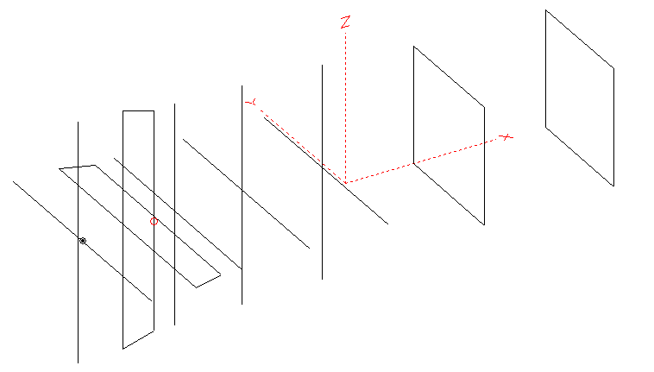
Horizontal components: Same as above
Vertical components: Same as above, except:
- All vertical yagi elements positioned 20 mm back regarding horizontals.
- All crossed elements must cross each other in their centerlines

HORIZONTAL PERFORMANCES
Everything as the above data

VERTICAL PERFORMANCES with no corrections
Loss included condition (for Aluminum)
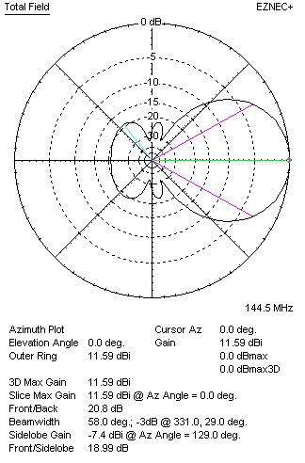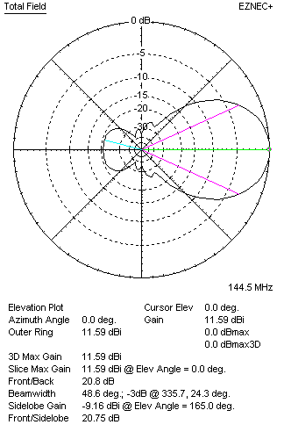

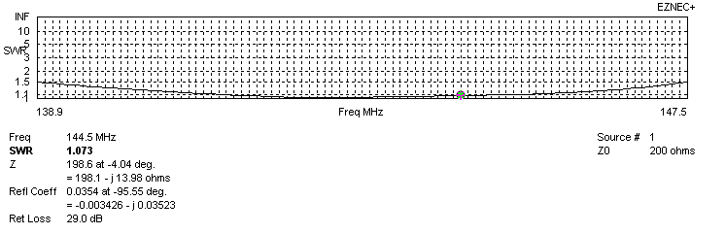
VERTICAL PERFORMANCES after corrections
If you want to get better SWR diagram for vertical antenna you can do the following:
- To change position of D1 for +5 mm
- To change length od DE2 from 930 to 938 mm
In this case the SWR diagram will be like this:
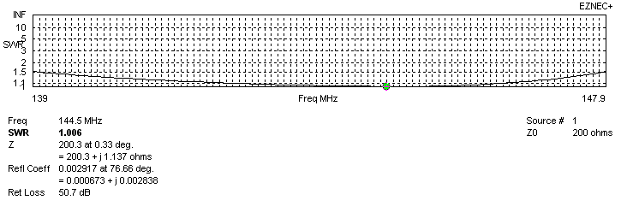
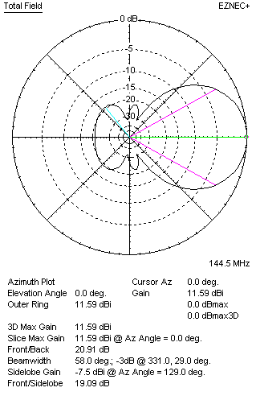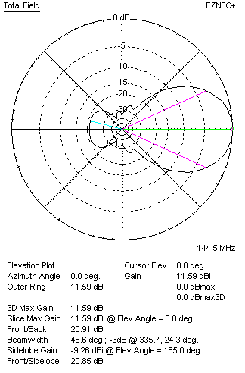

VERTICAL COMPONENT | Material | G (dB) | TA (°K) | G/T (dB)
VERTICAL COMPONENT | No loss | 11.62 | 269.0 | -12.68
VERTICAL COMPONENT | Aluminum | 11.59 | 269.3 | -12.71

