ANTENNA Q733D5XL
PERFORMANCES: (No loss condition)
TYPE | ELE | L (mm) | G (dBi) | F/B (dB) | F/Sh (dBi) | F/Sv (dBi) | Hor (◦) | Ver (◦) | Temp (◦K) | G/T (dB) | ΔF * (kHz)
Q733D5XL | 33 | 9035 | 20,90 | 56,91 | 20,70 | 19,93 | 18,4 | 18,6 | 16,0 | +8,87 | 7000
* ΔF given for SWR=1,5

PERFORMANCES: (Losses included)
Element material | G (dBi) | Temp (◦K) | G/T (dB)
Aluminum rods | 20,84 | 19,8 | +7,88
Silvered rods | 20,87 | 18,4 | +8,23

DIMENSIONS:
 | Ref | De | D1 | D2 | D3 | D4 | D5 | D6 | D7 | D8 | D9 | D10 | D11
Pos | 0 | 123 | 199 | 351 | 488 | 687 | 939 | 1226 | 1522 | 1825 | 2130 | 2449 | 2767
Length | 283 | 260 | 248 | 229 | 225 | 221 | 215 | 209 | 205 | 203 | 199 | 196 | 193
 | D12 | D13 | D14 | D15 | D16 | D17 | D18 | D19 | D20 | D21 | D22 | D23 | D24
Pos | 3089 | 3409 | 3733 | 4062 | 4382 | 4715 | 5045 | 5363 | 5685 | 5996 | 6319 | 6632 | 6935
Length | 191 | 189 | 186 | 184 | 182 | 180 | 180 | 180 | 180 | 176 | 176 | 176 | 176
 | D25 | D26 | D27 | D28 | D29 | D30 | D31 | - All elements made of Al rods Ǿ8,0 mm  - The height of all rectangles is 100 mm  - All dimensions given in milimetres
Pos | 7245 | 7555 | 7859 | 8158 | 8467 | 8765 | 9035
Length | 171 | 171 | 171 | 171 | 171 | 170 | 168

COMPARISON
Antenna | Boomlength (mm) | Material | Gain (dBi) | TA (◦K) | G/T (dB) | Bandwidth  (MHz)
Q733D5XL | 9035 | No loss | 20,90 | 16,0 | +8,87 | 427,500-434,500
Q733D5XL | 9035 | Aluminum | 20,84 | 19,8 | +7,88 | 427,500-434,500
Q733D5XL | 9035 | Silver | 20,87 | 18,4 | +8,23 | 427,500-434,500
NO REFERENCE TO COMPARE |  | No loss
 |  | Aluminum
 |  | Silver

DIAGRAMS
NO LOSS INCLUDED
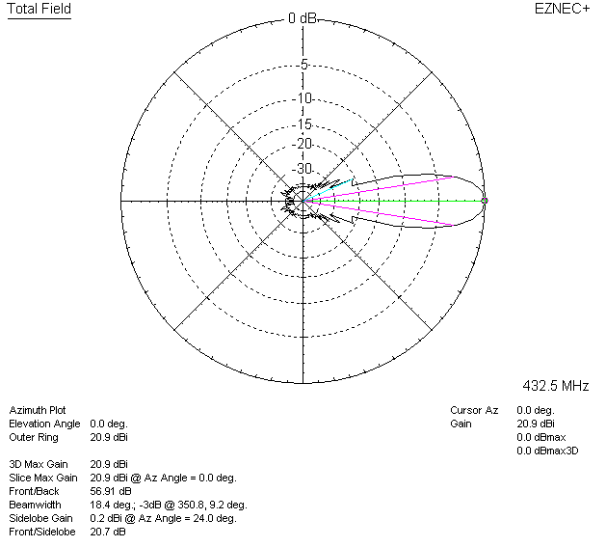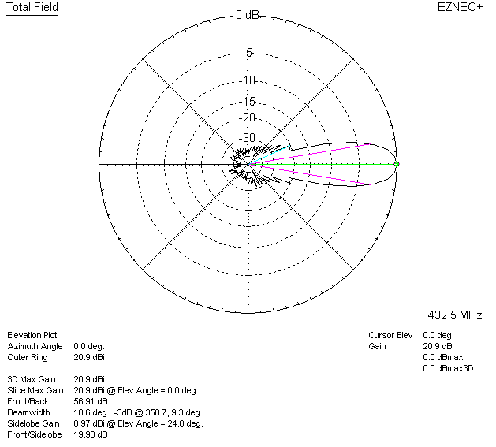

LOSSES INCLUDED (aluminum)
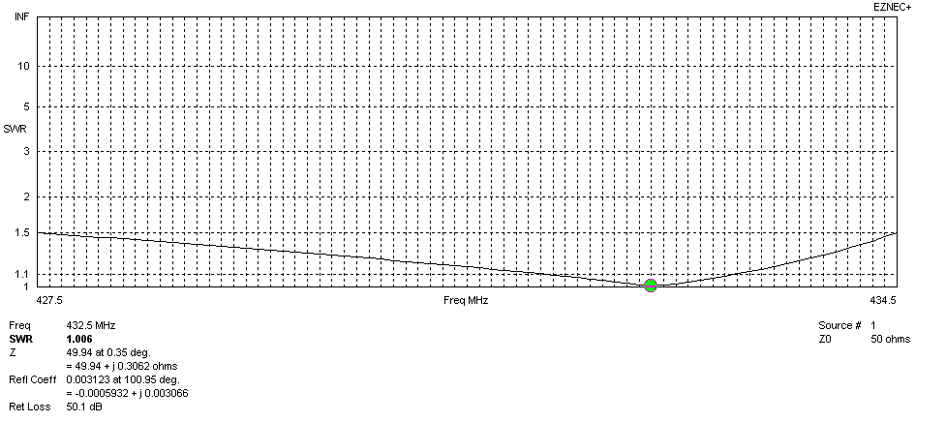
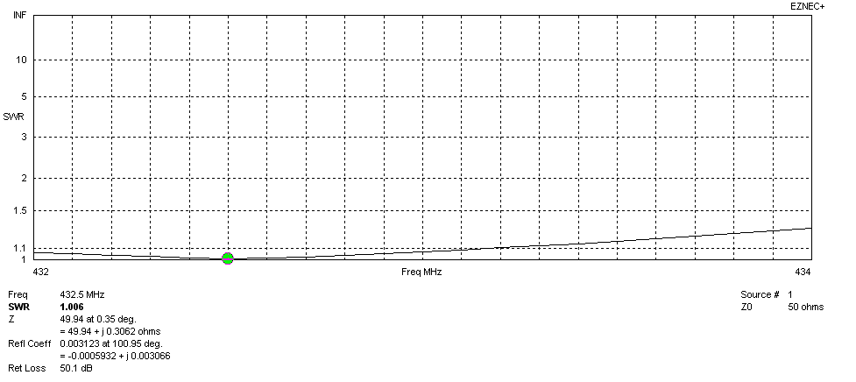
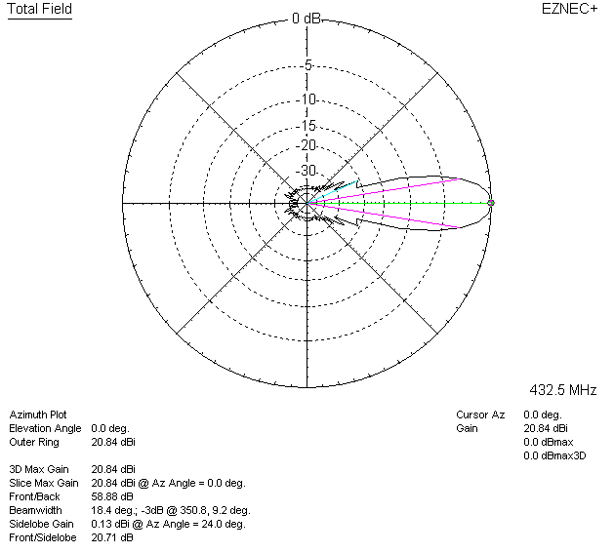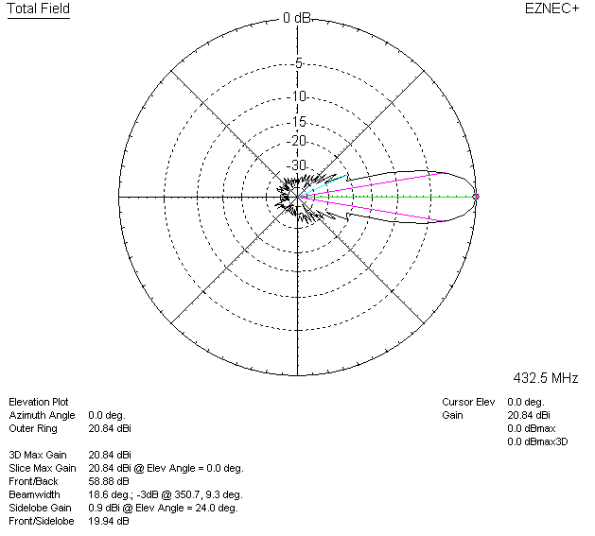

LOSSES INCLUDED (silver)
