ANTENNA Q731D9XL
PERFORMANCES: (No loss condition)
TYPE | ELE | L (mm) | G (dBi) | F/B (dB) | F/Sh (dBi) | F/Sv (dBi) | Hor (◦) | Ver (◦) | Temp (◦K) | G/T (dB) | ΔF * (kHz)
Q731D9XL | 31 | 8440 | 20,39 | 35,81 | 21,11 | 20,25 | 19,6 | 19,8 | 15,6 | +8,45 | 6750
* ΔF given for SWR=1,5

PERFORMANCES: (Losses included)
Element material | G (dBi) | Temp (◦K) | G/T (dB)
Aluminum rods | 20,35 | 18,2 | +7,76
Silvered rods | 20,36 | 17,2 | +8,00

DIMENSIONS:
 | Ref | De | D1 | D2 | D3 | D4 | D5 | D6 | D7 | D8 | D9 | D10 | D11
Pos | 0 | 116 | 199 | 349 | 484 | 689 | 942 | 1222 | 1519 | 1829 | 2139 | 2458 | 2775
Length | 284 | 257 | 245 | 223 | 219 | 217 | 213 | 207 | 202 | 196 | 194 | 191 | 188
 | D12 | D13 | D14 | D15 | D16 | D17 | D18 | D19 | D20 | D21 | D22 | D23 | D24
Pos | 3096 | 3427 | 3746 | 4072 | 4403 | 4728 | 5047 | 5369 | 5699 | 6028 | 6327 | 6645 | 6957
Length | 184 | 182 | 181 | 180 | 175 | 175 | 173 | 171 | 170 | 169 | 168 | 167 | 166
 | D25 | D26 | D27 | D28 | D29 | - All elements made of Al rods Ǿ10,0 mm  - The height of all rectangles is 100 mm  - All dimensions given in milimetres
Pos | 7268 | 7567 | 7855 | 8165 | 8440
Length | 164 | 164 | 162 | 162 | 155

COMPARISON
Antenna | Boomlength (mm) | Material | Gain (dBi) | TA (◦K) | G/T (dB) | Bandwidth  (MHz)
Q731D9XL | 8440 | No loss | 20,39 | 15,6 | +8,45 | 428,100-434,850
Q731D9XL | 8440 | Aluminum | 20,35 | 18,2 | +7,76 | 428,100-434,850
Q731D9XL | 8440 | Silver | 20,36 | 17,2 | +8,00 | 428,100-434,850
EF7032-5 | 8670 | No loss | 19,93 | 19,9 | +6,94 | 429,700-433,980
EF7032-5 | 8670 | Aluminum | 19,85 | 25,5 | +5,78 | 429,700-433,980
EF7032-5 | 8670 | Silver | 19,88 | 23,3 | +6,20 | 429,700-433,980

DIAGRAMS
NO LOSS INCLUDED
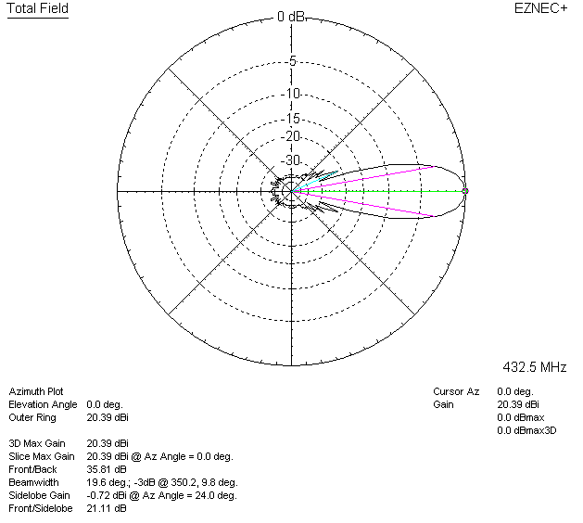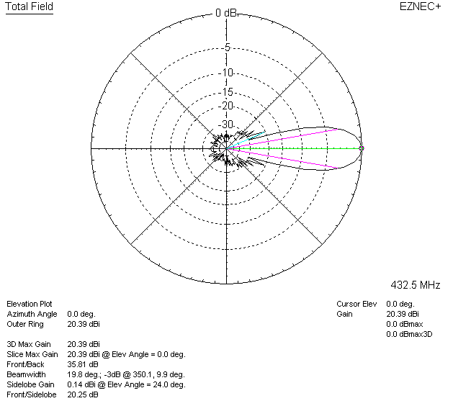

LOSSES INCLUDED (aluminum)
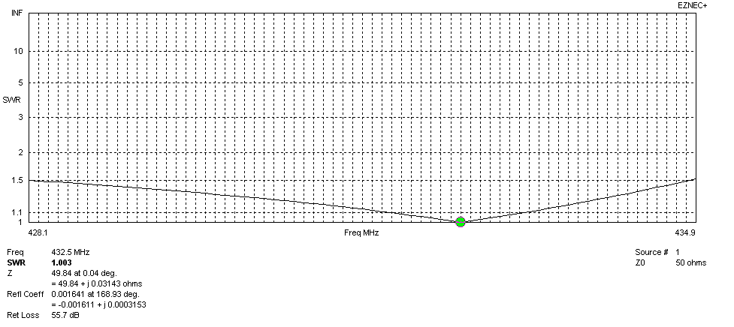
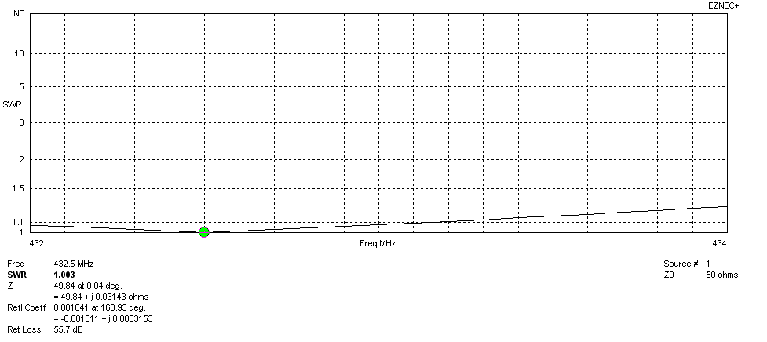
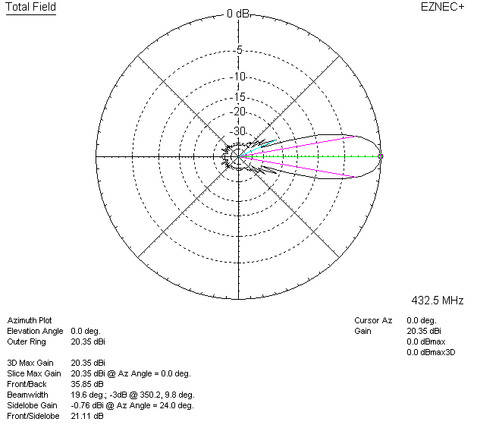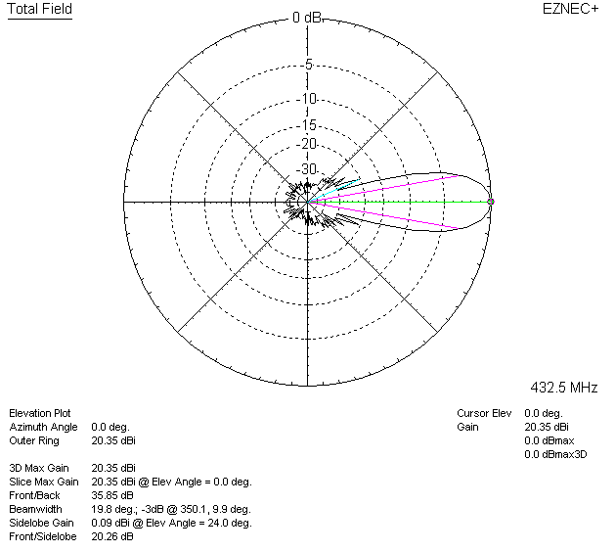

LOSSES INCLUDED (silver)
