ANTENNA Q729D11XL
PERFORMANCES: (No loss condition)
TYPE | ELE | L (mm) | G (dBi) | F/B (dB) | F/Sh (dBi) | F/Sv (dBi) | Hor (◦) | Ver (◦) | Temp (◦K) | G/T (dB) | ΔF * (kHz)
Q729D11XL | 29 | 7845 | 20,23 | 35,57 | 19,60 | 18,65 | 19,6 | 20,0 | 16,3 | +8,11 | 5200
* ΔF given for SWR=1,5

PERFORMANCES: (Losses included)
Element material | G (dBi) | Temp (◦K) | G/T (dB)
Aluminum rods | 20,17 | 20,2 | +7,11
Silvered rods | 20,19 | 18,8 | +7,48

DIMENSIONS:
 | Ref | De | D1 | D2 | D3 | D4 | D5 | D6 | D7 | D8 | D9 | D10 | D11
Pos | 0 | 122 | 199 | 349 | 489 | 680 | 934 | 1220 | 1522 | 1823 | 2141 | 2458 | 2772
Length | 280 | 255 | 246 | 228 | 221 | 219 | 214 | 209 | 205 | 202 | 199 | 197 | 193
 | D12 | D13 | D14 | D15 | D16 | D17 | D18 | D19 | D20 | D21 | D22 | D23 | D24
Pos | 3094 | 3418 | 3745 | 4067 | 4401 | 4721 | 5046 | 5363 | 5696 | 6023 | 6344 | 6656 | 6978
Length | 191 | 189 | 188 | 187 | 185 | 183 | 180 | 177 | 176 | 175 | 174 | 173 | 170
 | D25 | D26 | D27 | - All elements made of Al rods Ǿ6,0 mm  - The height of all rectangles is 100 mm  - All dimensions given in milimetres
Pos | 7288 | 7604 | 7845
Length | 169 | 168 | 166

COMPARISON
Antenna | Boomlength (mm) | Material | Gain (dBi) | TA  (◦K) | G/T  (dB) | Bandwidth  (MHz)
Q729D11XL | 7845 | No loss | 20,23 | 16,3 | +8,11 | 429,400-434,600
Q729D11XL | 7845 | Aluminum | 20,17 | 20,2 | +7,11 | 429,400-434,600
Q729D11XL | 7845 | Silver | 20,19 | 18,8 | +7,48 | 429,400-434,600
EF7032-5 | 8670 | No loss | 19,93 | 19,9 | +6,94 | 429,700-433,980
EF7032-5 | 8670 | Aluminum | 19,85 | 25,5 | +5,78 | 429,700-433,980
EF7032-5 | 8670 | Silver | 19,88 | 23,3 | +6,20 | 429,700-433,980

DIAGRAMS
NO LOSS INCLUDED
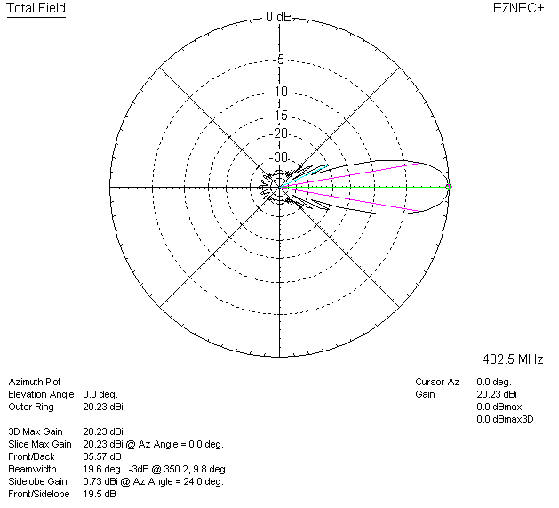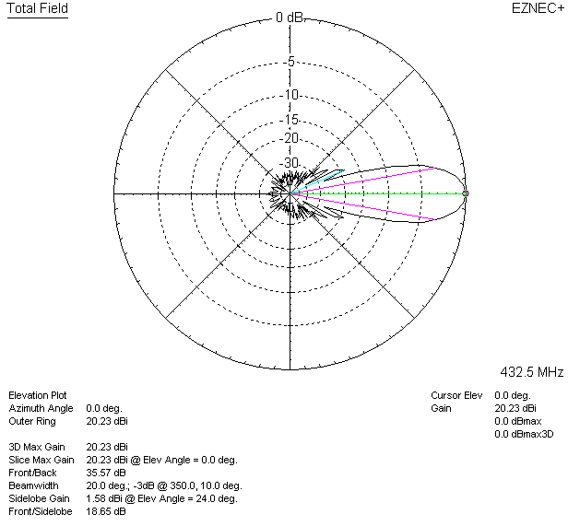

LOSSES INCLUDED (aluminum)
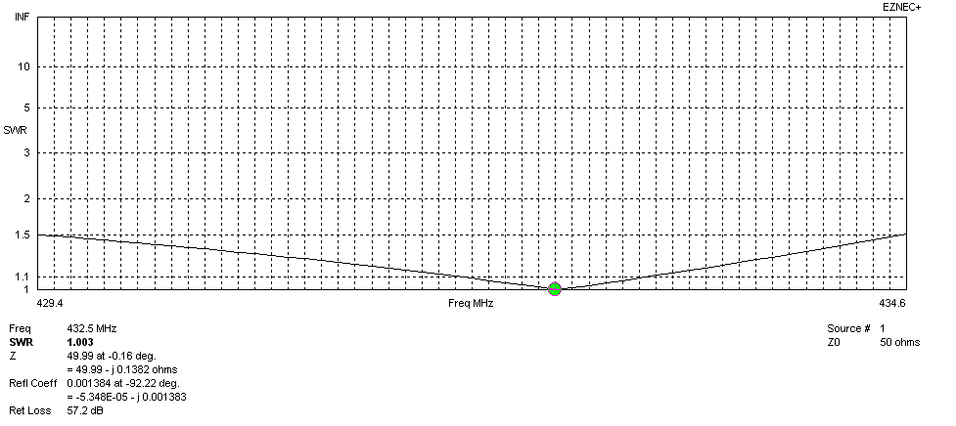
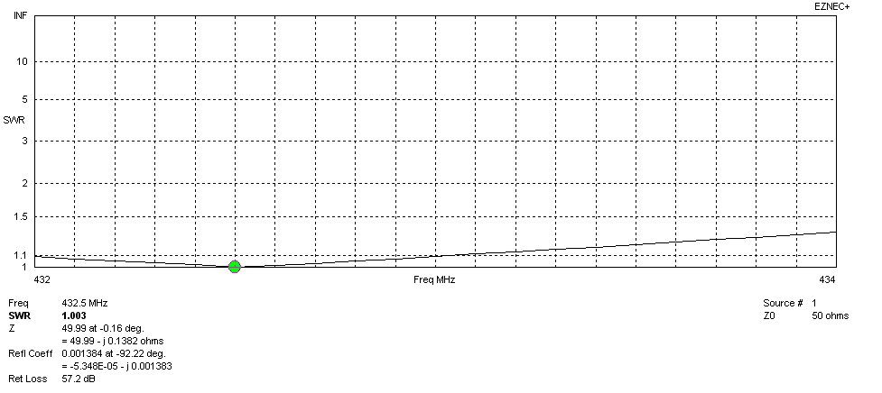
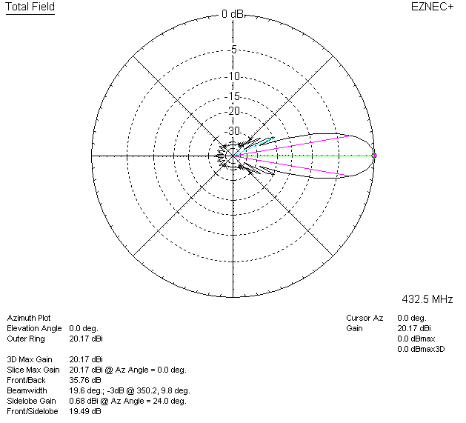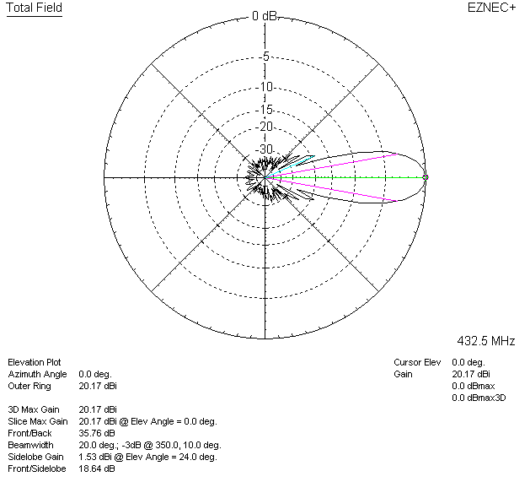

LOSSES INCLUDED (silver)
