ANTENNA Q728D11XL
PERFORMANCES: (No loss condition)
TYPE | ELE | L (mm) | G (dBi) | F/B (dB) | F/Sh (dBi) | F/Sv (dBi) | Hor (◦) | Ver (◦) | Temp (◦K) | G/T (dB) | ΔF * (kHz)
Q728D11XL | 28 | 7545 | 20,11 | 36,90 | 19,44 | 18,58 | 20,0 | 20,3 | 16,2 | +8,01 | 5500
* ΔF given for SWR=1,5

PERFORMANCES: (Losses included)
Element material | G (dBi) | Temp (◦K) | G/T (dB)
Aluminum rods | 20,05 | 20,2 | +7,00
Silvered rods | 20,08 | 18,7 | +7,37

DIMENSIONS:
 | Ref | De | D1 | D2 | D3 | D4 | D5 | D6 | D7 | D8 | D9 | D10 | D11 | D12
Pos | 0 | 120 | 199 | 349 | 489 | 680 | 934 | 1220 | 1522 | 1823 | 2141 | 2458 | 2772 | 3094
Length | 281 | 255 | 246 | 228 | 221 | 219 | 214 | 209 | 205 | 202 | 198 | 197 | 193 | 191
 | D13 | D14 | D15 | D16 | D17 | D18 | D19 | D20 | D21 | D22 | D23 | D24 | D25 | D26
Pos | 3418 | 3745 | 4067 | 4401 | 4721 | 5046 | 5363 | 5696 | 6023 | 6344 | 6656 | 6975 | 7285 | 7545
Length | 189 | 188 | 187 | 185 | 183 | 180 | 177 | 176 | 175 | 174 | 172 | 170 | 169 | 167
All elements made of Al rods Ǿ6,0 mm - The height of all rectangles is 100 mm - All dimensions given in milimetres

COMPARISON
Antenna | Boomlength (mm) | Material | Gain (dBi) | TA (◦K) | G/T (dB) | Bandwidth  (MHz)
Q728D11XL | 7545 | No loss | 20,11 | 16,2 | +8,01 | 429,200-434,700
Q728D11XL | 7545 | Aluminum | 20,05 | 20,2 | +7,00 | 429,200-434,700
Q728D11XL | 7545 | Silver | 20,08 | 18,7 | +7,37 | 429,200-434,700
EF7032-5 | 8670 | No loss | 19,93 | 19,9 | +6,94 | 429,700-433,980
EF7032-5 | 8670 | Aluminum | 19,85 | 25,5 | +5,78 | 429,700-433,980
EF7032-5 | 8670 | Silver | 19,88 | 23,3 | +6,20 | 429,700-433,980

DIAGRAMS
NO LOSS INCLUDED
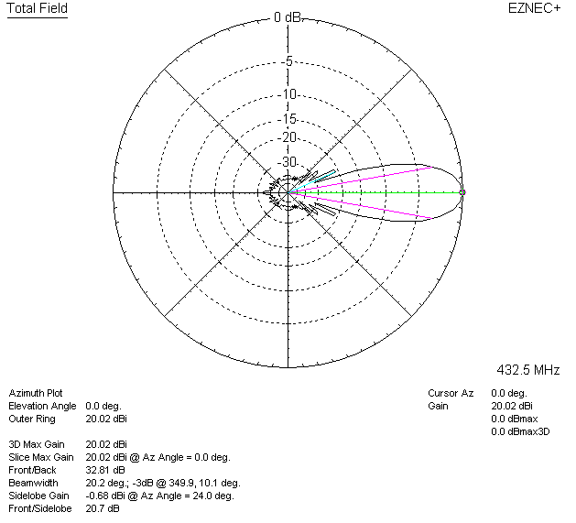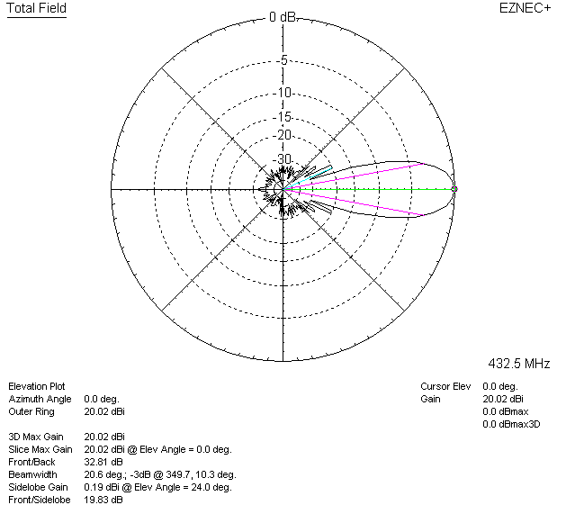

LOSSES INCLUDED (aluminum)
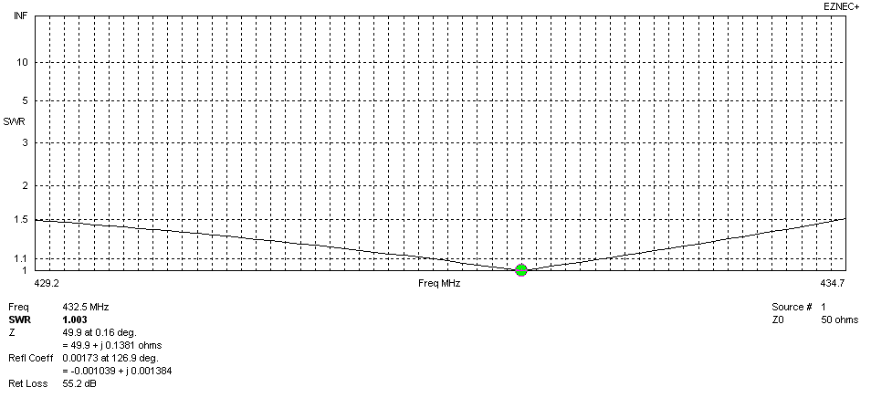
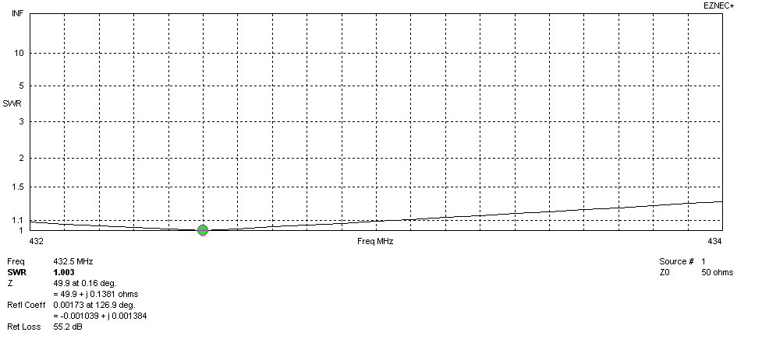
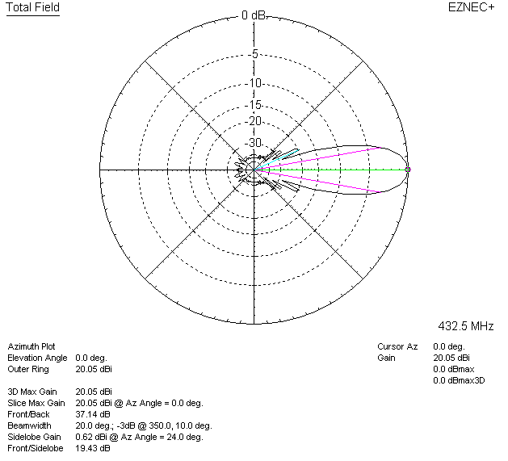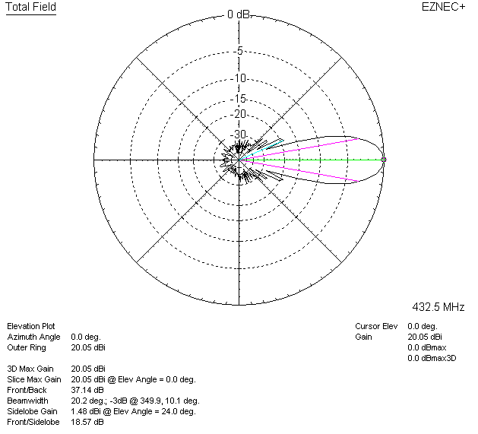

LOSSES INCLUDED (silver)
