ANTENNA Q726D3XL
PERFORMANCES: (No loss condition)
TYPE | ELE | L (mm) | G (dBi) | F/B (dB) | F/Sh (dBi) | F/Sv (dBi) | Hor (◦) | Ver (◦) | Temp (◦K) | G/T (dB) | ΔF * (kHz)
Q726D3XL | 26 | 6895 | 19,77 | 35,63 | 19,73 | 18,66 | 20,8 | 21,2 | 16,5 | +7,60 | 5400
* ΔF given for SWR=1,5

PERFORMANCES: (Losses included)
Element material | G (dBi) | Temp (◦K) | G/T (dB)
Aluminum rods | 19,70 | 21,1 | +6,46
Silvered rods | 19,72 | 19,3 | +6,86

DIMENSIONS:
 | Ref | De | D1 | D2 | D3 | D4 | D5 | D6 | D7 | D8 | D9 | D10 | D11 | D12 | D13 | D14
Pos | 0 | 129 | 205 | 346 | 485 | 680 | 936 | 1215 | 1515 | 1824 | 2132 | 2450 | 2770 | 3095 | 3408 | 3740
Length | 279 | 255 | 246 | 229 | 224 | 221 | 216 | 211 | 207 | 203 | 200 | 197 | 195 | 193 | 191 | 189
 | D15 | D16 | D17 | D18 | D19 | D20 | D21 | D22 | D23 | D24 | - All elements made of Al rods Ǿ5,0 mm  - The height of all rectangles is 100 mm  - All dimensions given in milimetres
Pos | 4072 | 4385 | 4708 | 5036 | 5375 | 5678 | 6012 | 6335 | 6628 | 6895
Length | 187 | 185 | 183 | 181 | 179 | 177 | 173 | 173 | 173 | 170

COMPARISON
Antenna | Boomlength (mm) | Material | Gain (dBi) | TA (◦K) | G/T (dB) | Bandwidth  (MHz)
Q726D3XL | 6895 | No loss | 19,77 | 16,5 | +7,60 | 429,200-434,600
Q726D3XL | 6895 | Aluminum | 19,70 | 21,1 | +6,46 | 429,200-434,600
Q726D3XL | 6895 | Silver | 19,72 | 19,3 | +6,86 | 429,200-434,600
EF7032-5 | 8670 | No loss | 19,93 | 19,9 | +6,94 | 429,700-433,980
EF7032-5 | 8670 | Aluminum | 19,85 | 25,5 | +5,78 | 429,700-433,980
EF7032-5 | 8670 | Silver | 19,88 | 23,3 | +6,20 | 429,700-433,980

DIAGRAMS
NO LOSS INCLUDED
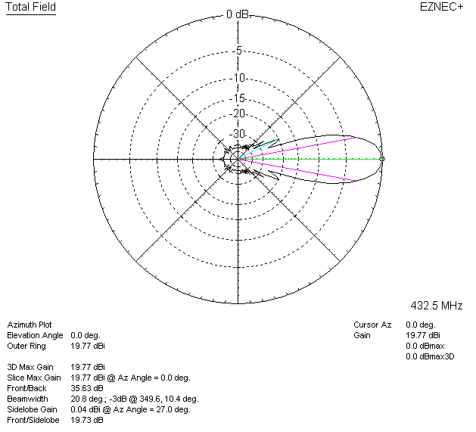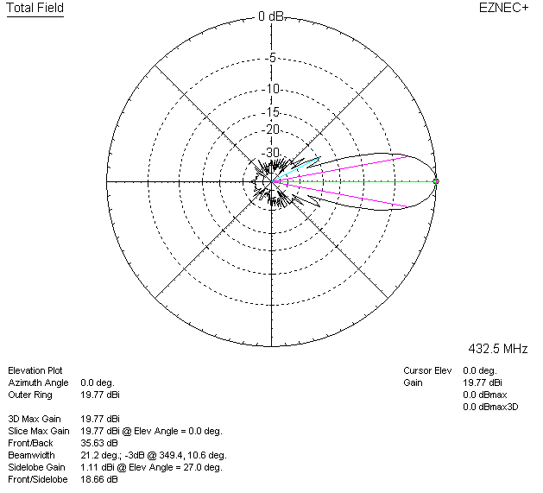

LOSSES INCLUDED (aluminum)
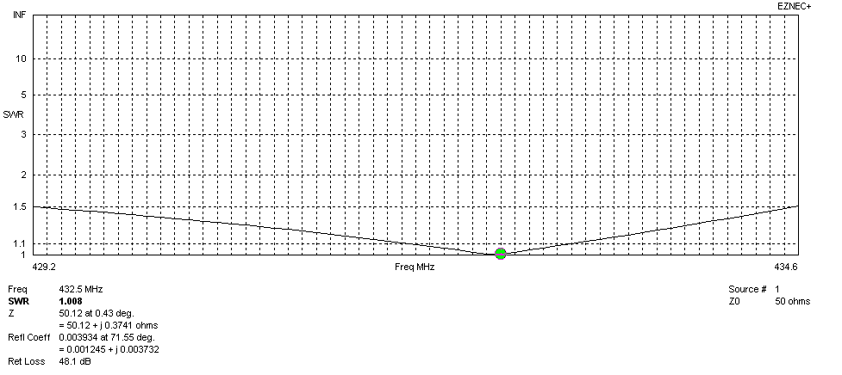
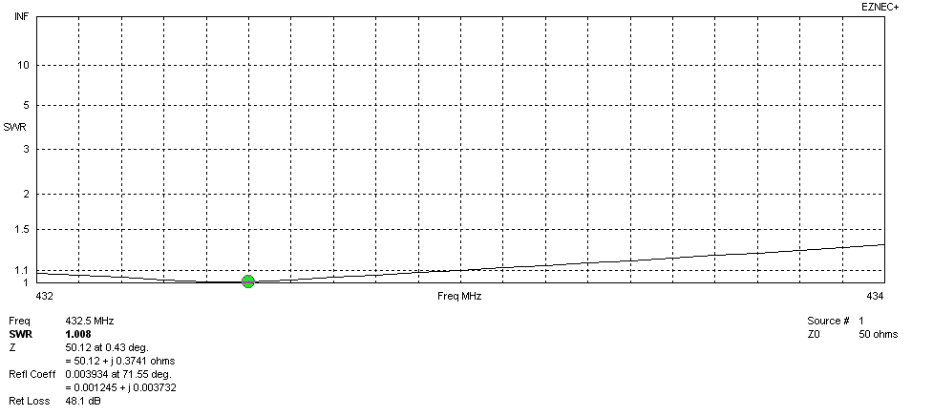
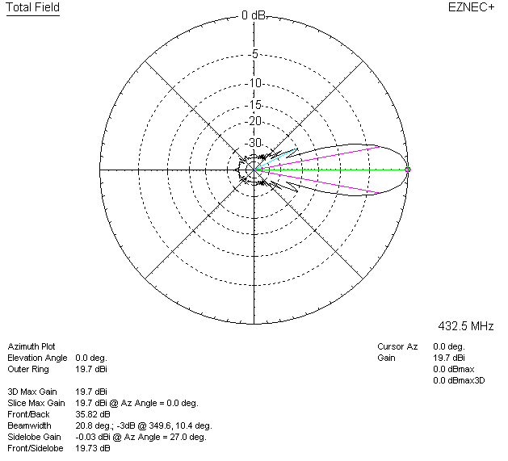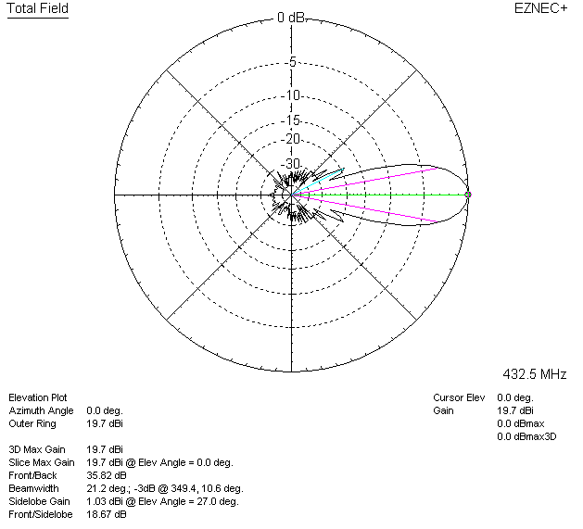

LOSSES INCLUDED (silver)
