ANTENNA Q724D9XL
PERFORMANCES: (No loss condition)
TYPE | ELE | L (mm) | G (dBi) | F/B (dB) | F/Sh (dBi) | F/Sv (dBi) | Hor (◦) | Ver (◦) | Temp (◦K) | G/T (dB) | ΔF * (kHz)
Q724D9XL | 24 | 6275 | 19,54 | 37,90 | 20,16 | 19,11 | 21,2 | 21,6 | 16,1 | +7,47 | 5100
* ΔF given for SWR=1,5

PERFORMANCES: (Losses included)
Element material | G (dBi) | Temp (◦K) | G/T (dB)
Aluminum rods | 19,50 | 18,7 | +6,78
Silvered rods | 19,51 | 17,7 | +7,03

DIMENSIONS:
 | Ref | De | D1 | D2 | D3 | D4 | D5 | D6 | D7 | D8 | D9 | D10
Pos | 0 | 125 | 199 | 351 | 485 | 690 | 940 | 1223 | 1519 | 1829 | 2139 | 2458
Length | 286 | 258 | 246 | 224 | 220 | 217 | 213 | 207 | 202 | 198 | 195 | 192
 | D11 | D12 | D13 | D14 | D15 | D16 | D17 | D18 | D19 | D20 | D21 | D22
Pos | 2773 | 3094 | 3422 | 3745 | 4072 | 4403 | 4728 | 5047 | 5369 | 5695 | 6022 | 6275
Length | 189 | 185 | 183 | 181 | 179 | 176 | 174 | 172 | 170 | 170 | 168 | 166
- All elements made of Al rods Ǿ10,0 mm
- The height of all rectangles is 100 mm
- All dimensions given in milimetres

COMPARISON
Antenna | Boomlength (mm) | Material | Gain (dBi) | TA (◦K) | G/T (dB) | Bandwidth  (MHz)
Q724D9XL | 6275 | No loss | 19,77 | 16,7 | +6,65 | 429,300-434,400
Q724D9XL | 6275 | Aluminum | 19,50 | 18,7 | +6,78 | 429,300-434,400
Q724D9XL | 6275 | Silver | 19,51 | 17,7 | +7,03 | 429,300-434,400
EF7024-5 | 6270 | No loss | 19,27 | 19,8 | +6,31 | 428,700-433,080
EF7024-5 | 6270 | Aluminum | 19,17 | 26,2 | +4,99 | 428,700-433,080
EF7024-5 | 6270 | Silver | 19,21 | 23,8 | +5,45 | 428,700-433,080

DIAGRAMS
NO LOSS INCLUDED
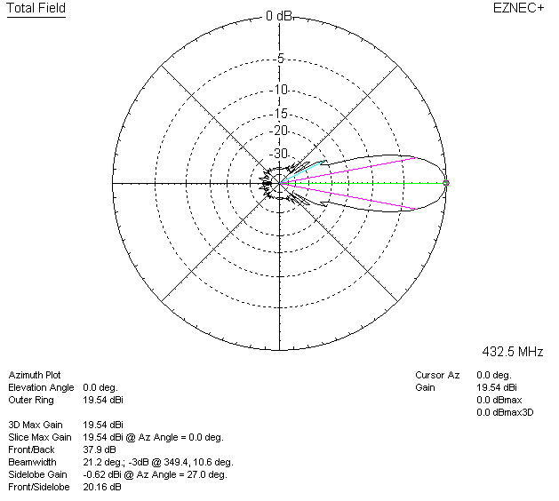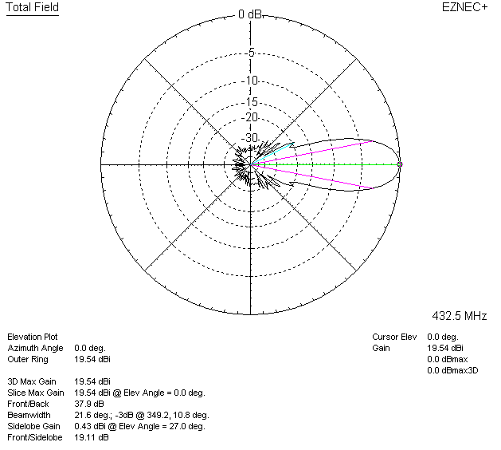

LOSSES INCLUDED (aluminum)
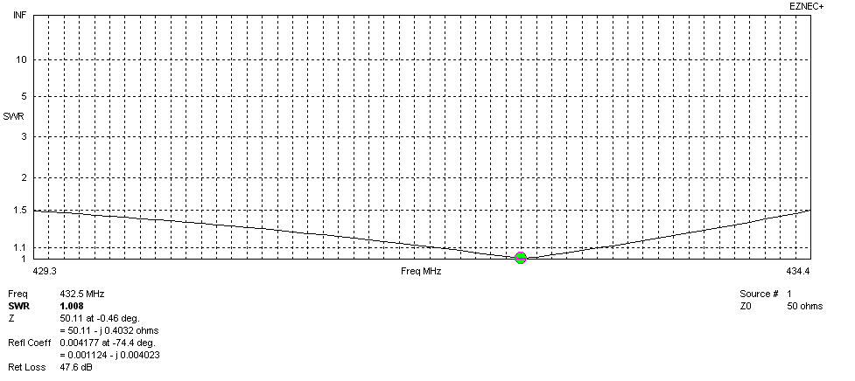
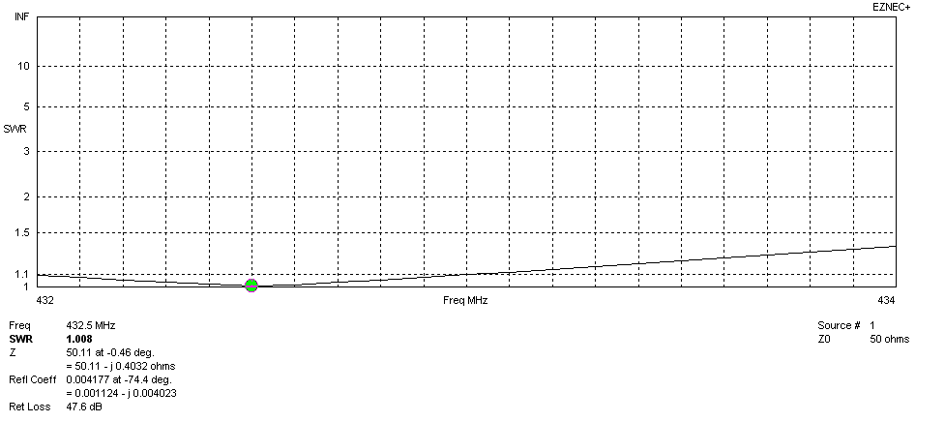
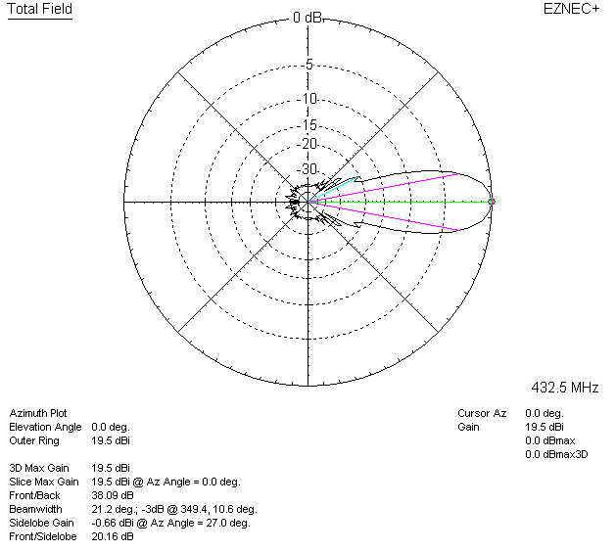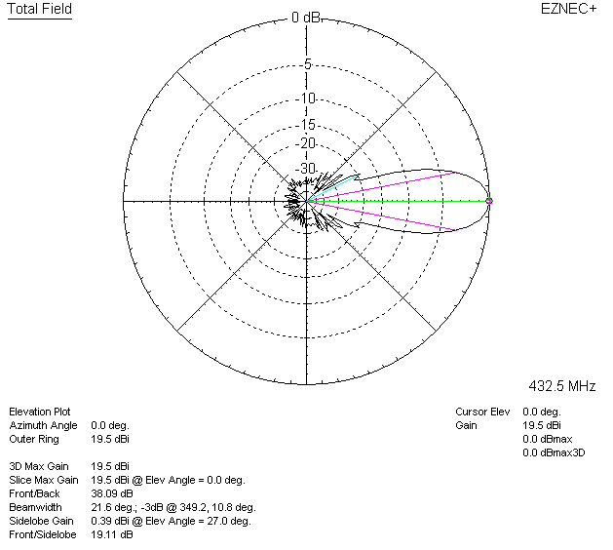

LOSSES INCLUDED (silver)
