ANTENNA Q724D4XL
PERFORMANCES: (No loss condition)
TYPE | ELE | L (mm) | G (dBi) | F/B (dB) | F/Sh (dBi) | F/Sv (dBi) | Hor  (◦) | Ver  (◦) | Temp (◦K) | G/T (dB) | ΔF * (kHz)
Q724D4XL | 24 | 6279 | 19,51 | 29,89 | 19,03 | 17,96 | 21,2 | 21,8 | 16,6 | +7,31 | 6100
* ΔF given for SWR=1,5

PERFORMANCES: (Losses included)
Element material | G (dBi) | Temp (◦K) | G/T (dB)
Aluminum rods | 19,44 | 21,3 | +6,16
Silvered rods | 19,46 | 19,5 | +6,55

DIMENSIONS:
 | Ref | De | D1 | D2 | D3 | D4 | D5 | D6 | D7 | D8 | D9 | D10 | D11 | D12 | D13
Pos | 0 | 124 | 200 | 343 | 482 | 678 | 936 | 1215 | 1515 | 1824 | 2132 | 2450 | 2770 | 3095 | 3408
Length | 279 | 256 | 246 | 229 | 224 | 221 | 216 | 211 | 207 | 203 | 200 | 197 | 195 | 193 | 191
 | D14 | D15 | D16 | D17 | D18 | D19 | D20 | D21 | D22 | - All elements made of Al rods Ǿ5,0 mm  - The height of all rectangles is 100 mm  - All dimensions given in milimetres
Pos | 3740 | 4072 | 4385 | 4708 | 5036 | 5375 | 5678 | 6012 | 6279
Length | 189 | 187 | 185 | 183 | 181 | 178 | 176 | 174 | 172

COMPARISON
Antenna | Boomlength (mm) | Material | Gain (dBi) | TA (◦K) | G/T (dB) | Bandwidth  (MHz)
Q724D4XL | 6279 | No loss | 19,51 | 16,6 | +7,31 | 428,600-434,700
Q724D4XL | 6279 | Aluminum | 19,44 | 21,3 | +6,16 | 428,600-434,700
Q724D4XL | 6279 | Silver | 19,46 | 19,5 | +6,55 | 428,600-434,700
EF7024-5 | 6270 | No loss | 19,27 | 19,8 | +6,31 | 428,700-433,080
EF7024-5 | 6270 | Aluminum | 19,17 | 26,2 | +4,99 | 428,700-433,080
EF7024-5 | 6270 | Silver | 19,21 | 23,8 | +5,45 | 428,700-433,080

DIAGRAMS
NO LOSS INCLUDED
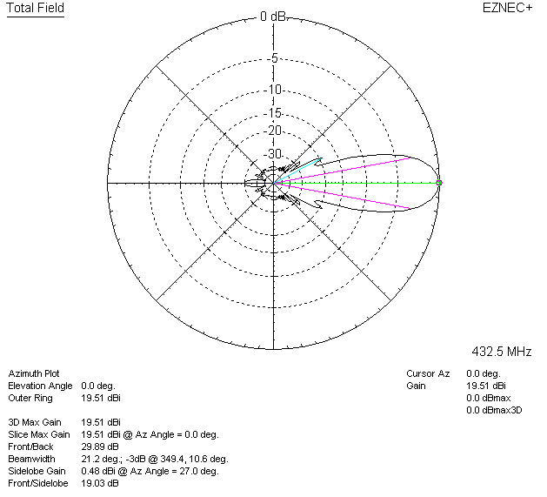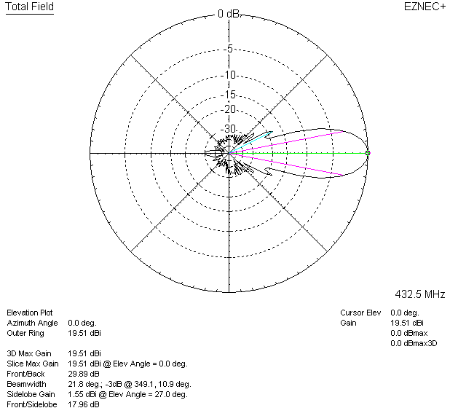

LOSSES INCLUDED (aluminum)
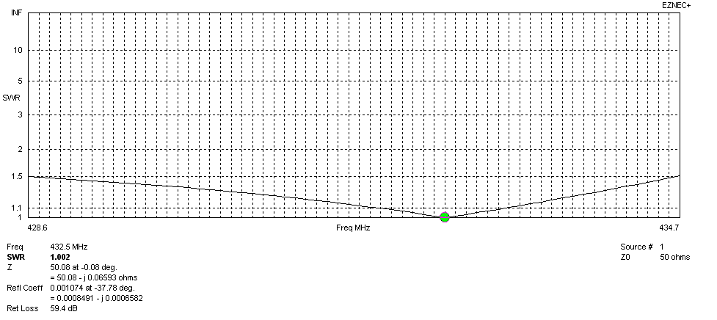
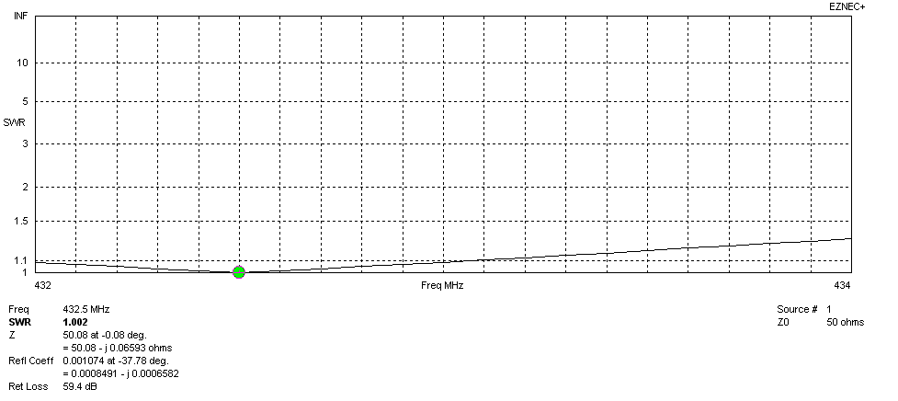
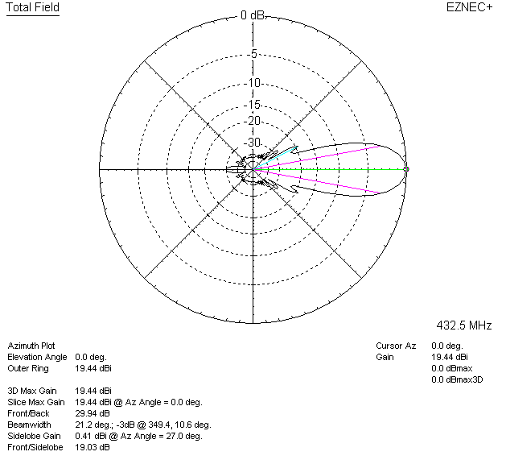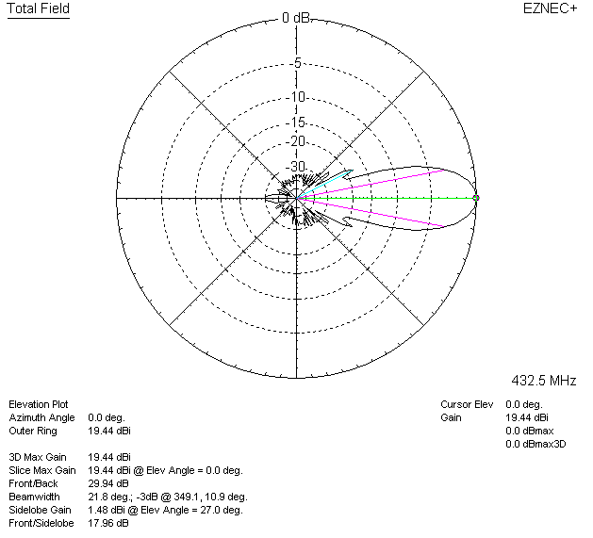

LOSSES INCLUDED (silver)
