ANTENNA Q724D1XL
PERFORMANCES: (No loss condition)
TYPE | ELE | L (mm) | G (dBi) | F/B (dB) | F/Sh (dBi) | F/Sv (dBi) | Hor (◦) | Ver (◦) | Temp (◦K) | G/T (dB) | ΔF * (kHz)
Q724D1XL | 24 | 6215 | 19,41 | 29,85 | 18,36 | 17,31 | 21,4 | 21,9 | 19,1 | +6,61 | 11220
* ΔF given for SWR=1,5

PERFORMANCES: (Losses included)
Element material | G (dBi) | Temp (◦K) | G/T (dB)
Aluminum rods | 19,30 | 26,4 | +5,09
Silvered rods | 19,34 | 23,7 | +5,59

DIMENSIONS:
 | Ref | De | D1 | D2 | D3 | D4 | D5 | D6 | D7 | D8 | D9 | D10
Pos | 0 | 102 | 181 | 290 | 489 | 735 | 992 | 1275 | 1562 | 1864 | 2180 | 2489
Length | 272 | 251 | 238 | 234 | 228 | 222 | 218 | 214 | 210 | 206 | 203 | 202
 | D11 | D12 | D13 | D14 | D15 | D16 | D17 | D18 | D19 | D20 | D21 | D22
Pos | 2805 | 3111 | 3431 | 3748 | 4069 | 4389 | 4699 | 5025 | 5340 | 5642 | 5952 | 6215
Length | 200 | 198 | 195 | 193 | 191 | 191 | 191 | 191 | 188 | 188 | 188 | 188
- All elements made of Al rods Ǿ2,5 mm
- The height of all rectangles is 100 mm
- All dimensions given in milimetres

COMPARISON
Antenna | Boomlength (mm) | Material | Gain (dBi) | TA (◦K) | G/T (dB) | Bandwidth  (MHz)
Q724D1XL | 6220 | No loss | 19,41 | 19,1 | +6,61 | 428,750-439,970
Q724D1XL | 6220 | Aluminum | 19,30 | 26,4 | +5,09 | 428,750-439,970
Q724D1XL | 6220 | Silver | 19,34 | 23,7 | +5,69 | 428,750-439,970
EF7024-5 | 6270 | No loss | 19,27 | 19,8 | +6,31 | 428,700-433,080
EF7024-5 | 6270 | Aluminum | 19,17 | 26,2 | +4,99 | 428,700-433,080
EF7024-5 | 6270 | Silver | 19,21 | 23,8 | +5,45 | 428,700-433,080

DIAGRAMS
NO LOSS INCLUDED
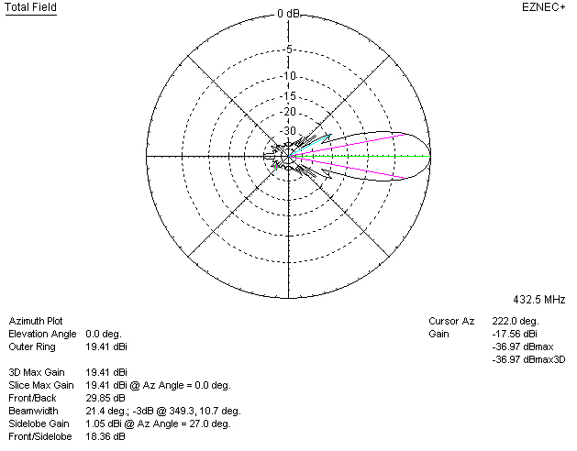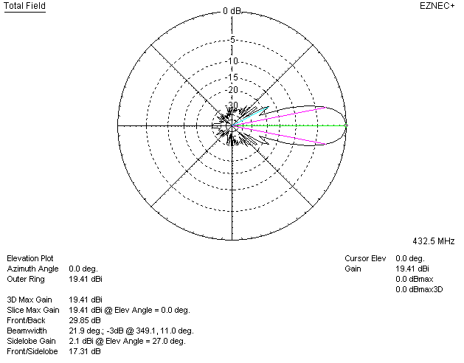

LOSSES INCLUDED (aluminum)
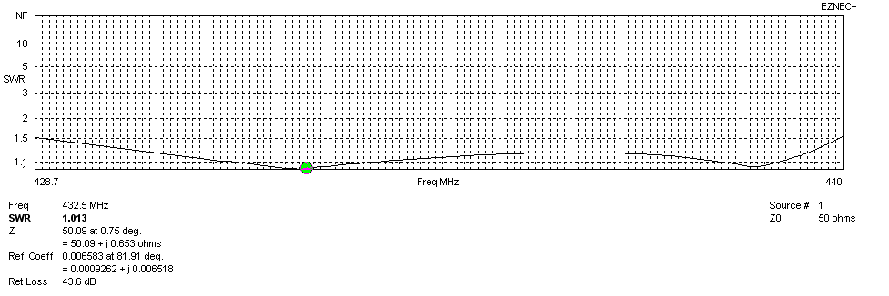
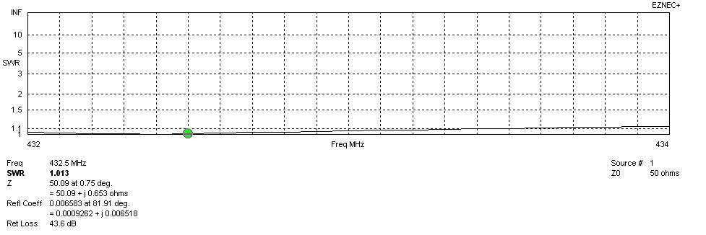
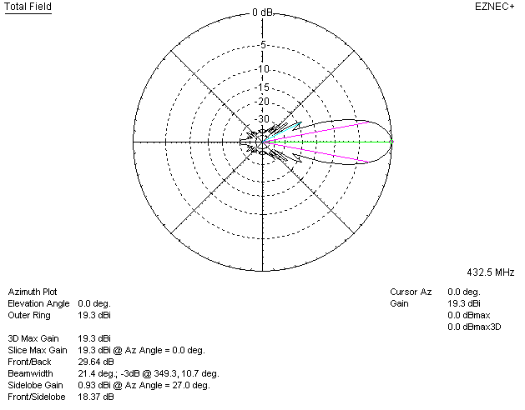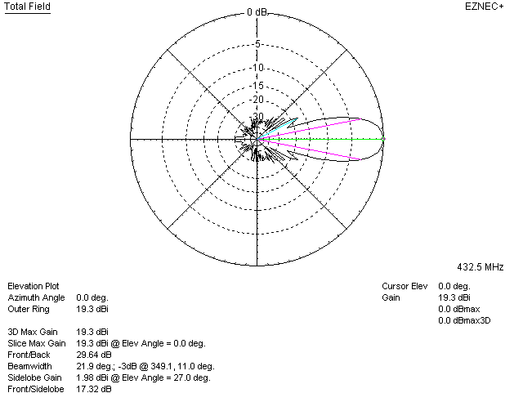

LOSSES INCLUDED (silver)
