ANTENNA Q724D11XL
PERFORMANCES: (No loss condition)
TYPE | ELE | L (mm) | G (dBi) | F/B (dB) | F/Sh (dBi) | F/Sv (dBi) | Hor (◦) | Ver (◦) | Temp (◦K) | G/T (dB) | ΔF * (kHz)
Q724D11XL | 24 | 6295 | 19,54 | 36,72 | 19,37 | 18,30 | 21,2 | 21,6 | 16,5 | +7,38 | 5700
* ΔF given for SWR=1,5

PERFORMANCES: (Losses included)
Element material | G (dBi) | Temp (◦K) | G/T (dB)
Aluminum rods | 19,48 | 20,5 | +6,37
Silvered rods | 19,50 | 19,0 | +6,71

DIMENSIONS:
 | Ref | De | D1 | D2 | D3 | D4 | D5 | D6 | D7 | D8 | D9 | D10
Pos | 0 | 117 | 197 | 349 | 492 | 683 | 937 | 1220 | 1516 | 1824 | 2139 | 2453
Length | 280 | 255 | 246 | 228 | 223 | 220 | 215 | 210 | 206 | 202 | 198 | 187
 | D11 | D12 | D13 | D14 | D15 | D16 | D17 | D18 | D19 | D20 | D21 | D22
Pos | 2770 | 3095 | 3426 | 3745 | 4068 | 4399 | 4719 | 5042 | 5365 | 5692 | 6018 | 6295
Length | 193 | 191 | 189 | 187 | 185 | 183 | 181 | 179 | 177 | 175 | 171 | 171
- All elements made of Al rods Ǿ6,0 mm
- The height of all rectangles is 100 mm
- All dimensions given in milimetres

COMPARISON
Antenna | Boomlength (mm) | Material | Gain (dBi) | TA (◦K) | G/T (dB) | Bandwidth  (MHz)
Q724D11XL | 6295 | No loss | 19,54 | 16,5 | +7,38 | 428,900-434,600
Q724D11XL | 6295 | Aluminum | 19,48 | 20,5 | +6,37 | 428,900-434,600
Q724D11XL | 6295 | Silver | 19,50 | 19,0 | +6,71 | 428,900-434,600
EF7024-5 | 6270 | No loss | 19,27 | 19,8 | +6,31 | 428,700-433,080
EF7024-5 | 6270 | Aluminum | 19,17 | 26,2 | +4,99 | 428,700-433,080
EF7024-5 | 6270 | Silver | 19,21 | 23,8 | +5,45 | 428,700-433,080

DIAGRAMS
NO LOSS INCLUDED
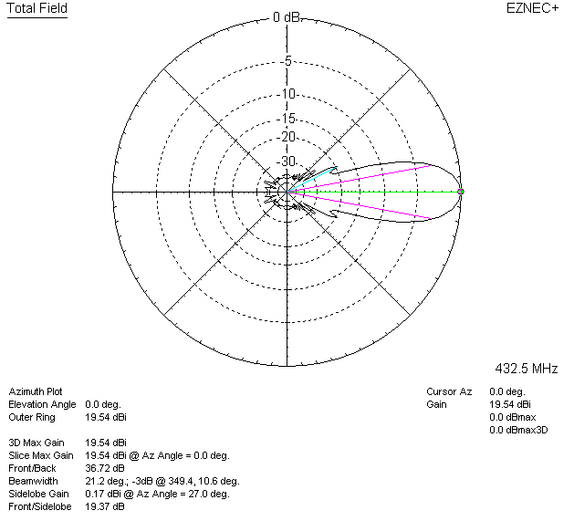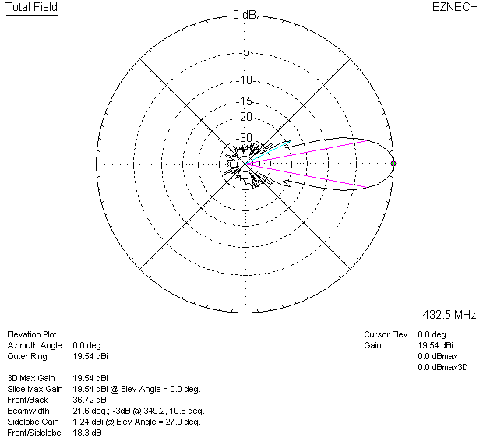

LOSSES INCLUDED (aluminum)
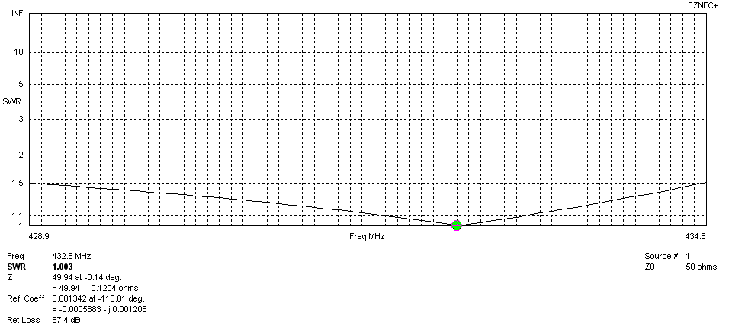
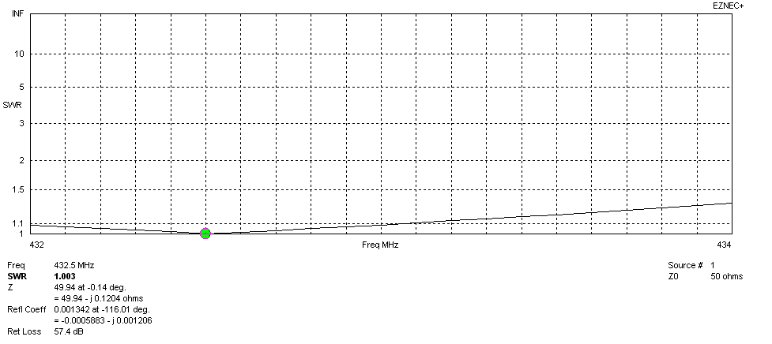
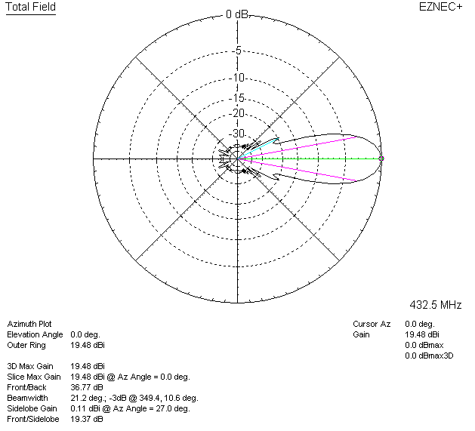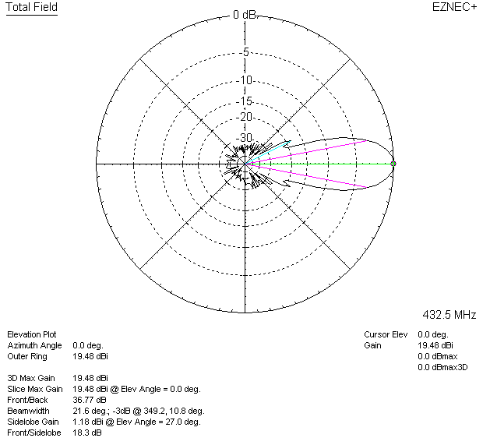

LOSSES INCLUDED (silver)
