ANTENNA Q723E1XL
PERFORMANCES: (No loss condition)
TYPE | ELE | L (mm) | G (dBi) | F/B (dB) | F/Sh (dBi) | F/Sv (dBi) | Hor (◦) | Ver (◦) | Temp (◦K) | G/T (dB) | ΔF * (kHz)
Q723E1XL | 23 | 5985 | 19,38 | 29,15 | 17,71 | 16,72 | 21,4 | 21,8 | 17,8 | +6,88 | 7150
* ΔF given for SWR=1,5

PERFORMANCES: (Losses included)
Element material | G (dBi) | Temp (◦K) | G/T (dB)
Aluminum rods | 19,29 | 23,8 | +5,53
Silvered rods | 19,32 | 21,5 | +5,99

DIMENSIONS:
 | Ref | De | D1 | D2 | D3 | D4 | D5 | D6 | D7 | D8 | D9 | D10 | D11 | D12
Pos | 0 | 113 | 185 | 339 | 493 | 676 | 936 | 1219 | 1525 | 1833 | 2153 | 2473 | 2777 | 3104
Length | 263 | 242 | 234 | 220 | 214 | 210 | 206 | 203 | 197 | 194 | 192 | 192 | 190 | 188
 | D13 | D14 | D15 | D16 | D17 | D18 | D19 | D20 | D21 | - All elements made of Al rods Ǿ4 mm  - The height of all rectangles is 115 mm  - All dimensions given in milimetres
Pos | 3425 | 3747 | 4061 | 4387 | 4714 | 5042 | 5365 | 5672 | 5985
Length | 186 | 183 | 181 | 178 | 176 | 174 | 172 | 170 | 168

COMPARISON
Antenna | Boomlength (mm) | Material | Gain (dBi) | TA (◦K) | G/T (dB) | Bandwidth  (MHz)
Q723E1XL | 5995 | No loss | 19,38 | 17,8 | +6,88 | 427,520-434,670
Q723E1XL | 5995 | Aluminum | 19,29 | 23,8 | +5,53 | 427,520-434,670
Q723E1XL | 5995 | Silver | 19,32 | 21,5 | +5,99 | 427,520-434,670
EF7023-5 | 5965 | No loss | 19,05 | 20,4 | +5,96 | 428,000-434,200
EF7023-5 | 5965 | Aluminum | 18,97 | 25,7 | +4,87 | 428,000-434,200
EF7023-5 | 5965 | Silver | 19,00 | 23,7 | +5,25 | 428,000-434,200

DIAGRAMS
NO LOSS INCLUDED
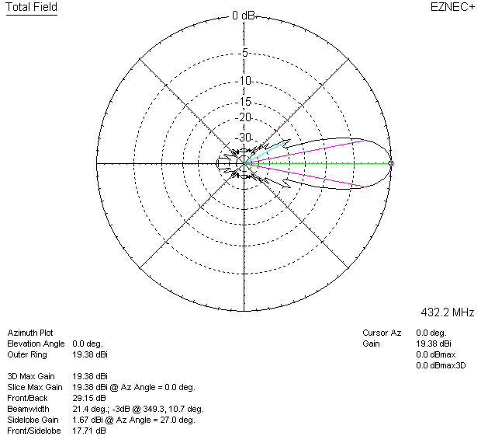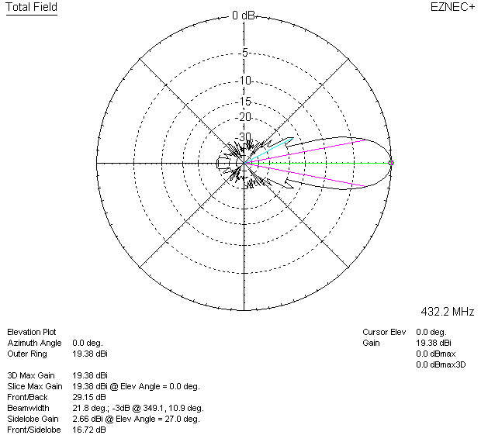

LOSSES INCLUDED (aluminum)
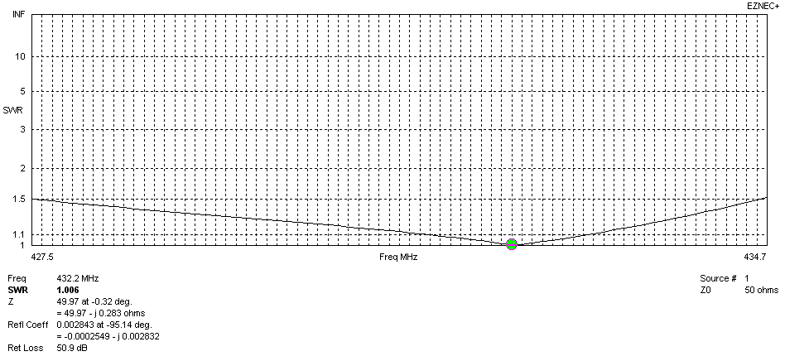
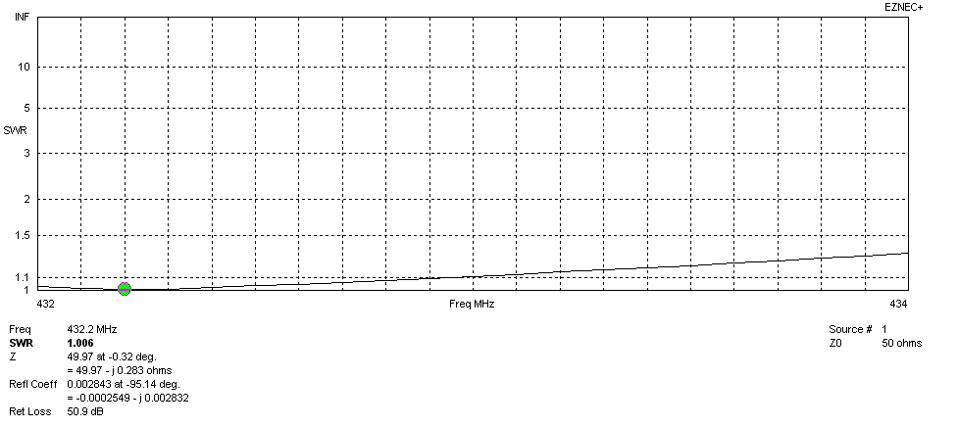
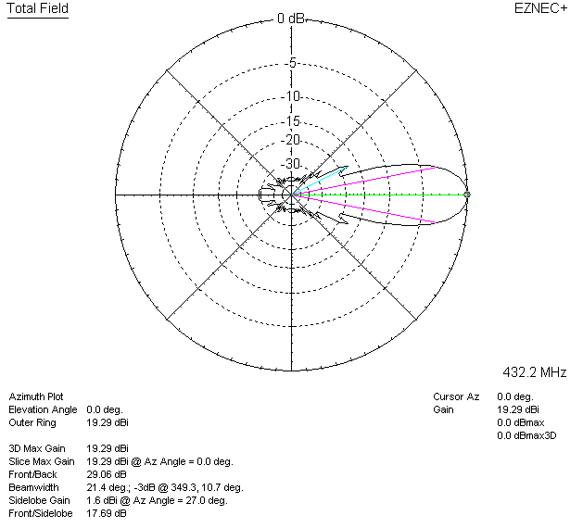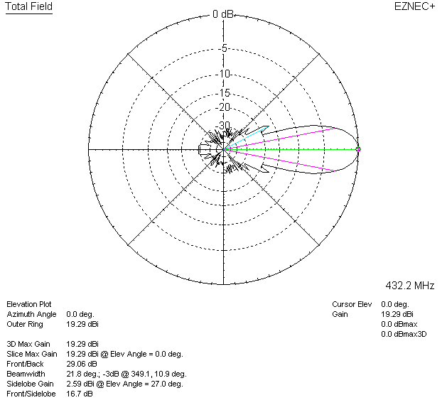

LOSSES INCLUDED (silver)
