ANTENNA Q723D6XL
PERFORMANCES: (No loss condition)
TYPE | ELE | L (mm) | G (dBi) | F/B (dB) | F/Sh (dBi) | F/Sv (dBi) | Hor (◦) | Ver (◦) | Temp (◦K) | G/T (dB) | ΔF * (kHz)
Q723D6XL | 23 | 5828 | 18,77 | 36,40 | 23,44 | 22,15 | 23,8 | 24,4 | 16,2 | +6,67 | 7100
* ΔF given for SWR=1,5

PERFORMANCES: (Losses included)
Element material | G (dBi) | Temp (◦K) | G/T (dB)
Aluminum rods | 18,70 | 20,6 | +5,57
Silvered rods | 18,73 | 18,9 | +5,96

DIMENSIONS:
 | Ref | De | D1 | D2 | D3 | D4 | D5 | D6 | D7 | D8 | D9 | D10 | D11 | D12 | D13
Pos | 0 | 118 | 167 | 299 | 484 | 683 | 916 | 1188 | 1481 | 1783 | 2092 | 2403 | 2719 | 3039 | 3363
Length | 279 | 255 | 245 | 234 | 225 | 220 | 216 | 212 | 206 | 202 | 199 | 195 | 190 | 187 | 183
 | D14 | D15 | D16 | D17 | D18 | D19 | D20 | D21 | - All elements made of Al rods Ǿ5,0 mm  - The height of all rectangles is 100 mm  - All dimensions given in milimetres
Pos | 3673 | 4009 | 4312 | 4635 | 4949 | 5269 | 5570 | 5828
Length | 181 | 179 | 177 | 175 | 174 | 172 | 171 | 170

COMPARISON
Antenna | Boomlength (mm) | Material | Gain (dBi) | TA (◦K) | G/T (dB) | Bandwidth  (MHz)
Q723D6XL | 5994 | No loss | 18,77 | 16,2 | +6,67 | 429,200-435,300
Q723D6XL | 5994 | Aluminum | 18,70 | 20,6 | +5,57 | 429,200-435,300
Q723D6XL | 5994 | Silver | 18,73 | 18,9 | +5,96 | 429,200-435,300
EF7023-5 | 5965 | No loss | 19,05 | 20,4 | +5,96 | 428,000-434,200
EF7023-5 | 5965 | Aluminum | 18,97 | 25,7 | +4,87 | 428,000-434,200
EF7023-5 | 5965 | Silver | 19,00 | 23,7 | +5,25 | 428,000-434,200

DIAGRAMS
NO LOSS INCLUDED
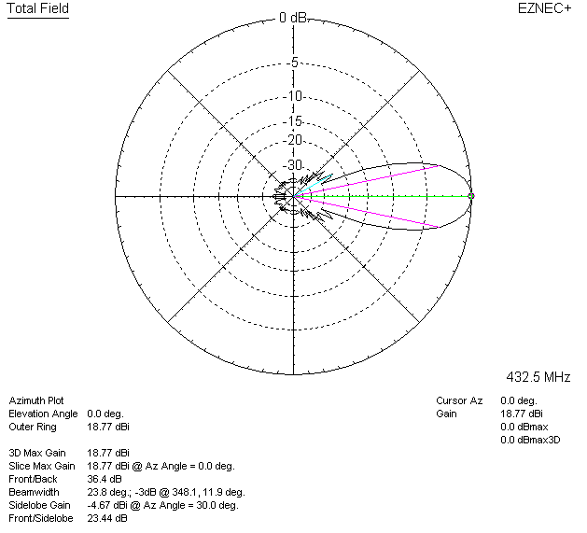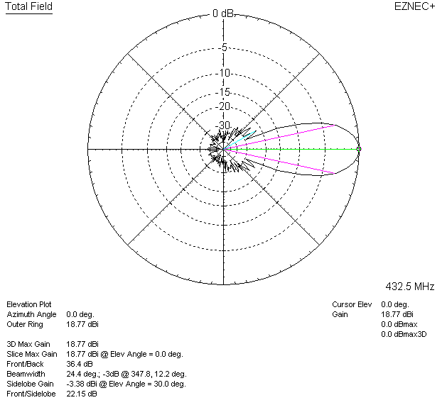

LOSSES INCLUDED (aluminum)
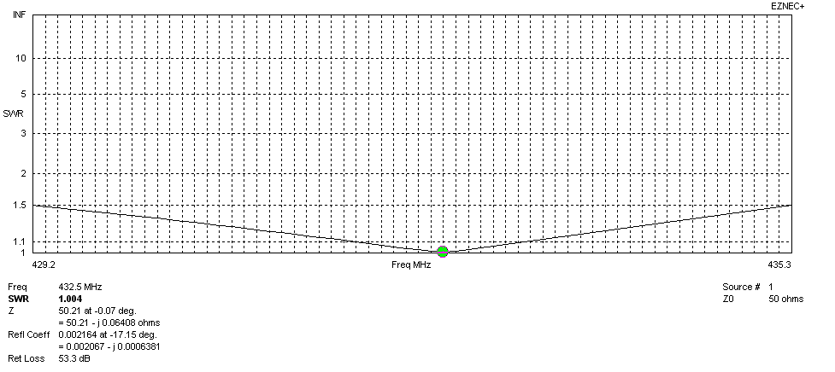
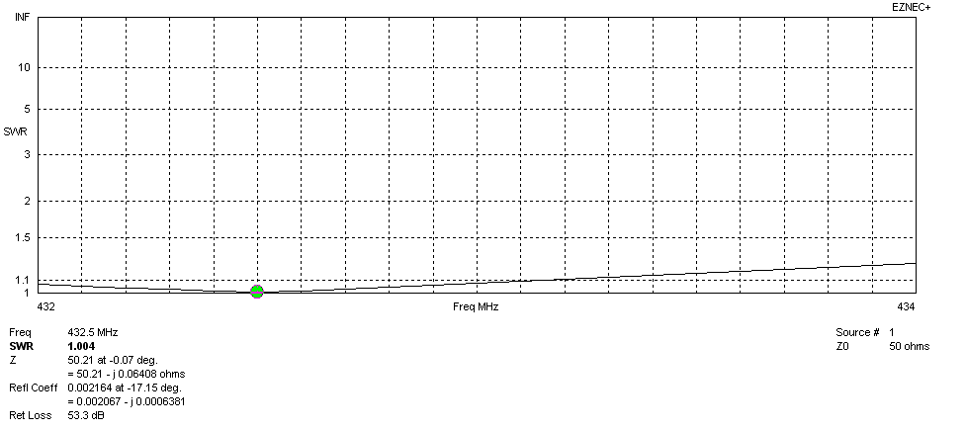
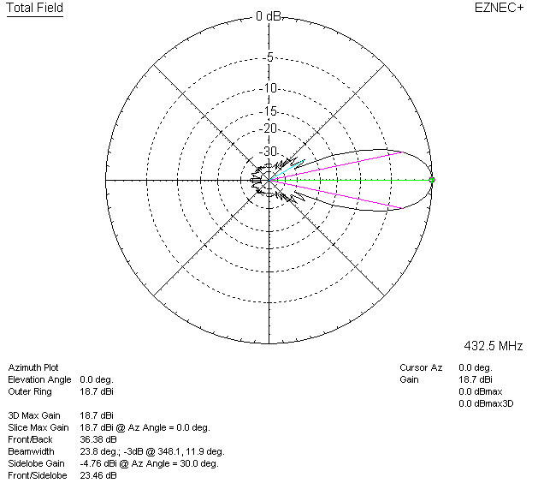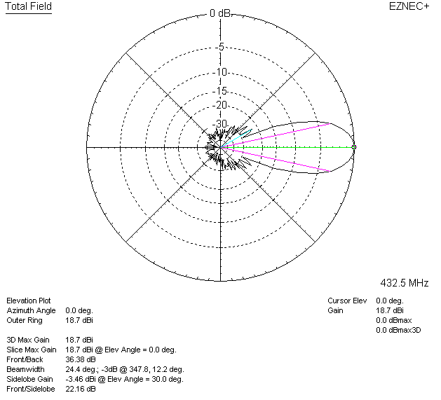

LOSSES INCLUDED (silver)
