ANTENNA Q723D5XL
PERFORMANCES: (No loss condition)
TYPE | ELE | L (mm) | G (dBi) | F/B (dB) | F/Sh (dBi) | F/Sv (dBi) | Hor (◦) | Ver (◦) | Temp (◦K) | G/T (dB) | ΔF * (kHz)
Q723D5XL | 23 | 5978 | 19,36 | 26,77 | 18,91 | 17,84 | 21,6 | 22,1 | 17,2 | +7,01 | 5670
* ΔF given for SWR=1,5

PERFORMANCES: (Losses included)
Element material | G (dBi) | Temp (◦K) | G/T (dB)
Aluminum rods | 19,29 | 21,7 | +5,92
Silvered rods | 19,32 | 20,1 | +6,30

DIMENSIONS:
 | Ref | De | D1 | D2 | D3 | D4 | D5 | D6 | D7 | D8 | D9 | D10 | D11 | D12
Pos | 0 | 130 | 202 | 341 | 483 | 678 | 936 | 1215 | 1515 | 1824 | 2132 | 2450 | 2770 | 3095
Length | 278 | 256 | 246 | 229 | 224 | 221 | 216 | 211 | 207 | 203 | 200 | 197 | 195 | 193
 | D13 | D14 | D15 | D16 | D17 | D18 | D19 | D20 | D21 | - All elements made of Al rods Ǿ5,0 mm  - The height of all rectangles is 100 mm  - All dimensions given in milimetres
Pos | 3408 | 3740 | 4072 | 4385 | 4708 | 5037 | 5374 | 5665 | 5978
Length | 191 | 189 | 187 | 185 | 183 | 181 | 178 | 176 | 174

COMPARISON
Antenna | Boomlength (mm) | Material | Gain (dBi) | TA (◦K) | G/T (dB) | Bandwidth  (MHz)
Q723D5XL | 5978 | No loss | 19,36 | 17,2 | +7,01 | 428,800-434,470
Q723D5XL | 5978 | Aluminum | 19,29 | 21,7 | +5,92 | 428,800-434,470
Q723D5XL | 5978 | Silver | 19,32 | 20,1 | +6,30 | 428,800-434,470
EF7023-5 | 5965 | No loss | 19,05 | 20,4 | +5,96 | 428,000-434,200
EF7023-5 | 5965 | Aluminum | 18,97 | 25,7 | +4,87 | 428,000-434,200
EF7023-5 | 5965 | Silver | 19,00 | 23,7 | +5,25 | 428,000-434,200
DIAGRAMS
NO LOSS INCLUDED
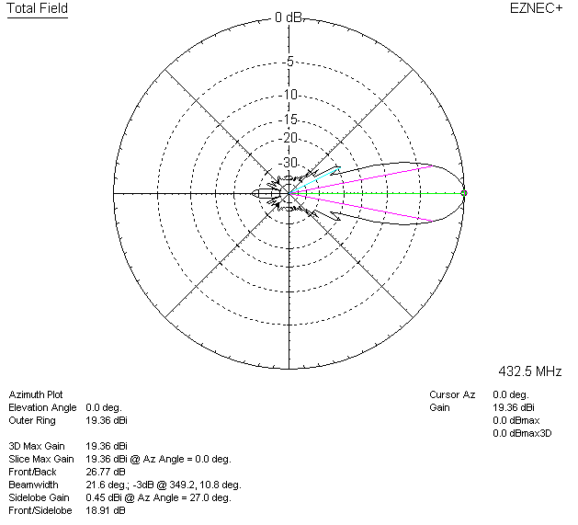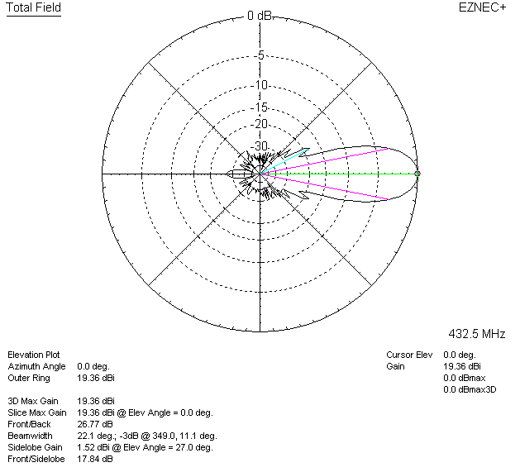

LOSSES INCLUDED (aluminum)
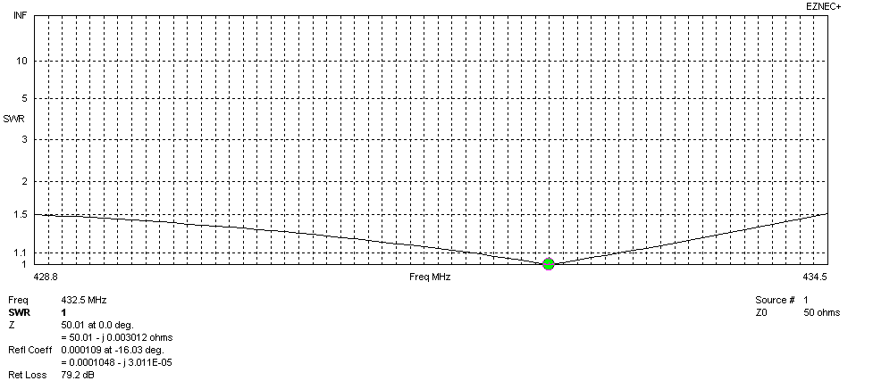
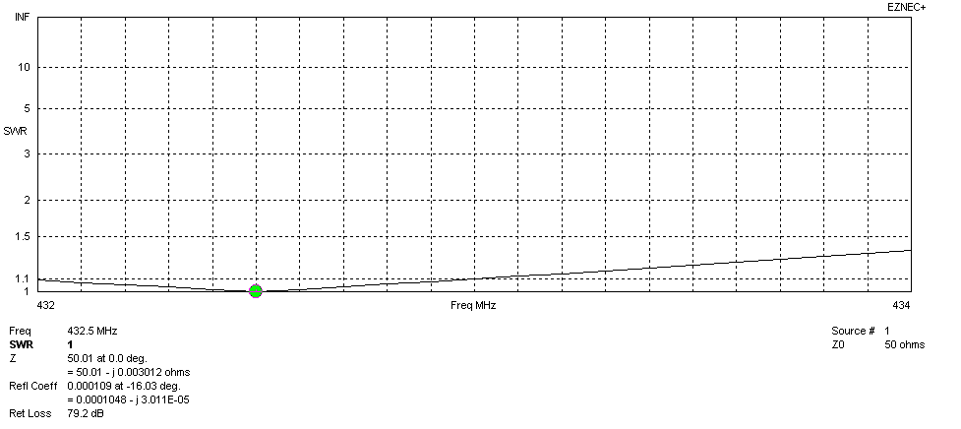
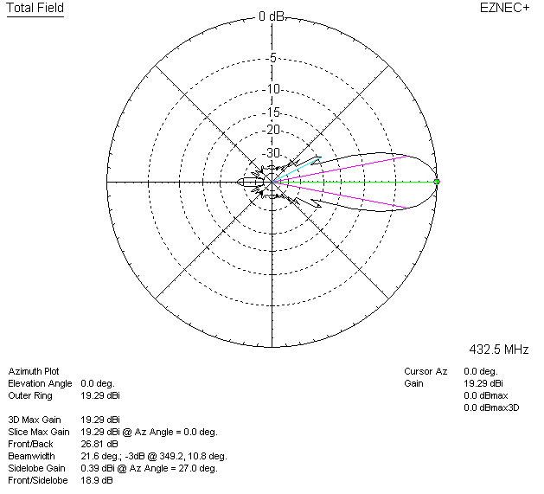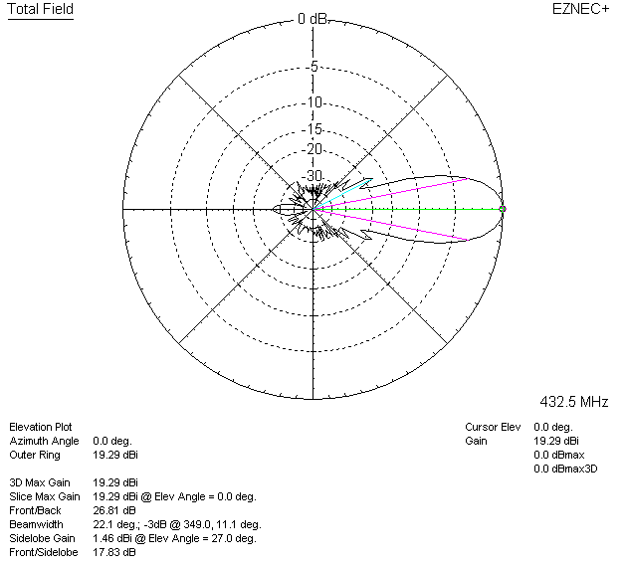

LOSSES INCLUDED (silver)
