ANTENNA Q723D3XL
PERFORMANCES: (No loss condition)
TYPE | ELE | L (mm) | G (dBi) | F/B (dB) | F/Sh (dBi) | F/Sv (dBi) | Hor (◦) | Ver (◦) | Temp (◦K) | G/T (dB) | ΔF * (kHz)
Q723D3XL | 23 | 5985 | 19,36 | 28,41 | 18,65 | 17,61 | 21,6 | 22,1 | 17,3 | +6,97 | 3550
* ΔF given for SWR=1,5

PERFORMANCES: (Losses included)
Element material | G (dBi) | Temp (◦K) | G/T (dB)
Aluminum rods | 19,30 | 21,7 | +5,94
Silvered rods | 19,32 | 20,1 | +6,29

DIMENSIONS:
 | Ref | De | D1 | D2 | D3 | D4 | D5 | D6 | D7 | D8 | D9 | D10 | D11 | D12 | D13
Pos | 0 | 129 | 200 | 335 | 482 | 675 | 931 | 1225 | 1522 | 1824 | 2146 | 2464 | 2789 | 3109 | 3435
Length | 279 | 252 | 244 | 228 | 224 | 219 | 215 | 210 | 206 | 202 | 199 | 196 | 194 | 192 | 190
 | D14 | D15 | D16 | D17 | D18 | D19 | D20 | D21 | - All elements made of Al rods Ǿ5,0 mm  - The height of all rectangles is 100 mm  - All dimensions given in milimetres
Pos | 3762 | 4085 | 4409 | 4745 | 5065 | 5392 | 5698 | 5985
Length | 188 | 186 | 184 | 182 | 180 | 178 | 176 | 175

COMPARISON
Antenna | Boomlength (mm) | Material | Gain (dBi) | TA (◦K) | G/T (dB) | Bandwidth  (MHz)
Q723D3XL | 5985 | No loss | 19,36 | 17,3 | +6,97 | 430,350-433,900
Q723D3XL | 5985 | Aluminum | 19,30 | 21,7 | +5,94 | 430,350-433,900
Q723D3XL | 5985 | Silver | 19,32 | 20,1 | +6,29 | 430,350-433,900
EF7023-5 | 5965 | No loss | 19,05 | 20,4 | +5,96 | 428,000-434,200
EF7023-5 | 5965 | Aluminum | 18,97 | 25,7 | +4,87 | 428,000-434,200
EF7023-5 | 5965 | Silver | 19,00 | 23,7 | +5,25 | 428,000-434,200

DIAGRAMS
NO LOSS INCLUDED
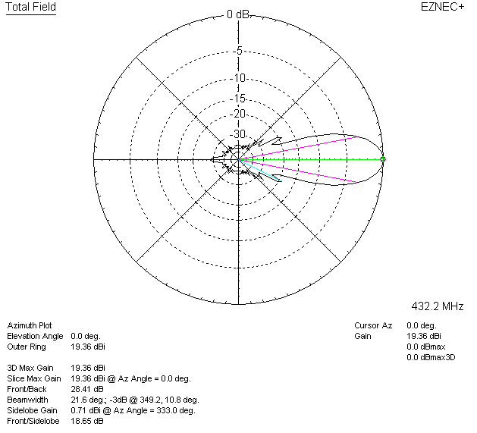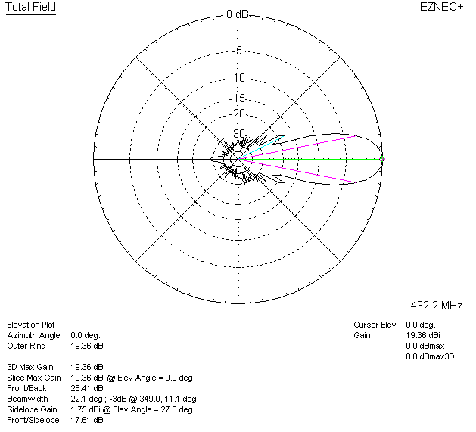

LOSSES INCLUDED (aluminum)
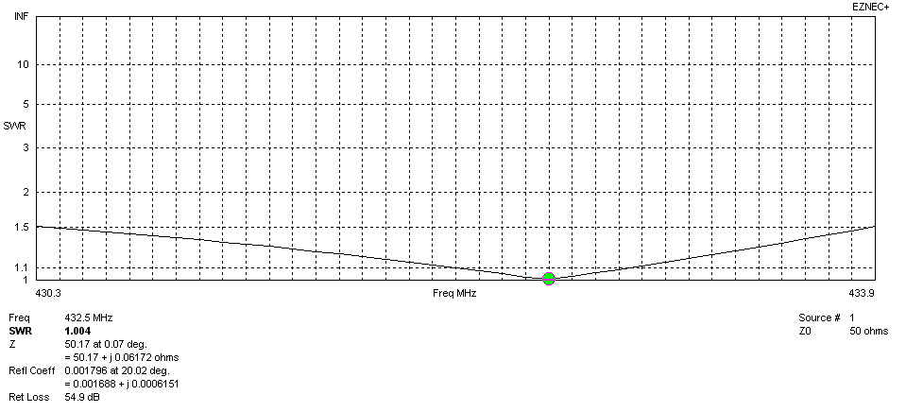
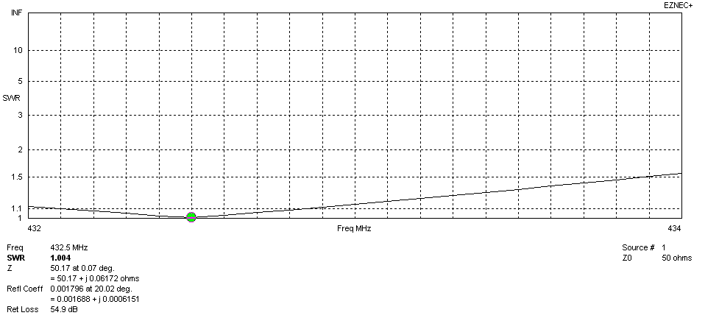
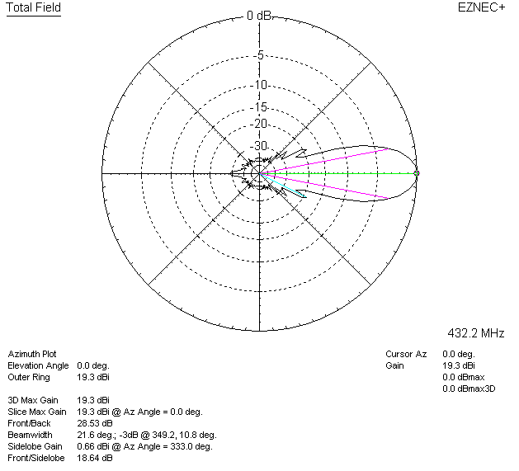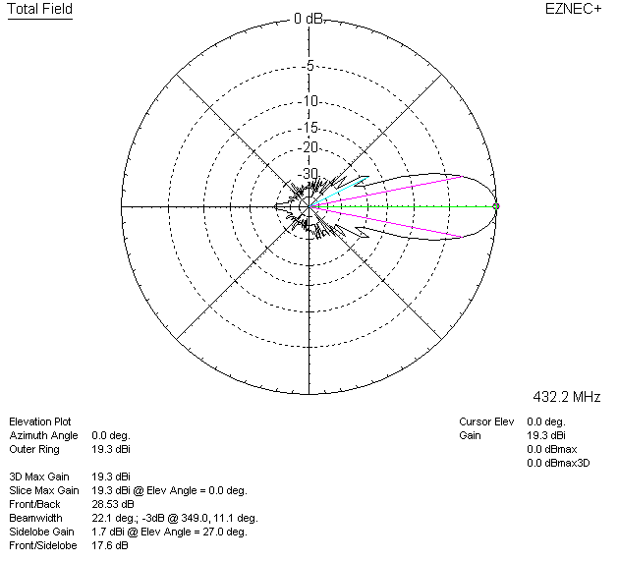

LOSSES INCLUDED (silver)
