ANTENNA Q723D1XL
PERFORMANCES: (No loss condition)
TYPE | ELE | L (mm) | G (dBi) | F/B (dB) | F/Sh (dBi) | F/Sv (dBi) | Hor (◦) | Ver (◦) | Temp (◦K) | G/T (dB) | ΔF * (kHz)
Q723D1XL | 23 | 5960 | 19,23 | 44,19 | 18,86 | 17,80 | 22,0 | 22,6 | 17,4 | +6,84 | 4530
* ΔF given for SWR=1,5

PERFORMANCES: (Losses included)
Element material | G (dBi) | Temp (◦K) | G/T (dB)
Aluminum rods | 19,15 | 22,2 | +5,69
Silvered rods | 19,18 | 20,6 | +6,04

DIMENSIONS:
 | Ref | De | D1 | D2 | D3 | D4 | D5 | D6 | D7 | D8 | D9 | D10 | D11 | D12
Pos | 0 | 131 | 199 | 335 | 485 | 672 | 939 | 1219 | 1524 | 1829 | 2146 | 2462 | 2784 | 3114
Length | 277 | 253 | 245 | 229 | 225 | 219 | 215 | 211 | 207 | 203 | 201 | 197 | 195 | 193
 | D13 | D14 | D15 | D16 | D17 | D18 | D19 | D20 | D21 | - All elements made of Al rods Ǿ4 mm  - The height of all rectangles is 100 mm  - All dimensions given in milimetres
Pos | 3433 | 3755 | 4081 | 4401 | 4731 | 5058 | 5367 | 5679 | 5960
Length | 191 | 189 | 187 | 185 | 182 | 182 | 181 | 176 | 175

COMPARISON
Antenna | Boomlength (mm) | Material | Gain (dBi) | TA (◦K) | G/T (dB) | Bandwidth  (MHz)
Q723D1XL | 5960 | No loss | 19,23 | 17,4 | +6,84 | 429,600-434,130
Q723D1XL | 5960 | Aluminum | 19,15 | 22,2 | +5,69 | 429,600-434,130
Q723D1XL | 5960 | Silver | 19,18 | 20,6 | +6,04 | 429,600-434,130
EF7023-5 | 5965 | No loss | 19,05 | 20,4 | +5,96 | 428,000-434,200
EF7023-5 | 5965 | Aluminum | 18,97 | 25,7 | +4,87 | 428,000-434,200
EF7023-5 | 5965 | Silver | 19,00 | 23,7 | +5,25 | 428,000-434,200

DIAGRAMS
NO LOSS INCLUDED
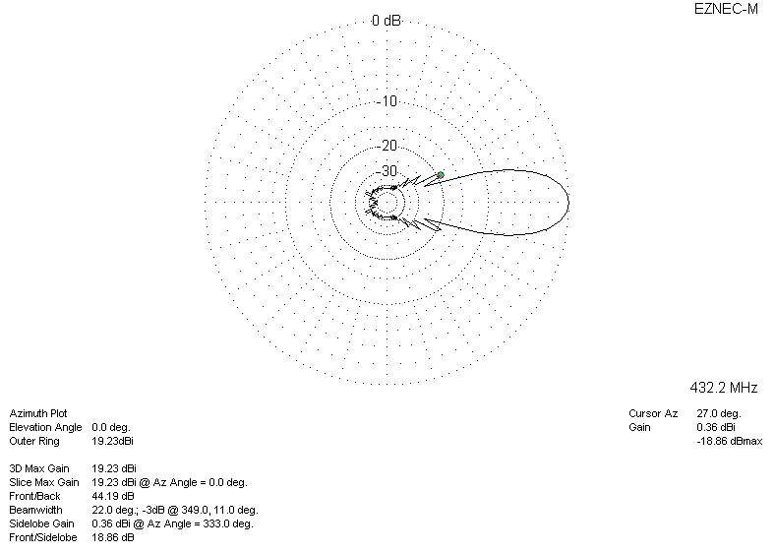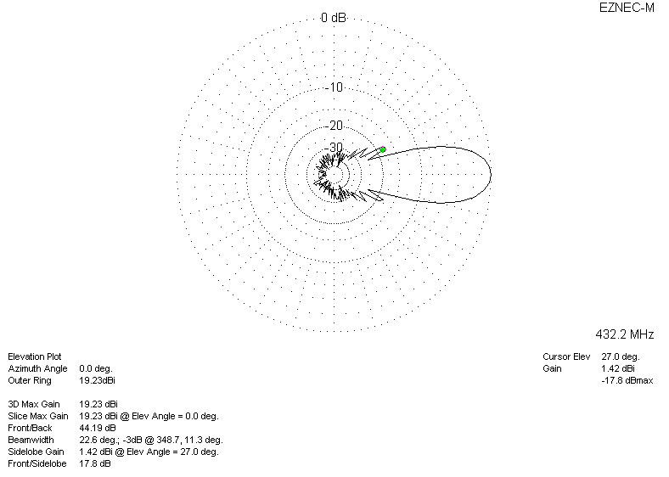

LOSSES INCLUDED (aluminum)
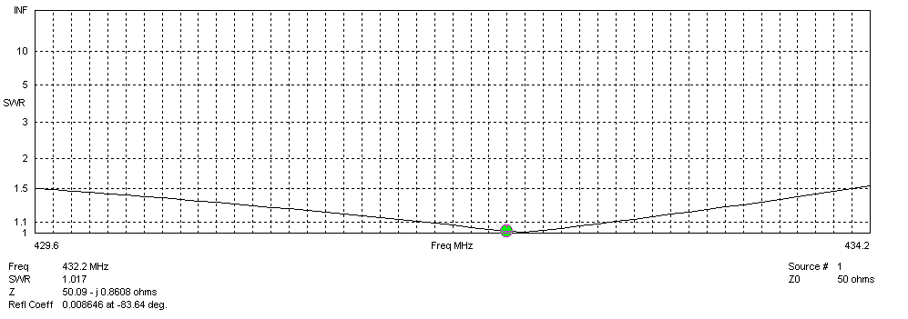
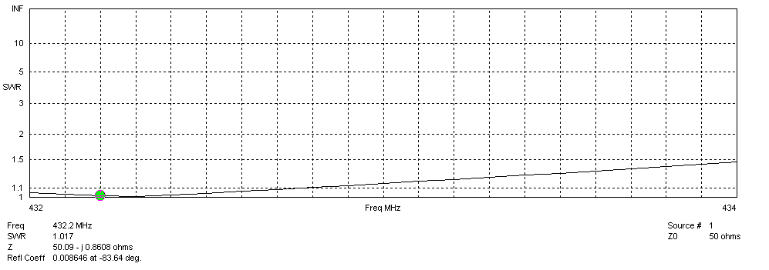
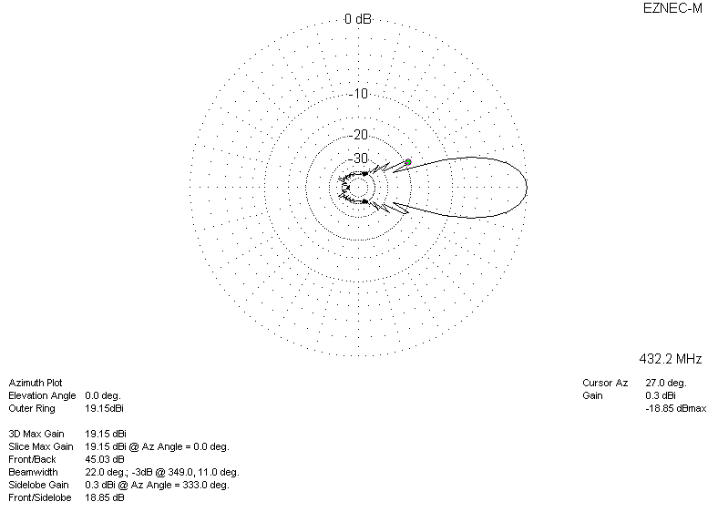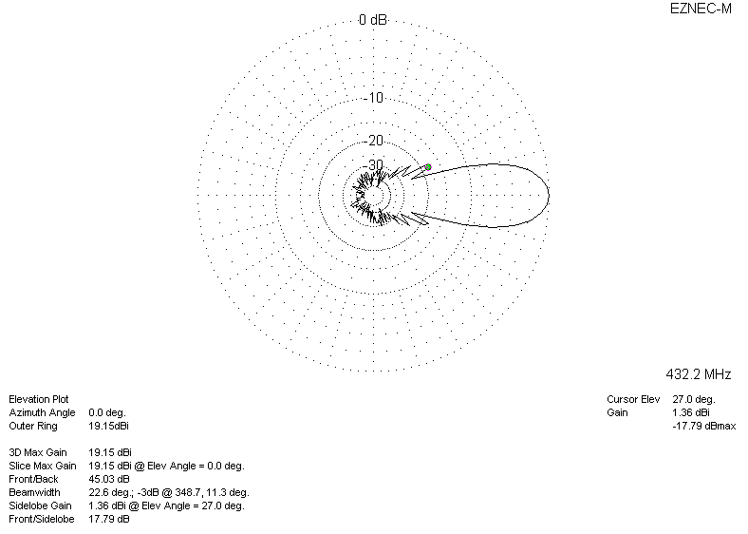

LOSSES INCLUDED (silver)
