ANTENNA Q723B3XL
PERFORMANCES: (No loss condition)
TYPE | ELE | L (mm) | G (dBi) | F/B (dB) | F/Sh (dBi) | F/Sv (dBi) | Hor (◦) | Ver (◦) | Temp (◦K) | G/T (dB) | ΔF * (kHz)
Q723B3XL | 23 | 5980 | 19,31 | 25,28 | 19,44 | 18,23 | 21,8 | 22,4 | 18,3 | +6,68 | 2750
* ΔF given for SWR=1,5

PERFORMANCES: (Losses included)
Element material | G (dBi) | Temp (◦K) | G/T (dB)
Aluminum rods | 19,21 | 24,7 | +5,28
Silvered rods | 19,25 | 22,4 | +5,76

DIMENSIONS:
 | Ref | De | D1 | D2 | D3 | D4 | D5 | D6 | D7 | D8 | D9 | D10 | D11 | D12
Pos | 0 | 97 | 190 | 326 | 489 | 683 | 925 | 1198 | 1501 | 1806 | 2129 | 2447 | 2770 | 3086
Length | 313 | 285 | 278 | 264 | 258 | 254 | 251 | 246 | 240 | 237 | 233 | 231 | 229 | 227
 | D13 | D14 | D15 | D16 | D17 | D18 | D19 | D20 | D21 | - All elements made of Al rods Ǿ3 mm  - The height of all rectangles is 50 mm  - All dimensions given in milimetres
Pos | 3418 | 3749 | 4065 | 4394 | 4738 | 5049 | 5377 | 5708 | 5980
Length | 224 | 222 | 222 | 219 | 217 | 212 | 212 | 212 | 212

COMPARISON
Antenna | Boomlength (mm) | Material | Gain (dBi) | TA (◦K) | G/T (dB) | Bandwidth  (MHz)
Q723B3XL | 5980 | No loss | 19,31 | 18,3 | +6,68 | 431,000-433,750
Q723B3XL | 5980 | Aluminum | 19,21 | 24,7 | +5,28 | 431,000-433,750
Q723B3XL | 5980 | Silver | 19,25 | 22,4 | +5,76 | 431,000-433,750
EF7023-5 | 5965 | No loss | 19,05 | 20,4 | +5,96 | 428,000-434,200
EF7023-5 | 5965 | Aluminum | 18,97 | 25,7 | +4,87 | 428,000-434,200
EF7023-5 | 5965 | Silver | 19,00 | 23,7 | +5,25 | 428,000-434,200

DIAGRAMS
NO LOSS INCLUDED
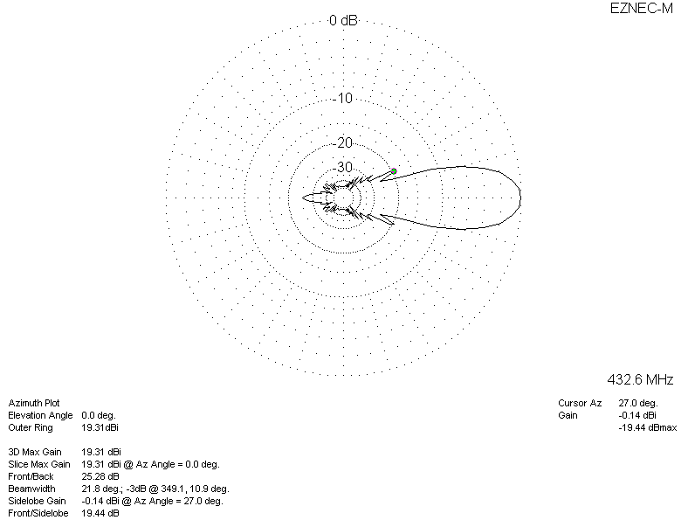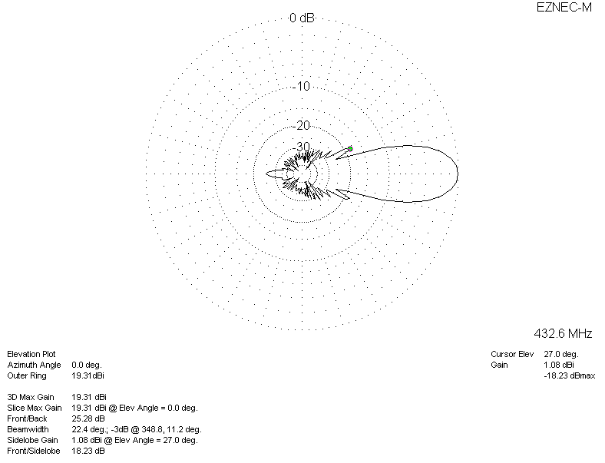

LOSSES INCLUDED (aluminum)
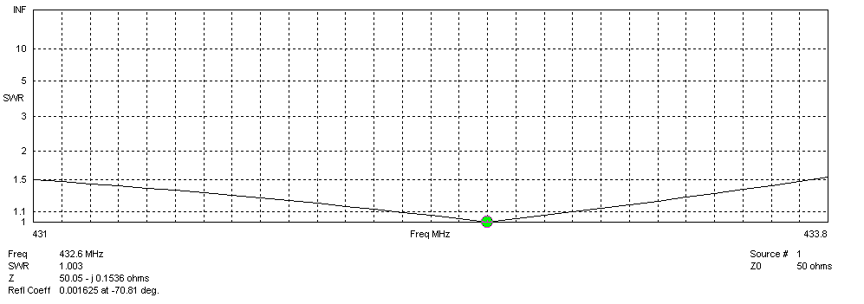
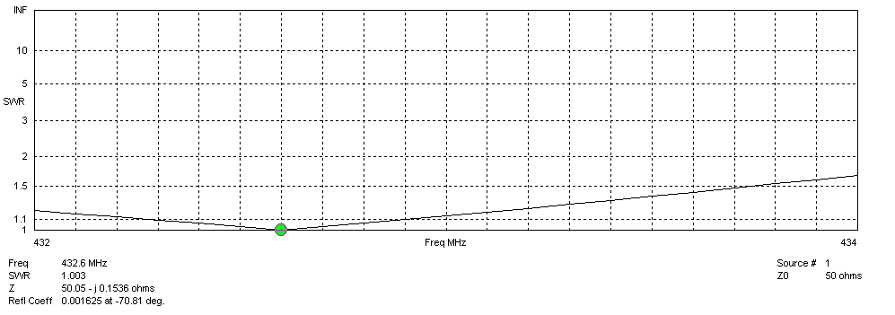
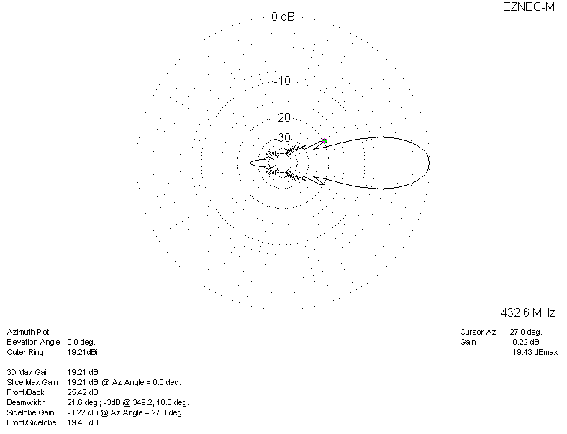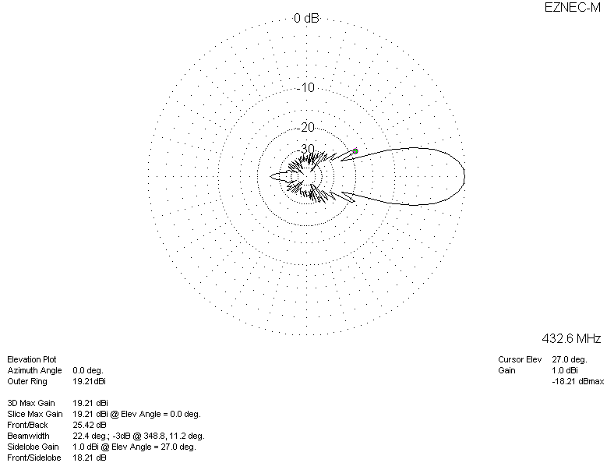

LOSSES INCLUDED (silver)
