ANTENNA Q722D9XL
PERFORMANCES: (No loss condition)
TYPE | ELE | L (mm) | G (dBi) | F/B (dB) | F/Sh (dBi) | F/Sv (dBi) | Hor (◦) | Ver (◦) | Temp (◦K) | G/T (dB) | ΔF * (kHz)
Q722D9XL | 22 | 5605 | 19,09 | 41,27 | 20,70 | 19,62 | 22,4 | 23,0 | 16,3 | +6,96 | 8560
* ΔF given for SWR=1,5

PERFORMANCES: (Losses included)
Element material | G (dBi) | Temp (◦K) | G/T (dB)
Aluminum rods | 19,05 | 19,1 | +6,25
Silvered rods | 19,07 | 18,1 | +6,49

DIMENSIONS:
 | Ref | De | D1 | D2 | D3 | D4 | D5 | D6 | D7 | D8 | D9 | D10 | D11 | D12
Pos | 0 | 120 | 199 | 351 | 484 | 691 | 939 | 1223 | 1519 | 1831 | 2139 | 2457 | 2769 | 3089
Length | 285 | 260 | 247 | 225 | 221 | 219 | 213 | 207 | 202 | 198 | 196 | 192 | 189 | 184
 | D13 | D14 | D15 | D16 | D17 | D18 | D19 | D20 | - All elements made of Al rods Ǿ10,0 mm  - The height of all rectangles is 100 mm  - All dimensions given in milimetres
Pos | 3416 | 3734 | 4065 | 4378 | 4708 | 5025 | 5342 | 5605
Length | 182 | 180 | 178 | 176 | 174 | 172 | 170 | 170

COMPARISON
Antenna | Boomlength (mm) | Material | Gain (dBi) | TA (◦K) | G/T (dB) | Bandwidth  (MHz)
Q722D9XL | 5605 | No loss | 19,09 | 16,3 | +6,96 | 426,500-435,060
Q722D9XL | 5605 | Aluminum | 19,05 | 19,1 | +6,25 | 426,500-435,060
Q722D9XL | 5605 | Silver | 19,07 | 18,1 | +6,49 | 426,500-435,060
EF7023-5 | 5965 | No loss | 19,05 | 20,4 | +5,96 | 428,000-434,200
EF7023-5 | 5965 | Aluminum | 18,97 | 25,7 | +4,87 | 428,000-434,200
EF7023-5 | 5965 | Silver | 19,00 | 23,7 | +5,25 | 428,000-434,200

DIAGRAMS
NO LOSS INCLUDED
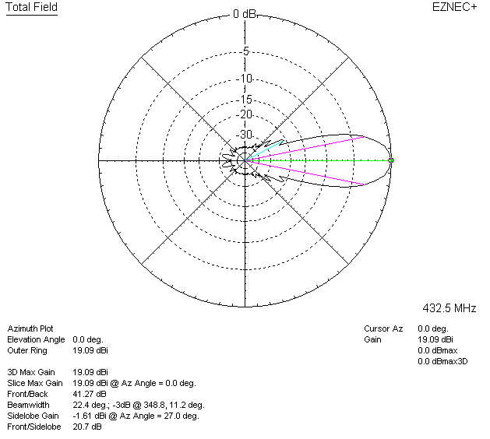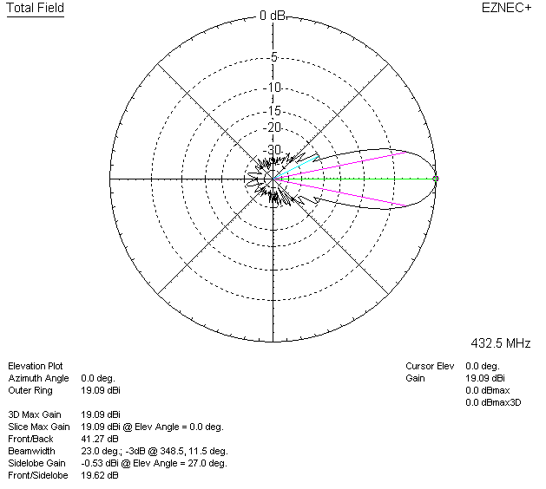

LOSSES INCLUDED (aluminum)
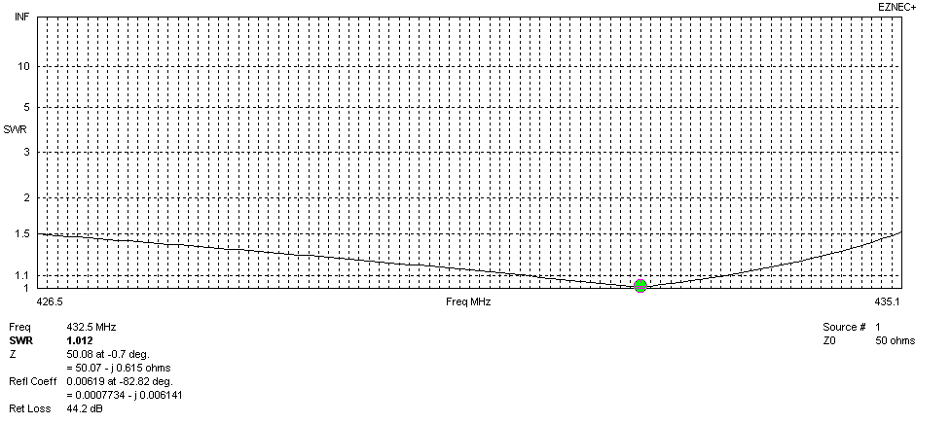
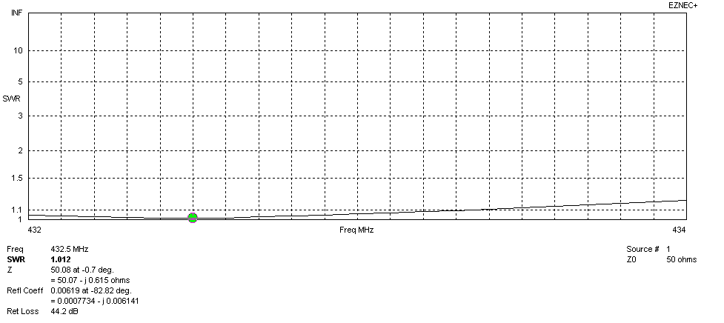
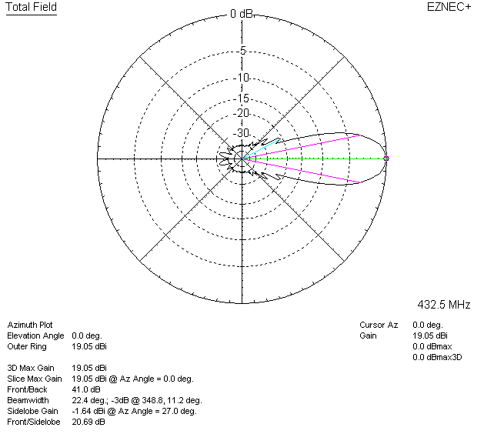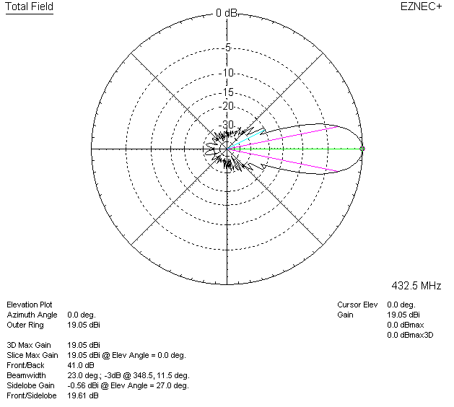

LOSSES INCLUDED (silver)
