ANTENNA Q722D4XL
PERFORMANCES: (No loss condition)
TYPE | ELE | L (mm) | G (dBi) | F/B (dB) | F/Sh (dBi) | F/Sv (dBi) | Hor (◦) | Ver (◦) | Temp (◦K) | G/T (dB) | ΔF * (kHz)
Q722D4XL | 22 | 5510 | 18,59 | 39,18 | 23,04 | 21,74 | 24,2 | 24,8 | 16,5 | +6,40 | 6450
* ΔF given for SWR=1,5

PERFORMANCES: (Losses included)
Element material | G (dBi) | Temp (◦K) | G/T (dB)
Aluminum rods | 18,53 | 20,7 | +5,36
Silvered rods | 18,55 | 19,2 | +5,72

DIMENSIONS:
 | Ref | De | D1 | D2 | D3 | D4 | D5 | D6 | D7 | D8 | D9 | D10 | D11
Pos | 0 | 118 | 168 | 299 | 484 | 683 | 916 | 1188 | 1481 | 1783 | 2092 | 2403 | 2720
Length | 279 | 255 | 245 | 234 | 225 | 220 | 216 | 212 | 206 | 202 | 199 | 194 | 190
 | D12 | D13 | D14 | D15 | D16 | D17 | D18 | D19 | D20 | - All elements made of Al rods Ǿ5 mm  - The height of all rectangles is 100 mm  - All dimensions given in milimetres
Pos | 3039 | 3363 | 3673 | 4009 | 4312 | 4635 | 4949 | 5255 | 5510
Length | 187 | 183 | 181 | 179 | 177 | 175 | 173 | 172 | 172

COMPARISON
Antenna | Boomlength (mm) | Material | Gain (dBi) | TA (◦K) | G/T (dB) | Bandwidth  (MHz)
Q722D4XL | 5992 | No loss | 18,59 | 16,5 | +6,40 | 428,950-435,400
Q722D4XL | 5992 | Aluminum | 18,53 | 20,7 | +5,36 | 428,950-435,400
Q722D4XL | 5992 | Silver | 18,55 | 19,2 | +5,72 | 428,950-435,400
EF7023-5 | 5965 | No loss | 19,05 | 20,4 | +5,96 | 428,000-434,200
EF7023-5 | 5965 | Aluminum | 18,97 | 25,7 | +4,87 | 428,000-434,200
EF7023-5 | 5965 | Silver | 19,00 | 23,7 | +5,25 | 428,000-434,200

DIAGRAMS
NO LOSS INCLUDED
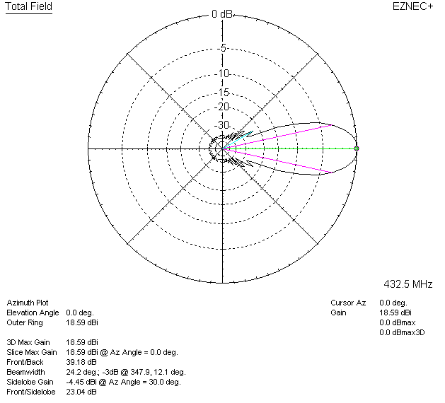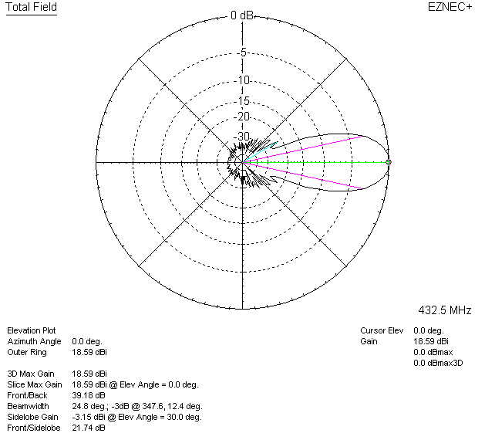

LOSSES INCLUDED (aluminum)
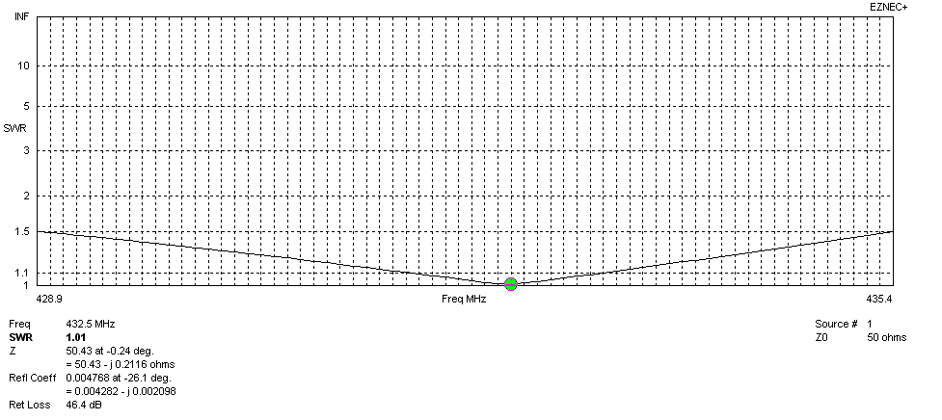
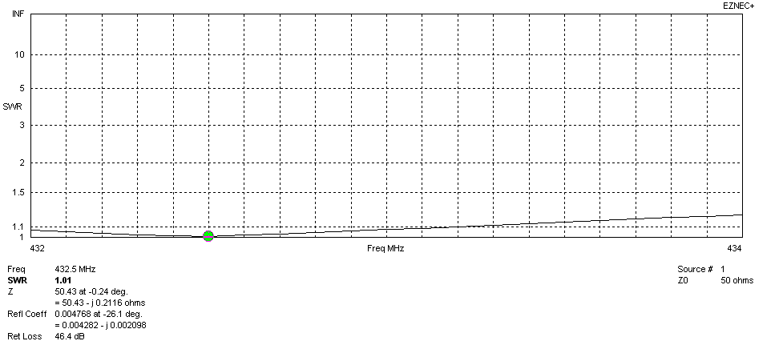
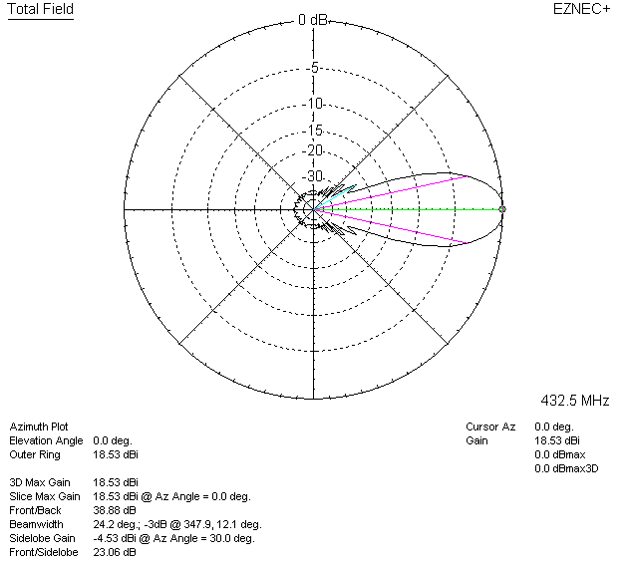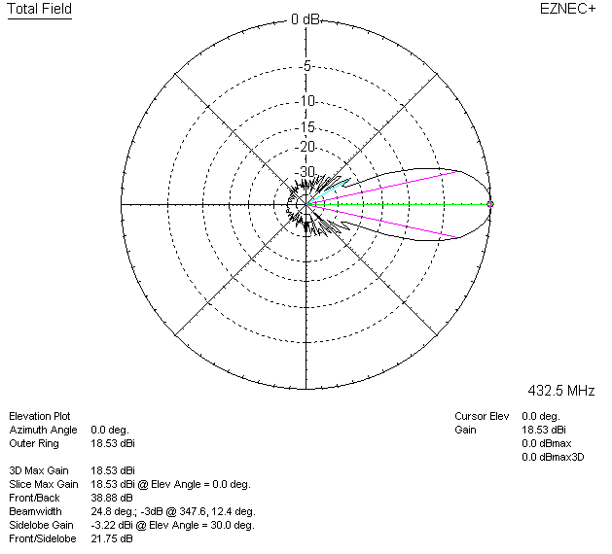

LOSSES INCLUDED (silver)
